Reading: If I ruled the world
Read the texts and do the exercises


Allan, 17
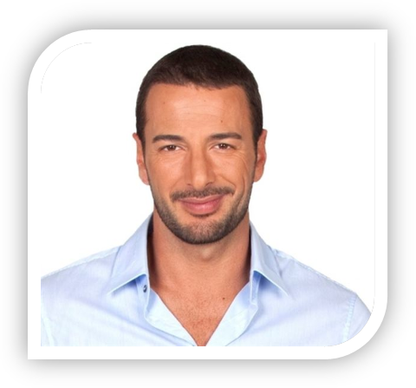
If I ruled the world, I would erase the borders! We would live in a world without countries. If we don’t have any countries, we won’t have any wars. If I had enough money, I would spend it on education and new technologies. People would live in a better world if every child could go to university and learn about other cultures and traditions. I would also finance new scientific projects like a journey to Mars! Finally, the most important thing: if I ruled the world, I would forbid Justin Bieber!

Bob, 41
I would do a lot of great things if I ruled the world! I would forbid men to cut down trees. If we don’t respect the environment, we will have a lot of problems in the future! I would also give 1000€ per month to every family in the world because poverty is the enemy number one of mankind. Finally, I would start great economic projects to help the African continent.
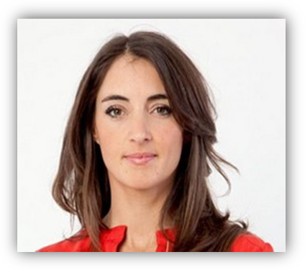
Clair, 29
If I ruled the world, I would get rid of the nuclear weapons! Those weapons are a major danger for all peoples in the world. If I could, I would also protect more animals. Some of them will disappear if we don’t do anything to help them. I would also try to find a cure for every illness!
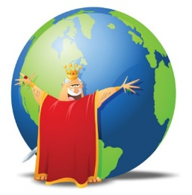
Reading: If I ruled the world
What would the different persons do if they could rule the world? Fill in the table!

People | Projects

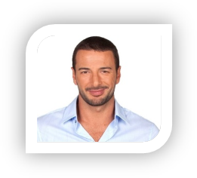
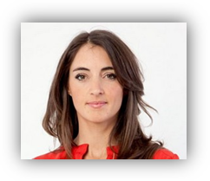

Your turn! What would you do if you could rule the world?
………………………………………………………………………………………………………………………………………………………………………………………………………………………………………………………………………………………………………………………………………………………………………………………………………………………………………………………………………………………………………………………………………………………………………………………………………………………………………………………………………………………………………………………………………………………………………………………………………………………………………………………………………………………………………………………………………………………………………………………………………………………………………………

