SOCIAL MEDIA - ARE WE LOST IN A WORLD LIKE THIS?

**Warm-up**

Look at the picture on the whiteboard. What are we talking about today?

Stand up and prepare to play the **Line Game**.



* **Activity 1**

Watch the video clip of the song “Are You Lost in the World like Me?" by Moby. Which of the problems in the list below are addressed? Tick the boxes.

|  |  |
| --- | --- |
| Α. | Too focused on self-image |
| Β. | Not paying attention |
| C. | Cyberbullying |
| D. | Ignoring other’s feelings |
| E. | Addiction to likes |
| F. | FOMO (fear of missing out) |
| G. | Feeling lonely |
| H. | Privacy concerns |
| I. | Fake news |

How did the video clip make you feel?

Which scene impacted you the most and why?

* **Activity 2**

Read the article from our school’s teenage magazine and try to put the sentences below, back where they belong in the text. There is **one extra sentence** that you won’t need. When you are done, switch photocopies with your partner and correct each other’s work. Make sure you both have the right answers on [Social Media | Live Worksheets](https://www.liveworksheets.com/w/en/efl/7608295)

* If you have any unknown words – I really don’t care! Just joking! There’s a mini dictionary below you can refer to. If you still have questions on vocabulary, ask your partner or me!

**The Disadvantages of Social Media: A Closer Look**

Social media has become an **integral** part of our lives, especially for us teenagers. A. However, it's important to step back and consider some of the disadvantages that come with constant social media use.

Firstly, as **depicted** in Moby's music video "Are You Lost In The World Like Me?", social media can significantly **distort** our self-image and **priorities**. B. This **obsession** with maintaining an online image can lead us to **neglect** genuine relationships and experiences.

Additionally, the video highlights how we can become dangerously distracted by our devices, leading to accidents or missing out on important moments. It also points out our sometimes apathetic behavior towards others' **struggles**, as we might choose to record rather than help.

C. Cyberbullying has become a significant issue, where the anonymity of social media allows harmful and hurtful behaviors to spread. Privacy is another concern; with so much personal information shared online, it's challenging to know who has access to our data and how they might use it.

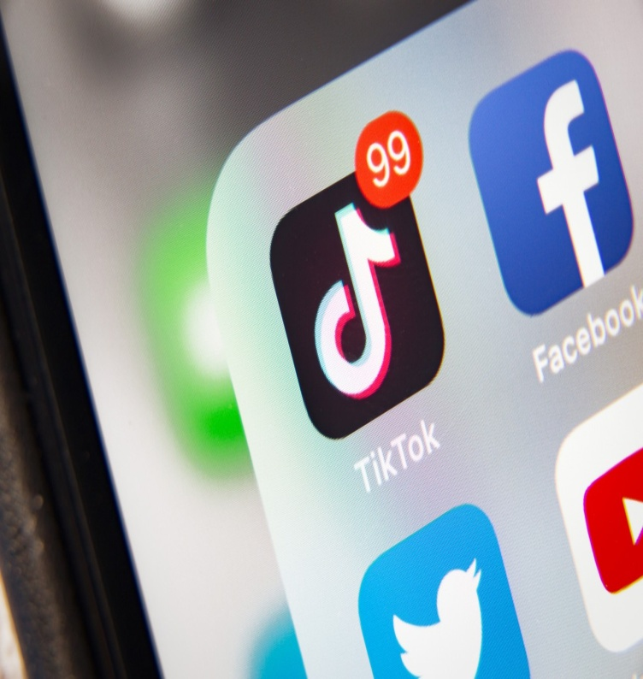Another problem is the **overwhelming** flow of information, leading to what's known as 'information overload'. D. Furthermore, the spread of misinformation or 'fake news' can create confusion and mislead people, often with serious consequences.

Social comparison and the fear of missing out (FOMO) are also common disadvantages. Constant **exposure** to the idealized lives of others can make us feel **inadequate** or left out, affecting our mental health and self-esteem.

In conclusion, while social media offers numerous benefits, it's essential to be aware of its drawbacks. E. Let's not forget the importance of real-world connections and staying present in the moment.

1. By understanding these issues, we can take steps to use social media more responsibly and maintain a healthier balance in our lives.
2. It's where we connect, share, and learn about the world around us.
3. Beyond what the video shows, there are other pressing concerns.
4. Many of us end up spending too much time taking the perfect selfie or creating the ideal post, ignoring the real people and events around us.
5. For example, there are many people who lose their jobs because of this.
6. This constant bombardment can make it hard to concentrate and can even be stressful.

* **Activity 3**

In groups, read the article again. Each disadvantage of social media has a specific effect. Complete the chart below.

|  |  |
| --- | --- |
| **Cause** | **Effect** |
| Distorted self-image | 1. 1. |
| 2. | 1. 3. |
| Cyberbullying | 1. 4. |
| 5. | 1. 6. |
| Overwhelming flow of information | 1. 7. |
| 8. | 1. It can lead to being wrongly informed about serious issues |
| FOMO | 9. |

|  |
| --- |
| **Mini dictionary:**   1. **Depict** To represent or show something in a picture, painting, photograph, or other visual form. In a broader sense, it can also mean to describe something in words. 2. **Distort**: Giving a misleading or false account or impression of something. 3. **Exposure:** The state of being exposed to something, such as to an environment or to certain conditions, or making something visible, especially to public attention. 4. **Inadequate:** Not enough or not good enough for a particular purpose. It can refer to things like resources, responses, or feelings of self-worth. 5. **Integral:** Necessary and important as a part of a whole, or contained within it. 6. **Neglect:** The failure to care for or attend to something or someone properly. This can refer to physical items, personal relationships, or duties. 7. **Obsession:**  An idea or thought that continually preoccupies or intrudes on a person’s mind more than they would like, often in a way that is not logical. 8. **Overwhelming:** Very great in amount, intensity, or difficulty, often so strong as to be unbearable. It can refer to feelings, tasks, or situations. 9. **Priority:**  Something that is considered more important than other matters and needs to be done or dealt with first. 10. **Struggle:**  To make tireless efforts in the face of difficulties. It can refer to physical or mental efforts. |

* **Activity 4**

As we know there are always two sides to a coin. We’ve talked about the disadvantages of Social media, now it’s time to see the advantages. Work in groups. Discuss the benefits of social media and prepare to report back to class. The group with the most ideas wins….a selfie….with me…for Instagram! Not really! Don’t get too excited!!!

|  |
| --- |
| **COMING UP SOON IN A CLASSROOM NEAR YOU (next lesson)**  **Debate!** You know the rules – and so the battle begins!  **Topic:** Social media is the death of communication |

**Homework**

Hey, you! I heard you’re multiply intelligent! Time to set those intelligences in motion!

Choose **ONE** individual activity from group A and **ONE** group project from group B.

* The individual activities will be handed in next time.
* For the group projects you have two weeks’ time. Your group projects will be posted on the **Padlet** you will find in **e-class** on the **Social Media Unit**.

|  |  |
| --- | --- |
| **GROUP A (Individual activity)** | **GROUP B (Group project)** |
| **Linguistic Intelligence (Word Smart)**  **Activity**: Essay Writing **Instructions**: Write an essay discussing the impact of social media on interpersonal communication. You should use examples from personal experience, the video "Are You Lost in the World like Me?", and the class reading material. | **Logical-Mathematical Intelligence (Number/Reasoning Smart)**  **Activity**: Statistical Analysis **Instructions**: Prepare a questionnaire for your classmates. Analyze the data and present your findings, discussing the implications of these statistics on society and individual behavior. |
| **Intrapersonal Intelligence (Self Smart)**  **Activity**: Personal Journal **Instructions**: Write a journal, noting your social media use, how it makes you feel, and any changes you wish to make. | **Spatial Intelligence (Picture Smart)**  **Activity**: Poster Creation **Instructions**: Create a poster illustrating the pros and cons of social media, incorporating images, diagrams, or mind maps. You can use visuals to represent concepts from the video and the reading material. |
| **Naturalistic Intelligence (Nature Smart)**  **Activity**: Connecting with Nature **Instructions**: Spend one day outdoors without your phones or social media. Write a reflection/journal on the experience, focusing on the differences in your mood and productivity. | **Bodily-Kinesthetic Intelligence (Body Smart)**  **Activity**: Role-Play **Instructions**: In groups, create and perform (in class) short role-plays that depict scenarios showing the effects of social media on everyday life. Brainstorm scenarios that effectively communicate your message. |
|  | **Musical Intelligence (Music Smart)**  **Activity**: Creating a Song of any genre **Instructions**: Write and perform a short song that expresses your views on social media, inspired by the video and class discussions. Focus on the emotional impact of social media or its effects on communication. |
|  | **Interpersonal Intelligence (People Smart)**  **Activity**: Campaign design **Instructions**: In groups, discuss how social media has affected your relationships and communication skills. Come up with strategies for healthier social media use and prepare a Healthy-Social Media use campaign. |