

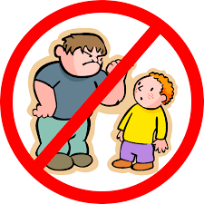

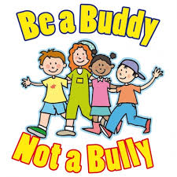

BULLYING IS REPEATEDLY HITTING, KICKING, PUSHING, HURTING, TEASING,CALLING NAMES, THREATENING,PHYSICALLY ABUSING, STEALING THINGS, MAKING FUN AND ISOLATING SOMEONE
THE VICTIMS FEEL SCARED, SAD, LONELY, EVEN DEPRESSED . THEY DON’T WANT TO GO TO SCHOOL ANY MORE, THEY GET BAD MARKS THEY LOSE THEIR SELF-ESTEEM, THEY HAVE NIGHTMRESAND SOME COMIT SUICIDE

