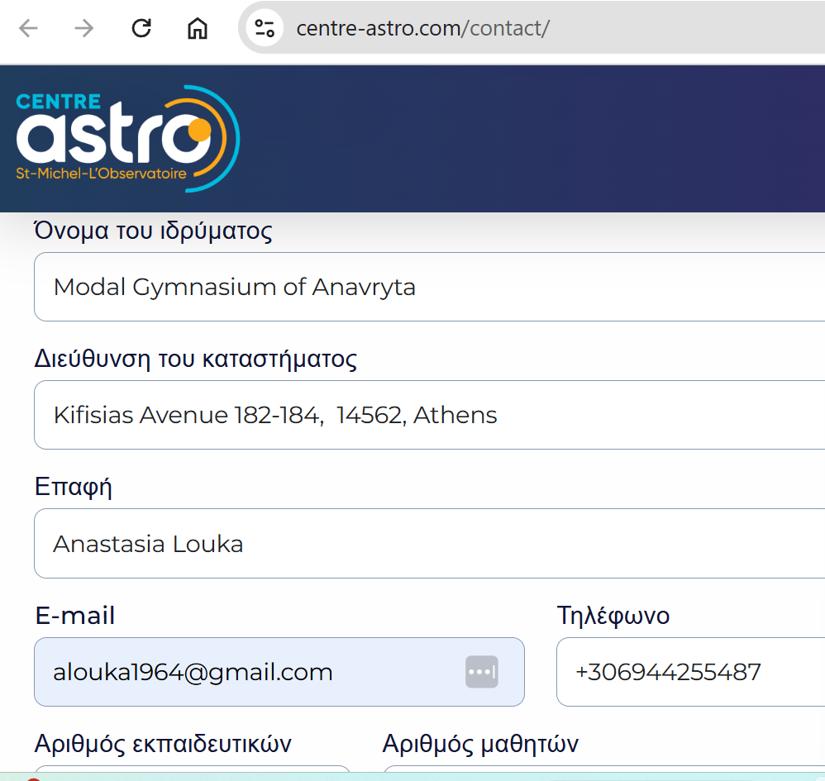
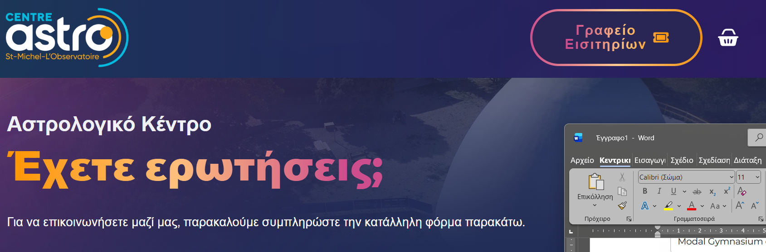
Dear Sir or Madam,

We are a Model School in Athens, and as part of our Physics and Biology Club we are organizing an educational visit to Southern France. Our trip will take place from Wednesday, March 11th to Sunday, March 15th. Our program includes a guided visit to ITER, where we will receive information on the nuclear fusion experiment that is currently being developed there.

We would like to explore the possibility of visiting your institution as well, so that our students may have an additional experience related to the natural sciences, scientific research, or astronomical observation, depending on the activities you offer.

Could you please inform us:

Whether it is possible to arrange a visit for a school group during the period March 11–14,

What types of activities, guided tours, or educational workshops are available for students,

And what the procedure and cost for booking such a visit would be.

Thank you very much for your time.
We look forward to your response.

Sincerely,
Anastasia Louka
teacher of physic
alouka1964@gmail.com

