
Lily’s mother had three kids and no husband – life was not easy, and she didn’t have much money. One day, she asked Lily to go to the shop and get some bread and milk. She gave Lily a five-pound note. Lily ran along to the shop, but when she got there – disaster! - she did not have the five-pound note! It must have fallen out of her pocket. Lily started to cry. There were three people in the shop. They all asked Lily what the matter was and where she lived. Through her tears, Lily told them that she had lost her five-pound note and that she lived at Number 23 Noble Street. The three customers said they would look for the fiver, and if they found it, they would bring it to Lily’s house.
Lily

When Lily got home, her mum was a bit cross and upset, but she told Lily not to worry. However, that £5 was her last money; her purse was empty. The bread and milk were for the breakfast the next day. So now, it was going to be a breakfast of cereal without milk and without toast for Lily’s family. The four of them went to bed feeling sad.
The next morning, Lily’s mum got up and went to the front door to collect the post. She was surprised to see three envelopes on the floor, addressed to ‘Lily’s mum’. When she opened them, she was even more surprised, and delighted: each envelope had a five-pound note inside it.
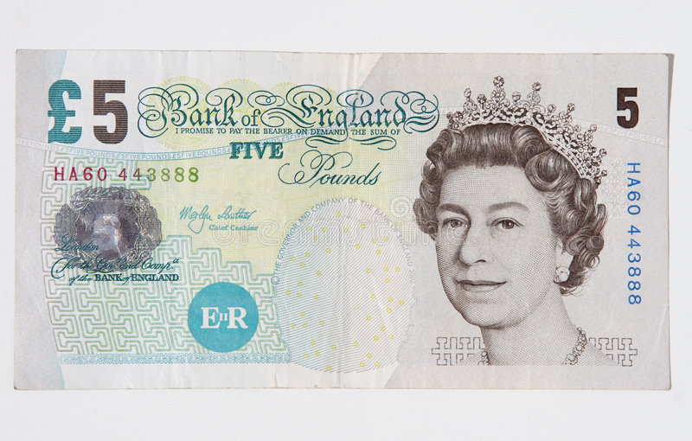
- Say if the sentences are true or false:
- __ Lily’s mother had an easy life
- __ She sent Lily to the shop for some bread and milk
- __ The five-pound note was in Lily’s bag.
- __ The people in the shop ignored Lily

- __ The customers promised to help Lily if they could
- __ Lily’s mum shouted at her for losing the money
- __ The family were unhappy when they went to bed
- __ Lily’s mum ended up with £15.

- Answer the questions in full sentences:
- How many people were there in Lily’s family?
- Why did her mum ask her to go to the shop?
- When Lily got to the shop, did she still have the five-pound note?
- What did the people in the shop ask Lily?
- What did they say they would do?
- How did Lily’s mum react when Lily told her about the missing money?
- What was the bread and milk going to be for?
- Who do you think posted the three envelopes? What do you think about their actions?

- Match up the sentence parts:
- Lily’s mum gave Lily __ a. the money fell out of Lily’s pocket
- Unfortunately, __ b. she opened the envelopes and saw the money
- The people in the shop were __ c. some money and sent her to the shop
- Lily’s mum was really happy when __ d. concerned and helpful…. And very kind.

KEYS:
I 1F, 2T, 3F, 4F, 5T, 6F, 7T, 8T

II
- There were four in her family
- To get some bread and milk
- No. It was lost/she had lost it
- They asked her what the matter was and where she lived
- They said they would look for the £5 and return it to her, if they found it.
- She was a bit cross and upset, but she told Lily not to worry
- It was going to be for the next morning’s breakfast
- I think it was the three people (customers) in the shop. (Their actions warmed my heart)

III 1c, 2a, 3d, 4b

Lily’s mother had three kids and no husband – life was not easy and she didn’t have much money. One day, she asked Lily to go to the shop and get some bread and milk. She gave Lily a five pound note. Lily ran along to the shop, but when she got there – disaster! - she did not have the five pound note! It must have fallen out of her pocket. Lily started to cry. There were four people in the shop. They all asked Lily what the matter was and where she lived live. Through her tears, Lily told them that she had lost her five pound note and that she lived at Number 23 Noble Street. The four customers said they would look for the fiver, and if they found it, they would bring it to Lily’s house.
When Lily got home, her mum was a bit cross and upset, but she told Lily not to worry. However, that £5 was her last money; her purse was empty. The bread and milk were for the breakfast the next day. So now, it was going to be a breakfast of cereal without milk and without toast for Lily’s family. The four of them went to bed feeling sad.
The next morning, Lily’s mum got up and went to the front door to collect the post. She was surprised to see four envelopes on the floor. When she opened them, she was even more surprised, and delighted: each one had a five pound note inside it.

