2. A revolving restaurant around the customers.

here are millions of restaurants around the world. Many of them are similar: they have tables, chairs, servers, customers and food. But some are very different!

**T**

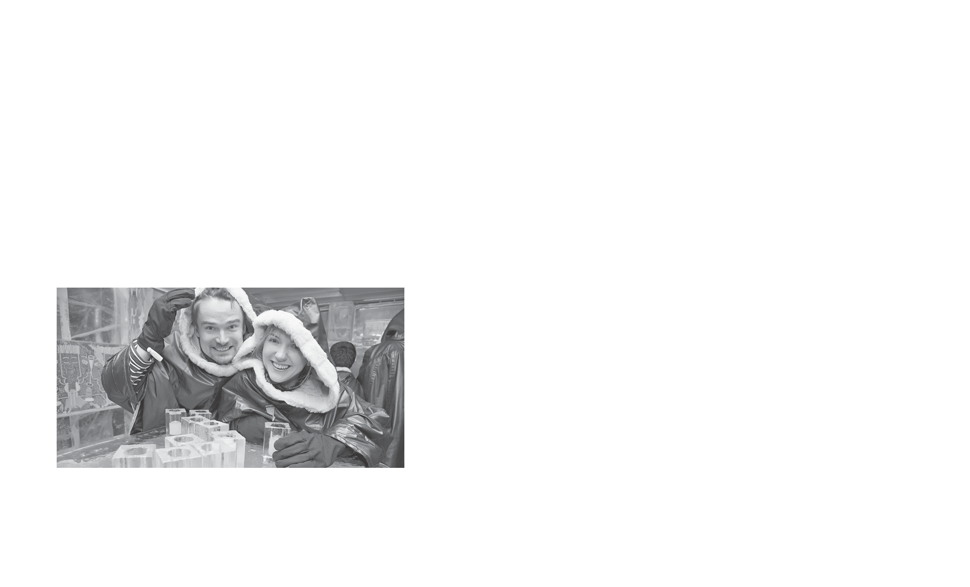

Can you imagine eating dinner without seeing your food? There are some restaurants that serve food in the dark! The servers wear special **night-vision** glasses so they can see. Customers say that the food tastes better this way!

Do you like **seafood**? You can eat some fish with the fish at **aquarium** restaurants. Some are completely underwater—the whole restaurant is surrounded by water! Others are like normal restaurants with giant aquariums.

Some restaurants **revolve** while the customers eat! They are usually on the top **floor** of a building. They move very slowly and they have a lot of windows!

There are restaurants in trees and restaurants that float on water. There are restaurants made of ice and restaurants that have robot servers. Can you believe it? It’s true!

**Activities**

1. move while you eat
2. drink from frozen glasses
3. eat without light
4. eat surrounded by fish

aquarium lights millions moves servers water

**night-vision:** for

seeing in the dark

**seafood:** fish, shrimp, crab, etc.

**aquarium:** glass

tank for fish

**revolve:** to move in a circle

**floor:** level

**drinks:** beverages

**G lossary**

**2 Read and match.**

**Restaurants**

1. restaurants in the dark

2. aquarium restaurants

3. revolving restaurants

4. ice restaurants

5. Some restaurants have robots for .

4. There are restaurants that float on .

3. Some restaurants are completely underwater.

1. At restaurants without , the servers wear special glasses.

0. There are millions of restaurants around the world.

**1 Read and complete.**

*These two friends are enjoying an ice restaurant.*

*Their* ***drinks*** *are in frozen glasses!*

**Restaurants Around**

**the World**

**Name**