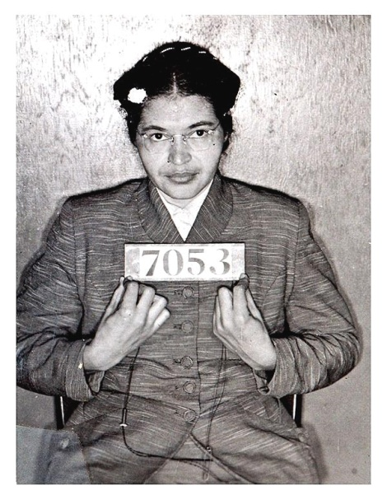**Civil rights icon Rosa Parks dies**

**Fill in the blanks with the appropriate word.**

**rights treated praised challenge civil laws symbol required movement effects revolution caught stood up fined**

Rosa Parks, the icon of the American _____________ rights movement, has died aged 92. Her refusal to give up her seat to a white man on an Alabama bus in 1955 started a _____________ in the US civil ____________ movement. She was one of the first people to ______________ America’s segregation laws.

Ms Parks passed away in her sleep at her home in Detroit. She suffered from the ____________ of old age in recent years and was rarely seen in public. The mayor of Detroit ____________her courage and strength. He said she was a ___________ of the civil rights movement. He also said: “Just by a simple act of sitting down she _______ _____ for so many people.”

Ms Parks is called the mother of America's civil rights _________________. In 1955, she was a 42-year-old department store worker in Montgomery, Alabama. She __________ a bus and sat down. Soon after, a white man got on and had to stand. The law _____________ black passengers to make room for white passengers. Ms Parks refused to move, saying: “No. I'm tired of being _____________ like a second-class citizen.” She was arrested and __________ $10. This incident sparked the famous bus boycott that lasted 381 days. It also led to the end of segregation __________ throughout America’s South.

**Look in the dictionary and find synonyms for the following phrasal verbs from the article**

give up ­­­­­­­­­­­­­­­­­_________________

passed away ­­­­­­­­­­­­­­­­­_________________

sitting down ­­­­­­­­­­­­­­­­­_________________

stood up­­­­­­­­­­­­­­­­­ for_________________

sat down ­­­­­­­­­­­­­­­­­_________________

got on ­­­­­­­­­­­­­­­­­_________________

make room ­­­­­­­­­­­­­­­­­_________________

breakingnewsenglish.com

**Match the following synonyms from the article**

1. **icon _____ sparked**
2. **movement _____ space**
3. **started _____ got on**
4. **passed away _____ resulted in**
5. **praised _____ died**
6. **caught ____ shortly**
7. **soon ____ campaign**
8. **room ____ continued for**
9. lasted **_____ s**ymbol
10. led to **_______**hailed

Look at the newspaper article. Answer true or false to the 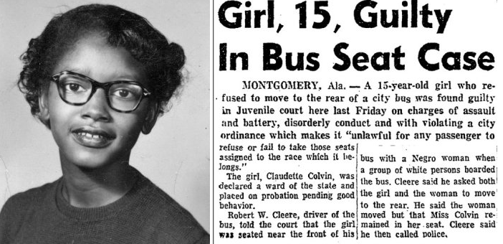following statements Justify your response.

a. She was tried as an adult True False

____________________________________________________________

b. She was a teenager at the time of her arrest. True False

____________________________________________________________

c. Montgomery is in the state of New Jersey True False

____________________________________________________________

d. She was the only one to not obey the request by the bus driver. True False

____________________________________________________________

e. She asked a white man on a bus if she could sit on his seat. True False

____________________________________________________________

____________________________________________________________

f. U.S. law required black passengers to give their seats to white people. True False

____________________________________________________________

____________________________________________________________

g. The bus driver immediately called the police. True False

____________________________________________________________

h. Claudette was sentenced to 6 months in prison. True False

____________________________________________________________