**EVERY BUILDING HAS ITS OWN STORY**

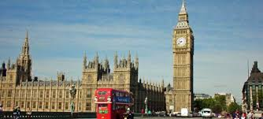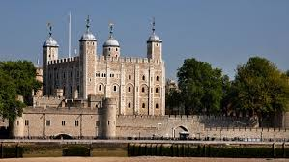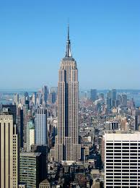

**BIG BEN THE TOWER OF LONDON EMPIRE STATE BUILDING**

**Study again Lesson 3 of our student’s coursebook (pages 20,21) which is about buildings and amazing structures.**

**Then choose one of the above buildings and write its story in the same way stories of other buildings are presented in your coursebook.**

**The following questions may help you.**

* **Where is it located?**
* **How old is it?**
* **Who made it?**
* **What purpose was it made for?**
* **What is the story behind it?**

**ANSWER**