**WORKSHEET**

**Communication through the Age**

**In Class Activities**

**1. Activity: Think-Pair-Share**

**Based on your viewing the video**

* Think about some **key milestones** in communication history that are mentioned in the video and what the biggest challenges of communication before the internet were.
* In pairs discuss the above and
* Share with the class

**2 .Activity :** Picture-Based Discussion

Look at these images of communication methods and discuss:

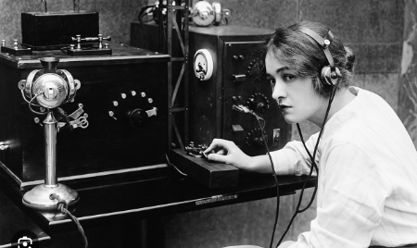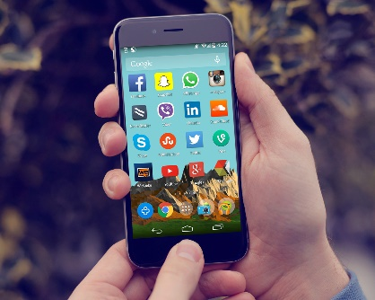

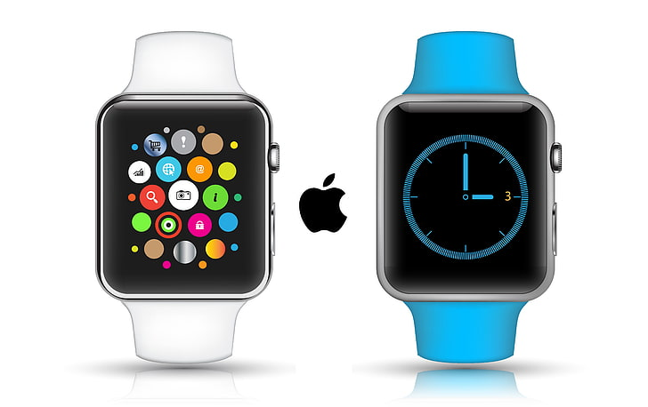

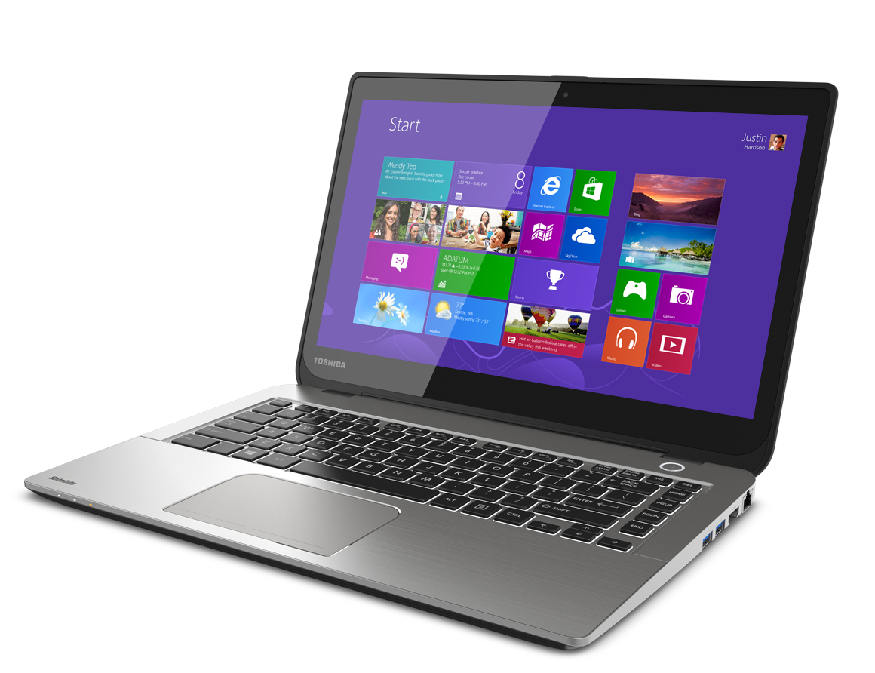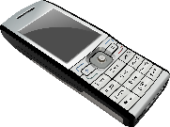 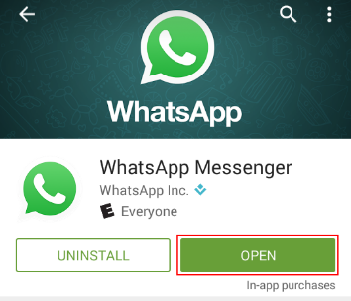

* “How do you think people communicated in the past compared to now?”
* Which means of communication influences your lives most?
* How has the internet changed the way we communicate? Do you think it’s **mostly positive or negative? Why?”**

**3. Activity : Timeline Activity**

Get into small groups (3-4) arrange the scrabbled cards displaying communication milestones into the correct chronological order. The first group to finish wins!

***4.* JIGSAW READING : Collaborative Activity**

You will be divided into small groups and each group will be given a short text (printed or digital) to read. Each group will have to write about the advantages and disadvantages of each era , underline 3 key points and prepare a 1-minute ***summary.*** Then a member of the group will **present** the summary to the whole class.

After sharing discuss: *the pros and cons of internet communication”*

**Group 1: Communication in the Past (Pre-Digital Era)**

Before the digital revolution, maintaining relationships across distances required significant time and patience. The primary method for personal communication was handwritten letters, which involved carefully composing thoughts on paper, purchasing stamps, and waiting days or even weeks for delivery. For more urgent matters, people relied on telegrams - brief, expensive messages sent through telegraph offices. Families typically shared a single landline telephone that was permanently connected to the wall, with long-distance calls costing substantial amounts per minute.

News and information came primarily from daily newspapers delivered each morning and scheduled television or radio broadcasts in the evening. Unlike today's constant updates, people had to wait hours or days to learn about important events. While these methods were slower, they often resulted in more thoughtful exchanges and stronger personal connections, as each communication required greater effort and anticipation.

**Group 2: The Digital Communication Revolution**

The advent of the internet fundamentally transformed how humans interact. Electronic mail (email) revolutionized written communication by delivering messages instantly anywhere in the world, eliminating the need for stamps, envelopes, or waiting periods. Modern messaging platforms like WhatsApp and Telegram allow not just text but also instant sharing of photos, documents and voice messages.

Video calling technology has made face-to-face communication possible across continents, with services like Zoom and Skype enabling families to connect visually despite being oceans apart. Social media networks have created global communities where people share life updates, news, and ideas in real-time. Remarkably, most of these services are completely free to use, unlike the expensive long-distance calls of the past.

**Group 3: The Future of Communication (AI, VR, and Beyond)**

Artificial Intelligence (AI) and virtual reality (VR) are shaping the next era of communication. AI chatbots (like ChatGPT) assist in writing and customer service, while VR meetings create immersive digital spaces for work and socializing. Brain-computer interfaces and holograms may one day make communication even more seamless. However, ethical concerns—such as deepfakes, data privacy, and digital dependency—remain critical challenges

**Group 4: Challenges of the Digital Age**

While digital communication offers incredible benefits, it has introduced new societal challenges. Cyberbullying has become a widespread issue, with studies showing 20% of teenagers experiencing harassment through social media platforms, sometimes with devastating psychological consequences. The rapid spread of misinformation is another major concern, with false stories gaining traction much faster than factual reporting due to sensationalized content.

Privacy breaches occur alarmingly frequently, with millions of passwords and personal data records stolen annually by hackers. Many users unknowingly expose sensitive information through oversharing on social media. Additionally, the constant connectivity has led to new forms of digital addiction, with many people struggling to disconnect from their devices even during meals or family time.