Extra 1: World Heritage (e-class)

a) know the different types of World Heritage (matching vocabulary exercise)

b) what events caused the UN and UNESCO, the World Heritage and the Intangible Cultural Heritage to be born? (watching a video, practicing listening , speaking, note taking skills and cultivating critical thinking)

c) be ready to describe the emblems we’ve examined in the worksheets and what they symbolize. (vocabulary and critical thinking to link an emblem with an idea)

ANSWERS:

a) Τhe following can be found on WORKSHEET 1

World Heritage: places on Earth that are of outstanding universal value to humanity and as such, have been inscribed on the World Heritage List to be protected for future generations to appreciate and enjoy.

Categories:

**Cultural World Heritage:** artefacts, monuments, a group of buildings and sites, museums that have a diversity of values including symbolic, historic, artistic, aesthetic, ethnological or anthropological, scientific and social significance.(e.g. Acropolis, Colosseum, Louvre)

**Natural World Heritage:** the most extraordinary natural places on the planet, characterized by their natural beauty or outstanding biodiversity, ecosystem and geological values. (Yellowstone Park, Galapagos islands)

**Intangible Cultural Heritage (or Living Heritage):** traditions or living expressions inherited from our ancestors and passed on to our descendants, such as oral traditions, performing arts, social practices, rituals, festive events, knowledge and practices concerning nature and the universe or the knowledge and skills to produce traditional crafts (e.g. traditional dances, festivals, crafts like ceramics)

b) We’ve examined how these organizations and ideas were born as a result of real world problems based on a short video we watched in class and can be found again on WORKSHEET 1 <https://www.youtube.com/watch?v=lOzxUVCCSug>

Based on what we’ve discussed, United Nations(UN) and UNESCO (United Nations Educational Scientific and Cultural Organisation) were born after the end of World War 2 , to promote understanding among people and to secure peace.

World Heritage and the need to be protected resulted from a specific event later on: Following the construction of a dam in 1960s, the ancient temples of Abu Simbel were about to sink. An international rescue team mission prevented this by breaking the monuments into pieces and rebuilding them on higher grounds. This successful project raised awareness about the fact that all over the world there are places of outstanding value to humankind, which must be protected.

Intangible Cultural Heritage: It was born at the beginning of this century. Because of the invention of Internet and the globalization, local customs , traditions and crafts started disappearing.

c) EMBLEMS – LOGOS

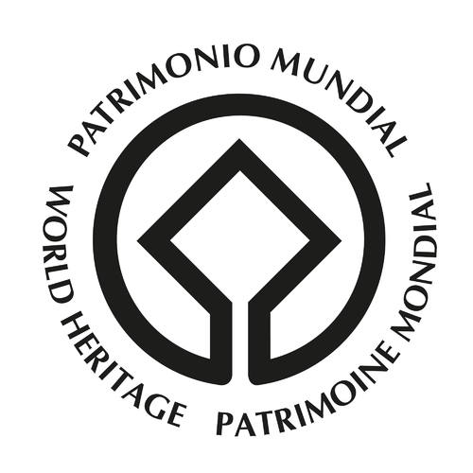

The emblem of World Heritage: The central square symbolizes the results of human skill and inspiration and the circle celebrates the gifts of nature. The emblem is round, like the world, a symbol of global protection for the heritage of all humankind. Answer can be found on the link [**https://whc.unesco.org/en/emblem/**](https://whc.unesco.org/en/emblem/) on WORKSHEET 1.

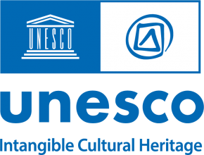

On the left side, it is the emblem of UNESCO. The image of an ancient temple, which symbolizes the first civilizations with the pillars replaced by UNESCO letters, symbolizing the importance of education, science and culture. On the right side, it is the emblem of Intangible Cultural Heritage. The triangle becomes a square, the square becomes a circle and the circle takes the form of the bubble. It is similar to the@ sign. It highlights the link between traditional – characterized by the hand movement, and modern – symbolized by the at-sign, which ties in with our theme: heritage in the age of modernity.

THIS INFORMATION CAN BE FOUND ON WORKSHEET 2

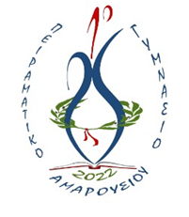

The emblem of the 1st Experimental Junior High School of Maroussi. In the center, there is a ceramic vase as a symbol of the long ceramic tradition of Maroussi (the area where our school is located). Around it, there is an olive wreath awarded to winners of the Olympic Games (Spyros Louis Greek, a water carrier from Maroussi won the first modern-day Olympic marathon at the 1896 Summer Olympics. Following his victory, he was celebrated as a national hero). At the bottom there is a book, which symbolizes education and the need to study to gain knowledge while at school….

GOOD LUCK to everyone !!!