**PRESENTING AN ANCIENT CIVILIZATION**

**B’ CLASS PROJECT WORK**

1. By now, you are all familiar with what you need to pay attention when presenting orally. For useful tips, check again Extra 1 in e-class, remember the four criteria (delivery/content/structure/visuals) we used to assess the presentations and the valuable experience you’ve had while presenting or watching other presentations in class.
2. For your team to be successful, assign roles and divide tasks after you make your choice all together.

**The Project Advocate**: This a traditional project manager type of role. As such, they take on the responsibility for having the general overview of the project, the general planning and ensuring that everything is on schedule.

**The Specialist**: The most common role is that of a specialist. This is a team member who is particularly good at something. They have a specialised skillset which allows them to take responsibility for an area of the project.

**The Researcher(s)**: The researcher will have the responsibility to come up with ways to gather the information the team needs and ensure that team can act upon this information.

**The Report Writer(s)**: The person responsible for typing and editing the plan so as to be presented in the class.

**The Project Presenter(s)**: The person who will present the plan to the class.

1. When choosing the ancient civilization your team will present, make sure you provide information using the GRAPES lens.

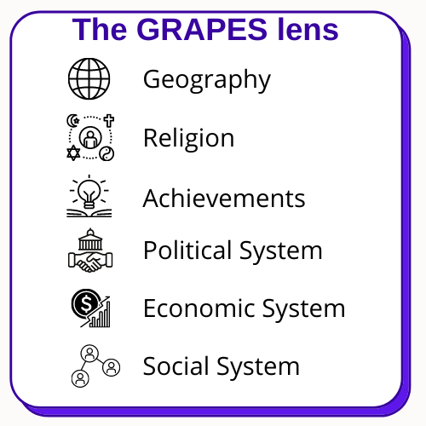

**BEST OF LUCK!**

**I know you can be even better this time!!!**