**ZERO FOOD WASTE**

**C’ Class**

**WORKSHEET 1**

Synchronous Stage (45 minutes)

1. **WARM UP**

**PART 1 Consolidation of previous knowledge about advice**

a. Who do you ask for advice and why?

b. What is the best advice you’ve ever received? Share it with your classmates.

c. Watch the video and fill in the box with 10 ways of giving advice.

<https://www.youtube.com/watch?v=f0mnx0_LWko&t=67s>

d. Write in pairs an example for each way of giving advice.

|  |  |
| --- | --- |
| WAYS OF GIVING ADVICE | Example of your own |
|  |  |
|  |  |
|  |  |
|  |  |
|  |  |
|  |  |
|  |  |
|  |  |
|  |  |
|  |  |

1. **Speaking Activity: Intro to the new topic of Zero Food waste**
2. Raise your hand if you think that your family wastes more food than it consumes.
3. Raise your hand if you have to throw food in your family because it’s gone bad.
4. In your opinion, is this bad and why?
5. **Homework**: (asynchronous stage) Watch the video on FOOD WASTE and try to answer the following questions. Write down the answers in your notebook and bring them in class to share and check with your classmates.

<https://www.youtube.com/watch?v=K3973p7K2Kw&t=23s>

1. Write down different examples of food waste.
2. How much food is wasted every year?
3. What are the three levels on which food waste causes problems? Give examples.
4. What needs to be done?
5. Can you write down some concrete ideas on how to save food?

**ZERO FOOD WASTE**

**C’ Class**

**WORKSHEET 2**

SYNCHRONOUS STAGE (45 min)

1. **Intro**

Share your answers from the video and check them in class.

Make all together a Hexagon analysis on board using the answers to the highlighted questions.

**Tips to complete your hexagons:**

* Put the main concept you analyse in the centre of the hexagon.
* Put the related concepts and ideas around the main concept, one per hexagon side.
* Try to put the concepts and ideas one next to the other, in a logical order, showing how they are related.

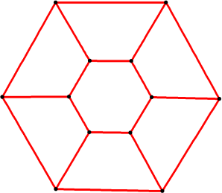

1. **Speaking activity:** I have decided to reduce food waste and I am asking for your help. Listen to Mrs Felliou, take notes, discuss in pairs and decide on two pieces of advice to report in class. You can use some of the ideas below. Remember to use different ways to give me advice.
2. **Homework**

**Make your own zero waste recipe.**

Give a **name** to your recipe, write the **ingredients**, **step-by-step instructions** and include a **picture of your zero waste food** once you make it. Don’t forget to write **your name and clas**s in the end!