

Lesson plan and more resources are available at: aka.ms/hackingstem

ANEMOMETER
Analyzing wind speed

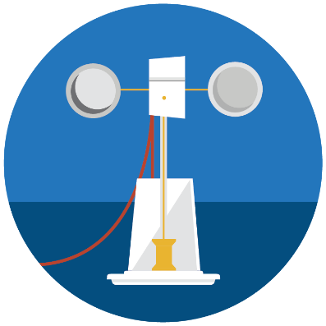
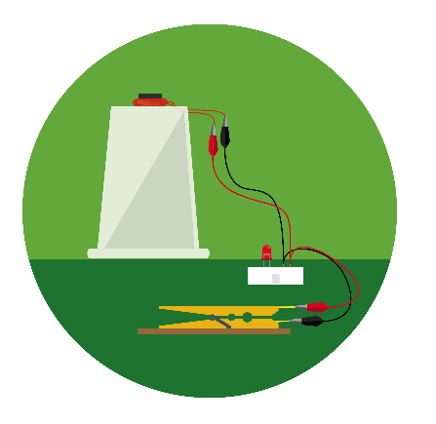
v
Activity overview
This project focuses on building anemometers to measure wind speed from everyday materials. It starts with a simple mechanical engineering problem, then progresses to include electrical and software engineering tasks. The sensor-enabled anemometer captures and displays data in Microsoft Excel. The motorized anemometer receives live data generated by a global weather web service. Students select a city on a map which in turn causes the anemometer to spin, simulating the wind speed at the selected location.
View the full lesson plans mapped to NGSS and ISTE standards, materials, and activities to support this unit at aka.ms/lessonplan.
Please note that lesson activities will require adult supervision.


Contents
02 Activity overview
03 Basic anemometer
04 Sensor-enabled
anemometer
11 Connect Arduino Uno
14 Connect micro:bit
17 Enable Data Streamer
18 Data Streamer basics
19 Excel workbook basics
20 Motorized anemometer
23 Connect Arduino Uno
25 Connect micro:bit
28 Excel workbook basics

Hack our projects
We love innovation and encourage you to hack our projects and make them your own. Submit your ideas at aka.ms/hackingstem
Build and learn
The basic model acts as a stand-alone lesson or can be enhanced with two variations of connected anemometers. The basic model supports students in mathematically determining wind speed. Students use a stopwatch while counting the revolutions of the anemometer, then use math to determine the wind speed.

Connect your tools
Sensor-enabled
Enhance the basic model by attaching a microcontroller and a few other components. This enables the device to collect, calculate, and record wind speed data in the customized Excel workbook.

Motorized
The addition of a small motor along with an internet connection allows students to mechanically spin the anemometer, representing the wind speed

Visualize the data
Have this lesson come to life by using the custom Excel workbook to visualize and analyze live data from student-built instruments.

BASIC
Anemometer

Things you’ll need to build
Safety guidelines

Hot Melt Tool
- Place it on a level surface to avoid tipping over.
- Place the electrical cable out of the way to avoid a tripping hazard.
- Do not touch the tip of the tool or the hot glue coming out of it.
Eye Protection
- Please wear appropriate eye protection while doing any engineering design or field projects.
Cutting Tools
- Keep the sharp edge away from your body.
- When cutting small pieces, do not place fingers very closed to the blades.
Materials
1 small paper plate
1 clear plastic 12 oz cup
5 12 oz paper cups
1 plastic drinking straw
1 wooden spool
2 skewers, at least 24 cm long

Toolkit
pen or pencil
ruler
scissors
hot melt tool
push-pin
stopwatch

Making for a group or need help finding materials?
View the shopping list to calculate quantities at: aka.ms/anemometershoppinglist
Build the base
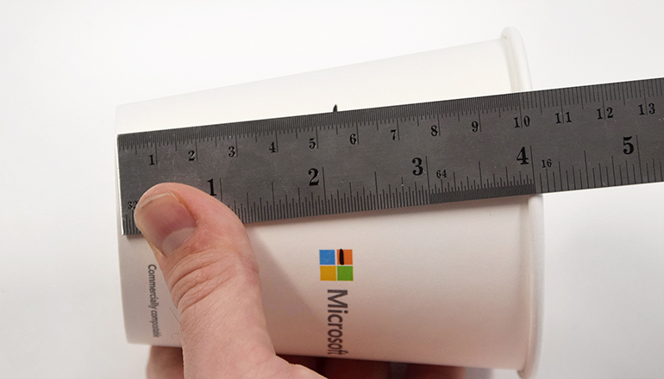 |  | 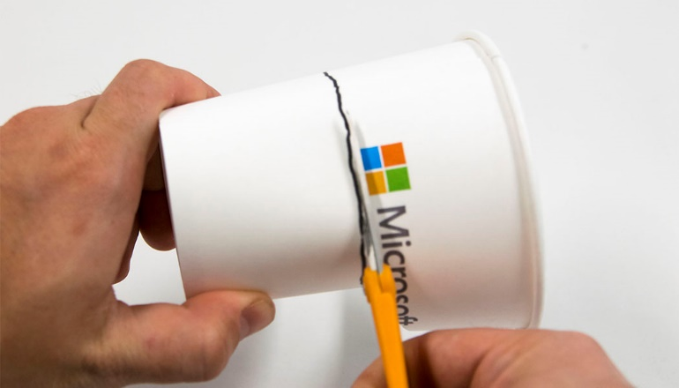
1 | Draw a dashed line 5.5 cm up from the bottom of the cup, all the way around the circumference. |  | 2 | Connect the dashes to make a solid line. Cut the cup on the line.
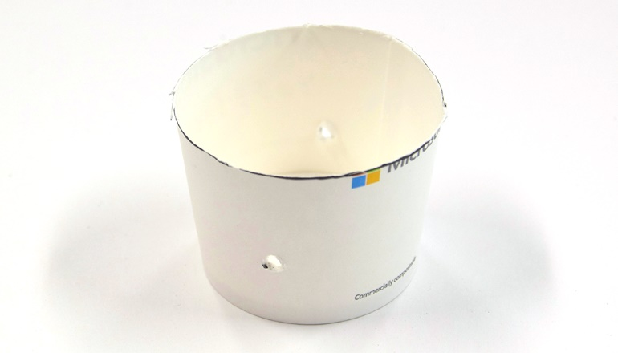 |  | 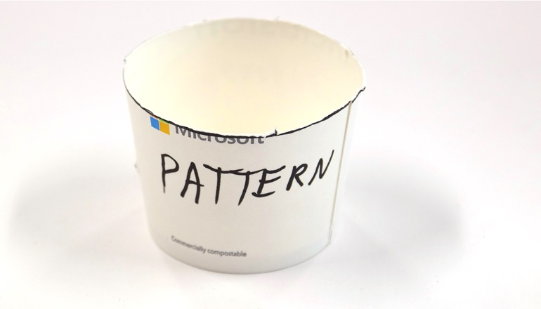
3 | Make two holes with a push pin, directly opposite one another, 2 cm up from the bottom of the cup. |  | 4 | Label this as the pattern cup. The dimensions of the pattern are slightly different than the resulting wind cups.
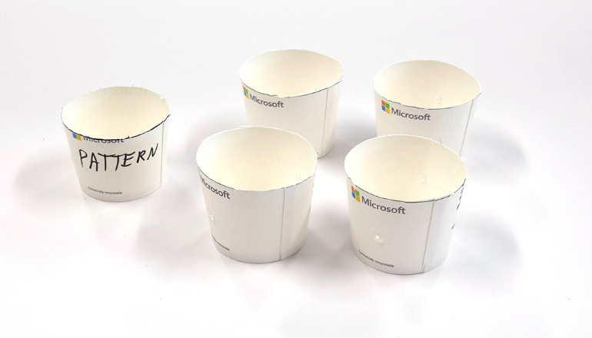 |  | 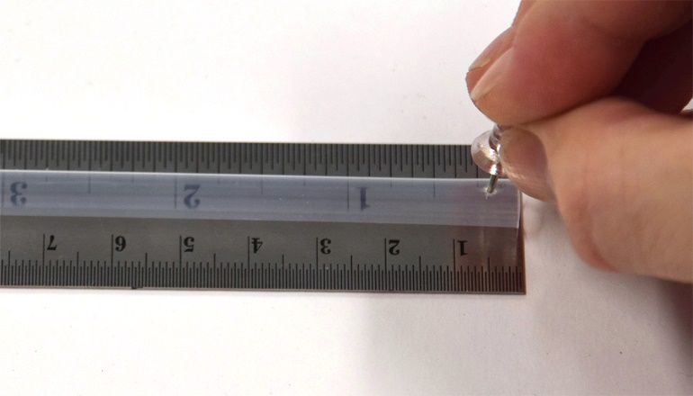
5 | Nest a cup in the pattern. Draw a line at the rim of the pattern then cut and punch holes in each remaining cup at the line. |  | 6 | Poke two holes in the straw with the push pin, .5 cm from the end. The holes should be directly opposite each other.
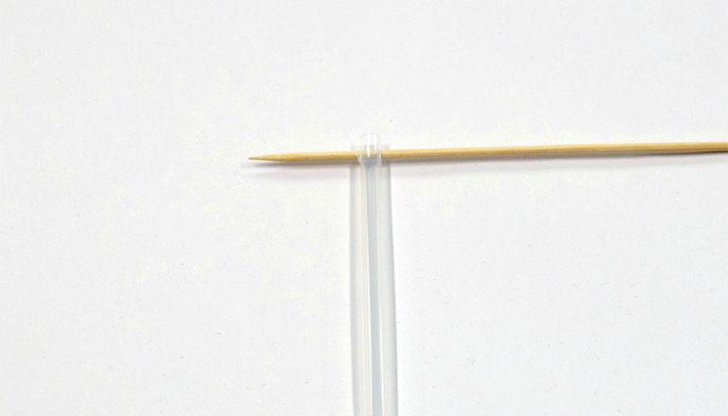 |  | 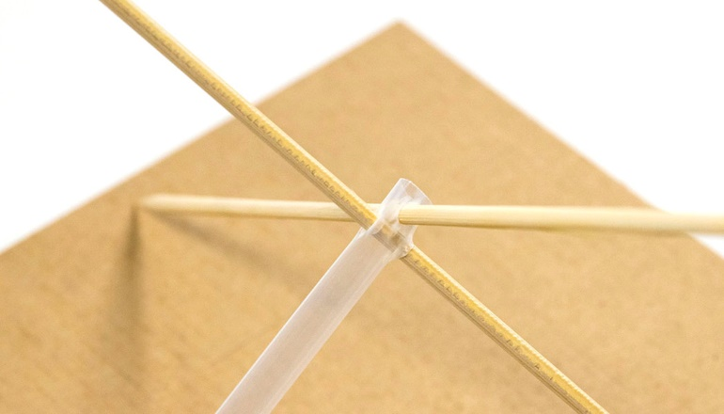
7 | Insert a skewer through the holes. |  | 8 | Repeat Step 6 making holes slightly below the level of the first, offset 90°, so that when the second skewer is inserted, an X is formed.
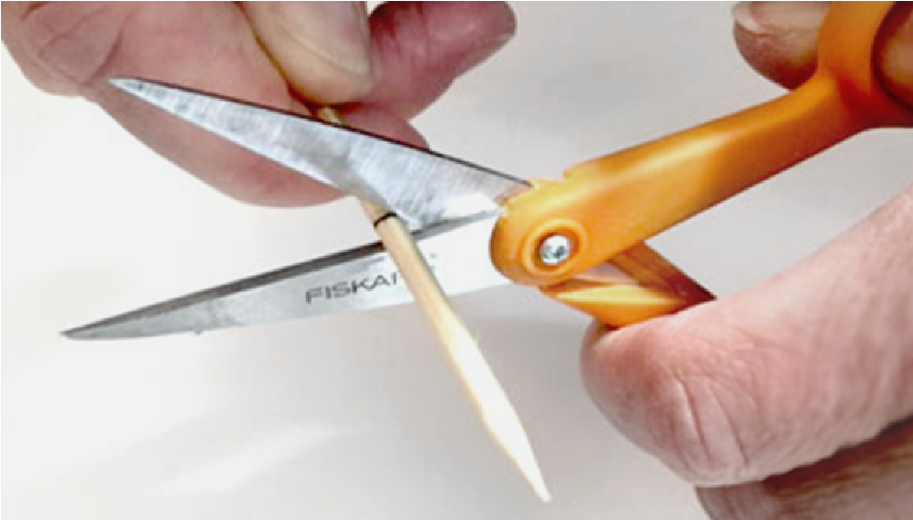 |  | 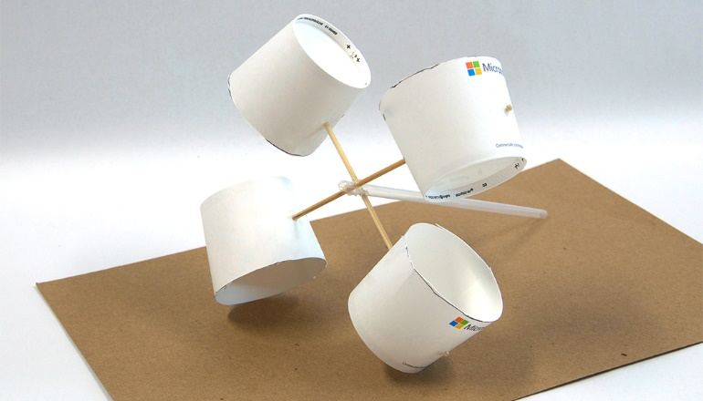
9 | Remove the skewers from the straw. Mark at 24 cm and cut both from the blunt end by scoring and snapping at the score. Discard the sharp end. |  | 10 | Replace the skewers into the straw. Attach the wind cups, arranging them so that all face the same direction, and secure the cups to the skewer with hot glue.
11 | Use the tip to melt a smooth hole into the bottom of the cup, wide enough to fit your straw through. |  | 12 | Glue the spool to the center of the plate, avoiding getting any glue in the hole.
13 | Center the plastic cup over the spool and plate. Insert and align the wind cups and straw. Glue the rim of the cup to the plate. |  | 14 | Test it by blowing on the cups to see if it rotates easily.  You’ve completed the basic anemometer. This will also be used in the next activity!

Measure wind speed

Now that you’ve completed the basic anemometer, you can use it to determine wind speed in kilometers per hour (km/h):

1 | Make a large and distinguishable mark on one of the cups to help you count the rotations.
2 | If weather conditions are sufficient, measure wind speed outdoors. If not, use a blow dryer or fan. Using a stopwatch, count how many times the symbol passes a certain point within 10 seconds.
Number of rotations:
3 | To calculate the rotations per second, divide the number of rotations by 10.
Rotations per second:
4 | Now determine the rotational circumference (3.14 x the diameter of the wind cup structure). The diameter is the length of the skewer connecting two wind cups - it should be 24 cm (as determined in step 9 above).
Rotational circumference:
5 | To determine the distance (in cm) traveled per second, multiply the number of rotations per second by the circumference.
Distance traveled per second:
6 | To determine the distance (in cm) traveled in 1 hour, multiply the distance traveled in one second by 3600.
Distance traveled in one hour:
7 | To convert this into km/h, divide the distance (cm) traveled in one hour by 100,000. This gives you the wind speed in km/h.
Wind speed in km/hr:

SENSOR-ENABLED
Anemometer

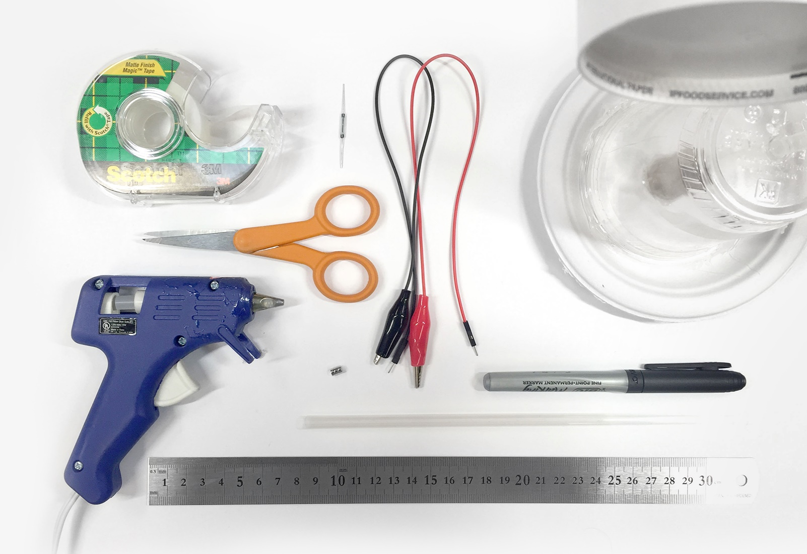
Things you’ll need to build

Materials  1 completed basic anemometer  1 reed switch  2 pin-ended alligator clips  1 plastic drinking straw  2 mini neodymium circular magnets (4mm diameter) | Toolkit  clear adhesive tape  hot melt tool  marker  metric ruler  scissors

Making for a group?
View the shopping list to calculate quantities at: aka.ms/anemometershoppinglist
Add a sensor
1 | Cut two small parallel notches at the end of the straw. |  | 2 | This will serve as the setting for the reed switch.
3 | Tape the reed switch into the notches and secure with tape. Bend both leads downward. Be careful as the read switch is very fragile. |  | 4 | Next, tape that straw to the plastic cup base. The top should sit just below the skewers so that it does not interrupt movement.
5 | Glue the magnets to the skewer so that they pass directly over the switch. Adjust the taping of the straw as needed. A faint clicking is heard when the magnets pass over the switch. |  | 6 | Finally, connect the alligator clips to the two leads on the reed switch.
You are now ready to connect your sensor-enabled anemometer. If you have an Arduino, turn to the next page. If you have a micro:bit, turn to page 14.
Connect Arduino Uno: Part 1

Materials
1 Arduino Uno board
1 breadboard
1 USB cable (USB micro) Arduino programming cable (2 meters)
1 temperature sensor (TMP 36)
1 100-ohm resistor
6 pin-ended wires

Making for a group or need help finding materials?
View the shopping list to calculate quantities and links to materials at: aka.ms/anemometershoppinglist
Upload Arduino code
 |  | 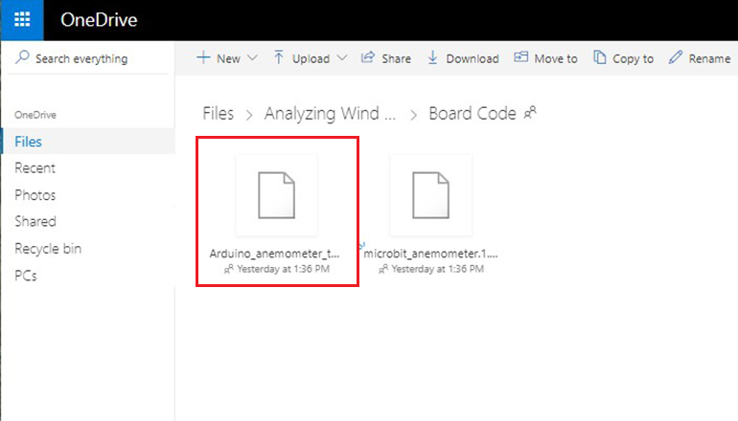
1 | Install the Arduino IDE from the Technical Requirement link on the lesson page at aka.ms/hackingSTEM or through the Microsoft Store. Follow prompts to complete the installation. |  | 2 | Go to aka.ms/flashcode and download the flash code.
3 | Open your downloaded file to launch the Arduino app. |  | 4 | In the Arduino app, select: Tools > Port > COM 3 (Arduino/Genuino Uno). Your port may be different than COM3.
5 | Then select Tools > Board: Arduino/Genuino Uno. |  | 6 | Click on the circular right arrow button to upload.
Create a circuit
7 | Connect four of the jumper wires from the Arduino to the breadboard as shown. The color of the wires can be helpful for organization but does not impact functionality. |  | 8 | Place the temperature sensor into the bread board as shown.
9 | Connect two more jumper wires as shown for power and ground. |  | 10 | Trim the ends of the resistor and insert into the breadboard then connect the alligator clips from the anemometer, as shown.
Great work!
You’ve made a sensor-enabled anemometer. Go to the next section to make the motorized version or go to page 17 to start visualizing data!
Circuit images made with Fritzing and are licensed for use under CC by SA 3.0. See http://creativecommons.org/licenses/by-sa/3.0/ for the full description.
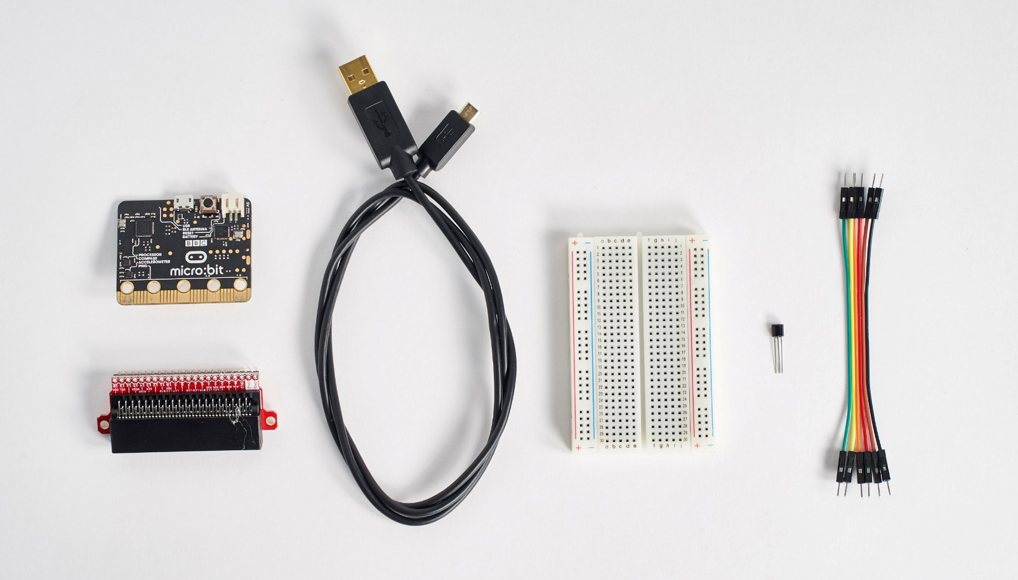
Connect micro:bit: Part 1

Materials
1 micro:bit
1 micro:bit edge connector
1 breadboard
1 USB micro cable
1 temperature sensor (TMP 36)
6 pin-ended wires

Making for a group?
View the shopping list to calculate quantities at: aka.ms/anemometershoppinglist
Upload micro:bit code
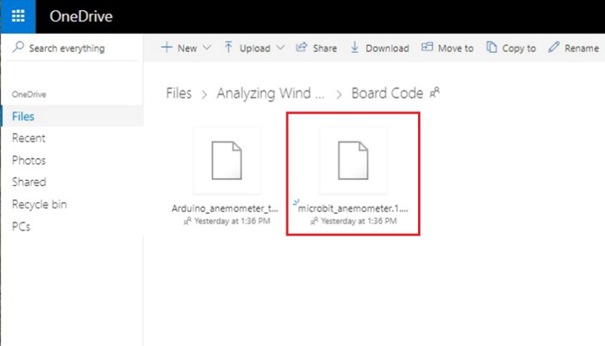 |  |  | 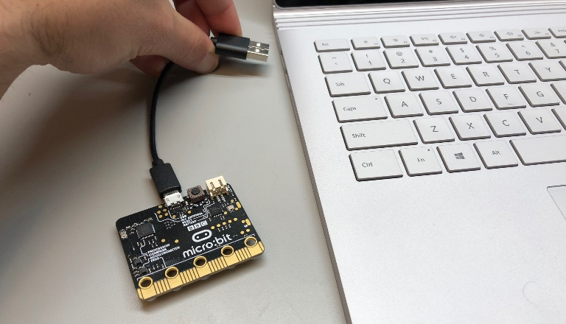
1 | Go to aka.ms/flashcode to download the .hex code file. |  |  | 2 | Plug your micro:bit to your computer using a USB cable. Install the mbed driver. If you’ve done this before, you won’t have to do it again.
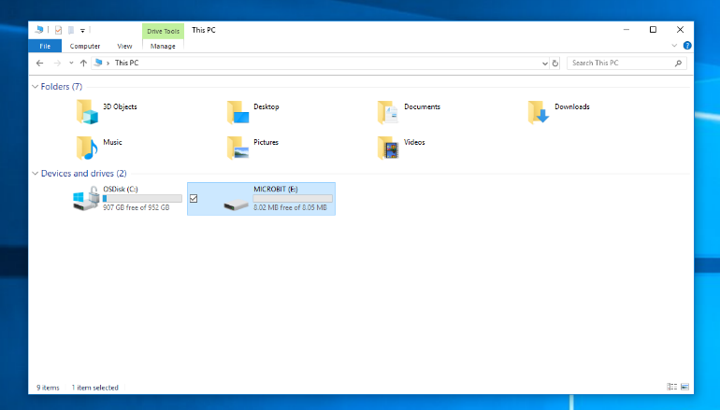 |  |  | 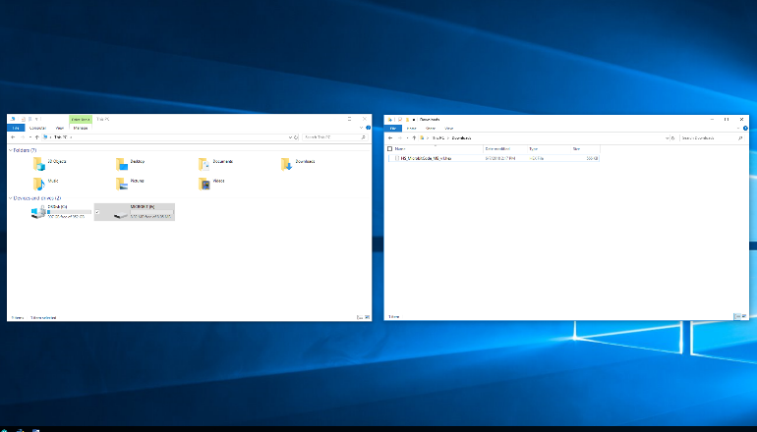
3 | In File Explorer, navigate to the micro:bit. It will appear like an external storage device (e.g. thumb drive, hard drive, etc.). |  |  | 4 | Open a second File Explorer window and navigate to the downloads folder. Make sure you can see both windows.
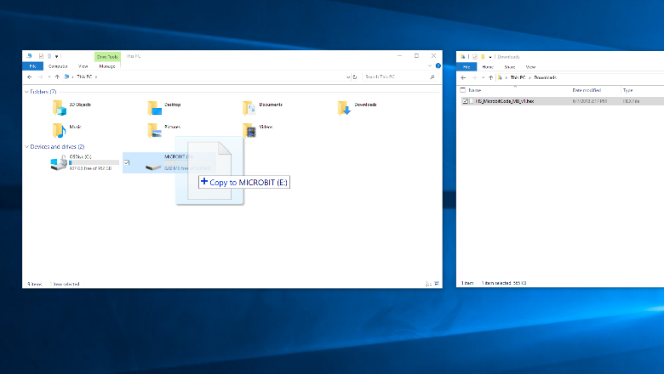 |  |  | 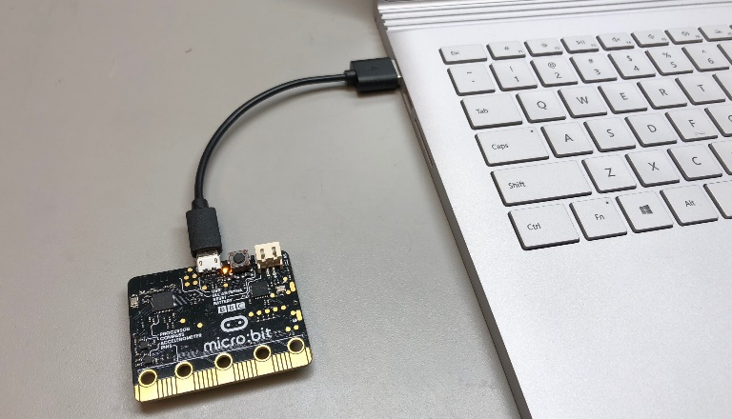
5 | Select the .hex file in downloads and drag it to the micro:bit window. |  |  | 6 | Once the LED light stops blinking, the code has been uploaded onto the micro:bit.

Create a circuit
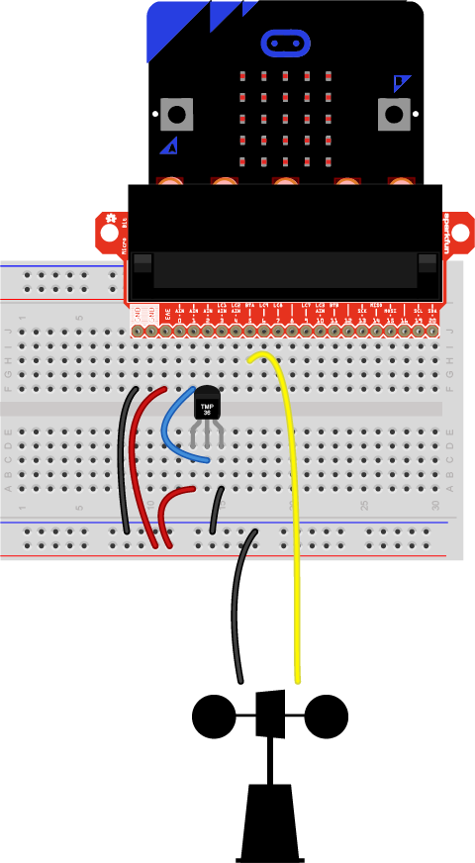

7 | Connect four of the jumper wires from the micro:bit to the breadboard as shown. The color of the wires can be helpful for organization but does not impact functionality. |  | 8 | Connect two more jumper wires as shown from micro:bit GND pin to negative rail of breadboard and 3V pin to positive rail of breadboard.
9 | Place the temperature sensor into the bread board as shown. Left leg of sensor to positive rail, middle leg to pin 1 of microbit, and right leg to ground rail. |  | 10 | Connect the alligator clips from the anemometer, as shown. From negative rail of breadboard and pin 5 of micro:bit.
Great work!
You’ve made a sensor-enabled anemometer. Go to the next section to visualize data or go to page 19 to make the motorized version!
Open Excel and enable Data Streamer
Data Streamer with Excel O365. The O365 subscription includes Excel and the Data Streamer add-in for free.
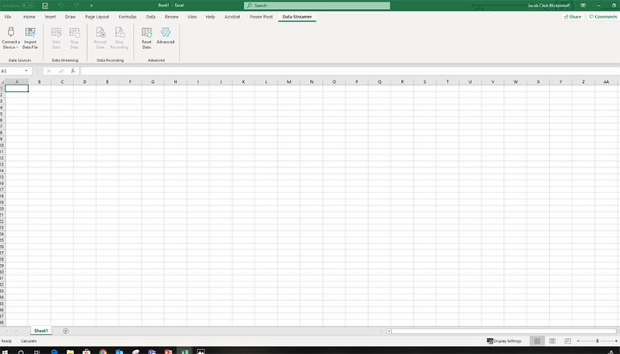 |  | 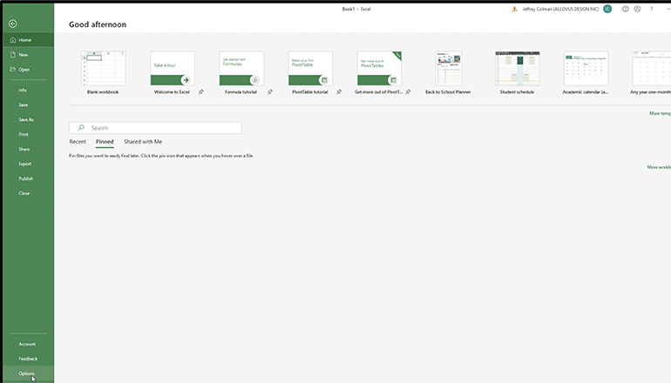
1 | Open Excel 0365. |  | 2 | Click on File and choose Options located at the bottom of the pane.
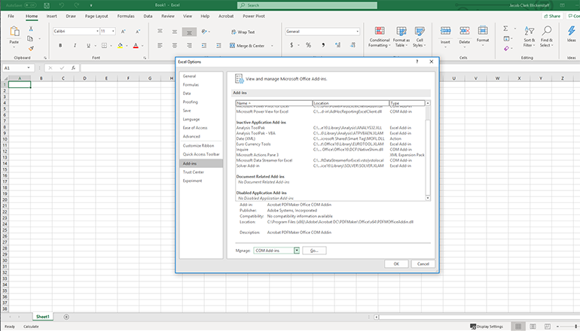
3 | Choose Add-ins in the dialog that opens. |  | 4 | From the Manage menu at the bottom of the dialog that opens, choose COM Add-Ins and click Go
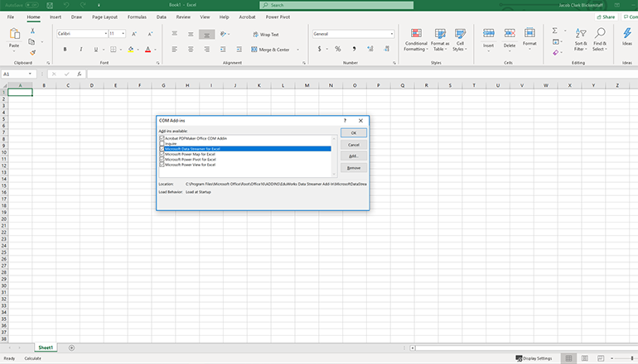 |  | 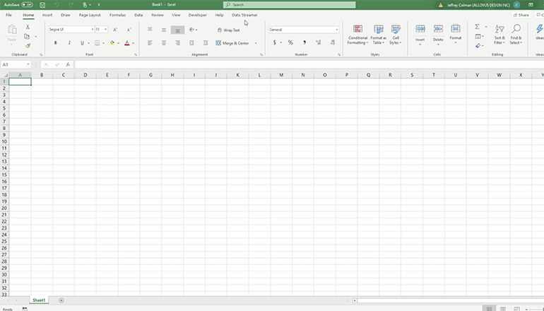
5 | Check the box for Microsoft Data Streamer  in the dialog that opens and click OK. |  | 6 | You should see a new Data Streamer tab in Excel’s menu ribbon.

Data Streamer with Excel O365 desktop version
For a limited time, Data Streamer can be used with the desktop version of Excel 2016. Download Data Streamer from the Microsoft Store. After installation, Data Streamer will be automatically enabled in Excel.

Get ready to visualize data

To run the Data Streamer Add-in, make sure you meet these technical requirements:
- PC running Windows 10 and Excel O365 Desktop.
- Enable the Data Streamer add-in. See instructions on previous page.
- Customized Excel Workbook available at: aka.ms/excelworkbook
Congratulations! You are now ready to visualize real-time data from the Electroconductivity sensor sensor. To see live data, follow these steps:

1 | Plug the Arduino or micro:bit microcontroller into your computer’s USB port |  | 2 | Click the Data Streamer tab on the Excel ribbon
3 | Click Connect a Device to connect Excel to the microcontroller |  | 4 | Start Data to begin streaming data into Excel

To connect your device, plug it into your computer via USB and then click “Connect a Device.”
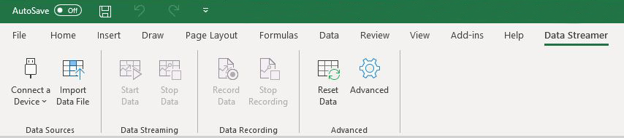

Once your device is connected, select “Start Data” to begin streaming data into Excel. If you do not click “Start Data” when your device is plugged in, you will not see any live data.
If you have recorded and saved a data file (.csv), you can import it with this button

Excel workbook basics
Make sure the radio button for “my device” is selected to collect data from your sensor.

Temperature  Data is displayed in Celsius in the range of -10 to 40 C. To stimulate the sensor, try squeezing the temperature sensor on your device, applying friction, or hot air from a hair dryer.  Beaufort Number  This rating system indicates wind speed from a Light Air (1) to a Hurricane Force (12). |  | Wind Speed  Displays the current wind speed as read by your anemometer. The “inner dial” reflects speeds on a range of 0-5 km/h. The “outer dial” reflects speeds on a range of 0-50 km/h.  RPM Counter  Visualizes the calculated revolutions per minute of the anemometer’s cup rotor.
MOTORIZED
Anemometer

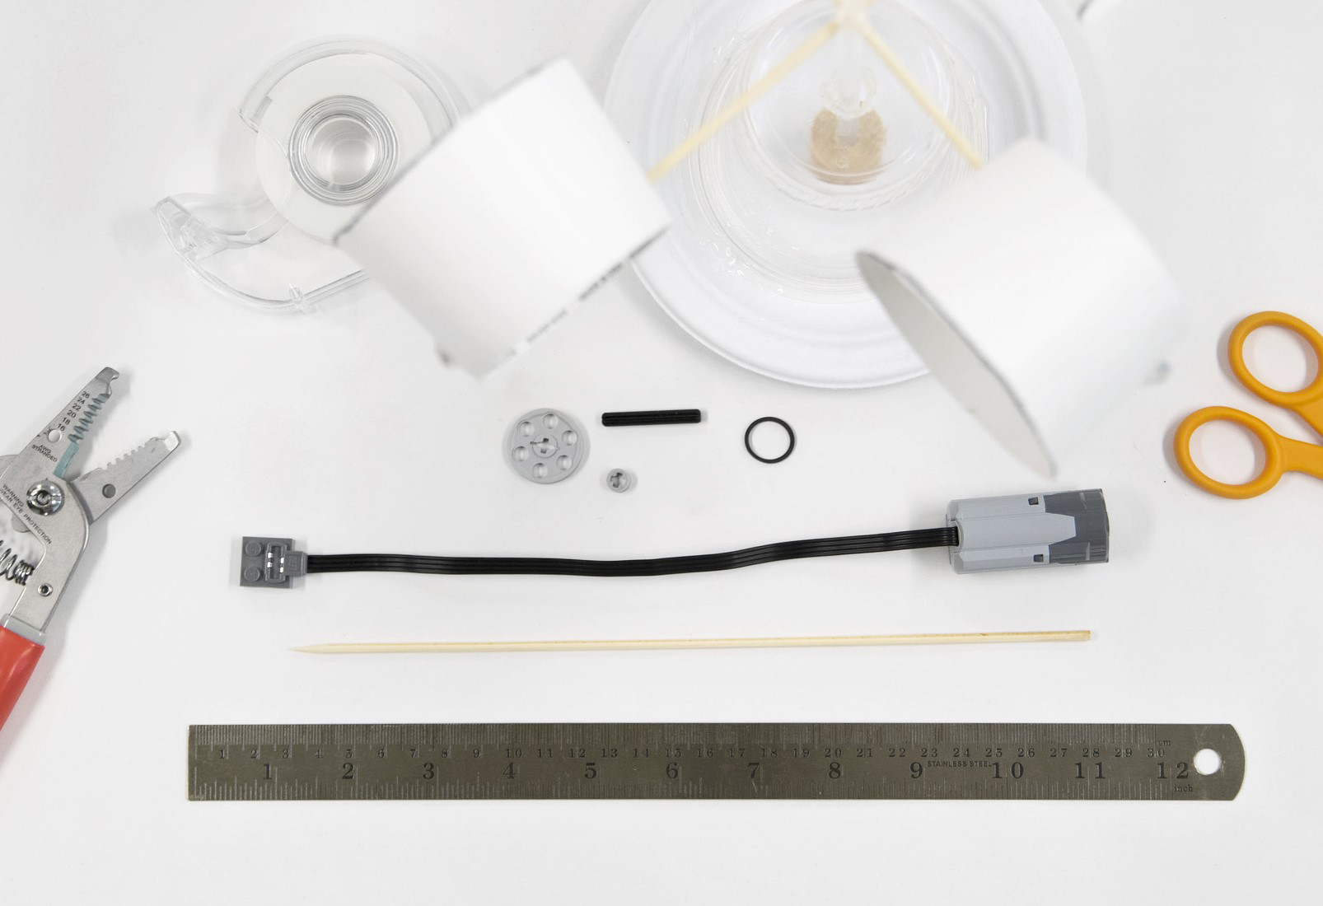
Things you’ll need to build your motor

Materials  1 completed basic or sensor-enabled anemometer  1 LEGO Technic motor (Part 888: Power Functions M-Motor)  1 LEGO Technic 2.5 cm pulley (Part 4185: Wedge-Belt Wheel)  1 LEGO Technic axle (Part 3705: Cross Axle 4M)  1 LEGO Technic bushing (Part 32123: ½ Bush)  Safety guidelines  Eye Protection  - Please wear appropriate eye protection while doing any engineering design or field projects.  Cutting Tools  - Keep the sharp edge away from your body.  - When cutting small pieces, do not place fingers very closed to the blades.  1 skewer  1 small rubber band (3 cm diameter) | Toolkit  metric ruler  scissors  adhesive tape  wire strippers

Making for a group or need help finding materials?
View the shopping list to calculate quantities and links to materials at: aka.ms/anemometershoppinglist
1 | Remove the straw and wind cups from the basic anemometer. Mark and cut the skewer 4 cm up from the cup. Discard the short end. |  | 2 | Cut the brick end of the motor cable. Strip the wires then snip the two out wires from far left and right.
 |  | 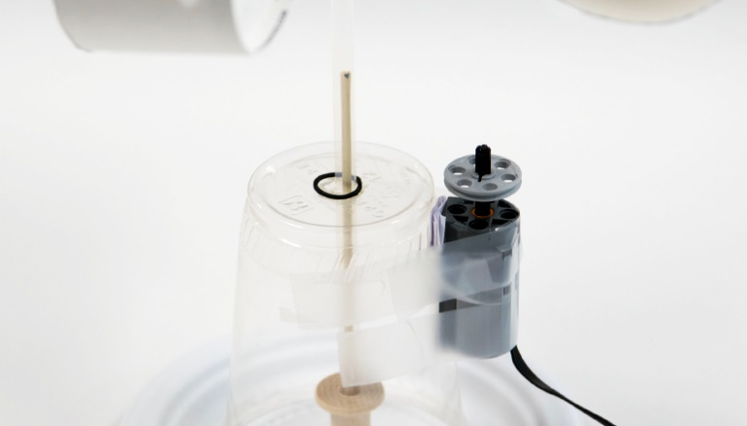
3 | Assemble the motor, axle, bushing, and pulley. |  | 4 | Tape the motor to the cup. The axle should be completely vertical to operate properly. Place the rubber band over the skewer.
5 | Add a shim of folded paper in between the cup and the motor to hold the axle parallel to the straw and skewer. |  | 6 | Your enhanced anemometer is ready to connect to the microcontroller.

Connect Arduino Uno: Part 2

Materials
1 diode
2 pin ended alligator clips
2 jumper wires
1 100-ohm resistor
1 NPN transistor
1 9V battery
1 9V battery pack

Making for a group or need help finding materials?
View the shopping list to calculate quantities and links to materials at: aka.ms/anemometershoppinglist
Connecting Arduino: Part 2
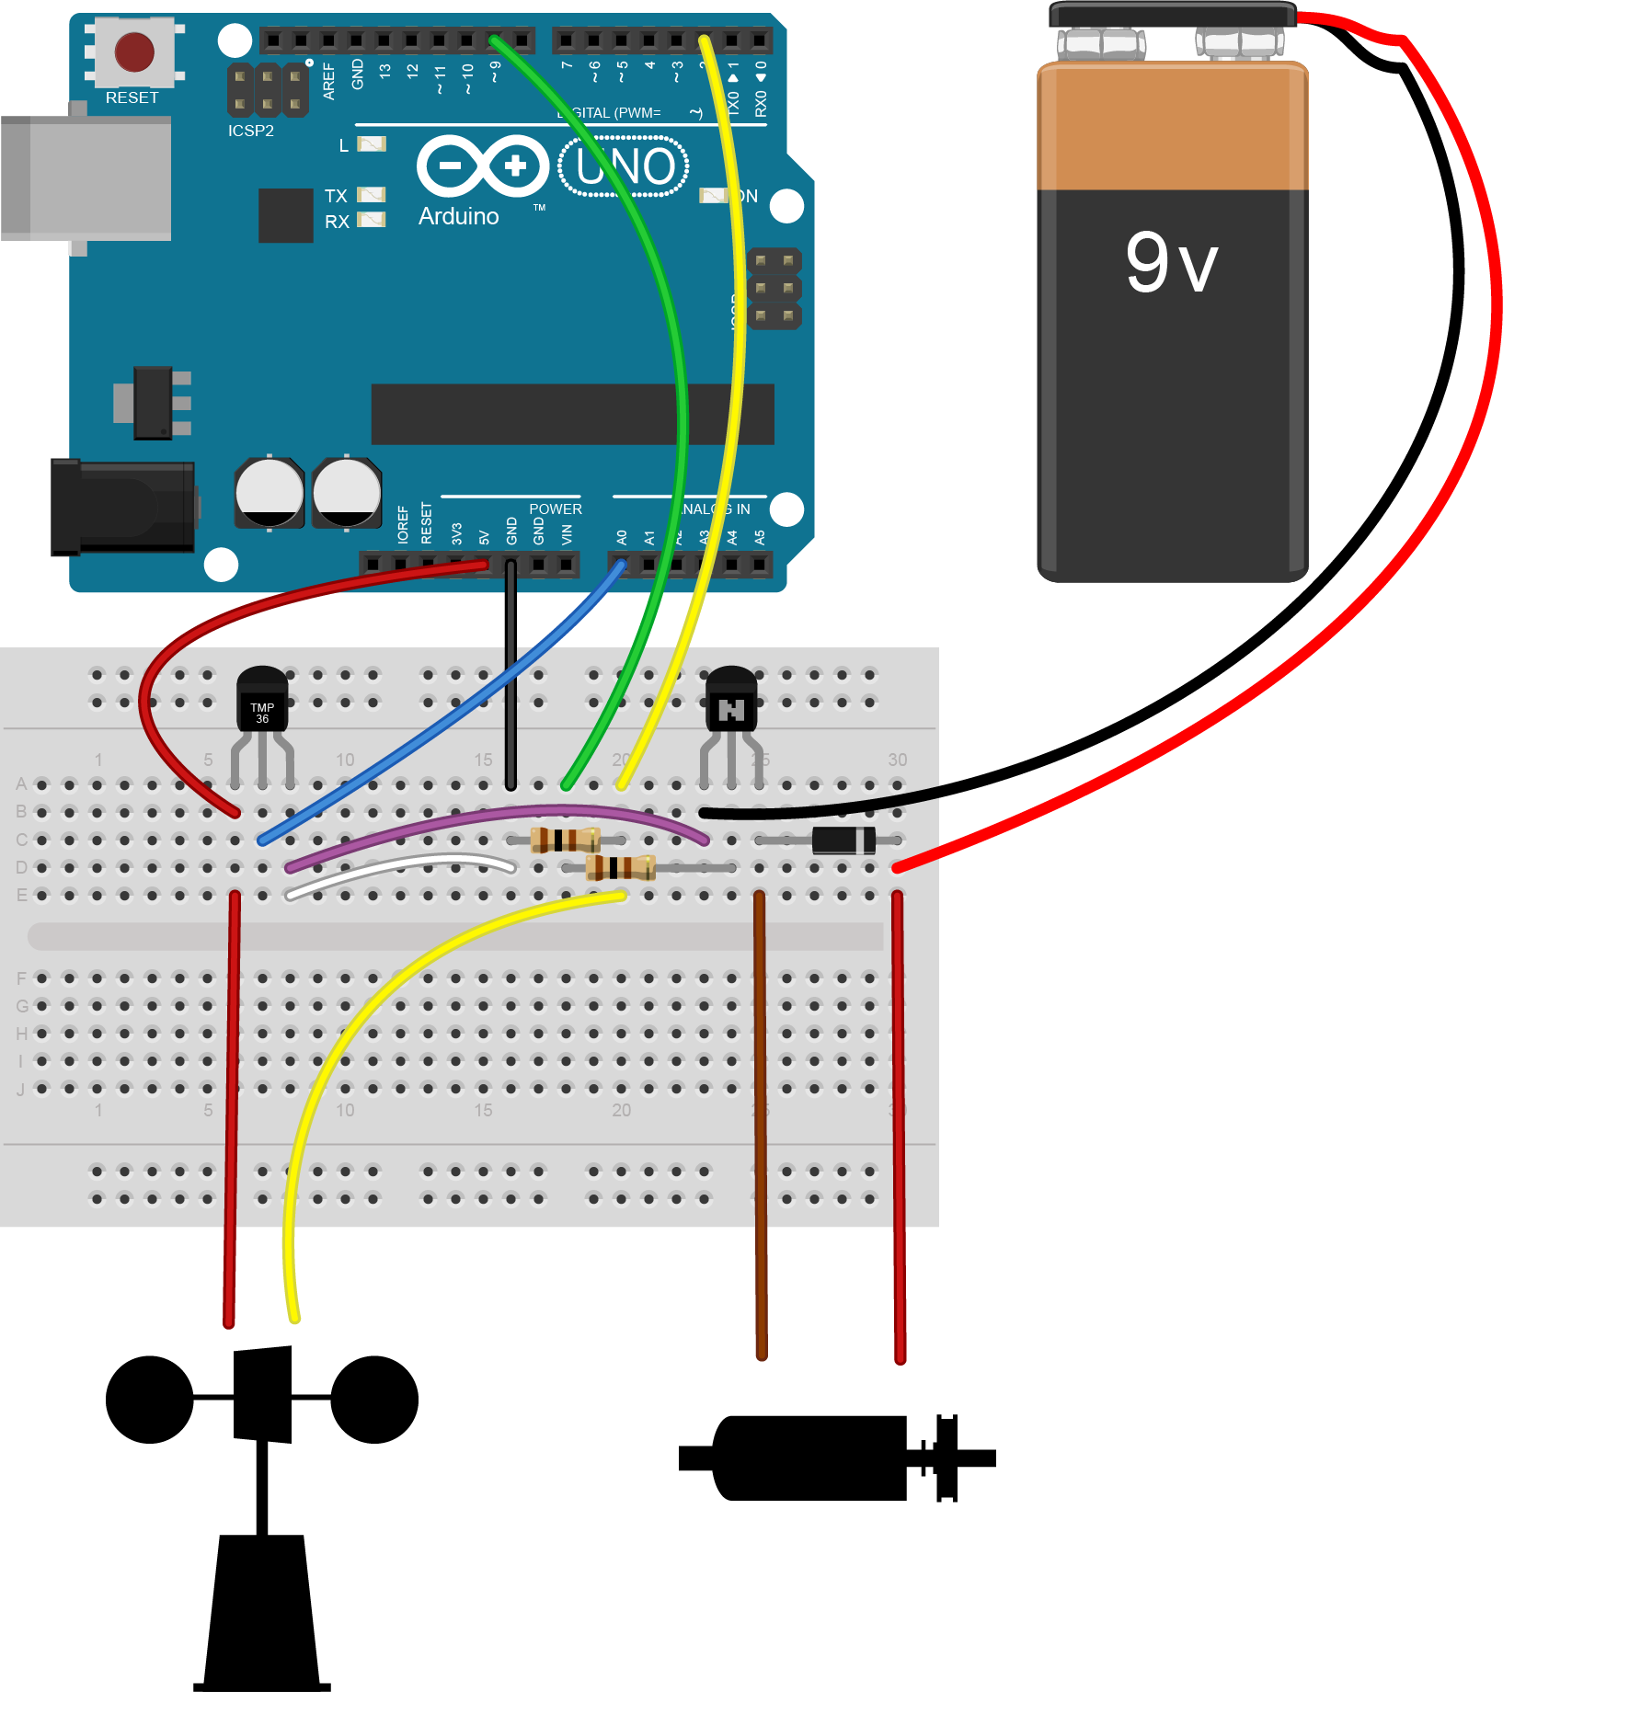

1 | Trim the ends of the 100-ohm resistor and insert into the breadboard as shown |  | 2 | Connect the transistor.
3 | Trim the ends of the diode and insert into the breadboard as shown. |  | 4 | Connect the LEGO motor leads to the alligator clips and insert the pin ends into the breadboard.
5 | Connect the battery to the alligator clips and insert the pin ends into the breadboard as shown. |  | 6 | Add two breadboard wires last to connect the circuit.
Connect micro:bit: Part 2

Materials
1 1N 4001 diode
2 pin ended alligator clips
2 jumper wires
1 100-ohm resistor
1 2N 3904 transistor
1 9V battery
1 9V battery pack

Making for a group or need help finding materials?
View the shopping list to calculate quantities and links to materials at: aka.ms/anemometershoppinglist
Connecting micro:bit Part 2

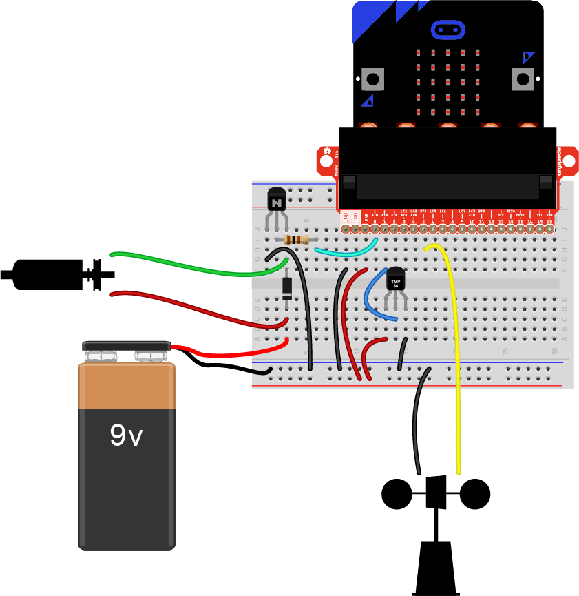
1 | Trim the ends of the 100-ohm resistor and insert into the breadboard as shown |  | 2 | Connect the transistor.
3 | Trim the ends of the diode and insert into the breadboard as shown. |  | 4 | Connect the LEGO motor leads to the alligator clips and insert the pin ends into the breadboard.
5 | Connect the battery to the alligator clips and insert the pin ends into the breadboard as shown. |  | 6 | Add two breadboard wires last to connect the circuit.
Get ready to visualize data

To run Data Streamer Add-in, make sure you meet these technical requirements:
• PC running Windows 10 and Excel 2016 (Desktop)
• Enable the Data Streamer add-in. See instructions on page 17.
• Customized Excel Workbook available at: aka.ms/excelworkbook
Once you have downloaded the Data Streamer Add-in, open Excel and get yourself acquainted with the UI:
To connect your Arduino, you need to plug in your device to your computer via USB and then click “Connect a Device”
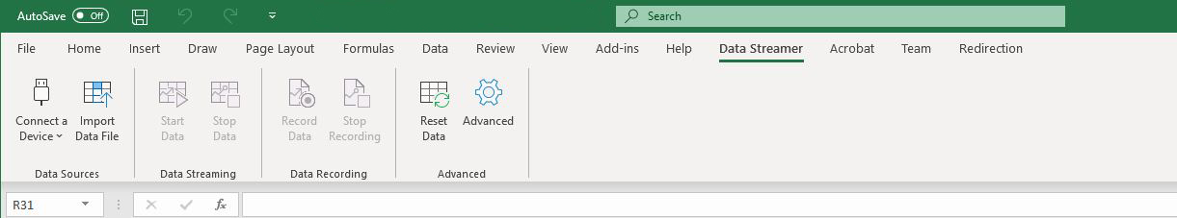

Once your device is connected, select “Start Data” to begin streaming data into Excel. If you do not click “Start Data” when your device is plugged in, you will not see any live data.
If you have recorded and saved a data file (.csv), you can import it with this button

Excel workbook basics

Weather Locations
The map is connected to the Bing Weather API and in real-time, pulls the prevalent wind speed and temperature data in the 10 cities (marked on the map). Click on the radio buttons on the map to select a location to see the live Bing Weather data on the charts. If you connect a motorized anemometer and select the “Wind Simulator” check box, you’ll be able to see your anemometer spin as if it were in that selected location.

1. Ένα άκρο του reed switch συνδέεται στο pin 0 του micro:bit.
2. Το άλλο άκρο του reed switch συνδέεται στη γείωση (GND).
3. Η αντίσταση συνδέεται παράλληλα με το reed switch, μεταξύ του pin 0 και GND, για να λειτουργεί ως pull-down resistor.
4. Όταν πλησιάσεις έναν μαγνήτη στο reed switch, ο διακόπτης κλείνει και το pin 0 διαβάζει λογικό 1.

