An Aesop’s fable for practicing Past Simple and Past Continuous
‘‘The grasshopper and the ant’’
(Κάνω εξάσκηση στους χρόνους Past Simple & Past Continuous μέσα από τον μύθο του Αισώπου «Η ακρίδα και το μυρμήγκι»
Watch the video and answer the questions. Then write the fable. https://www.youtube.com/watch?v=XPZXpuoIndo

ETTING
Characters and setting
- Who wrote the story?
- Who were the characters in the story? (main + other characters)
- Where did the story take place?
- What time of the year did the story take place?
PROBLEM

MAIN EVENTS
- What was the grasshopper doing all summer?
- What were the ants doing all summer?
- What did the grasshopper say to the ant when he saw it carrying the seed?
- What did the ant reply?
- What did the grasshopper do while the ants were enjoying their food?
- What did the ant queen say when she heard the grasshopper begging for help?
Moral of the story
- What lesson did the grasshopper learn?
- What is the moral of the story all people should remember?

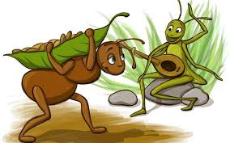

Write the fable

Characters Setting
Problem
Main Events Moral

USE THE LINKING WORDS TO WRITE YOUR STORY
RESOLUTION
MAIN EVENTS
Once upon a time , when , while , as , firstly , secondly , later , after that , then , suddenly , finally

