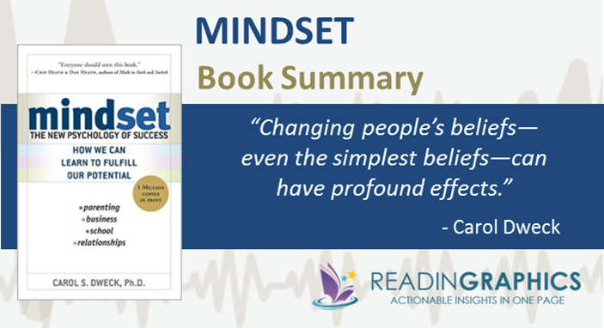

ΠΗΓΗ:

<https://readingraphics.com/book-summary-mindset/>

