3d European  Student Conference  Prague 2024  The astronomical clock of Prague  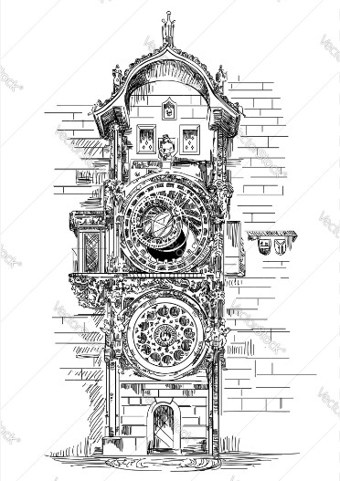  ELEMASYN, 1ο Γυμνάσιο Πεύκης | 3d European  Student Conference  Prague 2024  Dalibor’s violin  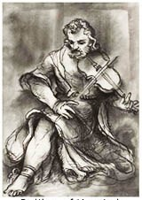  ELEMASYN, 1ο Γυμνάσιο Πεύκης | 3d European  Student Conference  Prague 2024  Queen Libuse and  the foundation of Prague  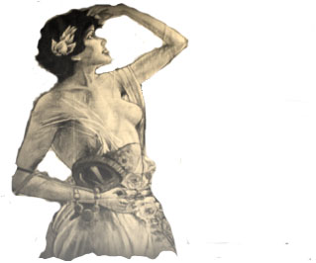  ELEMASYN, 1ο Γυμνάσιο Πεύκης

