William Shakespeare

Petruchio and Katherine

Padua

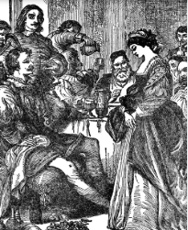

Petruchio and Katherine

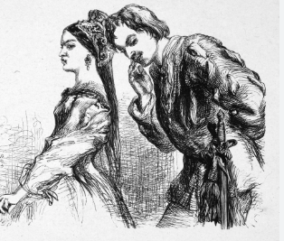

Petruchio and Katherine