1st Semester Test - Optional

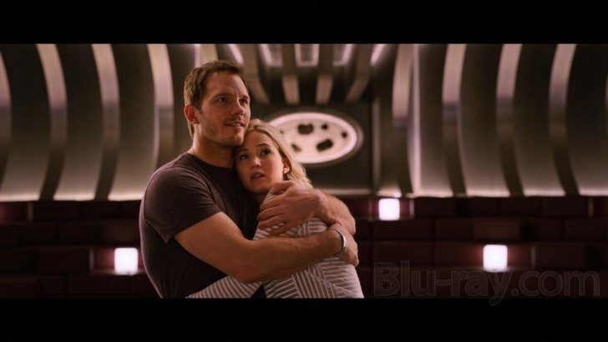

**Passengers movie**

**Name:**

**Class: Date**:

**Imagine you are a film critic and you have to write a review (κριτική, ανάλυση, αξιολόγηση) on the *Passengers* Movie for the Movie Reviews column of *The New York Times* online. Choose only one of the following topics to write your review:**

* **Why we loved the *Passengers* movie! (you can make reference to anything you liked, such as the actors, furniture decoration, space science, action scenes, the story line, the ending e.t.c.).**
* **Moral dilemmas in *Passengers* movie: for or against Jim’s decision to wake up Aurora.**
* **Astrophysics and space science behind *Passengers* movie: reality or science fiction.**

**You should insert screenshots from the movie to make your article appear more truthful and appealing. Also, at the end of your story you will have to list the links you used as a source of reference.**

**You can start by browsing the following links to get ideas and then do your own research and add as many as you wish. Be careful not to copy the information from other articles: paraphrase or use quotation marks when you want to use the exact words of another journalist.**

**Links**

How 'Passengers' Production Designer Brought the Film's Vegas-Inspired Spaceship to the Big Screen

<https://www.hollywoodreporter.com/behind-screen/how-passengers-production-designer-brought-films-vegas-inspired-spaceship-big-screen-960334>

# Sci-Fi Gets Science Right: 'Passengers' Nails the Physics

<https://www.space.com/35104-passengers-scifi-movie-nails-space-physics.html>

# Movie Reviews

<https://www.rottentomatoes.com/m/passengers_2016>

# Scientists Decipher Fact From Fantasy in Movie 'Passengers'

<https://www.youtube.com/watch?v=XDoA9RtfgaE>

# How screenwriter Jon Spaihts worked the physics of starship travel into ‘Passengers’

<https://www.geekwire.com/2016/jon-spaihts-physics-interstellar-travel-passengers-movie/>

Passengers, film review: Two’s company

<https://www.standard.co.uk/culture/film/passengers-film-review-two-s-company-a3427316.html>

How Realistic Is the Interstellar Ship from 'Passengers'?

<https://www.space.com/35133-how-realistic-ship-from-passengers.html>

Passengers review

<https://www.reelviews.net/reelviews/passengers>

Passengers review

<https://www.empireonline.com/movies/reviews/passengers-2-review/>

# How the sci-fi movie 'Passengers' went from development hell to big-screen blockbuster

<https://www.businessinsider.com/how-passengers-movie-was-made-2016-12>

Jennifer Lawrence and Chris Pratt as Adam and Eve in space

<https://www.smh.com.au/entertainment/movies/passengers-review-jennifer-lawrence-and-chris-pratt-as-adam-and-eve-in-space-20161227-gti93l.html>

Jennifer Lawrence and Chris Pratt are lost in space in the predictable sci-fi thriller *Passengers*

# <https://www.latimes.com/entertainment/movies/la-et-mn-passengers-review-20161216-story.html>

# Let’s discuss the Passenger’s ending and how the script was different from the ending <https://www.slashfilm.com/passengers-ending/>

# Passengers image

**Have lots of fun…!!!!!**