Active and passive voice

Exercise 1

**Choose the correct form, active or passive, to complete the sentences below.**

Αρχή φόρμας

1. **1** Hundreds of people *a. are employed b. employ* in this factory and many of them *a. will lose b. will be lost* their jobs.
2. Three men a. were arrested b. arrested after the incident, and five others *a. were taken b. took* to hospital.
3. About 71 percent of the Earth's surface *a. is covered b. covers* by water, and oceans *a. are held b. hold* about 96% of all Earth's water.
4. The package *a. sent b. was sent* more than a week ago, but it  *a. wasn't arrived b. didn't arrive* until yesterday.
5. The building *a. has destroyed b. has been destroyed* by the fire, but everybody *a. has been rescued b. rescued.*
6. My camera *a. was stolen b. stole* and I *a. lost b. was lost* all the photographs from my last trip.
7. You *a. should arrest b. should be arrested* for what you *a. were done b. did.*
8. **8**I know red wine *a. should be drunk b. should drink cold*, but we *a. are drunk b. drink it* at room temperature.
9. I *a. don't allow b. am not allowed* to see you any more, so you *a. shouldn't be come b. shouldn't come* again.
10. Please, *a. stay b. be stayed away* from the places where you *a. can see b. can be seen.*

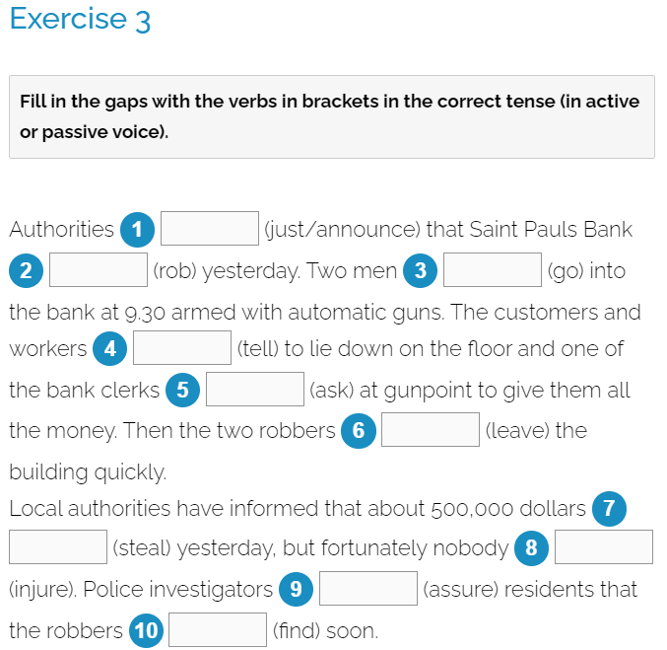

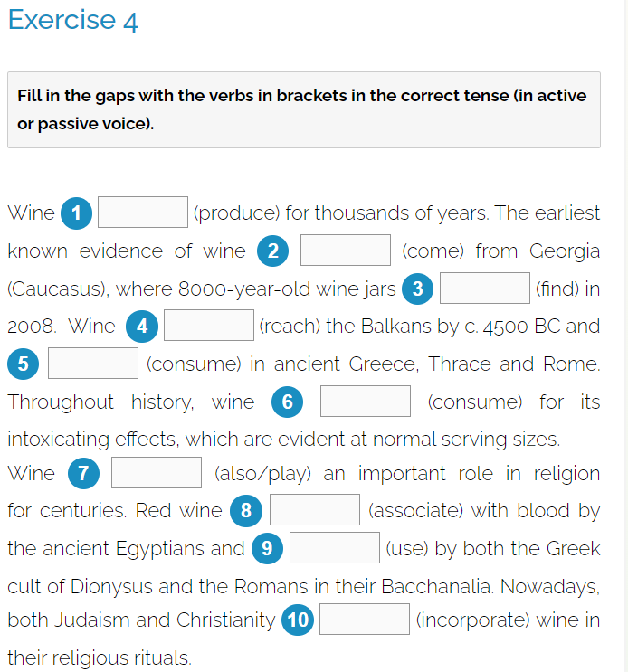

Τέλος φόρμας