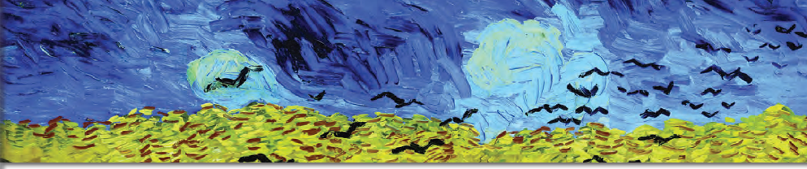

Choose one of the two following tasks on Vincent Van Gogh’s paintings and the poem “Starry Starry Night”.

1. In the *Starry Starry Night* poem you will find pairs of adjectives and nouns like *amber grain, winter chills, starry night e.t.c.* Pick up one of them that you like the most and try to create:

a poem using the pair of words as an acronym. For example:

Shadows of trees in the dark out there

Tremble like my troubled mind and thoughts

A________________________________________________

R________________________________________________

R________________________________________________

Y ________________________________________________

N________________________________________________

I_________________________________________________

G________________________________________________

H________________________________________________

T________________________________________________

Write it in a word document and choose a painting of Vincent Van Gogh that you think matches the meaning of your poem. Send it to me using the eclass.

1. Use one of the pairs of adjectives and nouns from the poem, as a title for a short story that you will write based on the paintings that you will choose from Van Gogh’s works of art (eclass – Multimedia and Links). Insert the paintings in your short story and send the document to me using the eclass.

____________________________________________________________________________________________________________________________________________________________________________________________________________________________________________________________________________________________________________________________________________________________________________________________________________________________________________________________________________________________________________________________________________________________________________________________________________________________________________________________________________________________________________________________________________________________________________________________________________________________________________________________________________________________________________________________________________________________________________________________________________________________________________________________________________________________________________________________________________________________________________________________________________________________________________________________________________________________________________________________________________________________________________________________________________________________________________________________________________________________________________________________________________________________________________________________________________________________________________________________________________________________________________________________________________________________________________________________________________________________________________________________________________________________________________________________________________________________________________________________________________________________________________________________________________________________________________________________________________________________________________________________________________