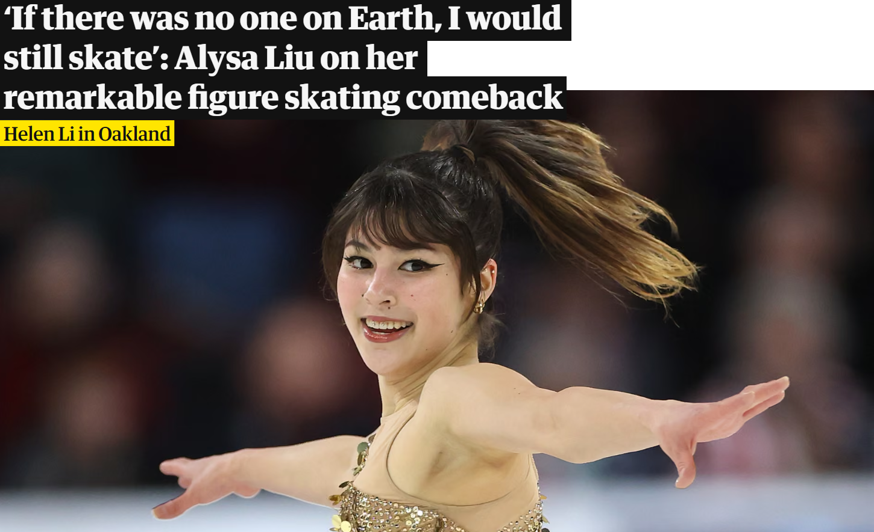Advanced Reading Lesson (C1)
Alysa Liu’s Remarkable Return to Figure Skating
Alysa Liu’s journey in figure skating has been anything but conventional. Once celebrated as the youngest U.S. national champion in history, Liu shocked the skating world when she stepped away from the sport shortly after competing at the 2022 Winter Olympics. At just 16 years old, she explained that years of intense training and competition had left her feeling exhausted and ready to explore life beyond elite sport.
During her time away from skating, Liu experienced a kind of freedom that had been largely absent from her life as a professional athlete. She traveled, spent time with family and friends, and began studying at university. For the first time in many years, she was able to make decisions without the pressure of competitions, training schedules, and public expectations.
Unexpectedly, the idea of returning to skating emerged during a ski trip. As Liu moved across the snow, she rediscovered the simple joy of speed and movement that had first attracted her to the ice. The experience reminded her that, beneath the pressure and discipline, skating had once been something she genuinely loved.
When Liu eventually decided to return to competition, she approached the sport with a new perspective. Rather than focusing solely on results, she aimed to rebuild her relationship with skating in a healthier and more personal way. She assembled a supportive team of coaches and choreographers and took an active role in shaping her programs, selecting music and artistic elements that reflected her personality and creative vision.
Her comeback quickly captured the attention of the skating community. Competing at the 2025 World Figure Skating Championships, Liu delivered a series of confident and expressive performances. To the surprise of many observers, she went on to win the gold medal, becoming the first American woman to claim the world title in almost twenty years.
For Liu, however, the victory represented more than a competitive achievement. She has often emphasized that her renewed commitment to skating is rooted in enjoyment and self-expression rather than external expectations. In interviews, she has suggested that even without an audience or medals at stake, she would still choose to skate simply because it brings her happiness.
Liu’s story highlights an important lesson about ambition and personal fulfillment. By stepping away from the sport and later returning on her own terms, she rediscovered the passion that first inspired her career. Her journey demonstrates that success in elite sport does not always follow a straight path—and that sometimes distance can provide the clarity needed to move forward.
Adapted from https://www.theguardian.com/sport/2025/mar/26/alysa-liu-figure-skating-world-championships-preview

2. Reading Comprehension
Answer the questions.
- Why did Alysa Liu initially decide to stop competing?
- What did she do during her break from figure skating?
- What experience made her think about returning to skating?
- How did her attitude toward skating change after her return?
- Why was her victory at the championships considered significant?
- According to Liu, what is now the most important reason for skating?

3. True or False
Decide whether the statements are True (T) or False (F).
- Liu retired from skating immediately after becoming a national champion.
- During her break, she focused only on training in other sports.
- A skiing experience reminded her of the joy of movement.
- After returning, she had no involvement in choosing her programs.
- Her victory marked the first world title for an American woman in nearly two decades.

4. Use of English (Word Formation)
Complete the sentences using the correct form of the word in capitals.
- Liu’s return to competition was completely __________. (EXPECT)
- Years of intense training had left her feeling physically and mentally __________. (EXHAUST)
- She wanted to rebuild her relationship with skating in a healthier and more __________ way. (PERSON)
- Her performances were both confident and highly __________. (EXPRESS)
- Winning the championship brought her a strong sense of __________. (FULFIL)

5. Discussion Questions
Discuss in pairs or small groups.
- Why do you think many athletes experience burnout at a young age?
- Do you think taking a break can improve performance in the long term? Why or why not?
- How important is personal happiness compared to professional success?
- Can failure or stepping away from something sometimes lead to greater success later?

English – Greek Vocabulary List
conventional | συμβατικός / παραδοσιακός
celebrated | διάσημος / καταξιωμένος
national champion | εθνικός πρωταθλητής
step away from (a sport) | αποχωρώ / απομακρύνομαι από
elite sport | αθλητισμός υψηλού επιπέδου
intense training | εντατική προπόνηση
competition | αγώνας / ανταγωνισμός
exhausted | εξαντλημένος
expectations | προσδοκίες
rediscover | ανακαλύπτω ξανά
genuine | γνήσιος / αληθινός
perspective | οπτική / τρόπος σκέψης
focus on | επικεντρώνομαι σε
rebuild | ξαναχτίζω / επαναδομώ
supportive | υποστηρικτικός
assemble a team | συγκροτώ / δημιουργώ μια ομάδα
coach | προπονητής
choreographer | χορογράφος
artistic elements | καλλιτεχνικά στοιχεία
personality | προσωπικότητα
creative vision | δημιουργικό όραμα
comeback | επιστροφή
performance | εμφάνιση / απόδοση
observer | παρατηρητής
claim the title | κατακτώ τον τίτλο
achievement | επίτευγμα
commitment | αφοσίωση / δέσμευση
self-expression | αυτοέκφραση
ambition | φιλοδοξία
fulfillment | προσωπική ολοκλήρωση
clarity | διαύγεια / καθαρή αντίληψη

Vocabulary Exercises
1. Match the Words with Their Meanings
Column A Word | Column B – Meaning

1. conventional | A. to find something again after forgetting it or losing it

2. exhausted | B. the feeling of satisfaction after achieving something important

3. rediscover | C. extremely tired

4. perspective | D. showing strong feelings or ideas

5. assemble | E. a particular way of thinking about something

6. expressive | F. a clear understanding of something

7. fulfillment | G. typical or traditional

8. clarity | H. to gather people together for a purpose

2. Fill in the Gaps
Complete the sentences using the correct word from the box.
Words:
pressure – comeback – passion – expectations – exhausted – achievement – perspective – supportive
- After years of intense training, she felt completely __________.
- Winning the championship was a great personal __________.
- Her return to the sport was described as an impressive __________.
- She felt less __________ once she stopped focusing only on winning.
- Taking a break helped her gain a new __________ on her career.
- Her coaches created a very __________ environment for her.
- She rediscovered her __________ for skating.
- Public __________ can sometimes create stress for athletes.

3. Word Formation
Complete the sentences using the correct form of the word in brackets.
- Her performances were very __________ and emotional. (EXPRESS)
- The victory brought her great personal __________. (FULFILL)
- The decision to return to skating was completely __________. (EXPECT)
- The athlete showed great __________ to the sport. (COMMIT)
- After years of training, she finally reached her professional __________. (ACHIEVE)

4. Synonyms
Replace the words in bold with a synonym from the list.
Words: perspective – rebuild – rediscover – assemble – achievement
- She decided to gather a new team of coaches.
- Winning the world title was a major success.
- Taking time off helped her find again her love for skating.
- She wanted to create again a healthy relationship with the sport.
- The break allowed her to see her career from a new point of view.

5. Discussion Vocabulary Practice
Students discuss the questions using at least three vocabulary words from the list.
- Why do athletes sometimes feel pressure from public expectations?
- Can taking a break help someone rediscover their passion?
- What personal achievement would bring you a sense of fulfillment?

English–Greek list of idiomatic phrases and expressions from Alysa Liu’s interview
English Idiom/Phrase | Greek Translation / Ιδιωματική Έκφραση
Careers with twists | Καριέρες γεμάτες ανατροπές
Leading at the World Championships | Προηγούμενη στο Παγκόσμιο Πρωτάθλημα
She was up to the moment | Στο ύψος της στιγμής / έτοιμη για την πρόκληση
Artistic flare | Καλλιτεχνική έμπνευση / εκφραστικότητα
Roared its approval | Έδειξε δυνατά την έγκριση / χειροκρότησε έντονα
Seized the night | Κατάφερε να κυριαρχήσει εκείνη τη νύχτα
At the top | Στην κορυφή
A little edgier | Λίγο πιο τολμηρή / με περισσότερο στυλ
Needed a lift to ascend | Χρειαζόταν ώθηση για να ανέβει
Abnormal childhood | Ασυνήθιστη παιδική ηλικία
A responsibility or a burden | Μια ευθύνη ή ένα βάρος
Engine of ambition | Μοχλός φιλοδοξίας
Spared no money, no time | Δεν απέφυγε καθόλου δαπάνες ή χρόνο
How did that go down? | Πώς εξελίχθηκε αυτό; / Τι συνέβη;
Tiger dad | «Τίγρης πατέρας» (αυστηρός πατέρας που πιέζει το παιδί)
Catch her breath | Πάρε ανάσα / ξεκουράσου
Calling quits | Παραιτούμαι / σταματώ
Living it up | Ζώντας τη ζωή στο έπακρο
Self-imposed exile | Αυτοεπιβαλλόμενη απομόνωση
Quick hits of dopamine | Γρήγορες δόσεις ευχαρίστησης
In charge | Υπεύθυνη / επικεφαλής
Back down / Ramp it up | Να υποχωρήσω / Να εντείνω
Out of shape | Εκτός φόρμας
Old magic reappear | Η παλιά μαγεία επανεμφανίστηκε
Hold / Reel her in | Στηρίζω / Ελέγχω (με μέτρο)
Determination's like up there | Η αποφασιστικότητά μου είναι στα ύψη
Pretty scrappy | Δυνατή, μαχητική
Makes me feel alive | Με κάνει να νιώθω ζωντανή
Traded her ice princess tiara for freedom | Άφησε το «παγωμένο στέμμα» για ελευθερία
Blend of jumping ability and alluring movement | Συνδυασμός άλματος και γοητευτικής κίνησης
Stage for performing | Σκηνή για να εμφανίζομαι
Hype people up | Να ενθουσιάζω / να προκαλώ ενθουσιασμό
Strong emotions and anticipation | Έντονα συναισθήματα και ανυπομονησία

Exercise 1: Multiple Choice – Choose the Correct Meaning
- “Careers with twists”
a) Careers with long hours
b) Careers with unexpected changes
c) Careers with famous people
d) Careers in sports only
- “Seized the night”
a) Took control of the night
b) Went out partying
c) Stayed awake all night
d) Skipped practice
- “Tiger dad”
a) A father who loves animals
b) A strict, demanding father
c) A fun and relaxed father
d) A father who teaches martial arts
- “Calling quits”
a) Making a phone call
b) Quitting or giving up
c) Taking a break
d) Winning a competition
- “Quick hits of dopamine”
a) Fast snacks
b) Small doses of pleasure or happiness
c) Exercise routines
d) Dangerous actions

Exercise 2: Match the Idiom with Its Greek Meaning
English Idiom | Greek Meaning
1. Back down | a) Ζώντας τη ζωή στο έπακρο
2. Living it up | b) Υποχωρώ / κάνω πίσω
3. Out of shape | c) Εκτός φόρμας
4. Engine of ambition | d) Μοχλός φιλοδοξίας
5. Makes me feel alive | e) Με κάνει να νιώθω ζωντανή

Exercise 3: Fill in the Blank
Complete the sentences using the idioms from the list. Choose the best fit.
- Alysa was nervous, but she was ______________ and ready for the championship. (up to the moment / tiger dad / calling quits)
- After the pandemic, she realized she liked taking a break and ______________. (living it up / back down / old magic reappear)
- Her father was the ______________ behind her success, supporting her at every step. (engine of ambition / hype people up / pretty scrappy)
- Even though she struggled, skating always ______________. (makes me feel alive / bam / blend of jumping ability)
- Some athletes are initially ______________ after a long break or injury. (out of shape / self-imposed exile / old magic reappear)

Exercise 4: Sentence Creation
Choose 5 idioms from the list and write your own sentences using them in context. Example:
- Idiom: “Seized the night”
- Sentence: “At the concert, the singer seized the night with an amazing performance that left everyone cheering.”

Exercise 5: True or False
Decide if the statement is True (T) or False (F) based on the meaning of the idioms.
- “Bam” is an expression of surprise or excitement. (T / F)
- “Self-imposed exile” means someone was forced to leave a place. (T / F)
- “Hype people up” means to motivate or excite others. (T / F)
- “Quick hits of dopamine” refers to painful experiences. (T / F)
- “Blend of jumping ability and alluring movement” is used to describe a combination of skill and style. (T / F)

