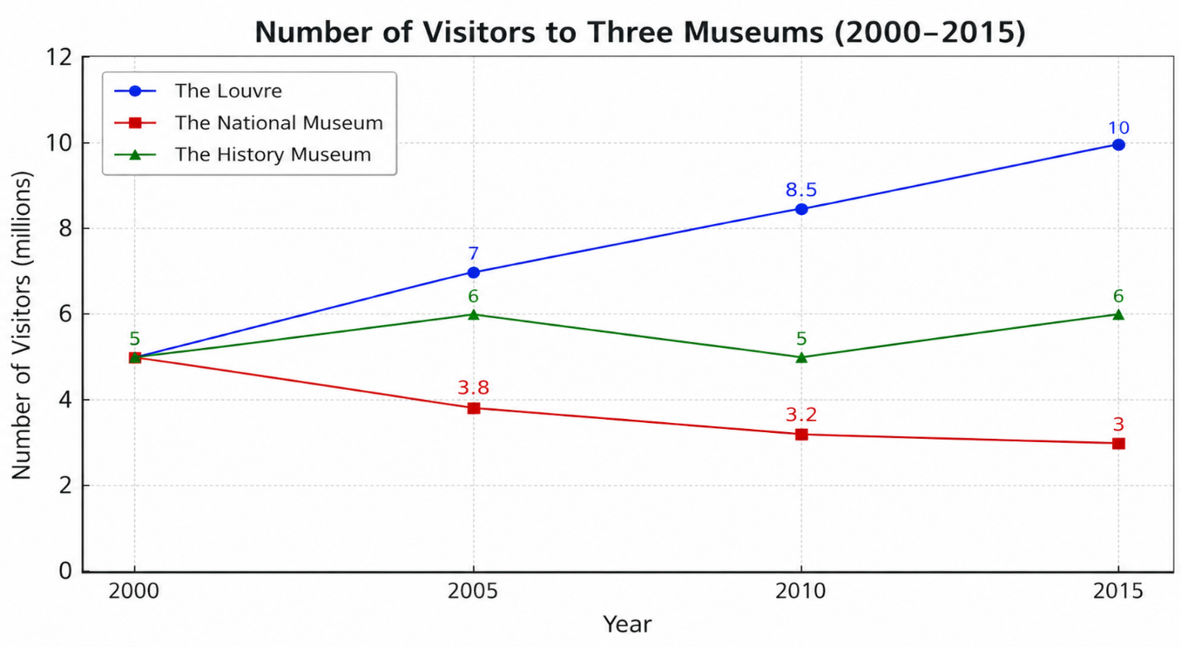
IELTS WRITING 1
📝 Sample Answer (Line Graph) - analytical and specific
The line graph illustrates the number of people visiting three different museums in a city between 2000 and 2015, measured in millions.
Overall, it is clear that the Louvre experienced a significant increase in visitor numbers over the period, while visits to the National Museum declined gradually. Meanwhile, the History Museum showed some fluctuations but remained relatively stable compared to the other two.
In 2000, all three museums had similar visitor figures, at around 5 million each. Over the next five years, the number of visitors to the Louvre rose steadily to approximately 7 million. In contrast, attendance at the National Museum fell slightly to just under 4 million. The History Museum saw a small increase to about 6 million during the same period.
From 2005 to 2015, the upward trend for the Louvre continued, reaching a peak of nearly 10 million visitors by the end of the period, although the growth rate slowed slightly after 2010. On the other hand, the National Museum experienced a continuous decline, dropping to around 3 million visitors in 2015. The History Museum fluctuated modestly, falling to 5 million in 2010 before recovering slightly to about 6 million at the end.
Overall, the graph highlights contrasting trends, with the Louvre gaining popularity, the National Museum losing visitors, and the History Museum maintaining a relatively stable level of attendance

Language for Trends
The video emphasizes using a variety of vocabulary to describe changes.
For increases:
- rise, increase, grow, climb
For decreases:
- fall, decline, drop, decrease
For stability:
- remain stable, stay the same, level off
For speed/degree (adverbs):
- sharply, gradually, significantly, slightly
Using varied vocabulary makes your writing more natural and avoids repetition.

Sample Answer - general
The graph illustrates changes in a particular set of data over a given period of time, measured in specific units. Overall, it is clear that there are noticeable trends, including both increases and decreases, as well as some periods of stability.
In general, the most significant feature of the graph is that one category shows a steady rise throughout the period, while another experiences a gradual decline. Additionally, there are some fluctuations in the remaining data, although these are less dramatic. By the end of the period, the gap between the highest and lowest figures becomes more pronounced.
Looking at the details, in the initial stage, the figures for all categories are relatively close. However, one category begins to increase steadily, reaching a peak towards the end of the timeframe. In contrast, another category declines gradually, falling to its lowest point in the final stage. The remaining categories show minor variations, with small increases and decreases at different points.
In the latter part of the period, the upward trend continues for the leading category, although the rate of growth slows slightly. Meanwhile, the declining category stabilizes somewhat before experiencing a further slight drop. Overall, the data demonstrates clear differences in trends among the categories, with one showing consistent growth and another a general downward movement.

