Side, R. & Wellman, G., *Grammar and Vocabulary for Cambridge Advanced and Proficiency*, Longman, pp. 36-37

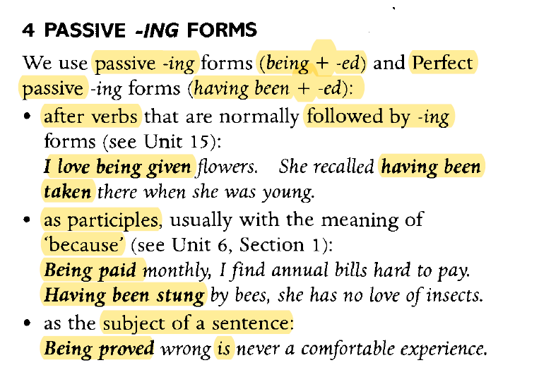

**Note**

**Keep in mind that we use the Perfect passive -ing form to talk about actions in the past.**

**Exercise 4 → Go to the next page of the Word doc. (you will have to copy it in order to write the answers since I have taken it with a snipping tool).**

