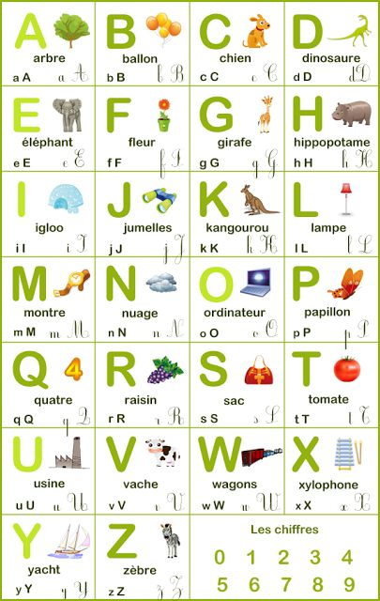
VIDEO: https://www.youtube.com/watch?v=_LYy3P2okyw

