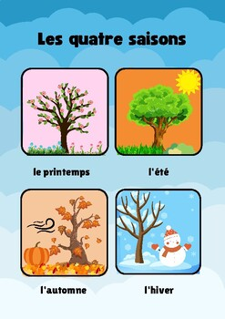
VIDEO: https://www.youtube.com/watch?v=946g0xAfnEA

VIDEO: https://www.youtube.com/watch?v=7_u2SigckNQ


