
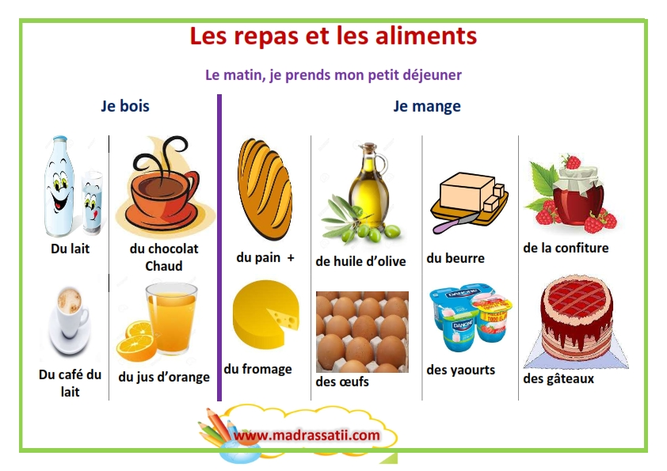
https://www.youtube.com/watch?v=wy28jJDar9o
https://www.youtube.com/watch?v=H32XHs54SdE
