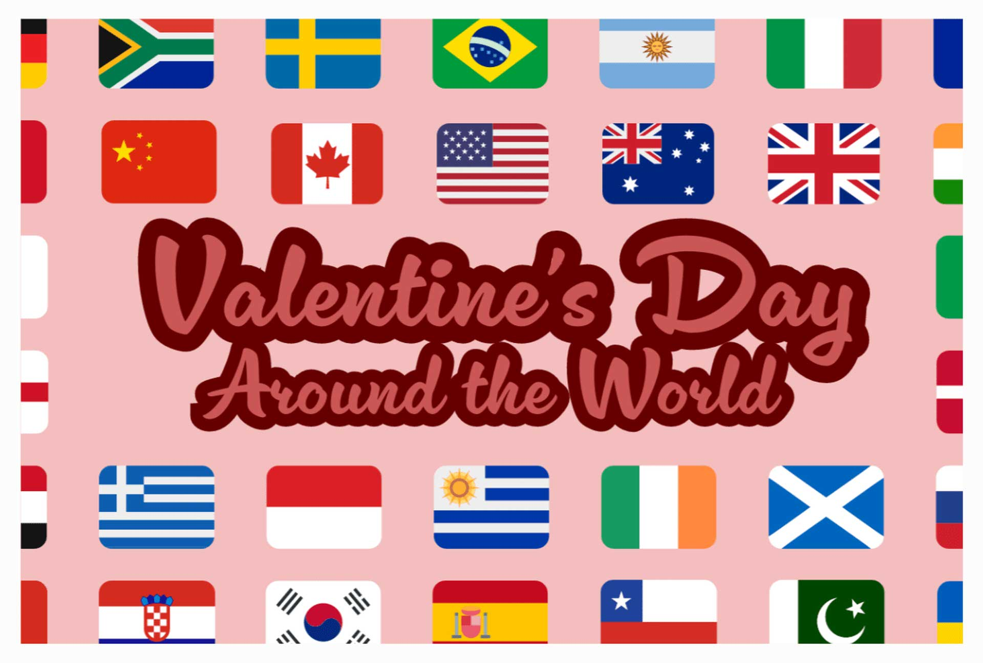

customs and celebrations - Valentines versus Haloween

|  |
| --- |
| customs and celebrations - Valentines versus Haloween |
| Valentine's Day and Halloween are two holidays that are celebrated in many different ways around the world. While both holidays are associated with fun and festivities, they have distinct origins and traditions. Valentine's Day, named after Saint Valentine, a Christian martyr, is a day dedicated to expressing love and affection for loved ones. Halloween, on the other hand, has roots in ancient Celtic traditions and is associated with costumes, trick-or-treating, and spooky decorations.  While Valentine's Day is often celebrated with chocolates, roses, and heartfelt cards, different cultures have developed their own unique traditions. In Argentina, Valentine's Day is celebrated for an entire week in July, culminating in Friendship Day. In Brazil, Valentine's Day is celebrated on June 12th, known as Dia dos Namorados, with similar traditions to those found worldwide. China celebrates Valentine's Day on February 14th, but also has its own traditional day called Qixi Festival, which is celebrated on the seventh day of the seventh Lunar month, usually in August.  Denmark has a unique tradition of sending anonymous joke letters called "gaekkebrev" to admirers on Valentine's Day. These letters are written in rhyme or poetry and signed with dots instead of a name. If the recipient guesses the sender correctly, they receive an egg at Easter. In Germany, Valentine's Day is a more grown-up holiday, with no exchange of valentines in schools. The holiday was first celebrated in Germany after World War II, and a unique symbol of German Valentine's Day is the pig, which symbolizes luck and lust.  Japan celebrates Valentine's Day in a unique way, with two separate days dedicated to the holiday. On February 14th, women give chocolates to men they admire. This chocolate is categorized into two types: Giri Choco, which is given to friends, colleagues, or bosses, and Honmei Choco, which is homemade chocolate given to romantic interests. On March 14th, men reciprocate by giving gifts to the women who gave them chocolate on February 14th. This day is known as White Day.  While both Valentine's Day and Halloween are celebrated with gifts and festivities, there are some key differences between the two holidays. Halloween is often seen as a more lighthearted and fun holiday, with costumes and trick-or-treating being central to the celebrations. Valentine's Day, on the other hand, is often seen as a more romantic and sentimental holiday, with a focus on expressing love and affection for loved ones. Ultimately, both holidays provide opportunities for people to celebrate and enjoy themselves in their own unique ways. |

|  |
| --- |
| Reading Summary |
| * Valentine's Day and Halloween are both celebrated globally, but have distinct origins and traditions. * Valentine's Day is associated with love and affection, while Halloween is linked to costumes and spooky decorations. * Different cultures have unique Valentine's Day traditions, including gift-giving customs, special dates, and even anonymous love letters. |

Vocabulary

|  |  |  |
| --- | --- | --- |
| Term | Definition | Example Sentence |
| distinct (adjective) | clearly different or separate | The two sisters had distinct personalities, one being outgoing and the other shy. |
| culminating (verb) | reaching a climax or highest point | The weeks of training culminated in a thrilling championship game. |
| reciprocate (verb) | to give or feel something in return | After receiving a gift, she reciprocated by sending a thank-you note. |
| sentimental (adjective) | having or expressing feelings of tenderness, sadness, or nostalgia | The old photograph brought back sentimental memories of her childhood. |
| affection (noun) | a feeling of love or fondness | She showed her affection for her dog by giving it a big hug. |

Multiple Choice Questions

|  |  |  |
| --- | --- | --- |
| Question #1 | Question #2 | Question #3 |
| Which country celebrates Valentine's Day for an entire week in July? | What is the unique symbol of German Valentine's Day and what does it represent? | What is the name of the Japanese holiday on March 14th where men reciprocate gifts to women who gave them chocolate on February 14th? |
| A. Brazil  B. Argentina  C. Denmark  D. Japan | A. A heart, representing love  B. A rose, representing beauty  C. A pig, representing luck and lust  D. A dove, representing peace | A. Giri Choco  B. Honmei Choco  C. White Day  D. Qixi Festival |

<https://www.hrp.org.uk/tower-of-london/history-and-stories/guy-fawkes-and-the-gunpowder-plot/#gs.hqcynq>

Short Answer Questions

|  |  |
| --- | --- |
| Question #1 | What are the two types of chocolate given by women to men in Japan on February 14th? |
| __________________________________________________________________________________________________________________________________________________________________________________________________________________________________________________________________________________________________________________________________________________________________________________ | |
| Question #2 | What is the unique tradition in Denmark for Valentine's Day? |
| __________________________________________________________________________________________________________________________________________________________________________________________________________________________________________________________________________________________________________________________________________________________________________________ | |
| Question #3 | What is the origin of Halloween? |
| __________________________________________________________________________________________________________________________________________________________________________________________________________________________________________________________________________________________________________________________________________________________________________________ | |

Open Ended Questions

|  |  |
| --- | --- |
| Question #1 | The text discusses how Valentine's Day is celebrated in different countries. How do you think these cultural differences impact how people experience the holiday? Do you think it's important to celebrate holidays in a way that is meaningful to your own culture? |
| __________________________________________________________________________________________________________________________________________________________________________________________________________________________________________________________________________________________________________________________________________________________________________________ | |
| Question #2 | The text mentions that Halloween is often seen as a more lighthearted holiday, while Valentine's Day is seen as more romantic. Do you agree with this assessment? Why or why not? How do you think these different perceptions of the holidays affect how people celebrate them? |
| __________________________________________________________________________________________________________________________________________________________________________________________________________________________________________________________________________________________________________________________________________________________________________________ | |
| Question #3 | The text describes how Japan celebrates Valentine's Day with two separate days, one for women giving chocolate to men and another for men reciprocating. Do you think this is a fair way to celebrate the holiday? Why or why not? How do you think gender roles influence how holidays are celebrated? |
| __________________________________________________________________________________________________________________________________________________________________________________________________________________________________________________________________________________________________________________________________________________________________________________ | |

*This* [*Diffit*](https://www.google.com/url?q=https://web.diffit.me&sa=D&source=editors&ust=1718218821469671&usg=AOvVaw1fq6LVzYVp43ZNWhm6ip32)*resource was created by ΑΓΑΠΗ ΜΥΛΩΝΑ*