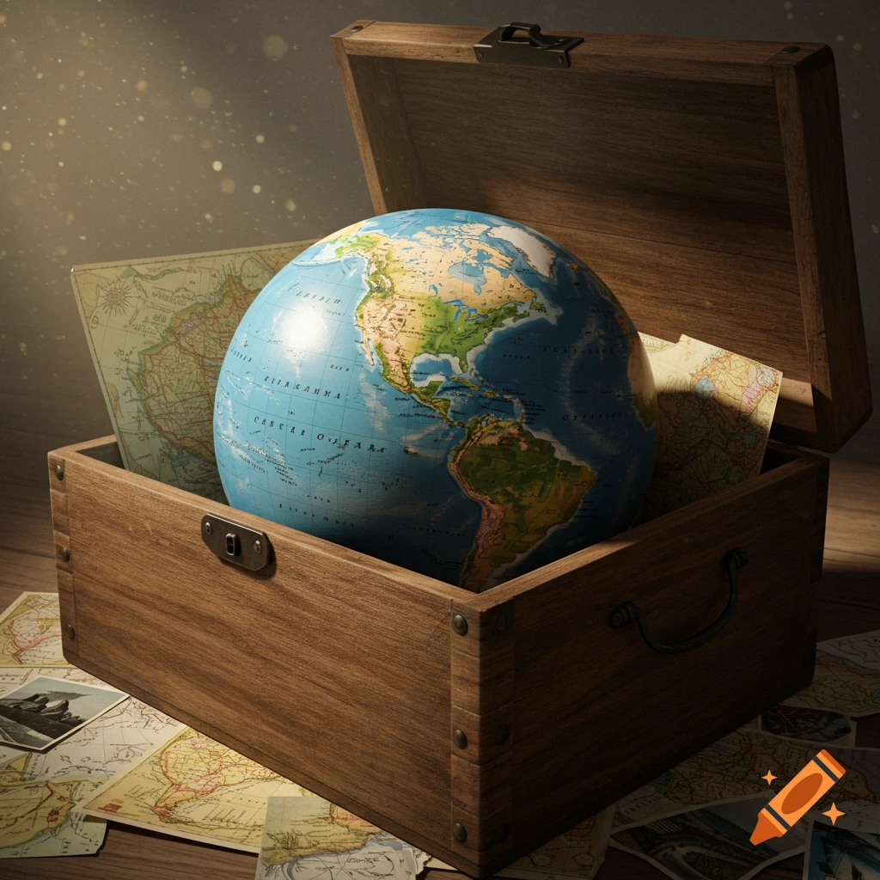

Student Worksheet 5 –City Highlights: Presenting Our findings

Name/Surname: ____________________________
Group: ____________________________
Date: ____________________________
Activity 1: Presenting Your City Findings 🌍
🎯 Aim of the Activity: To share and present the information your group has collected about your city, and to contribute to a collaborative class Padlet with all teams’ findings.

🧭 Instructions for Students
- Work with your group and get ready to present your city information to the class.
- Use the information you collected in Worksheet 3: City research questions 1a & Worksheet 4: City research questions 1b
- When it’s your turn, present your findings clearly and confidently to your classmates.
- After each presentation, listen to the teacher’s feedback about your content, language, and clarity.
- Make the necessary corrections to your information based on the feedback.
- Use your tablet to upload your corrected information to the class Padlet https://shorturl.at/ZTDEf
- Make sure your text is accurate, well-written, and visually clear on the Padlet! 💻

Have fun sharing your amazing city discoveries! 🏙️✨

