Group 1

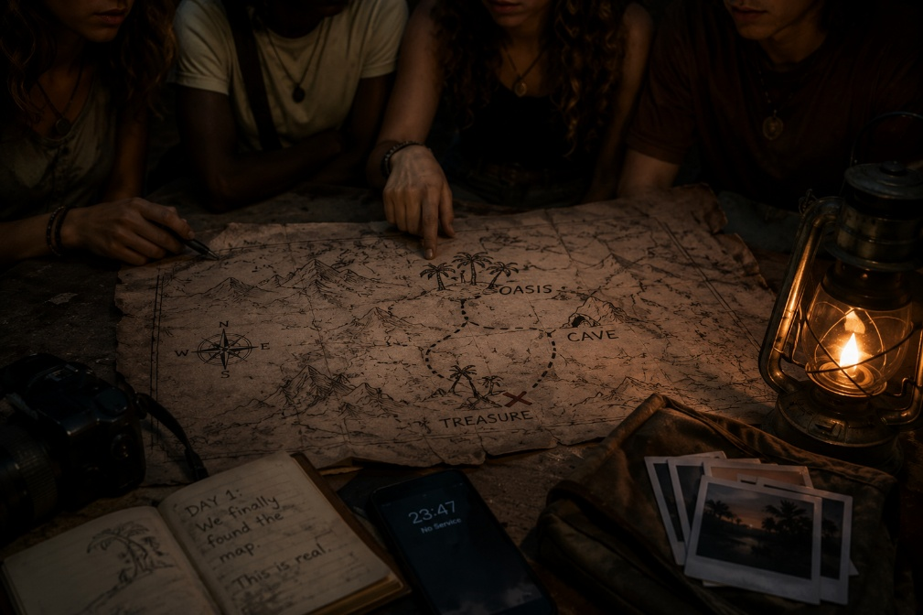

Story Title: A Journey to the Unknown
Deborah 18, from Congo, Selma 19, from Morocco, Chloe, 18 from Poland and Jade 19 from Algeria are friends and it’s their first trip together They met each other at a chat for people who want to go to Syria for vacation (which is quite weird). Deborah pretends to be a completely normal teenager, but in reality she is a serial killer. They have arranged to meet at the airport in Syria. At the crowded airport in Damascus, Deborah finally met Selma, Chloe, and Jade after months of talking in a strange online travel chat for people obsessed with visiting Syria. Selma was loud and fearless, Chloe awkward and nervous, and Jade calm enough to make the others slightly uncomfortable, but Deborah fit in perfectly, smiling and joking like a completely normal teenager while hiding the fact that she was a serial killer. As they left the airport together and climbed into an old van heading toward the city, their driver casually warned them that several tourists had vanished near the eastern desert only weeks earlier, causing the girls to laugh nervously except Deborah, who quietly stared out the window with the unsettling feeling that someone, or something, in Syria might actually be more dangerous than her.
They were all quite happy and excited that they had finally arrived at the desert. They would all share the same tent. The next morning they would set out for a journey in the desert under the scorching Sun. Their aim was to reach an oasis which, rumours said, kept a secret treasure under the sand. They would use an old map they had bought from a street vendor in a flea market in Morocco. Deborah knew that she needed the rest of the girls.
At the beginning of their journey, at the airport, they were searching for a website where you can rent a car for not so much money. At first everything looked very expensive, since they were still so young and all did not really have a job to earn money, they did not have very much to spend. Until they found a website called “car rental Syria”, where every car was so cheap, even the most expensive cars. So the girls rented a nice black car but when they arrived at the place where the car would be according to the owner of the car rental company, there wasn’t any car. They were all panicking because they spent all their money on this car but Deborah had an idea: “What if we just call the owner of the rental company and ask where the car is?” Selma and Chloe were excited, they said: “That sounds amazing!” But Jade said: “What if he or she just doesn’t answer the phone?!” “That’s true,” said Selma.
But Deborah answered: “Then we just go to the place where the company is located according to the site”. “You’re right” said Selma, Chloe and Jade all at the same time. “Let’s just try it!” So they called the owner of the rental company but as expected, he didn’t answer the phone. Selma immediately grabbed her phone out of her pocket and searched for the location where the company was established but it was not on the website. They all looked at Deborah about what to do now but she was silent. For 5 minutes, they stood there and said nothing.’ Then some guy came out of nowhere and said: “I heard you needed a ride..” and because they didn’t have another option they decided to accept the offer. While they were walking to the car that guy said: “My name is Tarzan by the way.’’ After what felt like ages of walking, they finally got to something that barely looked like a small van. because there wasn't enough space everyone had to sit in the trunk of the van… except Deborah.
The trunk smelled awful. Selma, Chloe, and Jade were crammed together, sweating and uncomfortable, while Deborah sat in front chatting with Tarzan like nothing was wrong.
After an hour of bumpy roads, Tarzan stopped the van in the middle of nowhere.
"That's your oasis," he said, pointing at some palm trees in the distance. "But I'm not going closer. Something's not right about that place."
"How did you even know where we were going?" Jade asked suspiciously.
Tarzan lit a cigarette. "Everyone who comes here is looking for the same treasure. They all have the same map from Morocco." He looked at them seriously. "And they all disappear."
"We'll be fine," Deborah said coldly, grabbing her backpack. She started walking.
The others hesitated, but eventually followed. What choice did they have?
They reached the oasis at sunset. The water looked dark and still. There was a cave entrance with the map's symbol carved above it.
"This is it!" Selma said excitedly.
But Jade noticed something on the rocks. Names. Dozens of names carved into the stone, with recent dates next to them.
"Guys... I think these are the missing tourists."
Before anyone could respond, they heard voices coming from inside the cave. Not one voice. Many voices. Speaking in whispers.
Deborah's face went pale. For the first time since they'd met her, she looked actually scared.
"We need to leave," she said quietly. "Right now."
But it was too late. Shadows started moving at the cave entrance. And in the distance, they could see Tarzan's van driving away, leaving them completely alone in the desert.
The girls stood frozen as the shadows moved closer from the cave. The whispering voices called their names again and again.
“Run!” Jade shouted.
They ran across the sand, but the voices followed them. Suddenly, Deborah saw the old map on the ground. She understood at once.
“It’s the map!” she cried. “It brought us here!”
Deborah took out a lighter and burned it. Immediately, the shadows screamed and disappeared. The oasis, the cave, and the dark water slowly vanished into the desert.
For a moment, everything was silent.
“We survived,” Chloe whispered.
At sunrise, Tarzan returned with his van. This time, the girls all sat together inside. Nobody spoke much. They were tired, scared, and changed forever.
When they reached the airport, Selma said, “Next time, we will choose a normal vacation.”

Students:

Greek students: Alexandros, Kimonas, Alexios

