Group 4

Story Title: A Surprising Journey
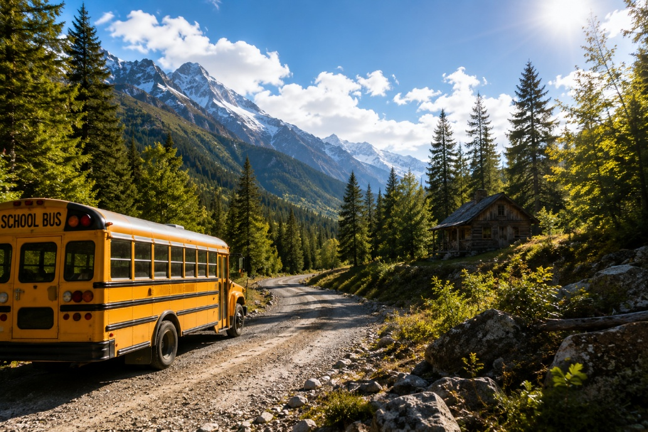
The school bus rattled as it climbed the winding mountain path. Jean, small for his thirteen years, pushed his glasses up his nose and tucked a strand of long hair behind his ear. He was reading a manual on geology, his mind drifting between the rock formations outside and his mother, who was back home and very pregnant. Being the only boy with two sisters had made him mature beyond his years, a "geek" who preferred facts to small talk.
Alex looked at the broken road and stayed calm. She was strong and determined, even while the other students were scared.

“We need to find shelter,” she said.

Jean pointed toward a small path in the forest. The group followed it carefully through the rain while Patrick watched over everyone.

After a few minutes, Alex saw a small cabin between the trees.

“Look!” she shouted.

The students ran toward the cabin, hoping they would finally be safe.
There was nobody inside the cabin. There was a fireplace in a corner of the room and they thought they could light a fire to dry their dripping wet clothes.
It was getting dark and the creepy sounds of the woods made them really scared. But they had to be brave. Afterall, what could go wrong? They were in the middle of nowhere without food and drink and no signal in the cell phones…
“So, what now?” Jean says.
“Well I suppose if we could find anything we could use right? Maybe something to eat?” Alex suggests. Everyone starts searching for something they could use. Jean starts searching in the cabin. Everyone was still searching around the place for something edible. Jean was still searching in the cabin, but then suddenly the wind blew and the door of the cabin closed! Jean was stuck in the cabin! “Help!” screamed Jean. Alex said we get you out of there. She tried to open the door by kicking, but the door was strong. Alex said to Jean: try to find another exit Jean. Jean tried to find an exit, but then he tripped over a hook, one that seemingly came out of nowhere. But then Jean heard a sudden movement. Like in his words “Sisyphus dragging his stone across the mountain”. Jean, trying to recover from the fall, looks up and suddenly sees that the walls opened up. Looking into a seemingly infinite abyss, Jean spots something. Wanting to identify the “structure” he walks closer. And then he screams, a blood curdling scream. He spots a ribcage, an arm multiple heads on places where they shouldn’t. It seems to be an artwork referencing a tree of some sorts. Comparable to a mangrove tree. The thing is entirely made out of human bones. All of the limbs are holding the heavier parts up as the tree seemingly looks as if it has thousands of legs, it looks alive, but it isn’t. ‘’What… is… this?’’ said Jean, terrified. Hoping for his friends to find him. ‘’We are coming to you Jean!’’ screams Alex. Jean is still terrified but he is a little bit relieved knowing Alex heard him but suddenly a large round figure appears. Jean jumps back, scared of his life, almost knocking the tower down.
‘’Wh-who are you?’’ says Jean. ‘’dont worry i am a teacher, i have been stuck here for a week and we have to get out of here before he comes.’’
‘’Who is he? And who are you?’’ says Jean, still scared for his life.
‘’Im Patrick, what's your name?’’ My name is Jean. I am here with my class. What are you doing here?’’ I fell into the hole. I am trying to find a solution to escape. Maybe we could make a stair out of bones?” Jean said. They picked up some bones, but they found a little hole. They pushed aside more bones and the hole became bigger, and bigger. They put all the bones on the side, and they saw a big hole. Big enough for a bear to fit in.”I'll go in first” Patrick says. Patrick walks in. He walks further and further until he sees a corner. He looks around the corner and sees twinkling red eyes…
Patrick froze. The red eyes didn't move. They just stared at him from the darkness, unblinking.
"Patrick?" Jean whispered from behind. "What do you see?"
Before Patrick could answer, the eyes moved closer. And then they heard it—a low growl that made both of them step back.
"Run!" Patrick screamed, pushing Jean back toward the hole they came from.
But Jean didn't run. Something about the growl sounded... wrong. Not like an animal. More like a person trying to sound like an animal.
"Wait," Jean said, his geek brain taking over even though he was terrified. He remembered something from his geology manual—how sounds echo differently in tunnels depending on what's making them.
He took a deep breath and shouted into the darkness: "WHO ARE YOU?"
The growling stopped. Silence.
Then a voice, shaky and scared: "Please... don't hurt me."
A figure stepped into the dim light. Not a monster. A girl, maybe sixteen years old, dirt covering her face, her eyes red from crying in the dark.
"I've been trapped here for three days," she said, starting to cry. "I thought you were... them."
"Them?" Patrick asked. "Who's them?"
The girl pointed up at the bone tree they'd seen earlier. "The people who made that. They come back sometimes. To add more... pieces."
Jean felt sick. "We need to get out of here. All of us. Now."
From above, they heard Alex's voice: "Jean! I found a rope! Can you climb up?"
"There's three of us now!" Jean shouted back.
Working together, they helped the girl climb up first. Then Jean. Patrick was last. Just as he grabbed the rope, they heard footsteps in the tunnel below. Heavy footsteps. Multiple people.
"PULL!" Patrick screamed.
Alex and the other students pulled with all their strength. Patrick scrambled up just as hands reached for his legs from below. They slammed the cabin door shut and pushed furniture against it.
"We need to leave. NOW," Jean said.
They all ran out of the cabin into the rainy forest. Behind them, they could hear the cabin door breaking open. But they didn't look back. They just ran until they saw lights in the distance—a rescue team that had been searching for them.
Later, the police went back to the cabin and found the tunnel. They also found the strange tree made of bones. Nobody really explained everything to the students, and most of them did not want to ask too many questions.
When Jean finally got home, he did not tell his mother the whole story. He only told her that the trip had gone wrong and that he was happy to be back. Then he hugged her for a long time.
After that day, Jean was different. He still liked reading his books, but he also spent more time with his sisters and his friends. Sometimes, when it was late at night, he thought about the cabin, the tunnel, and the red eyes in the dark.
He never found out exactly what had been down there.
And maybe he was glad he didn’t.

Students:

Greek students: Panagiota, Penny, Nikos

