1. **Benier MDD High-Speed Mixer**

[**https://kaakgroup.com/products/mixing/**](https://kaakgroup.com/products/mixing/)

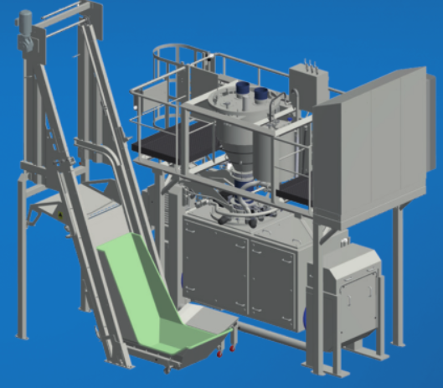



1. Dough Expert Basic

<https://kaakgroup.com/wp-content/uploads/2018/09/Benier-Flyer-Dough-Expert_EN.pdf>

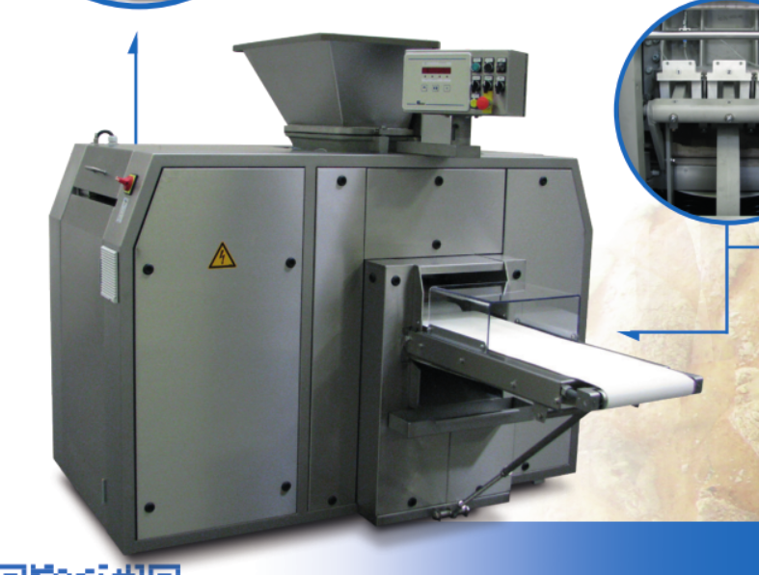

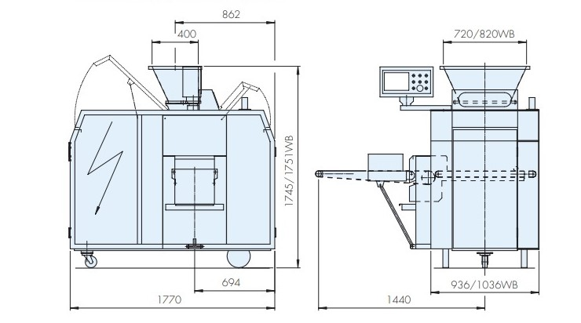

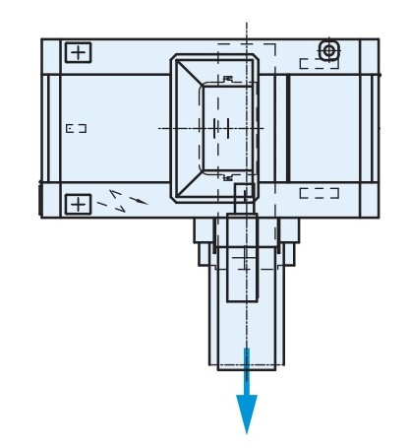

# BenierTallround (HDS)

# <https://kaakgroup.com/products/tallround-hds/>

# https://kaakgroup.com/wp-content/uploads/2014/11/Tallround.jpg

# Benier First Proofer BP

<https://kaakgroup.com/products/proofer-bp/>

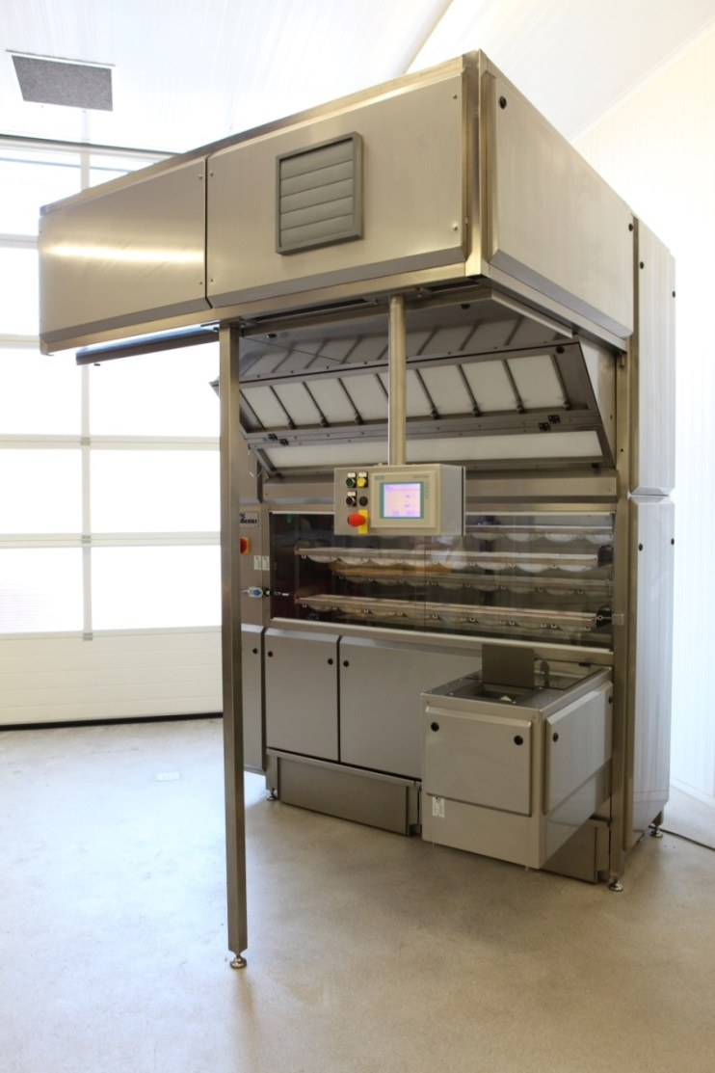

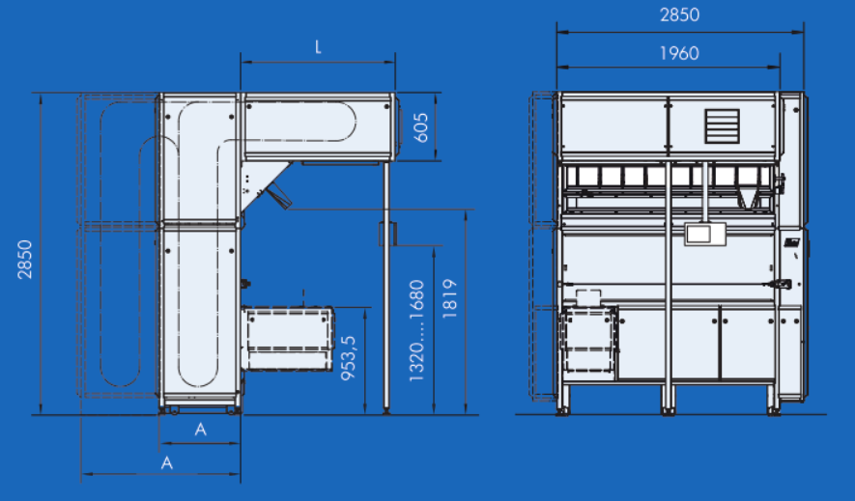

# BenierUnimoulder

# <https://kaakgroup.com/products/unimoulder/>

# 

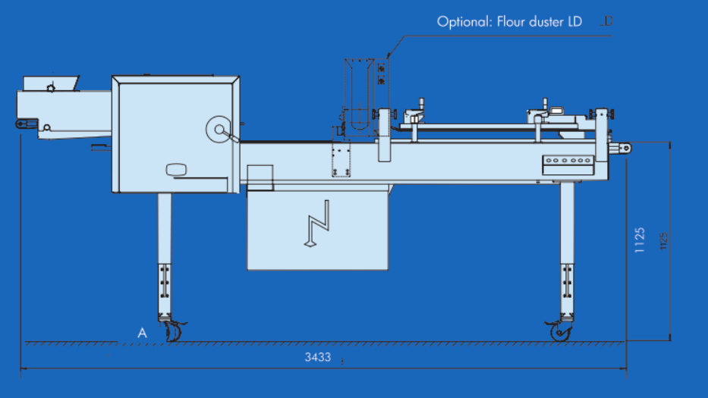

# Kaak Spirals Multi-Spiral

<https://kaakgroup.com/products/multi-spiral/>

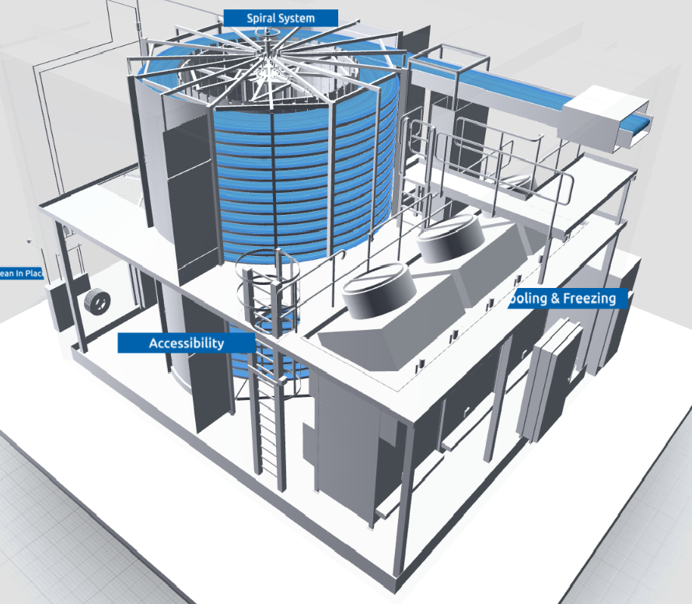

# Daub Tunnel Oven

xs