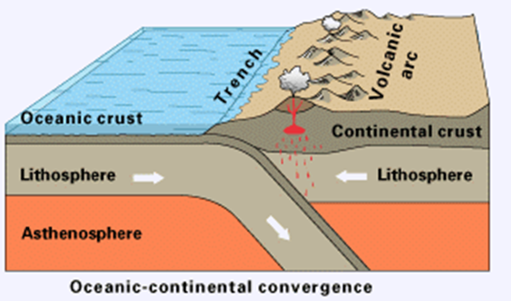

ΕΙΚΟΝΑ 1

………………………………………………………………………………………………………………………………………………

……………………………………………………………………………………………………………………………………………..

……………………………………………………………………………………………………………………………………………..

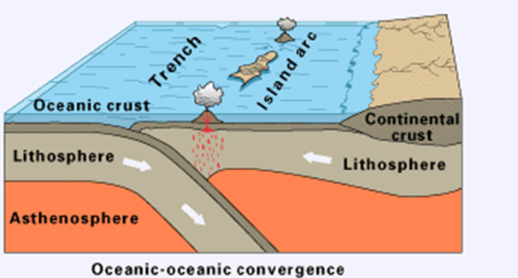

ΕΙΚΟΝΑ 2

………………………………………………………………………………………………………………………………………………………………………………………………………………………………………………………………………………………………………………………………………………………………………………………………………………………………………………

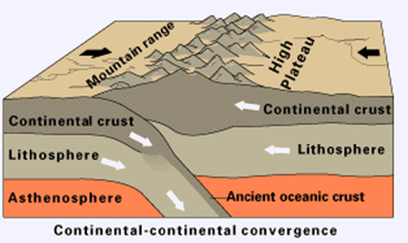

ΕΙΚΟΝΑ 3

……………………………………………………………………………………………………………………………………………………………………………………………………………………………………………………………………………………………………………………………………………………………………………………………………………………………………………..

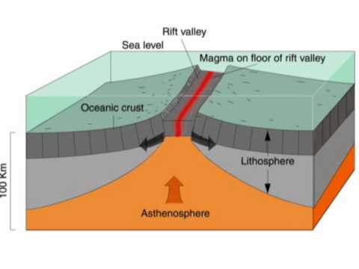

ΕΙΚΟΝΑ 4

……………………………………………………………………………………………………………………………………………………………………………………………………………………………………………………………………………………………………………………………………………………………………………………………………………………………………………..