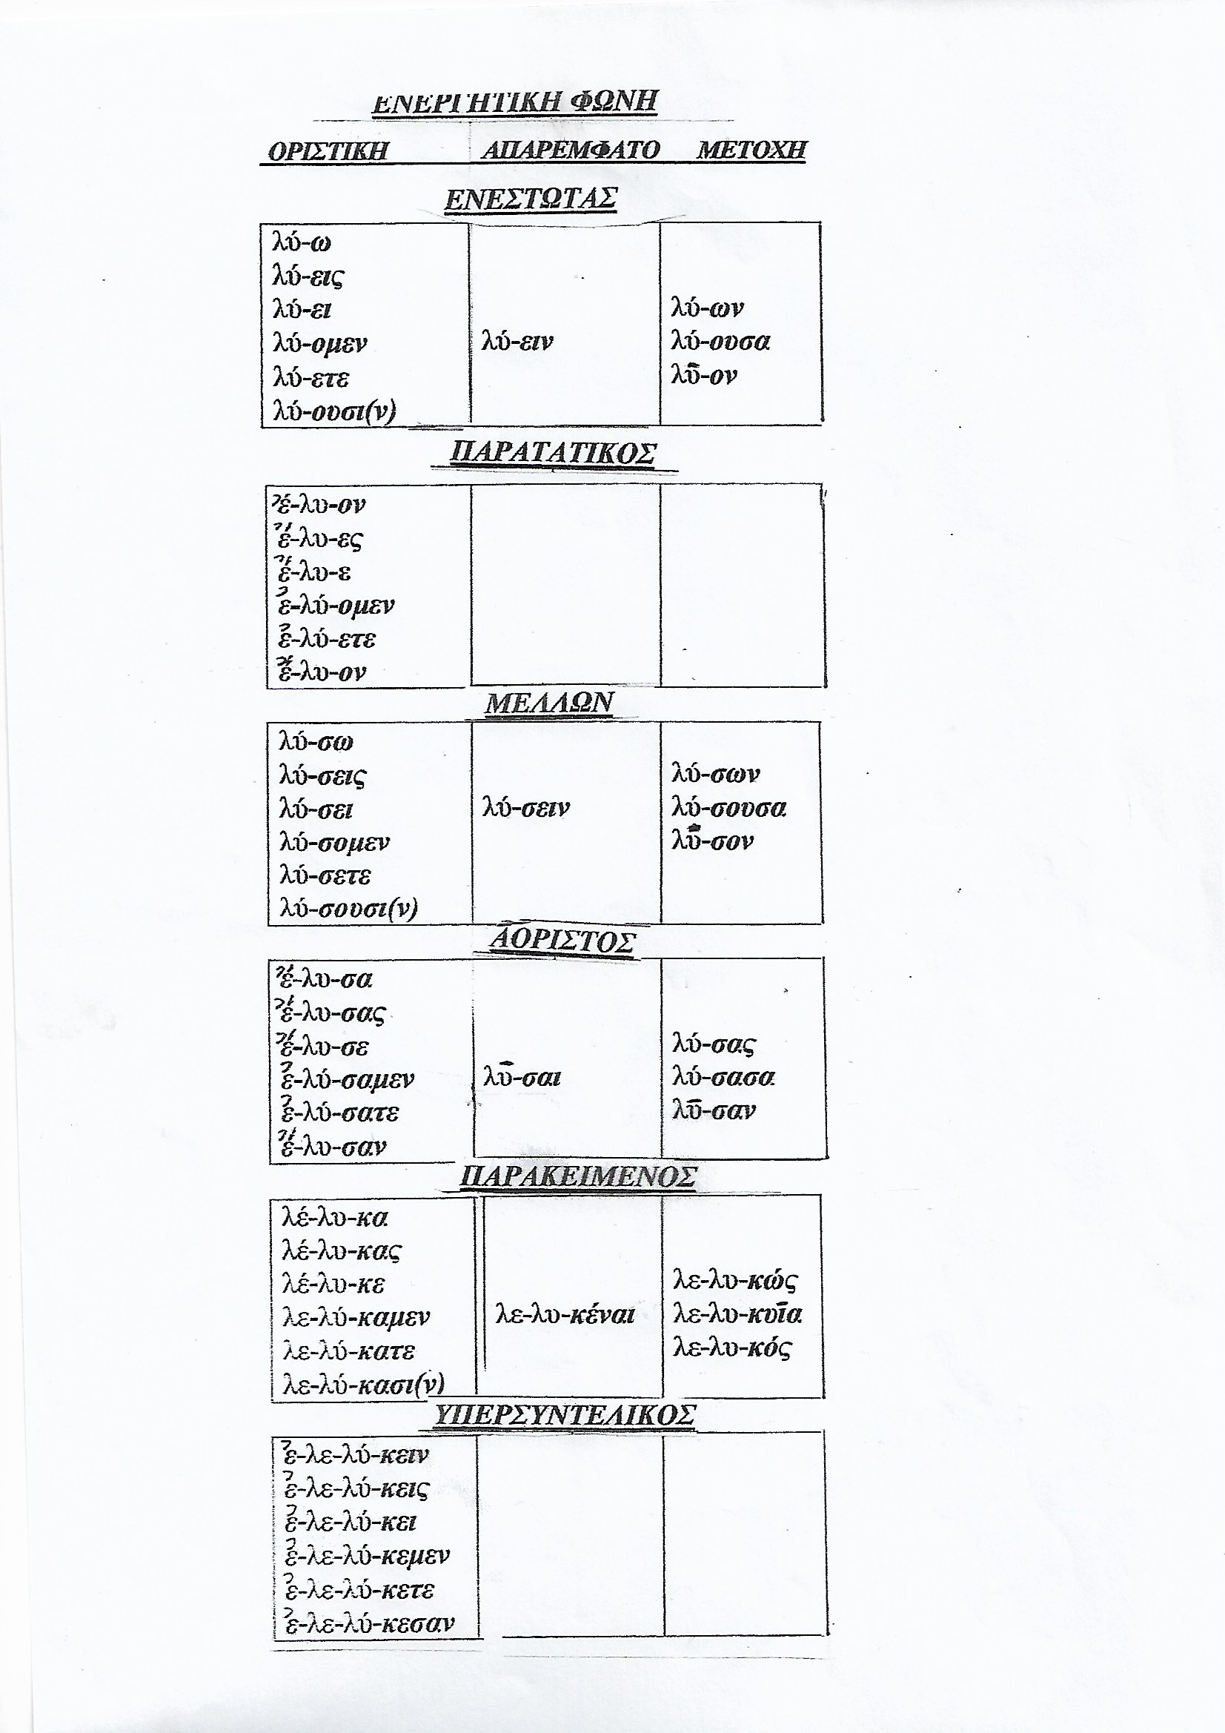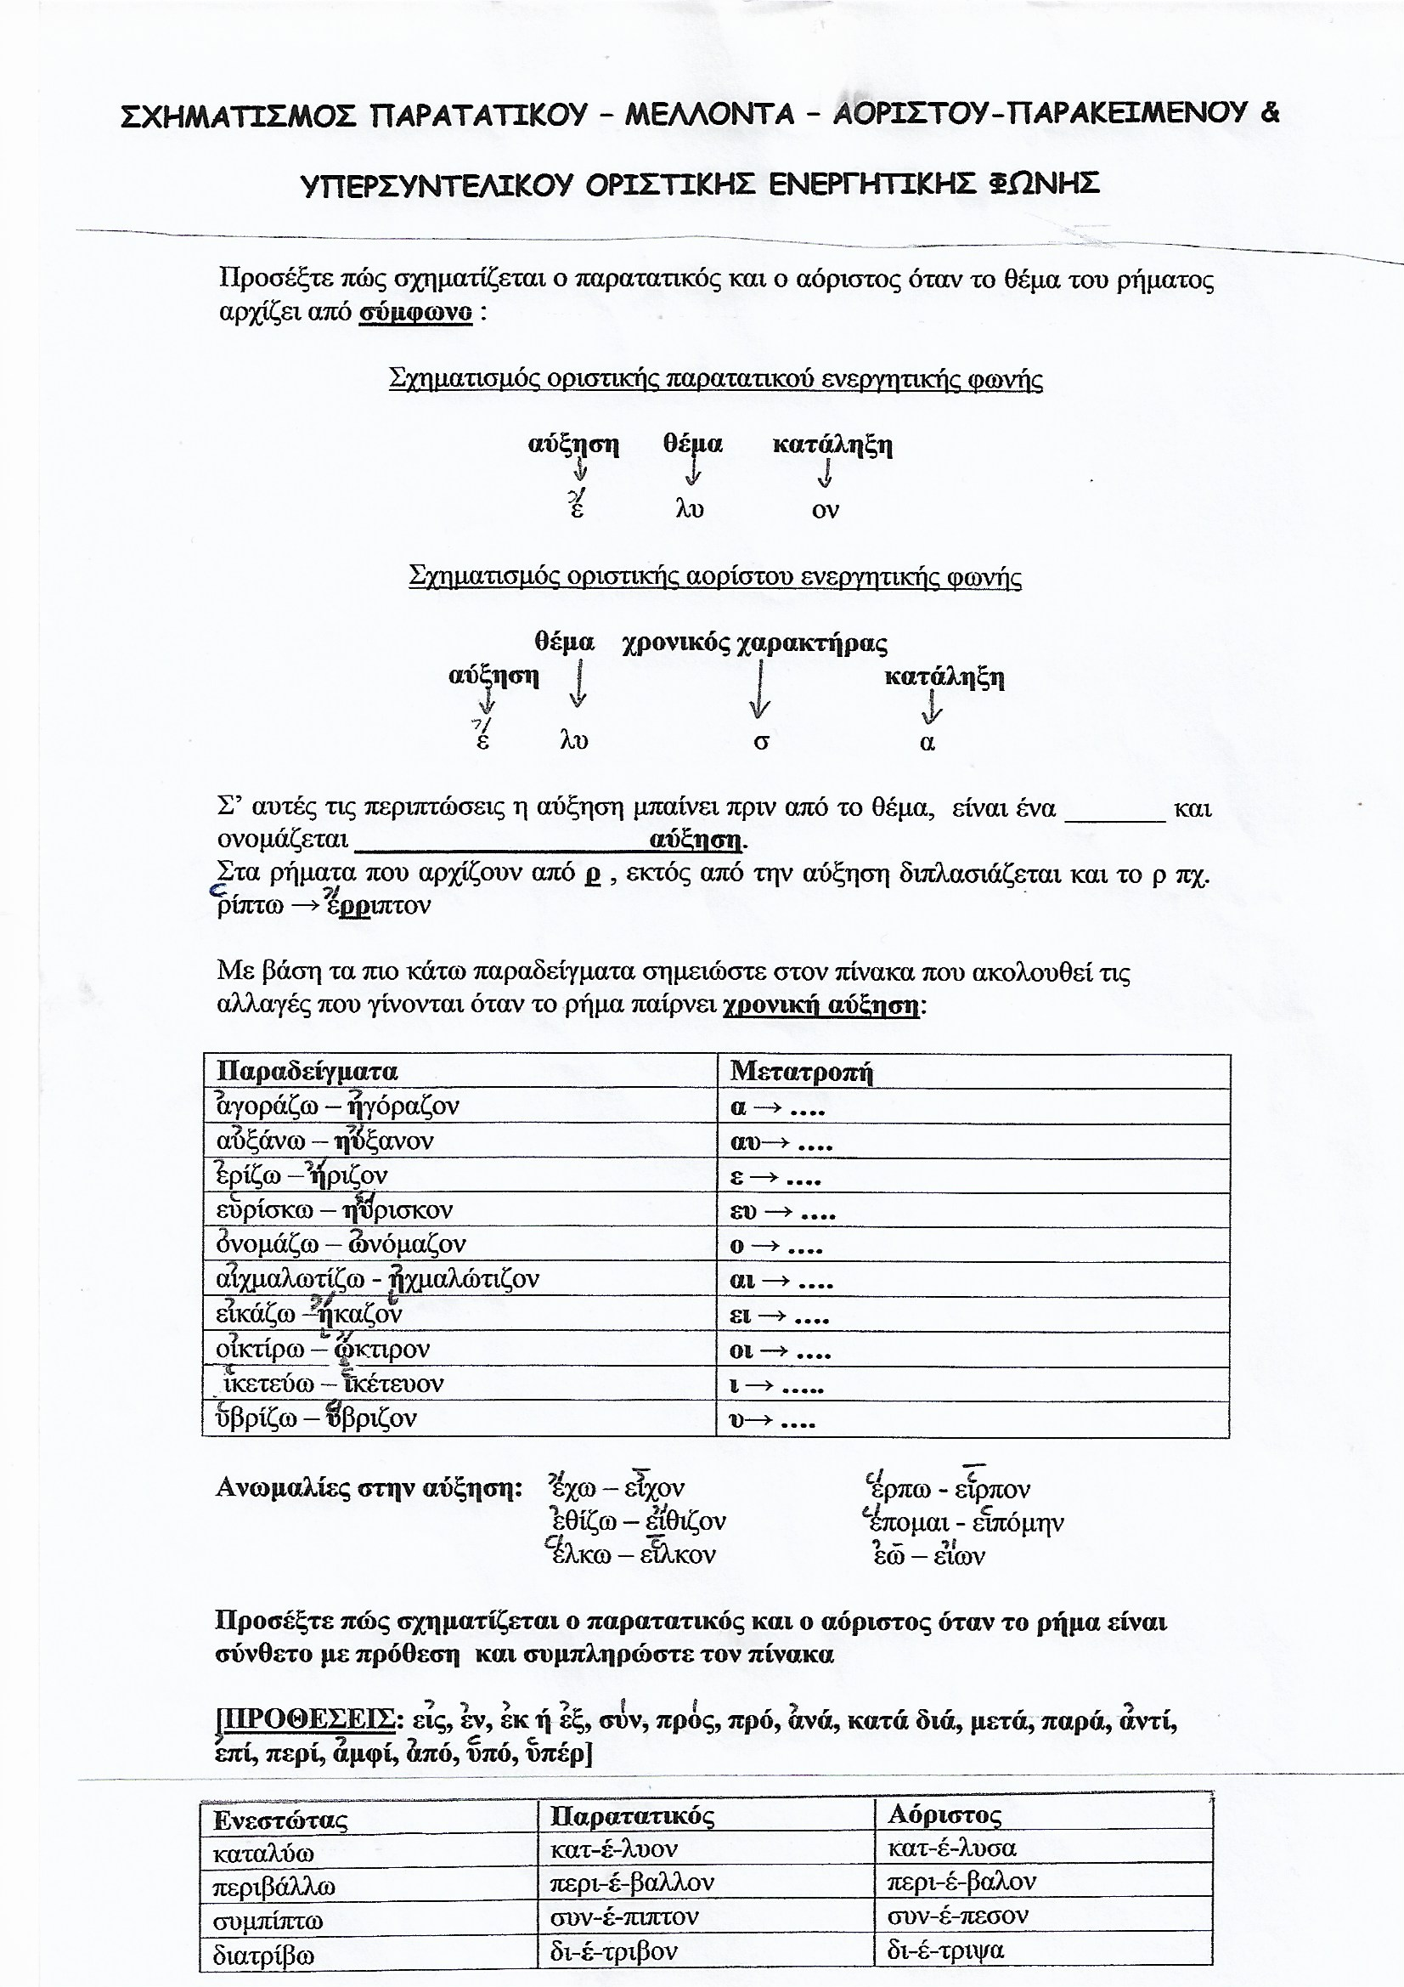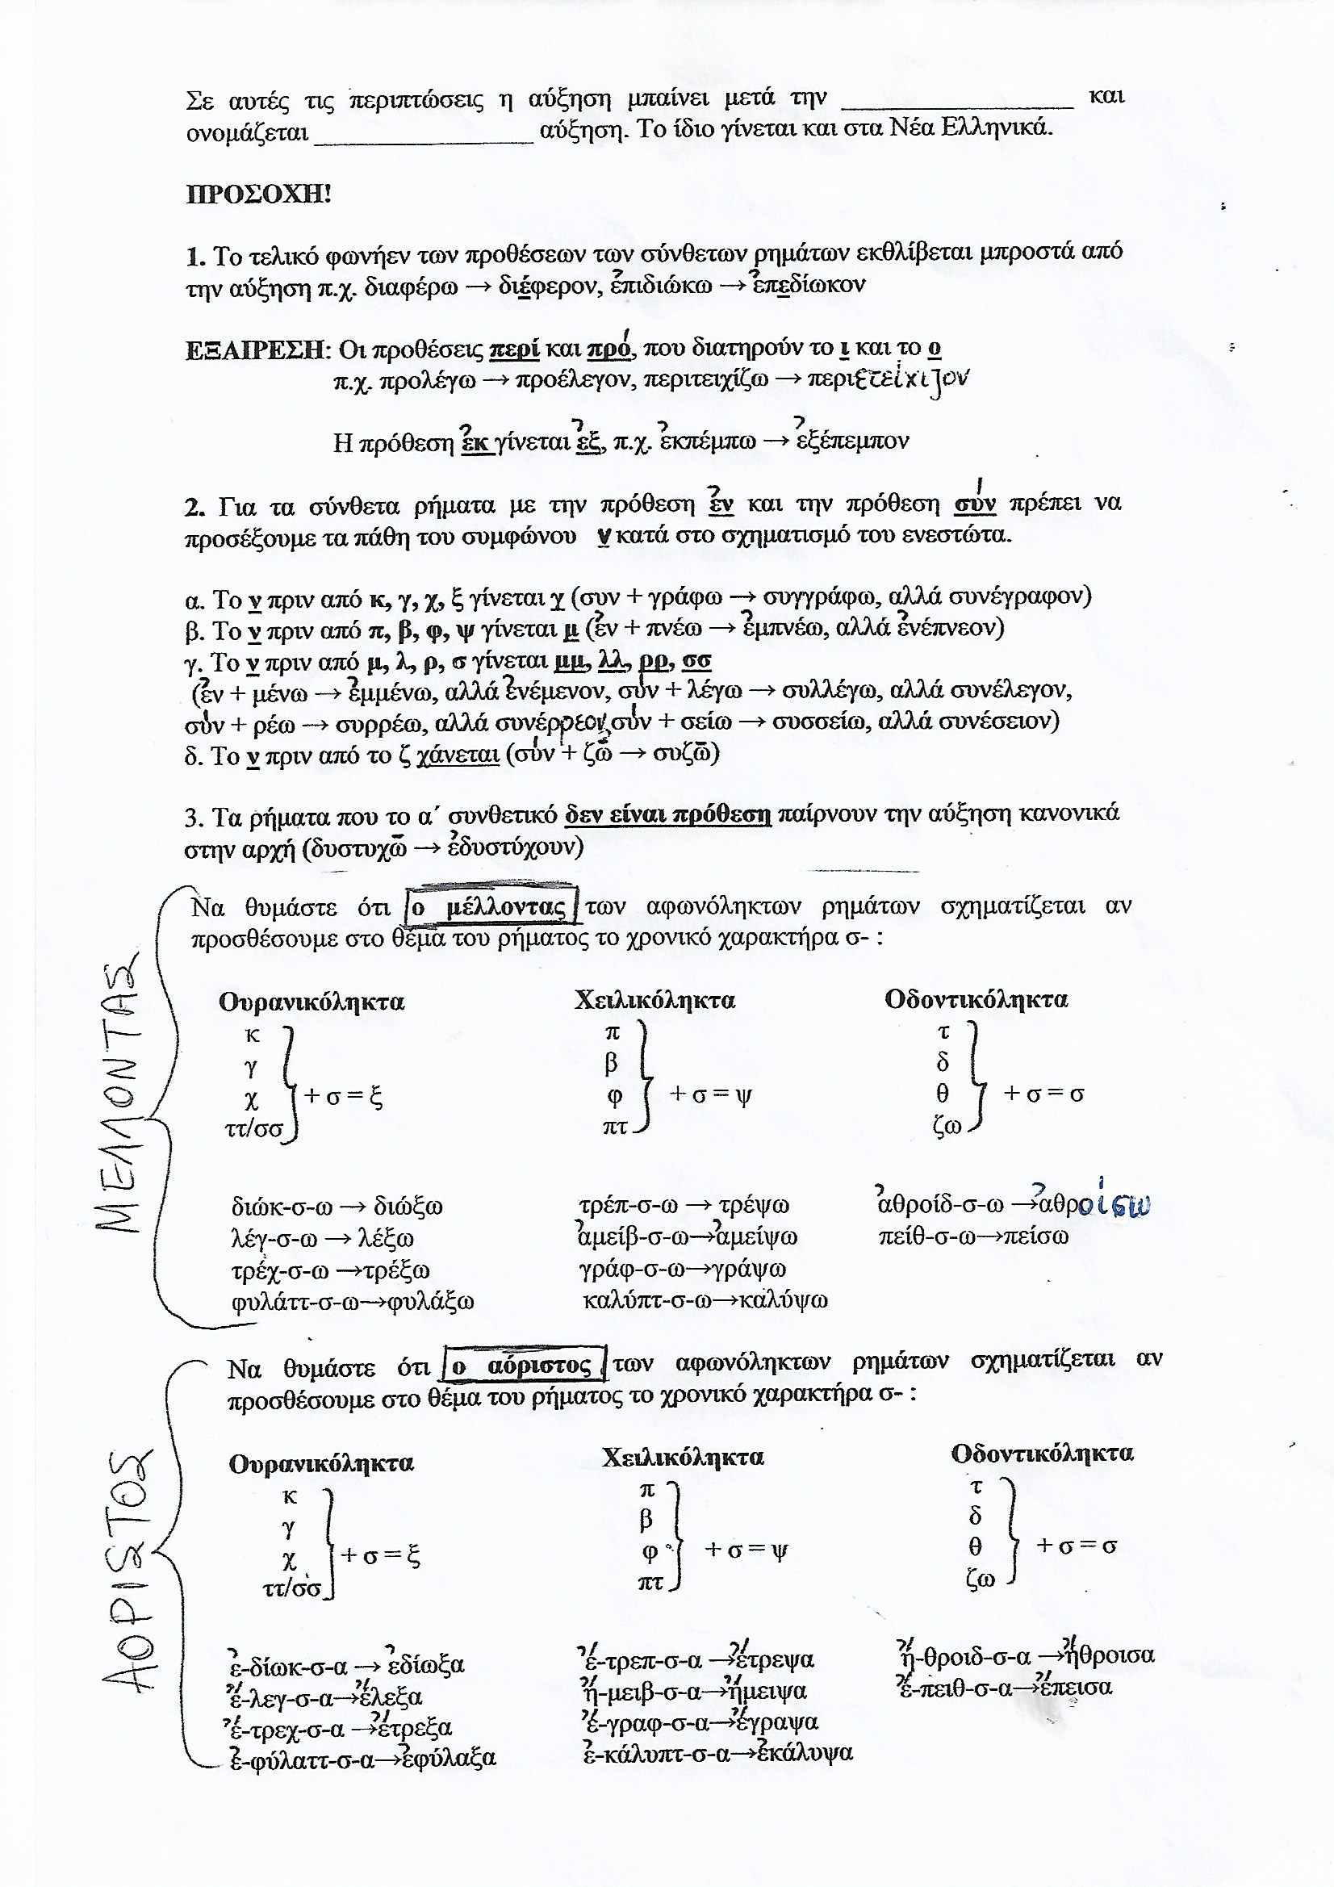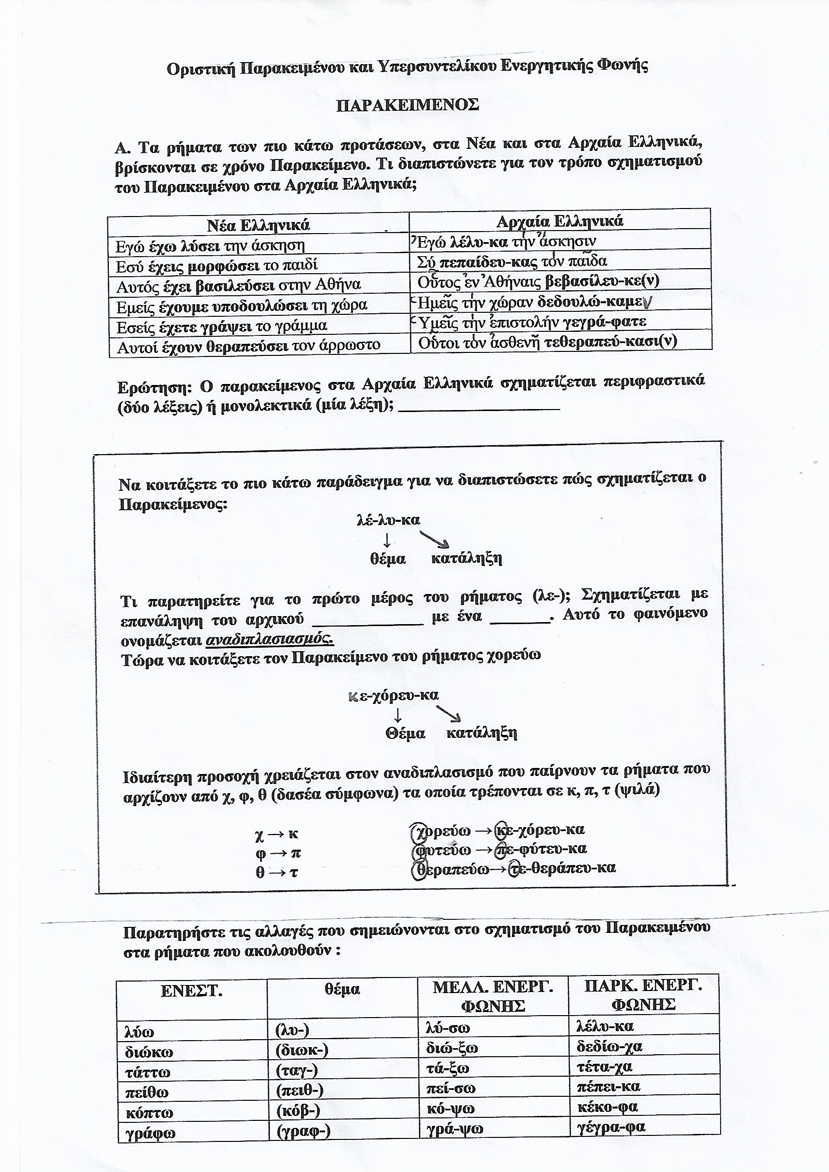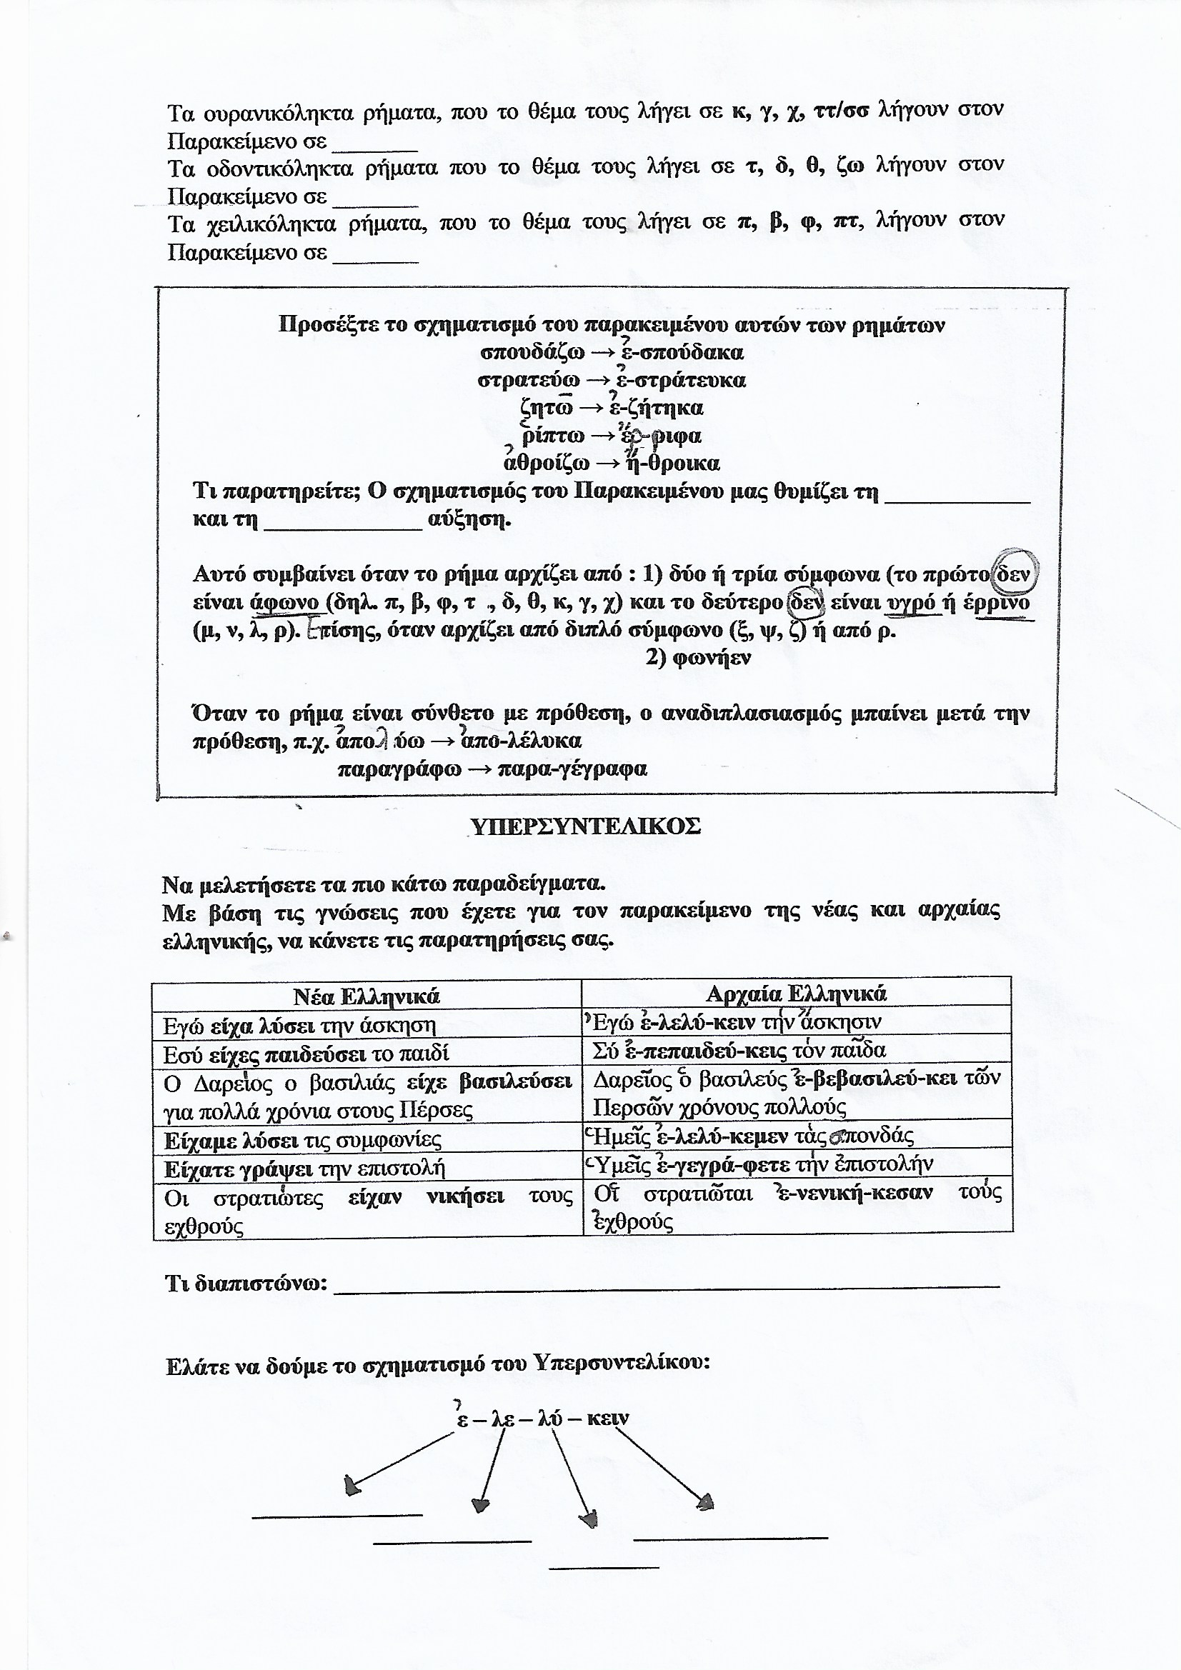

**ΕΝΕΡΓΗΤΙΚΗ ΦΩΝΗ ΟΡΙΣΤΙΚΗ ΕΝΕΣΤΩΤΑΣ**

|  |  |  |  |
| --- | --- | --- | --- |
| **παιδεύω** | **ἄρχω** | **καλύπτω** | **ἀθροίζω** |
|  |  |  |  |
|  |  |  |  |
|  |  |  |  |
|  |  |  |  |
|  |  |  |  |

**ΠΑΡΑΤΑΤΙΚΟΣ**

|  |  |  |  |
| --- | --- | --- | --- |
|  |  |  |  |
|  |  |  |  |
|  |  |  |  |
|  |  |  |  |
|  |  |  |  |
|  |  |  |  |

**ΜΕΛΛΟΝΤΑΣ**

|  |  |  |  |
| --- | --- | --- | --- |
|  |  |  |  |
|  |  |  |  |
|  |  |  |  |
|  |  |  |  |
|  |  |  |  |
|  |  |  |  |

**ΑΟΡΙΣΤΟΣ**

|  |  |  |  |
| --- | --- | --- | --- |
|  |  |  |  |
|  |  |  |  |
|  |  |  |  |
|  |  |  |  |
|  |  |  |  |
|  |  |  |  |

**ΠΑΡΑΚΕΙΜΕΝΟΣ**

|  |  |  |  |
| --- | --- | --- | --- |
|  |  |  |  |
|  |  |  |  |
|  |  |  |  |
|  |  |  |  |
|  |  |  |  |
|  |  |  |  |

**ΥΠΕΡΣΥΝΤΕΛΙΚΟΣ**

|  |  |  |  |
| --- | --- | --- | --- |
|  |  |  |  |
|  |  |  |  |
|  |  |  |  |
|  |  |  |  |
|  |  |  |  |
|  |  |  |  |

**ΕΝΕΡΓΗΤΙΚΗ ΦΩΝΗ ΟΡΙΣΤΙΚΗ ΕΝΕΣΤΩΤΑΣ**

|  |  |  |  |
| --- | --- | --- | --- |
| **ῥίπτω** | **στρατεύω** | **θύω** | **περιγράφω** |
|  |  |  |  |
|  |  |  |  |
|  |  |  |  |
|  |  |  |  |
|  |  |  |  |

**ΠΑΡΑΤΑΤΙΚΟΣ**

|  |  |  |  |
| --- | --- | --- | --- |
|  |  |  |  |
|  |  |  |  |
|  |  |  |  |
|  |  |  |  |
|  |  |  |  |
|  |  |  |  |

**ΜΕΛΛΟΝΤΑΣ**

|  |  |  |  |
| --- | --- | --- | --- |
|  |  |  |  |
|  |  |  |  |
|  |  |  |  |
|  |  |  |  |
|  |  |  |  |
|  |  |  |  |

**ΑΟΡΙΣΤΟΣ**

|  |  |  |  |
| --- | --- | --- | --- |
|  |  |  |  |
|  |  |  |  |
|  |  |  |  |
|  |  |  |  |
|  |  |  |  |
|  |  |  |  |

**ΠΑΡΑΚΕΙΜΕΝΟΣ**

|  |  |  |  |
| --- | --- | --- | --- |
|  |  |  |  |
|  |  |  |  |
|  |  |  |  |
|  |  |  |  |
|  |  |  |  |
|  |  |  |  |

**ΥΠΕΡΣΥΝΤΕΛΙΚΟΣ**

|  |  |  |  |
| --- | --- | --- | --- |
|  |  |  |  |
|  |  |  |  |
|  |  |  |  |
|  |  |  |  |
|  |  |  |  |
|  |  |  |  |

