All about upcycling

Creativity applied to recycling
Upcycling involves waste recovery through transformative processes where creativity is key. Little could Gary Anderson, then an architecture student, have imagined that the logo with which he won the 1970 competition to design the universal symbol for recycling would inspire the 3R principle more than 30 years later. The triad formed by the words reduce, reuse, and recycle laid the foundations for a philosophy that Japanese Prime Minister, Koizumi Junichiro, brought to the G8 summit in 2004. He presented it as a key factor in social development.
03 April 2024
.
5 minutes
Share
Two decades later, the environmental principle that promotes reducing the amount of resources we use, reusing materials instead of discarding them, and recycling those that can no longer be reused in order to minimize the environmental impact of our actions has not only been consolidated, but has incorporated new 'R's' into the equation. Have you heard of upcycling? What is known as upcycling is basically the natural evolution of the 3R rule, a transformation in which energy recovery, ecodesign, or refurbishment play a key role.
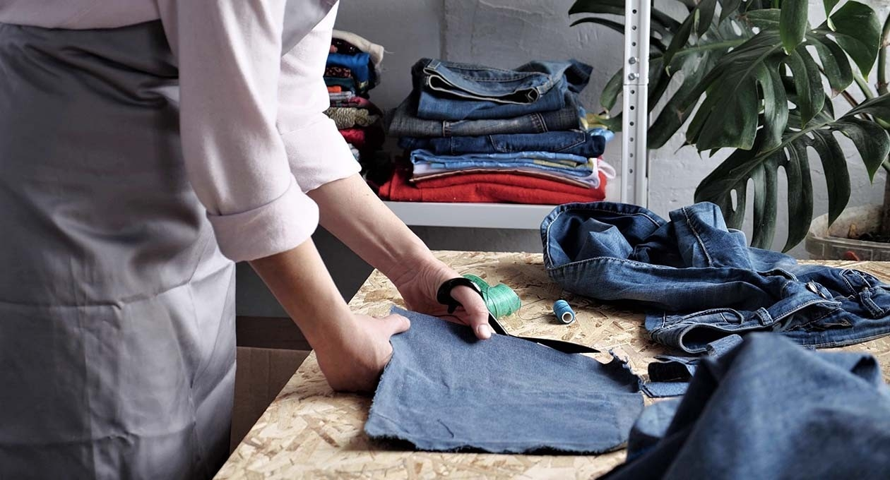

What is upcycling?
Upcycling is a concept based on the idea of converting materials or products that are no longer useful into others of higher quality, ecological, and economic value. Unlike conventional recycling, which consists of breaking down materials to reuse the raw material, upcycling seeks to give them a new life but in a creative and transformative way.
The term has become popular as a response to the environmental challenges associated with the accumulation of waste and the exploitation of natural resources. In this way, as awareness of the importance of the circular economy and the reduction of resource consumption increases, upcycling gains weight as an innovative and creative practice that contributes to promoting sustainability and reducing environmental impact.

Differences between upcycling and recycling
Upcycling and recycling are two different approaches to tackle the management of materials and waste products, each one with its own characteristics. Although both aim to reduce the environmental impact of our actions, there are differences in three main aspects:
- Objectives
While it is true that recycling and upcycling are based on the idea of reducing our ecological footprint, the two practices differ in their particular objectives. The former uses an industrial process to transform waste into raw materials that will later be used to produce new objects or materials. However, upcycling focuses on creative reuse, thus recovering waste and moving away from linear economy models.
- Transformation process
In recycling, waste is broken down by applying different processes ranging from collection and sorting, through crushing and separation, to reconversion. The ultimate goal is to obtain recycled materials that will be used in the manufacturing of new products. But if we talk about upcycling, the process is based on creativity by applying different techniques and methods depending on the materials and the desired end product which, in any case, involves waste recovery.
- Value of resulting products
The resulting products of upcycling usually have a greater value than the orginal materials, since they have been transformed in a creative manner and unique characteristics have been added. However, in the case of recycling, the formula doesn't imply a recovery of the materials but rather focuses on extending their useful life by converting them back into raw materials.

