**Passive Voice: Present Simple – Past Simple**

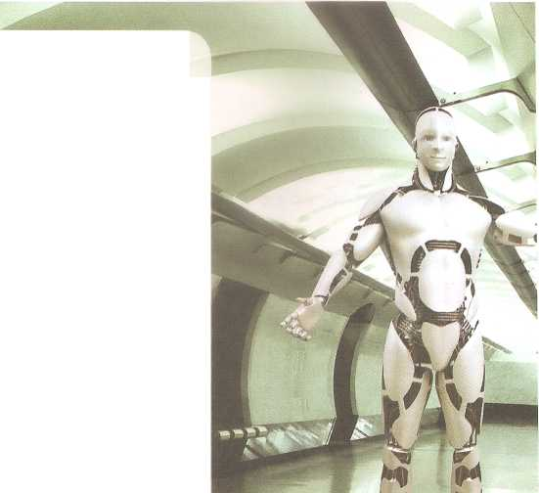

Artificial intelligence (AI) is used to make intelligent machines and especially intelligent computer programs.

**Al Facts**

In 1637 it was predicted by Rend Descartes, a French scientist, that it would not be possible to have machines that think like humans do.

About two centuries later a test was presented by the father of AI, Alan Mathison Turing, known as the *‘Turing Test’*. The test was designed to show that AI exists.

The idea of AI is found in many popular films and books, like Star Wars, The Matrix, *AI: Artificial Intelligence*, etc.

**A. Now read the sentences below and write T for True or F for False.**

1. In the past, scientists predicted that machines would be able to think like humans. ________
2. Turing wanted to show that AI is possible. _______
3. AI is not found in books and films. ________

**B. Complete the following text with the correct Passive form of the verbs in brackets.**

The purpose of the Wilmington Bird Sanctuary is to help and protect birds. Last year almost 900 hundred birds _________________________ (find) with broken wings or legs that needed help and care.

These birds ____________________ (bring) to the sanctuary and they _________________________ (take care of) by experts. All the birds _________________________ (keep) in large cages, they ___________________________ (feed) twice a day and their cages ___________________________ (clean) three times a week.