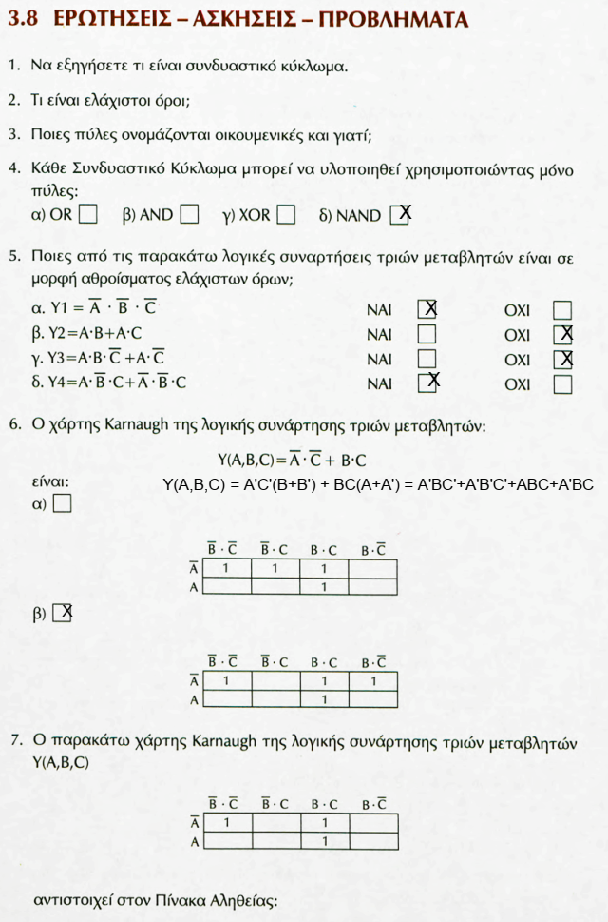***Λύσεις Ασκήσεων 3ου Κεφαλαίου***

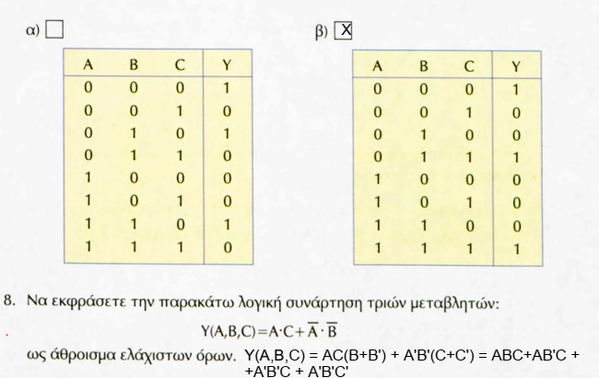

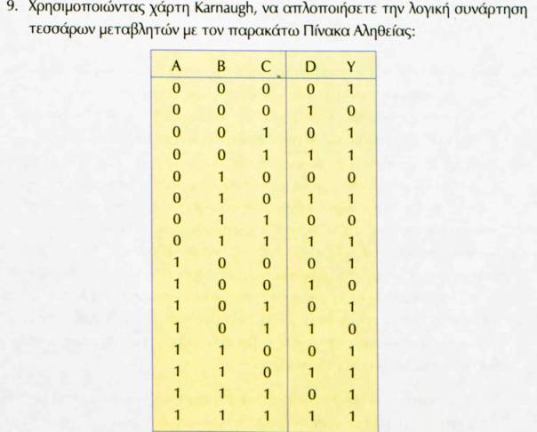

Λύση άσκησης

|  |  |  |  |  |  |
| --- | --- | --- | --- | --- | --- |
| |  | | --- | | CD | | C’D’ | C’D | CD | CD’ |
| AB | 00 | 01 | 11 | 10 |
| A'B' 00 | 1 | 0 | 1 | 1 |
| A'B 01 | 0 | 1 | 1 | 0 |
| AB 11 | 1 | 1 | 1 | 1 |
| AB' 10 | 1 | 0 | 0 | 1 |

**FSIM (A,B,C,D) = AD’ + BD + A’B’C + B’C’D’**

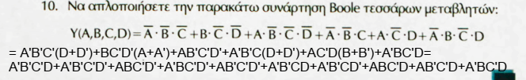

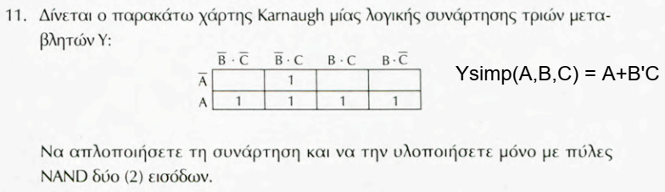

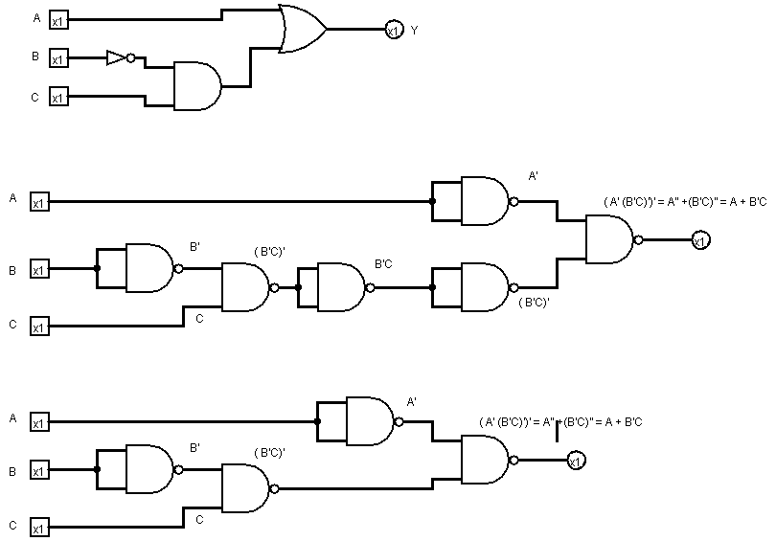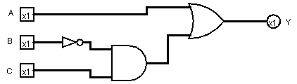Κύκλωμα: με NOT, AND, OR μετατροπή κυκλώματος μόνο με πύλες NAND

Τελικό κύκλωμα με πύλες NAND απλοποιημένο

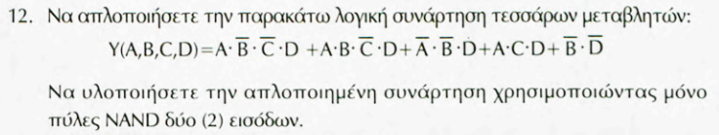

Να υλοποιηθεί το λογικό κύκλωμα με πύλες NOT, AND, OR δύο εισόδων

Λύση:

Συμπλήρωση των ελλιπών ελαχίστων όρων

Y(A,B,C,D) = AB’C’D + ABC’D+A’B’D(C+C’) + ABD(C+C’) + (A+A’)B’D’(C+C’) =

Y(A,B,C,D) = AB’C’D + ABC’D + A’B’CD+A’B’C’D + ABCD+ABC’D + AB’D’(C+C’) +A’B’D’(C+C’)

Y(A,B,C,D) = AB’C’D + ABC’D + A’B’CD+A’B’C’D + ABCD+ABC’D + AB’CD’ + AB’C’D’ + A’B’CD’+A’B’C’D’

|  |  |  |  |  |  |
| --- | --- | --- | --- | --- | --- |
| |  | | --- | | CD | | C’D’ | C’D | CD | CD’ |
| AB | 00 | 01 | 11 | 10 |
| A'B' 00 | 1 | 1 | 1 | 1 |
| A'B 01 | 0 | 1 | 0 | 0 |
| AB 11 | 0 | 1 | 1 | 0 |
| AB' 10 | 0 | 1 | 0 | 1 |

YSIM(A,B,C,D) = A’B’ + C’D + ABD + B’CD’

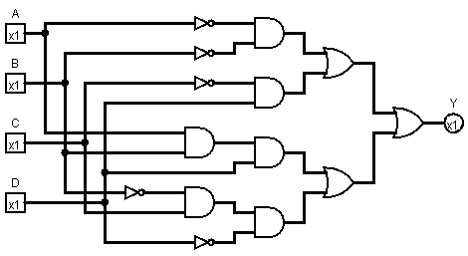 ΚΎΚΛΩΜΑ ΜΕ ΠΥΛΕΣ ΝΟΤ, AND, OR

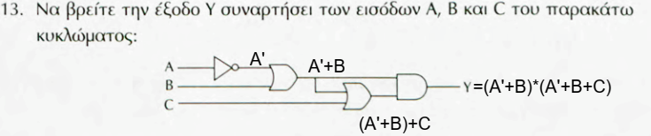

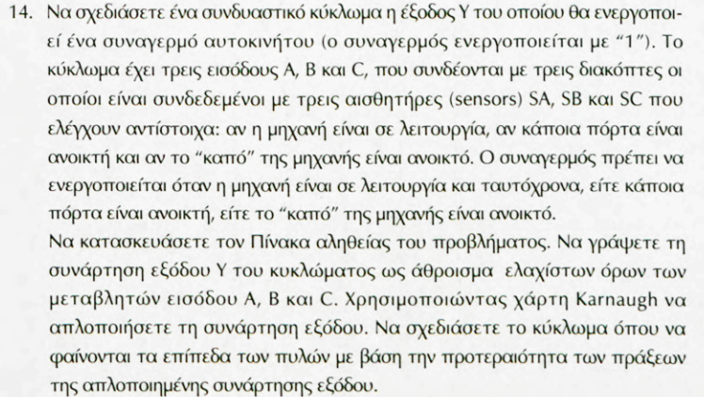

**Λύση**

|  |  |  |  |
| --- | --- | --- | --- |
| A | B | C | **Υ** |
| 0 | 0 | 0 | 0 |
| 0 | 0 | 1 | 0 |
| 0 | 1 | 0 | 0 |
| 0 | 1 | 1 | 0 |
| 1 | 0 | 0 | 0 |
| 1 | 0 | 1 | 1 |
| 1 | 1 | 0 | 1 |
| 1 | 1 | 1 | 1 |

|  |  |  |  |  |  |
| --- | --- | --- | --- | --- | --- |
| |  | | --- | | **BC** | | B'C' | B'C | BC | BC' |
| Α | 00 | 01 | 11 | 10 |
| A' 0 | 0 | 0 | 0 | 0 |
| A 1 | 0 | 1 | 1 | 1 |

**YSIM = AC + AB**

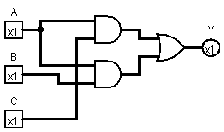 **με πύλες NOT,AND,OR Μόνο με πύλες NAND**

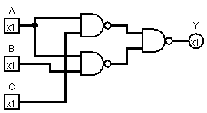

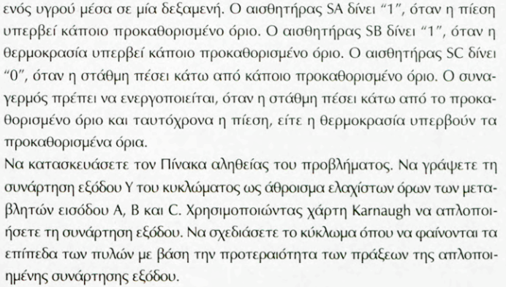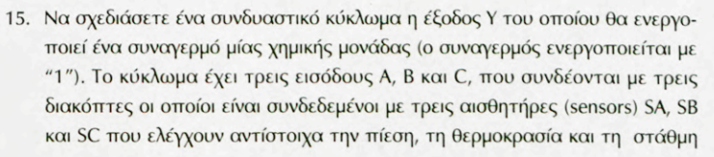

**Λύση**

|  |  |  |  |
| --- | --- | --- | --- |
| A | B | C | **Υ** |
| 0 | 0 | 0 | 0 |
| 0 | 0 | 1 | 0 |
| 0 | 1 | 0 | 1 |
| 0 | 1 | 1 | 0 |
| 1 | 0 | 0 | 1 |
| 1 | 0 | 1 | 0 |
| 1 | 1 | 0 | 1 |
| 1 | 1 | 1 | 0 |

|  |  |  |  |  |  |
| --- | --- | --- | --- | --- | --- |
| |  | | --- | | **BC** | | B'C' | B'C | BC | BC' |
| Α | 00 | 01 | 11 | 10 |
| A' 0 | 0 | 0 | 0 | 1 |
| A 1 | 1 | 0 | 0 | 1 |

YSIM = BC’ + AC’

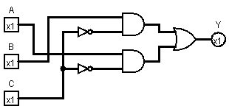

**με πύλες NOT,AND,OR Μόνο με πύλες NAND**

