Full Mission

Engine Room Simulator

**Manual For DMSCTS**



2021.11.10

**Content**

1 Start simulator program 3

1.1 Shortcut Start 3

1.2 Start Taskbar Launch 5

1.3 Root directory startup 6

2、Introduction to M terminal 7

2.1 Synchronization clock 8

2.2 Signal sending and receiving indication 9

2.3 Variable Information &Value Setting and Malfunction Information & Value Setting 9

2.4 System Data 10

2.5 Net State 11

2.6 File Path 12

2.7 Operating 12

2.8 Load Condition and Save 13

2.9 Load Scenario 14

2.10 Evaluation 15

2.11 Start/Stop SnapShot 17

3、Introduction to 2D terminal 19

3.1 Introduction of 2D Interface 19

3.2 System Settings 20

3.3 Overall Page 20

3.4 Evaluation Page 21

3.5 V Setting 23

3.6 M Setting 24

3.7 System Date 24

# 1 Start simulator program

There are three ways to start the simulator, from the "DMSCTS" shortcut on the Windows desktop, from the "Start" menu on the Windows taskbar, to the root directory of the file where the starter is located.

## 1.1 Shortcut Start

1、Double-click the "DMSCTS" shortcut on the desktop, and the program starts.

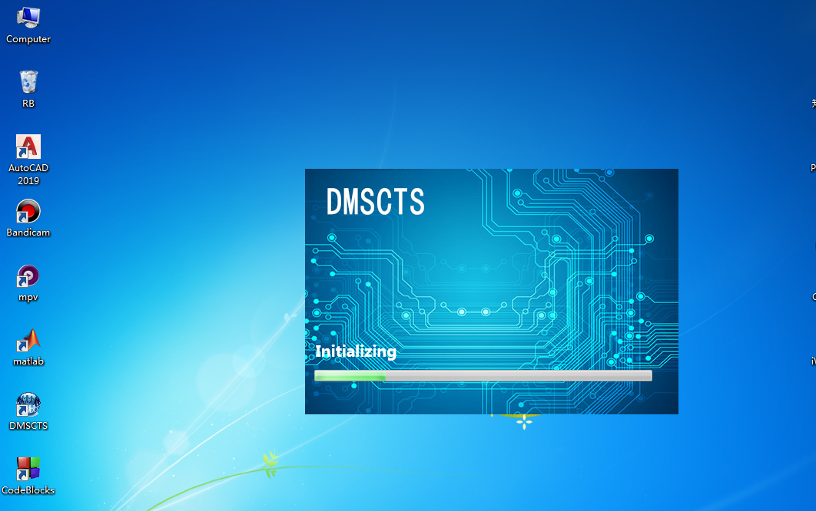

**Figure 1 Startup Interface**

2、Enter the account, password and login to the simulator

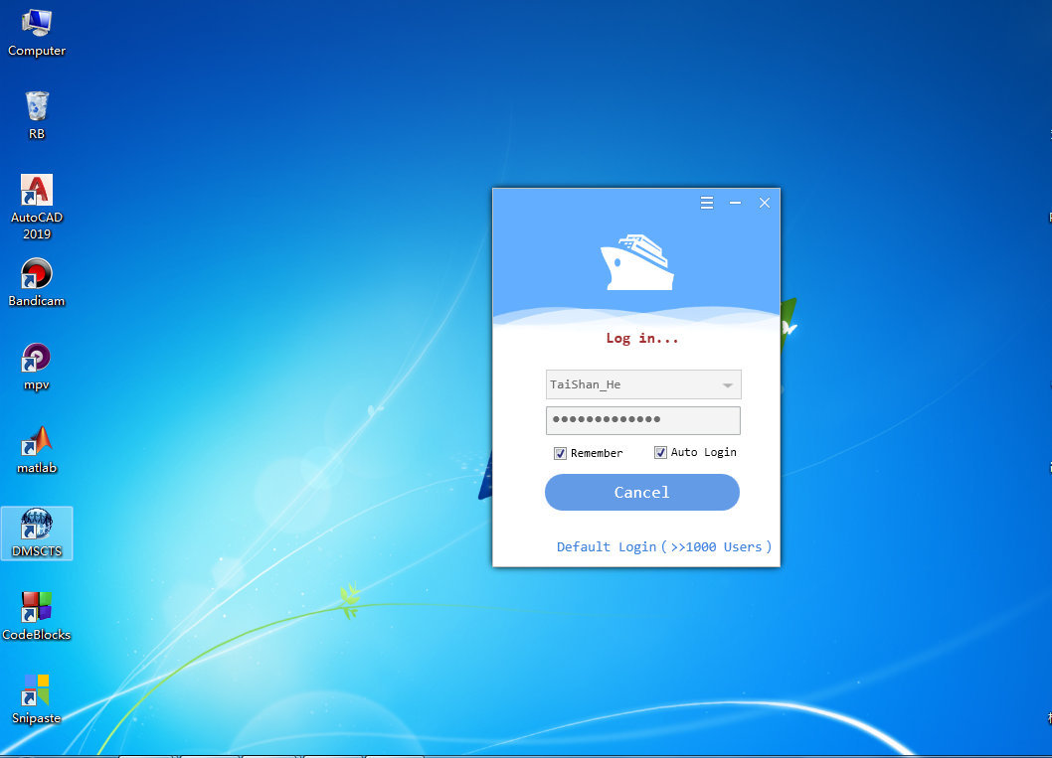

**Figure 2 Login Interface**

3、Click on the "Room" set by the simulator for the operator.

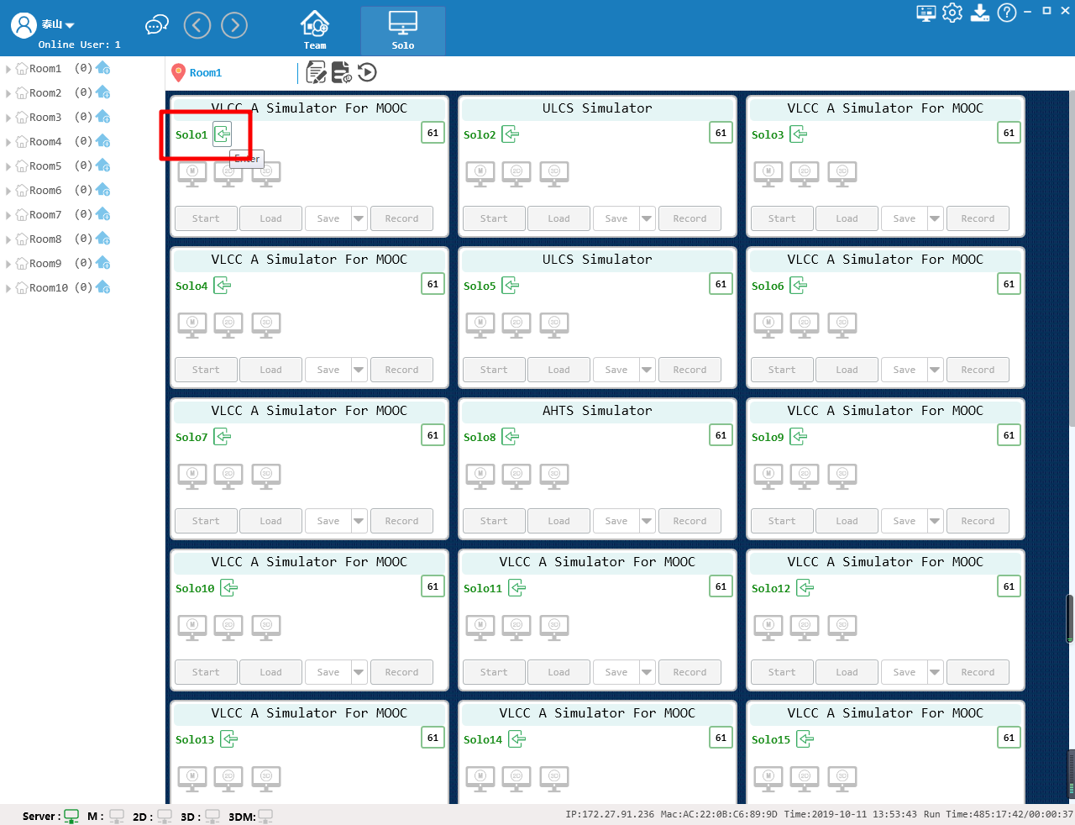

**Figure 3 enters the operating interface**

4、Click on "start" to run the program

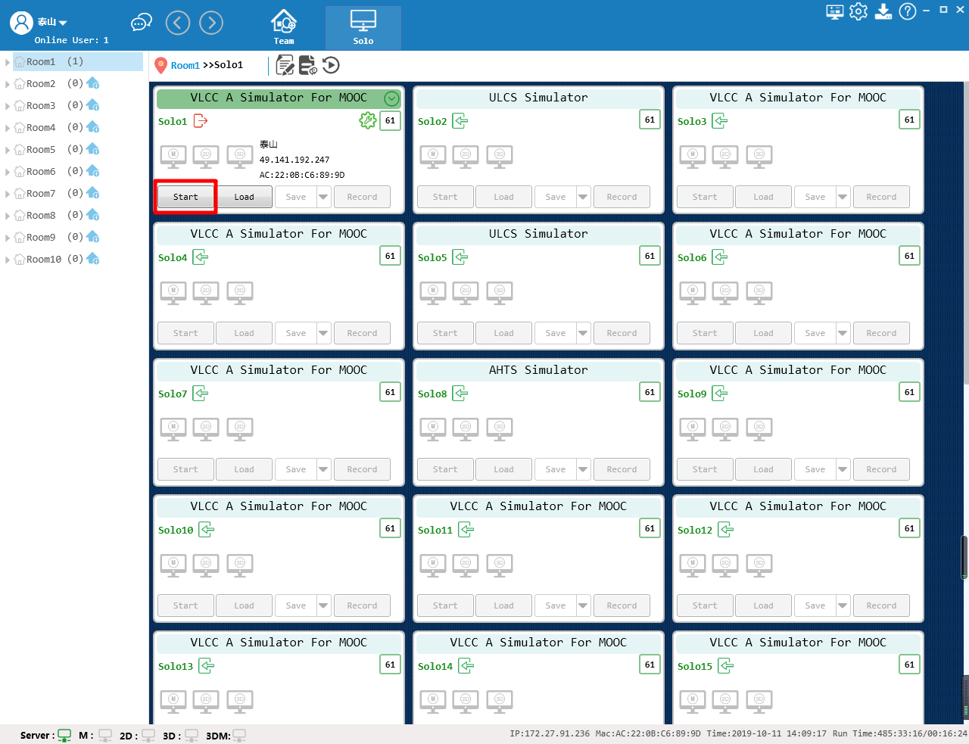

**Figure 4 Beginning Interface**

5、The program starts. Both the 2D terminal and the M terminal programs are started. The graphics show the interface of the 2D terminal, and the interface of the M terminal is displayed in the taskbar.

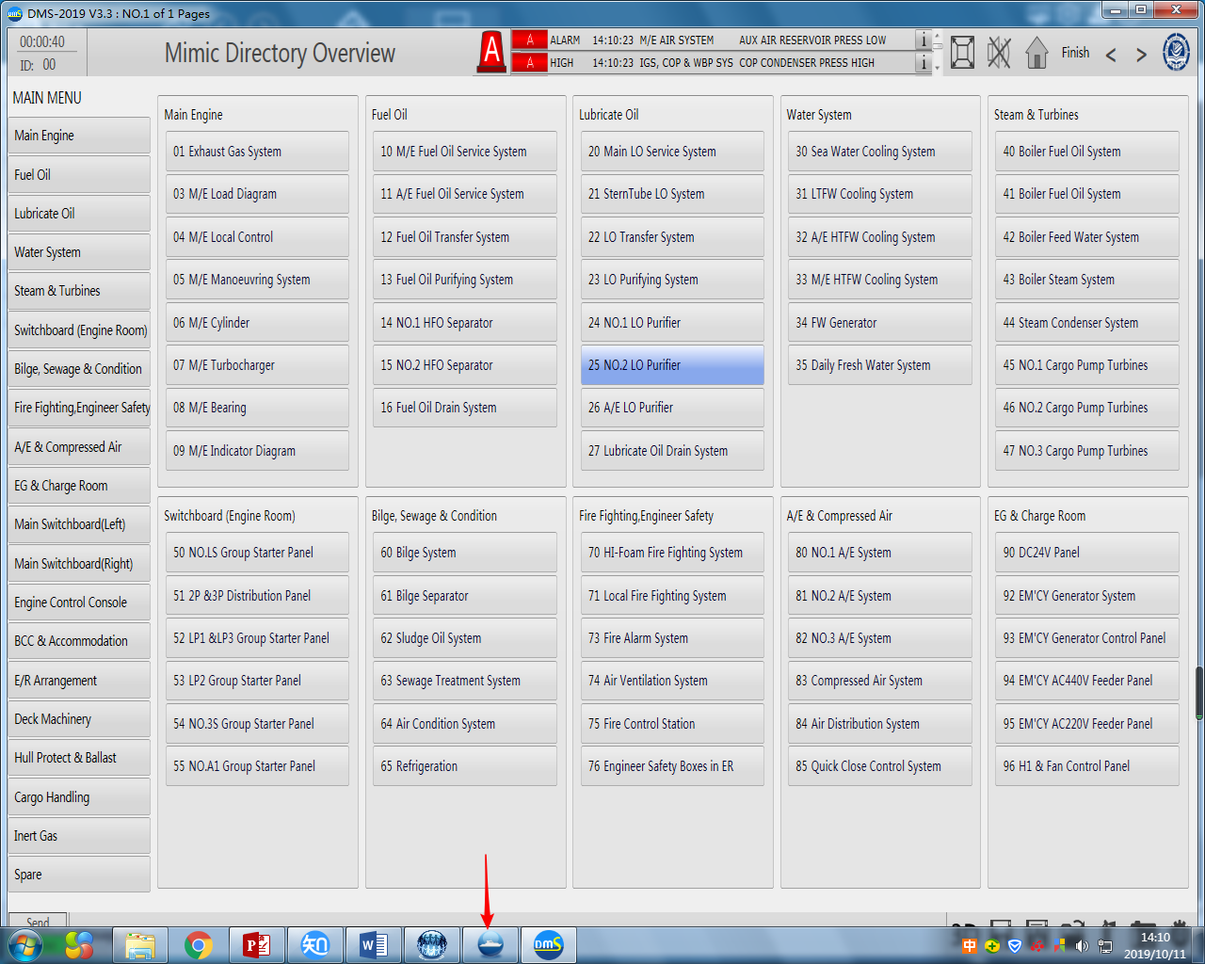

**Figure 5 Overall Page**

## 1.2 Start Taskbar Launch

1、In the Start Taskbar, click DMSCTS, and the program starts running. After that, the startup mode is the same as in 1.1.

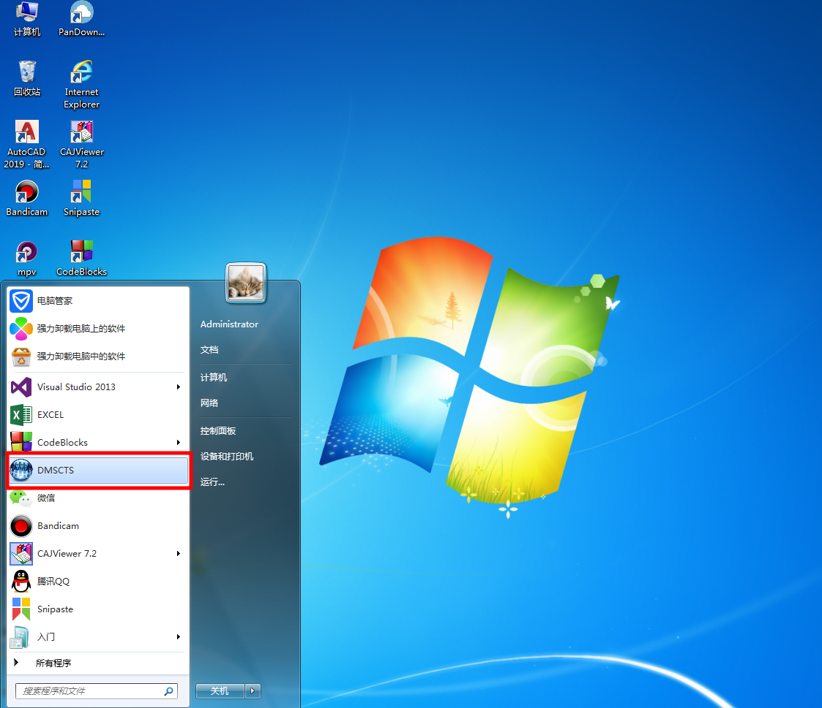

**Figure 6 Taskbar Start Page**

## 1.3 Root directory startup

1、First, open the root directory where the M terminal of the simulator is located:

D:\Program Files\DMSCTS\simulator\VLCCAForMOOC\M. Double-click the application to run the M-side. (Demonstrated by the root directory where the M-terminal of this computer is located.)

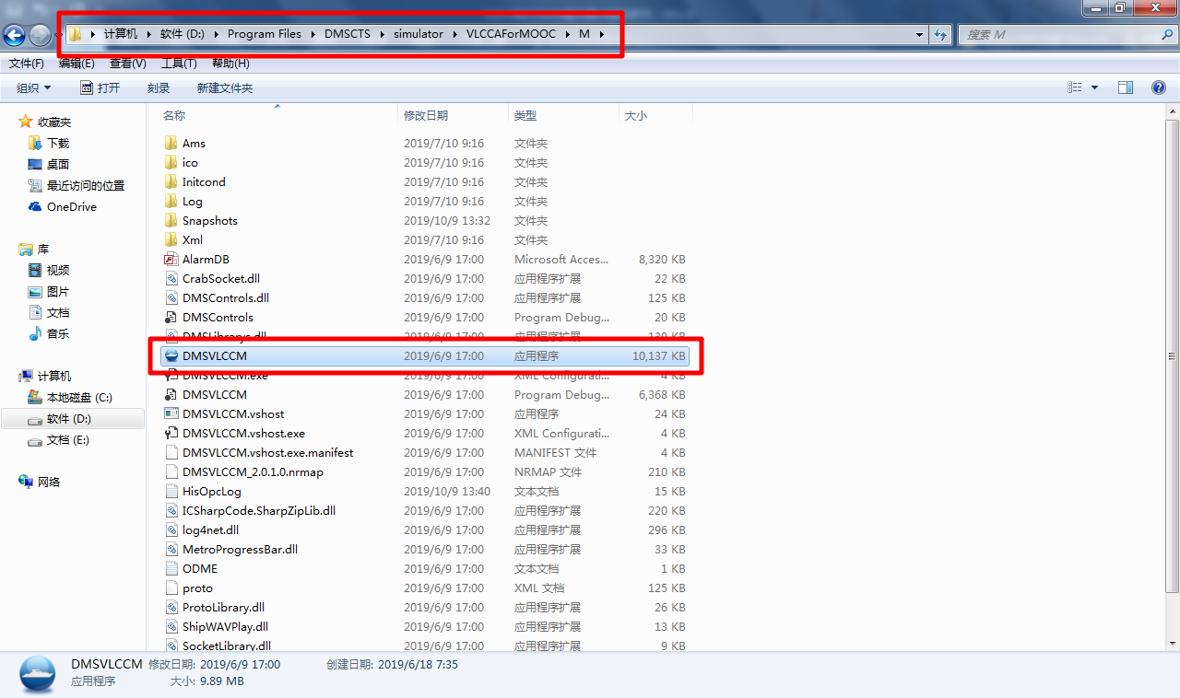

**Figure 7 Root Directory Startup Interface**

2、After the program runs, the M-side main page is displayed.

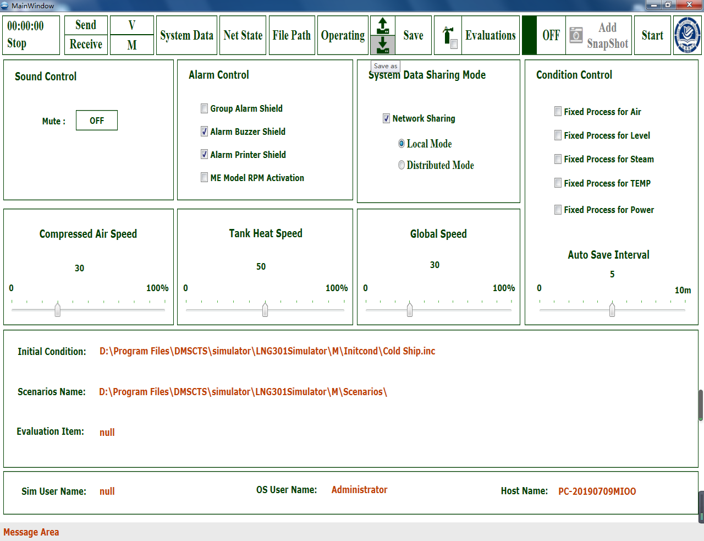

**Figure 8 M-side home page**

3、The 2D terminal can be started as the same way like M terminal.

# 2、Introduction to M terminal

As shown in the figure, the interface is the main page of M end, the upper part is the menu bar of the main page, and the lower part is the function contained in the submenu bar. As shown in the following figure (shown in this figure is the content of the operation control bar). The menu bar of the page is as follows.

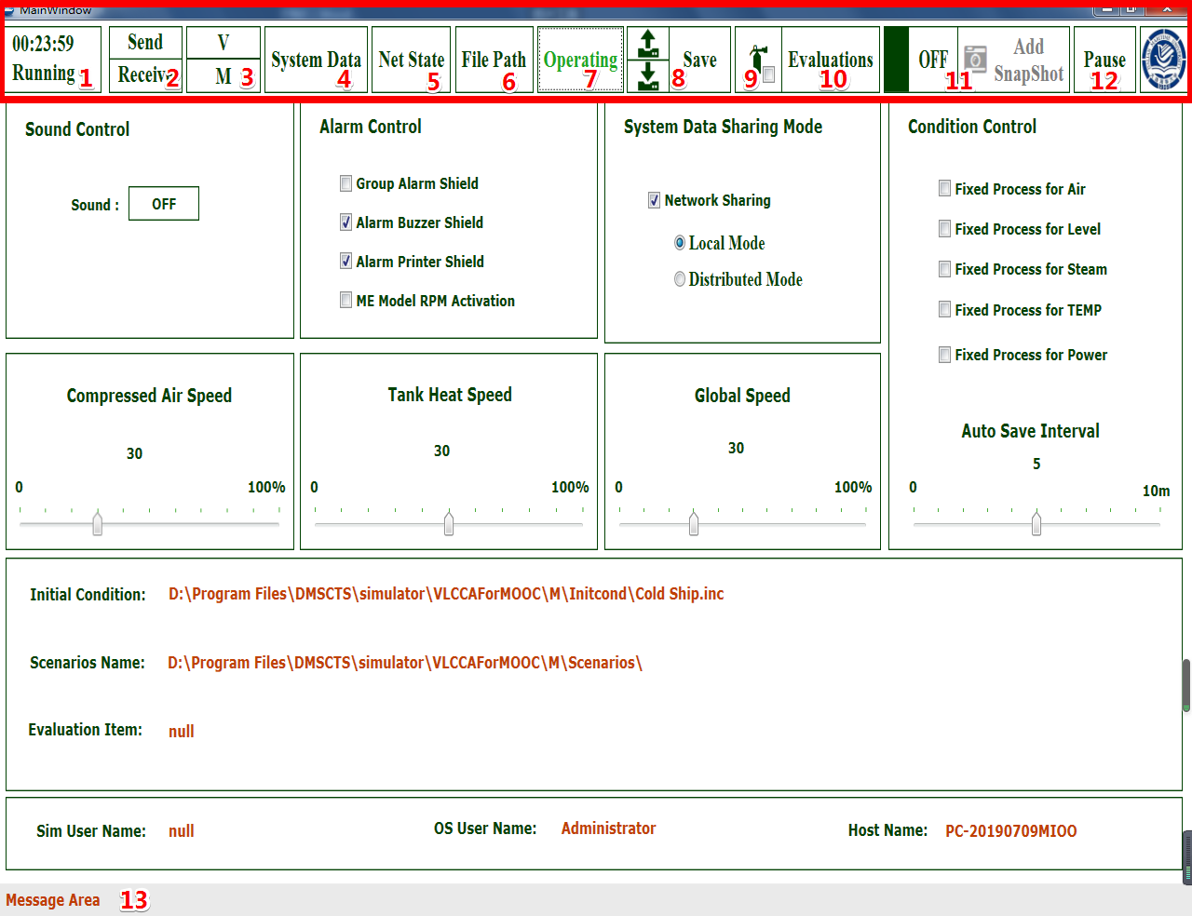

**Figure 9 Menu Bar Interface**

1. Synchronization clock;
2. Signal sending and receiving indication；
3. Variable Information &Value Setting and Malfunction Information & Value Setting；
4. System Data；
5. Net State；
6. File Path；
7. Operating；
8. Load Condition and Save；
9. Load Scenario；
10. Evaluation；
11. Start/Stop SnapShot；
12. Start or Pause.
13. Message Area.

## 2.1 Synchronization clock

The clock indicates the running time of the simulator and represents the running time of the simulator. When you click pause, the time stops, the click starts, and the clock recounts. At the same time, it is also the basis of simulating detection and alarm, refreshing events. When "evaluating" is displayed below, it means project testing is in progress; "freeze" means clock stop timing, and the simulator stops in this state; "running" means clock timing, and the simulator is running.

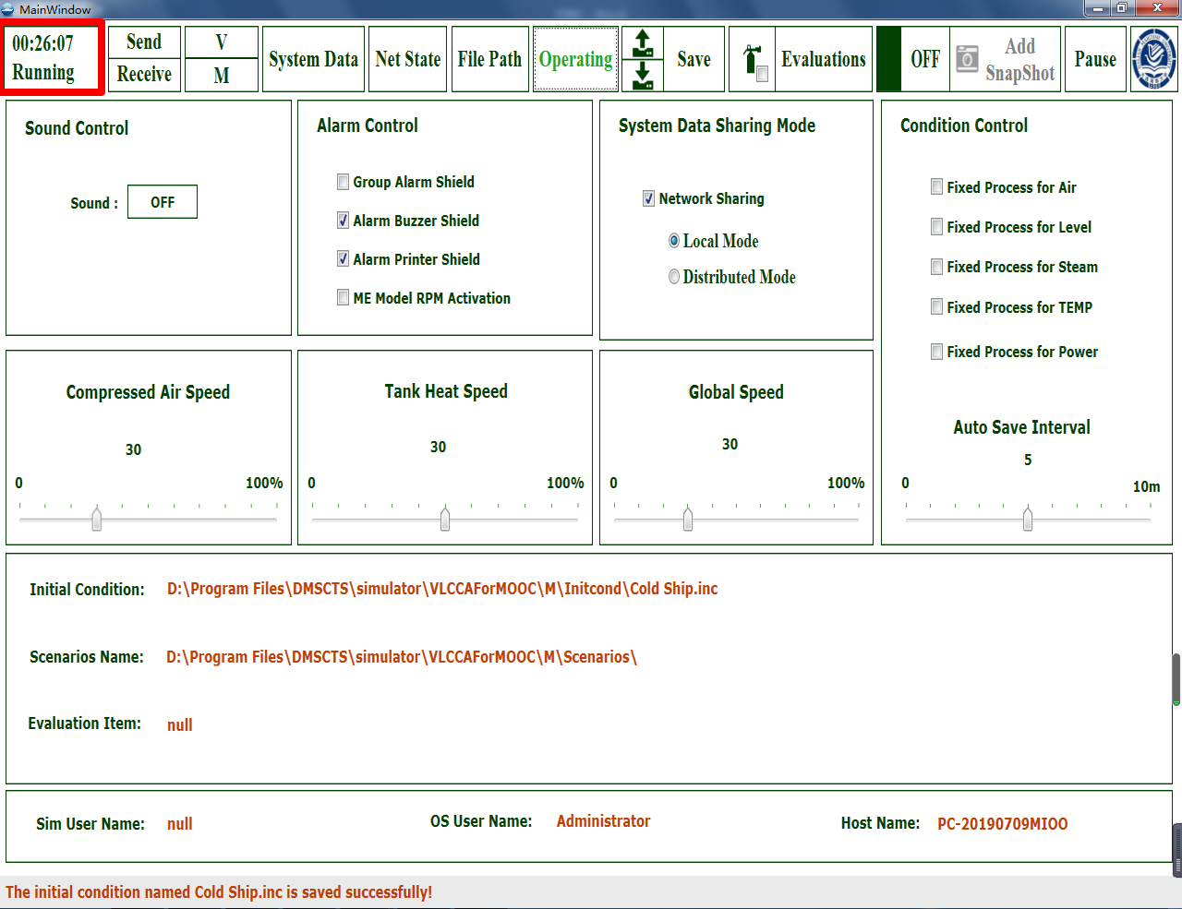

**Figure 10 Synchronization clock**

## 2.2 Signal sending and receiving indication

When the simulator operator operates on the 2D terminal, the corresponding signal will be sent and received, and the status of signal reception and transmission will be indicated in the menu bar. A green light flashes when the message is sent and received successfully.

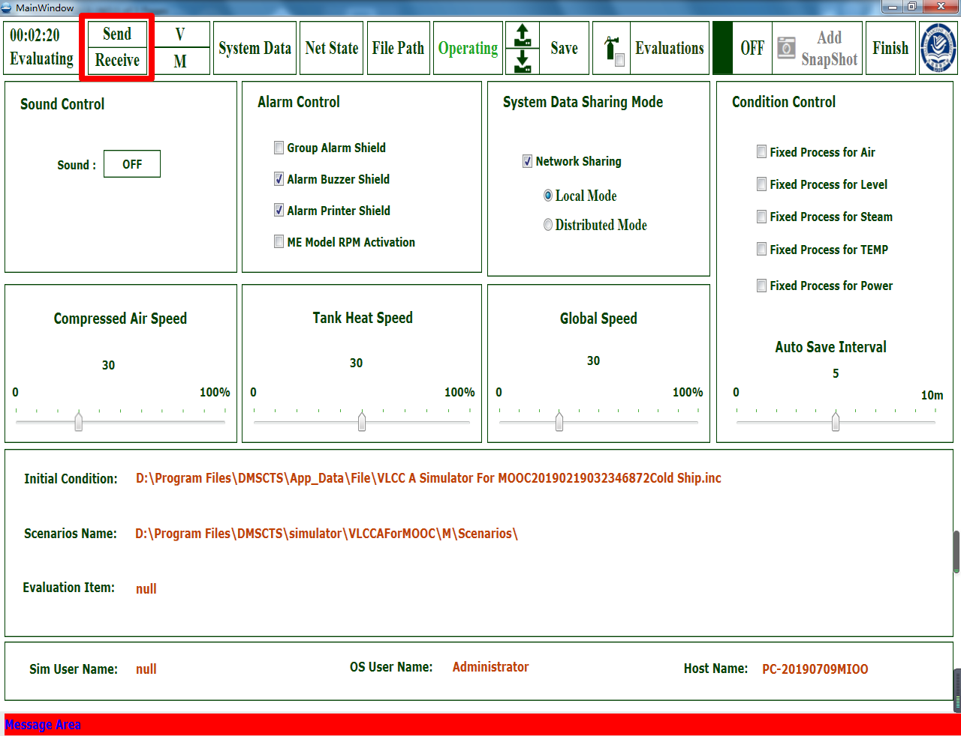

**Figure 11 Information Sending and Receiving**

## 2.3 Variable Information &Value Setting and Malfunction Information & Value Setting

As shown in the figure below, the interface is a Variable Information &Value Setting. The left side is the group project part, including the Main Engine, Fuel Oil, Lubricate Oil, Water System and so on. All the necessary systems for ships are included. In the middle is the page item, which is the detailed part of the group item. On the right is the range of values for each variable.

The group items shown on this page are water system. The page items (water system) include Sea Water Cooling System, LTFW Cooling System, A/E HTFW Cooling System, M/E HTFW Cooling System, FW Generator, Daily Fresh Water System. On the right is the name of the relevant variables and the range of the equipment variables, such as the pressure of the main engine fuel mixing barrel, liquid level, light oil daily cabinet pressure, liquid level and so on. The "ID" shown in the figure represents the position of the variable in the simulator; "Value" represents the value displayed by the variable; "0" and "1" represent the two quantities of "on" and "off"; "Description" is the description of the event variable; "LL" represents the lowest water level; "HL" represents the highest water level.

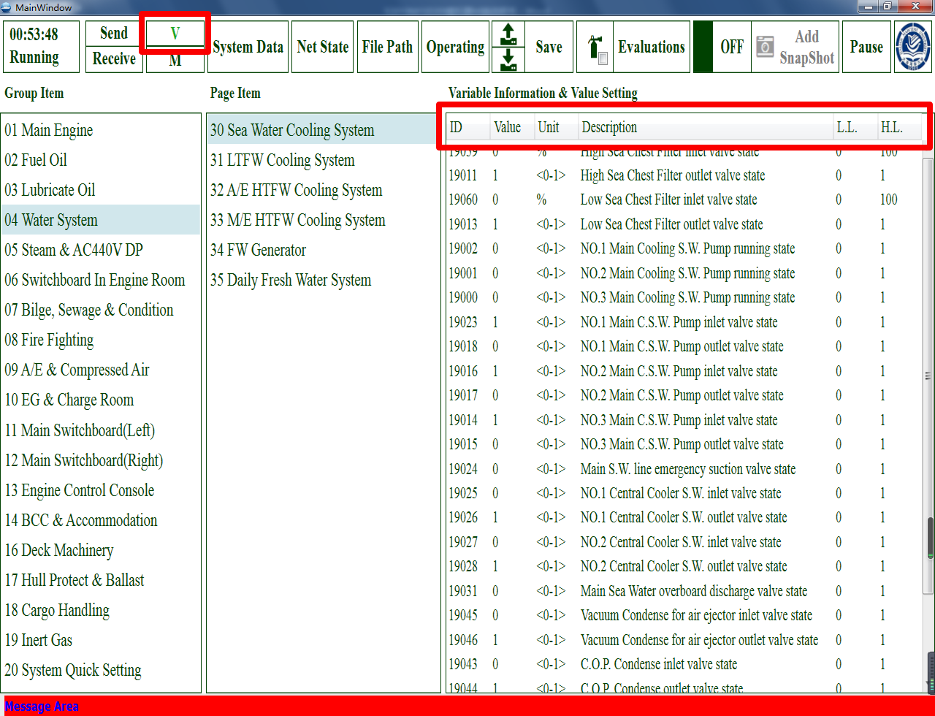

**Figure 12 Variable Information &Value Setting**

The interface is Malfunction Information & Value Setting. Its page layout is similar to variable information and value setting pages. The difference is that the part on the right side sets the fault state, which can be changed from "OFF" to "ON" by clicking on the mouse.

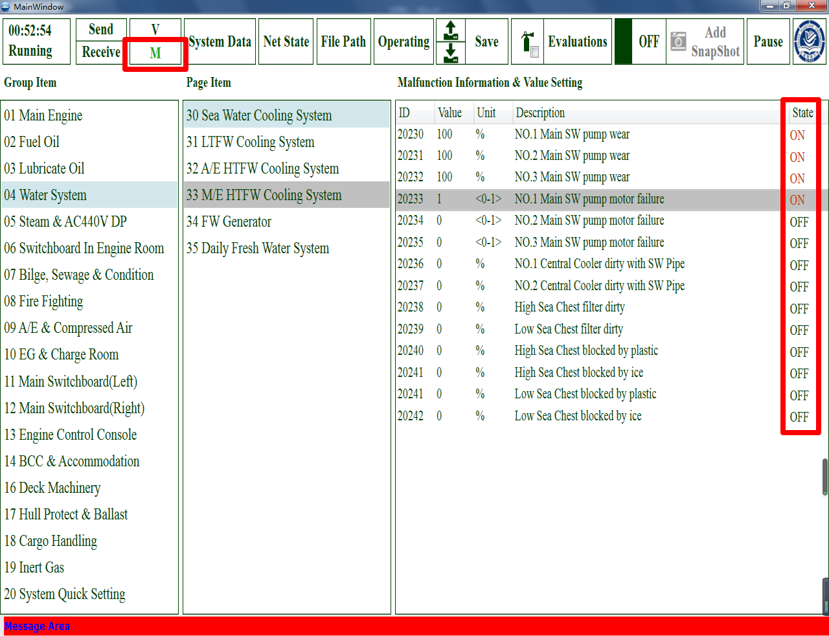

**Figure 13 Malfunction Information & Value Setting**

## 2.4 System Data

The interface is the System Data, which mainly shows the name and type of data. "DateName" is the name of the data and "Type" is the type of the data. It can be seen that the data types are Boolean, Int32, Single and so on. "Value" is the value of the data. Boolean type values are "True" and "False".

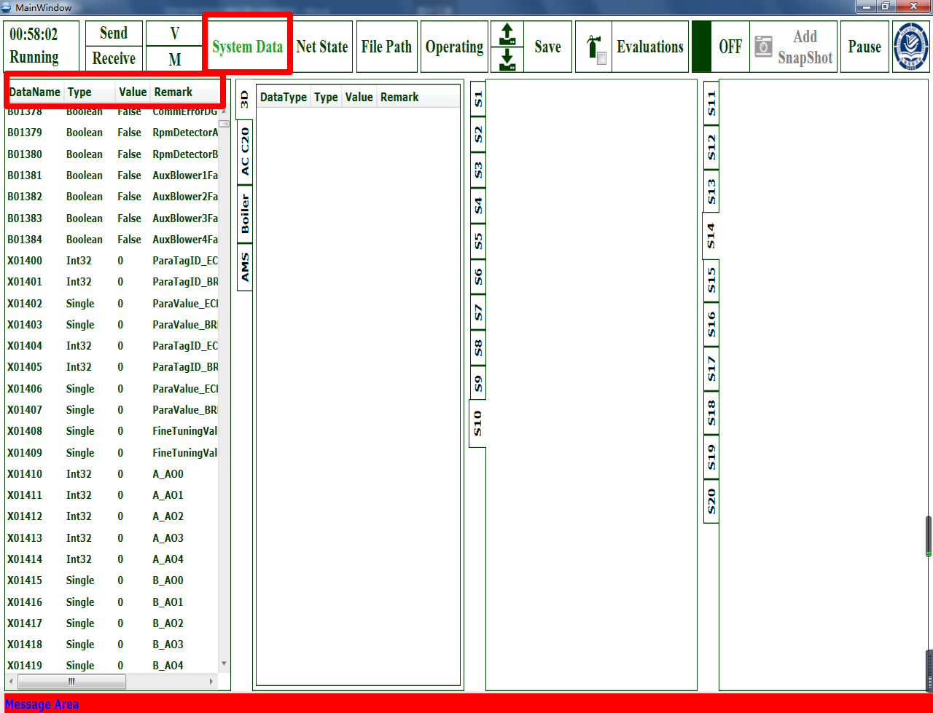

**Figure 14 System Data**

## 2.5 Net State

This interface sets the interface for the network state, mainly when the simulator operates on the network, it can set the Internet connection state of the simulator. The main parts are as follows.

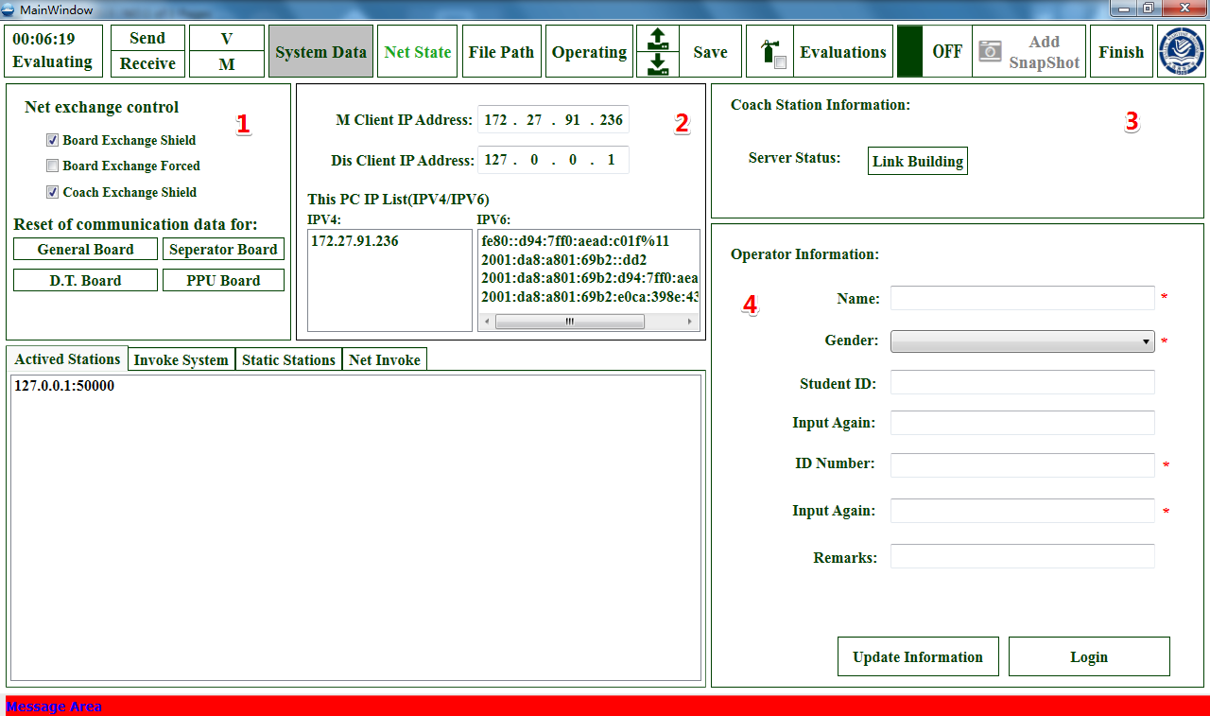

**Figure 15 Net State**

1 Net Exchange control: three different ways of interaction can be chosen.Such as Board Exchange Shield, Board Exchange Forced and Coach Exchange Sheield. Different combinations can be selected according to need.

2 Computer IP Location: It include M Client IP Address and Dis Client Adress. The M Client IP Adsress is the user’s IP Address.The Dis Client IP Address is the Address of system.

3 Coach station Information: The status information of the coach indicates whether the coach establishes a network connection with the operator or not.

4: Operator Information: This column is the information of operator registration, register, ID, password and so on. At the same time, you can login without registering, but the information bar is empty.

## 2.6 File Path

This page is the file storage path interface. Through this interface, you can know the path of the saved file or change the default storage path of the system. It saves different files in different storage paths.

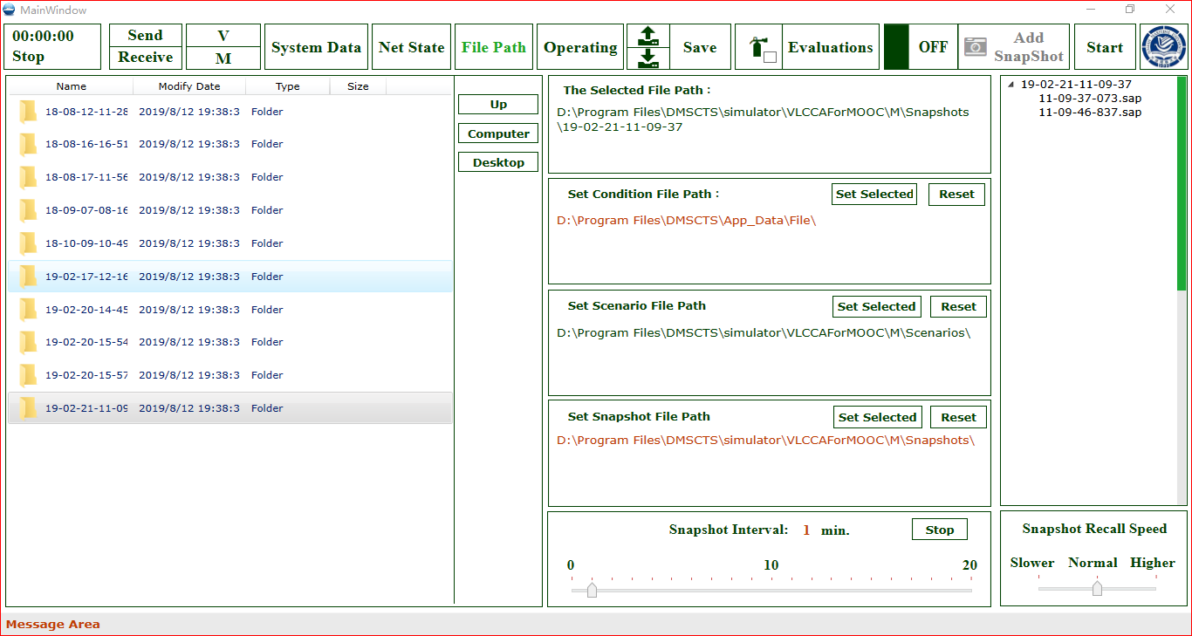

**Figure 16 File Path**

1:The storage disk in the computer. You can select folders in your computer by using the "UP" button to find the files you need.

2:Display the root directory of the folder selected in 1. The root directory of the selected file will be displayed at this location.

3:Set conditional file path. The root directory of the folder where the environment settings tool resides.

4:Set Scenario File Path.It is the place where is used to save the scenarios.

## 2.7 Operating

The interface is an operation control page, which can be used to set the initial state of the simulator. Its functional composition is shown in the following figure.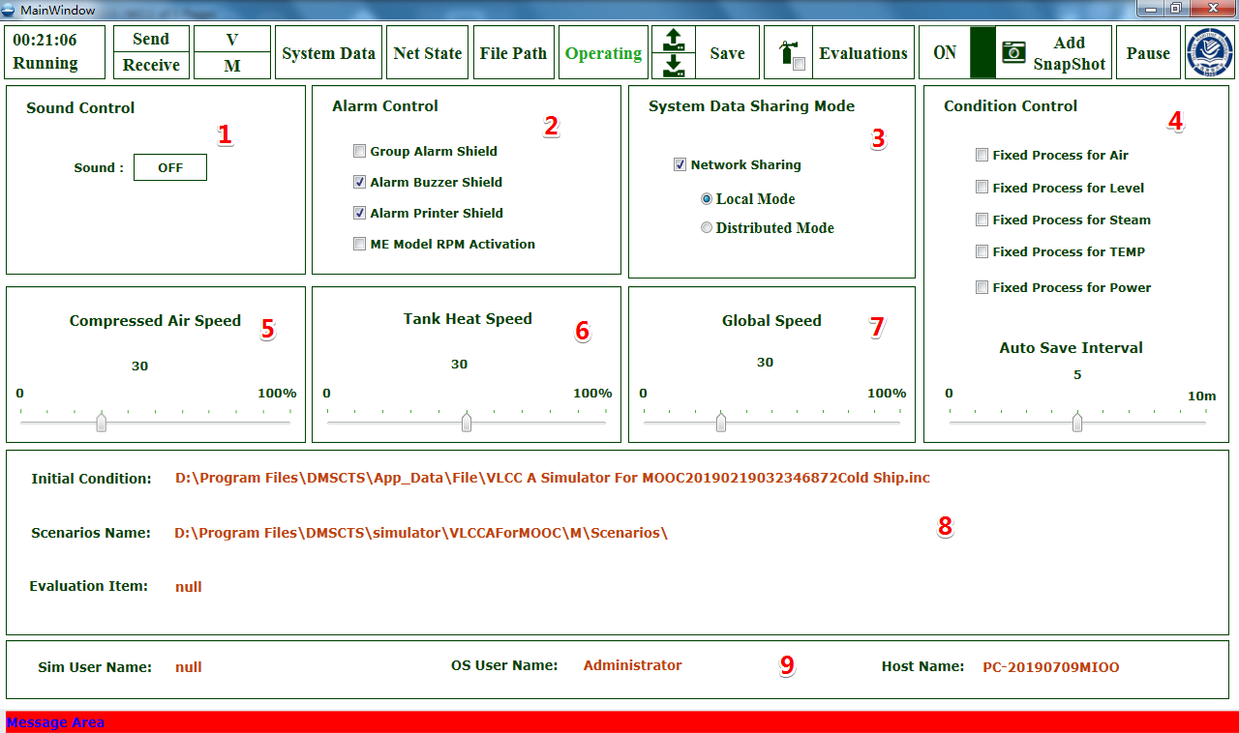

**Figure 17 Operating Interface**

1: Sound Control

2: Alarm Control: Group Alarm Shield, Alarm Buzzer Shield, Alarm Printer Shield, ME Model RPM Activation. Different combinations can be selected according to needs.

3: System Sate Sharing Mode: You can choose whether to share online or not. When selecting network sharing, you can select local model or distributed mode.

4: Condition Control: Air, Steam, Power etc. can be provided to the simulator as needed, it is imporment for us to check the Simulator.

5: Compressed Air Speed: used to regulate the working efficiency of the air compressor, so that the rate of increase in air pressure.

6: Tank Heat Speed: used to regulate the heating efficiency of hot water cabinet.

7: Global Speed;

8: File Path Location: Storage Path of Simulator Generated Files.

9: Operator's Information.

## 2.8 Load Condition and Save

The interface is a loading and storage interface, which is mainly used to save the state of the simulator and the state of the simulator before loading. As shown in the figure below.

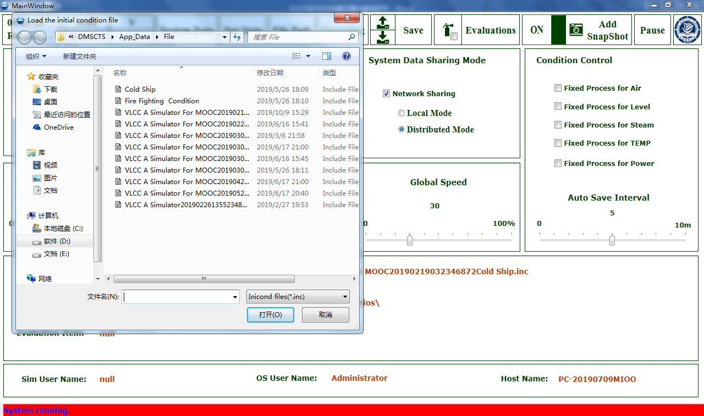

**Figure 18 Loading Interface**

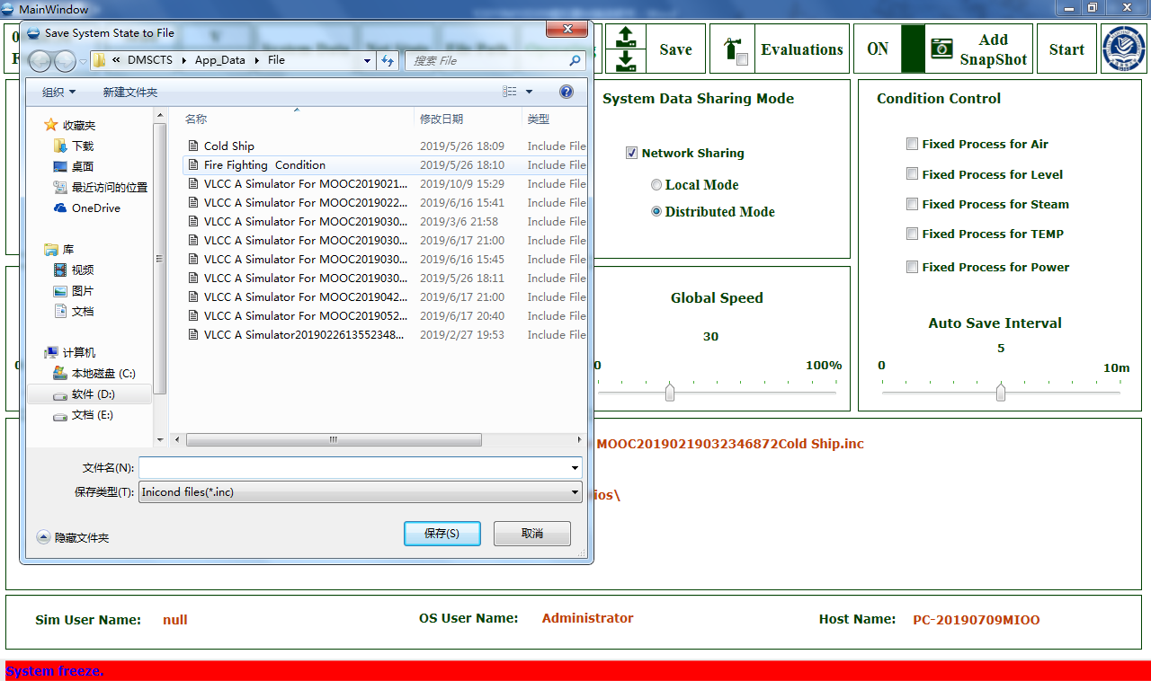

**Figure 19 Saving Interface**

## 2.9 Load Scenario

Clicking on the logo button will pop up the dialog box "Load the scenario file" in the folder to select the type of file you want. The state of the simulator in the file can be loaded immediately.

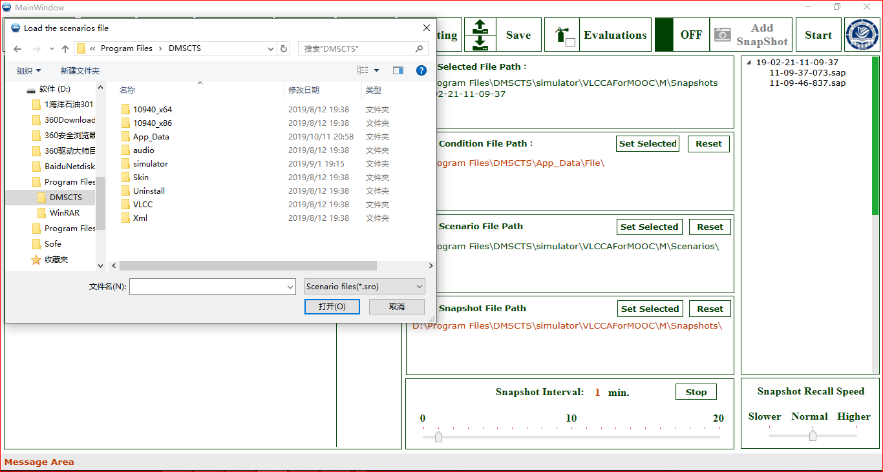

**Figure 20 Load Setup Interface**

## 2.10 Evaluation

The interface is an evaluation and assessment interface, which is mainly used to test the proficiency of operators. The following figure shows the composition of the assessment interface. What is shown in the figure is the examination and test items. For example: Power Plant ManuSyn. Para and Discon. Operation, SW System Preparation and Temp. Regulation, etc.

Before the evaluation and evaluation test, suspend the running state of the simulator at this time, otherwise the following situations will occur.

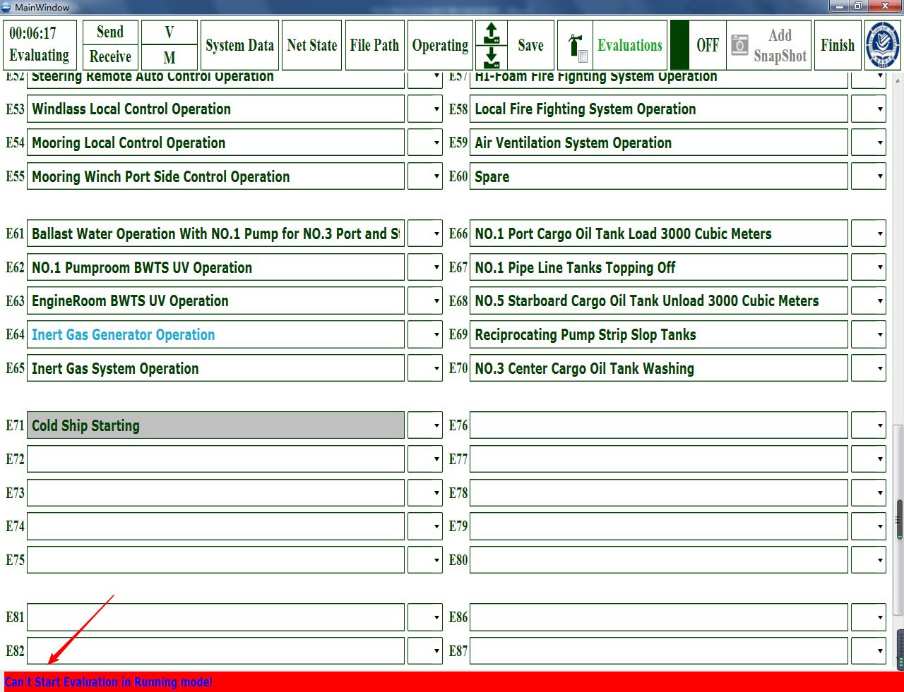

**Figure 21 Assessment Interface 1**

Suspend the operation of the simulator and select the items that need to be evaluated again. The simulator is now ready.

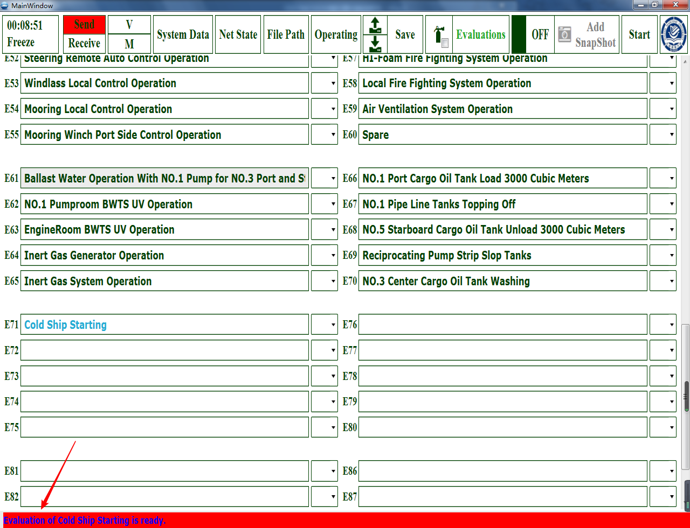

**Figure 22 Assessment Interface 2**

Click Start, Assessment proceeds, then click Stop button, Assessment ends. The system will give the score according to the operator's order of operation and the control range of variables.

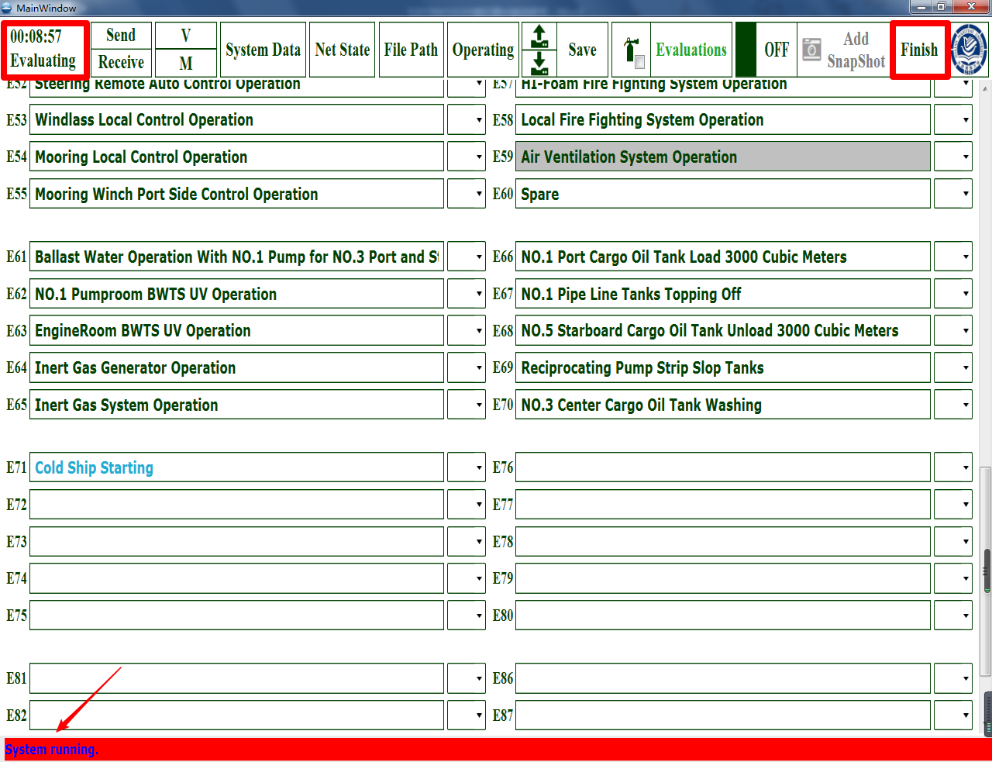

**Figure 23 Assessment Interface 3**

According to the main parameters of the system, the score is given by comparing the range of the set values of the system with the values obtained by the operator in the actual operation under certain rules.

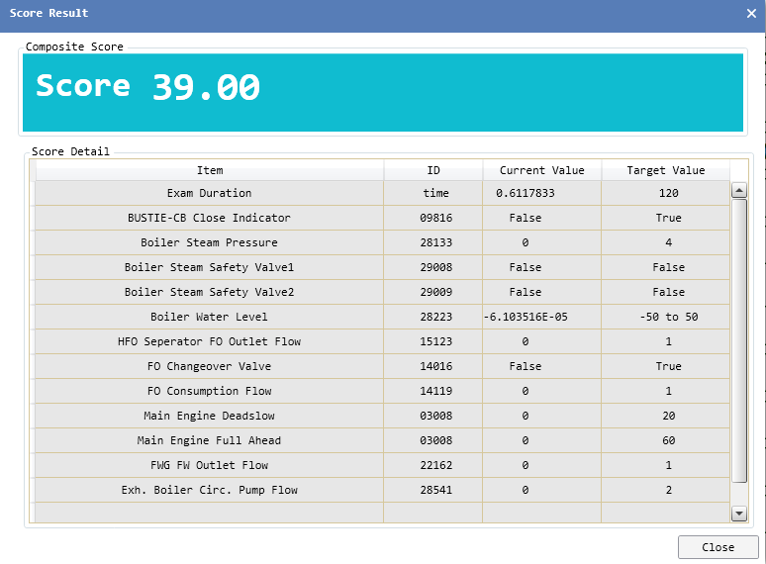

**Figure 24 score interface**

## 2.11 Start/Stop SnapShot

Whether to start the snapshot recording mode or not. When the screen recording mode is turned on, the screen recording time can be controlled by adjusting the screen recording frequency, and the screen recording process can also be used for playback. SanpShot Interal can be used to adjust the ratings of video recordings. SanpShot Recall Speed can be used to control playback speed.

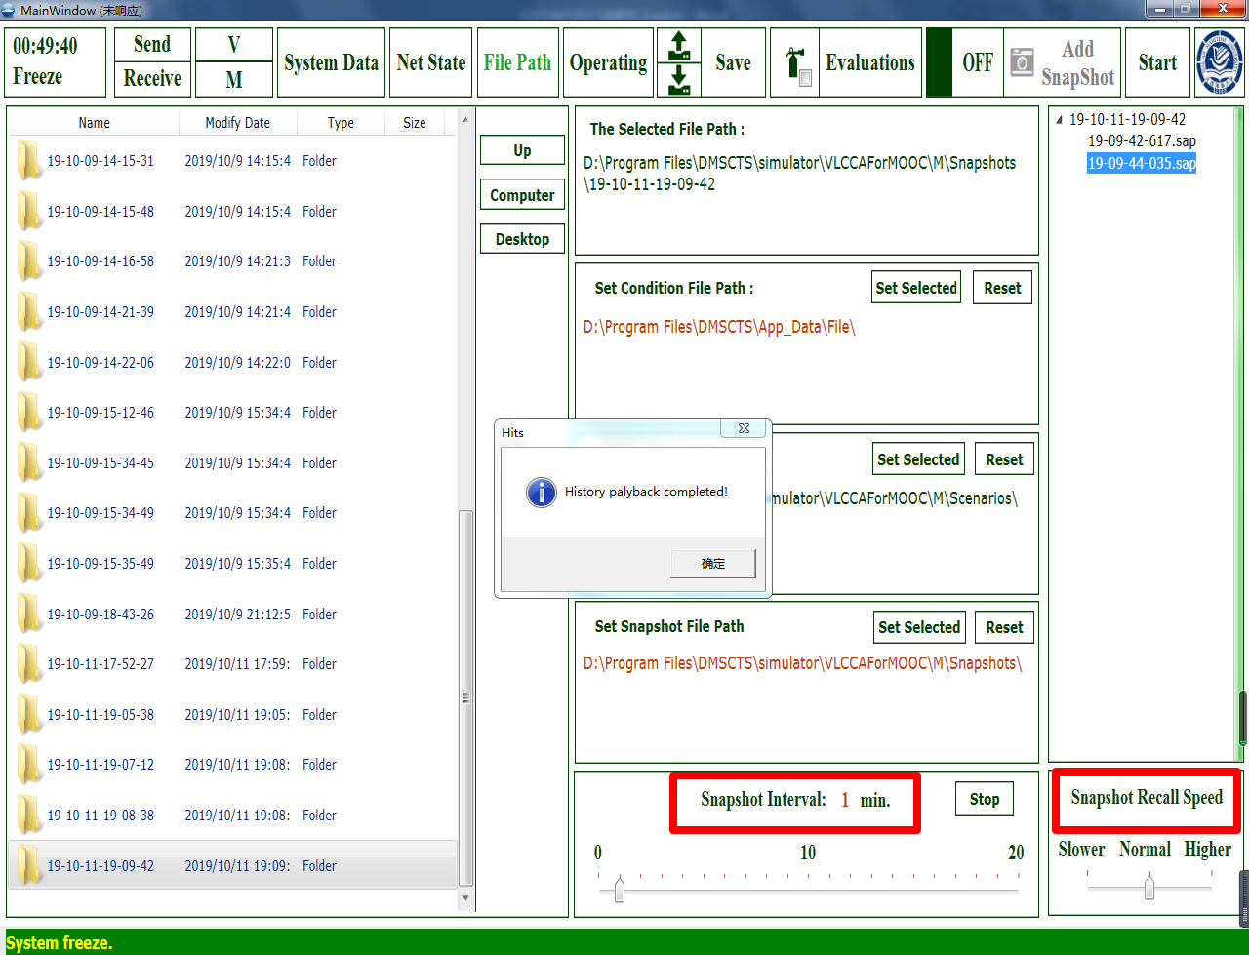

**Figure 25 Snapshot Setup Interface**

# 3、Introduction to 2D terminal

## 3.1 Introduction of 2D Interface

The 2D terminal is an interface for operators to conduct relevant operation training. Some of the functions of the interface are shown below.

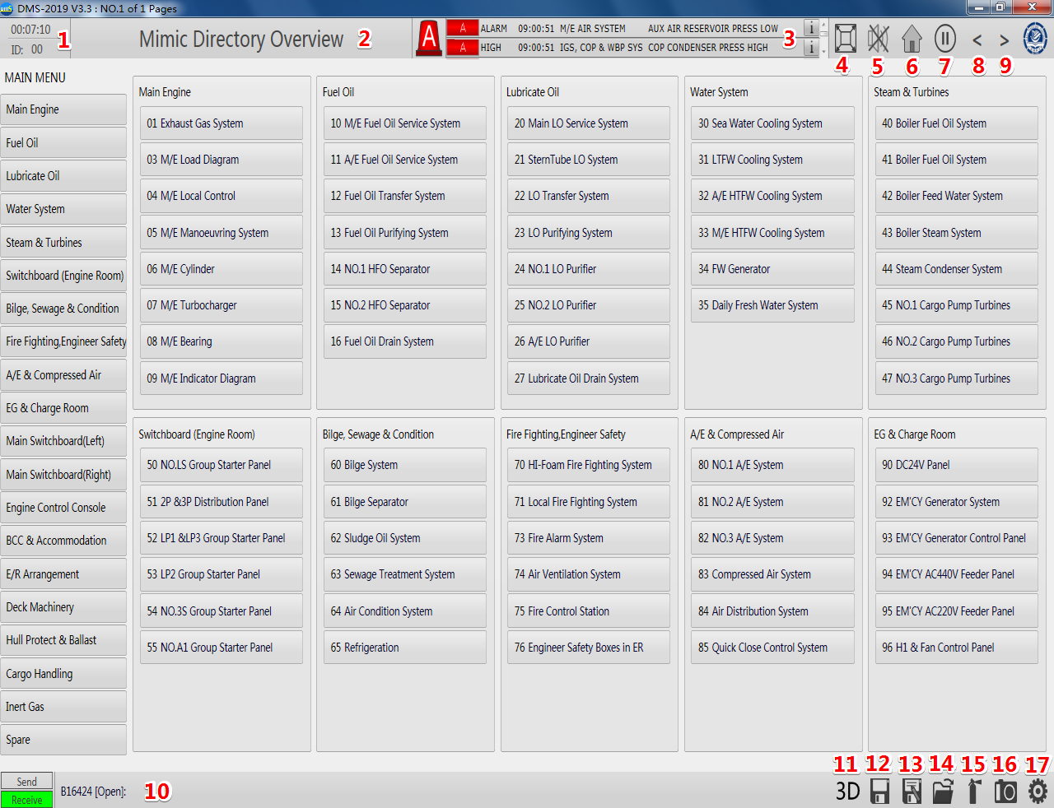

**Figure 1. 2D End Interface**

1. ID number of simulator clock and current interface: running time record of simulator and ID number of currently displayed page.
2. Page Name: The name of the page currently displayed. The name of the page shown in the figure is Mimic Directory Overview.
3. Alarm information instructions: used to display scalar indicators that do not meet the requirements of the system, used to remind operators to find problems in time, and to solve them, to prevent more serious problems.
4. To adapt to the size of the screen page: so that the simulator can be displayed on the hardware display device, to meet the size of the screen interface.
5. Muffle: When there is an alarm information, the simulator will send out an alarm sound. Click the muffler button to eliminate the sound alarm. Used to remind operators to find fault alarm, press the muffler to prove that the fault has been found at this time.
6. Return to the home page: Return to the home page from other pages.
7. pause, start: start and stop timing in simulator operation training.
8. Go forward: Go up to the previous page
9. Backward: Downward to the next page
10. Current page variables display: when the operator operates on the simulator, the changes of variables caused by clicking on the operation will be displayed at that location.
11. Switch:Switch to the 3D interface of the simulator. The 3D end is the simulation of the cabin, which can restore the structure of the cabin. More vivid and true.
12. Save: Save the state of the simulator that needs to be saved to the folder specified by the system.
13. Save as follows: Save the state of the simulator that needs to be saved to any folder according to the operator's requirements.
14. Load the file: Open the save file.
15. Loading scheme: Loading the scheme set by the system according to the need.
16. Snapshot: Used to intercept a part of the simulator operation process.
17. Settings: Settings for some initial environments, state variables, storage paths, etc. of the simulator.

## 3.2 System Settings

The system on the 2D side consists of general page, evaluation page, variable setting page, fault setting page and system data page. The corresponding environment, initial state and failure can be set up according to the operator's practice requirements. Can be more targeted practice.

## 3.3 Overall Page

The overall page of the system settings is shown in Figure 2 below. This page deals with the routine settings and functions of the simulator. The functions of the simulator are described below.

1. Navigation window bar: This window indicates all the functional areas in the system settings. It can switch the functional areas displayed on the 2D side through the navigation window bar.
2. The sound control bar of the simulator can be switched on or off by selecting ON or OFF, and the volume can be adjusted by Volume below.
3. Address settings of network services: display and settings of M-terminal and operator's network service addresses. IPV4 is the network service.
4. System data sharing mode: There are two modes: local mode and decentralized mode. Operators can choose them according to their needs.

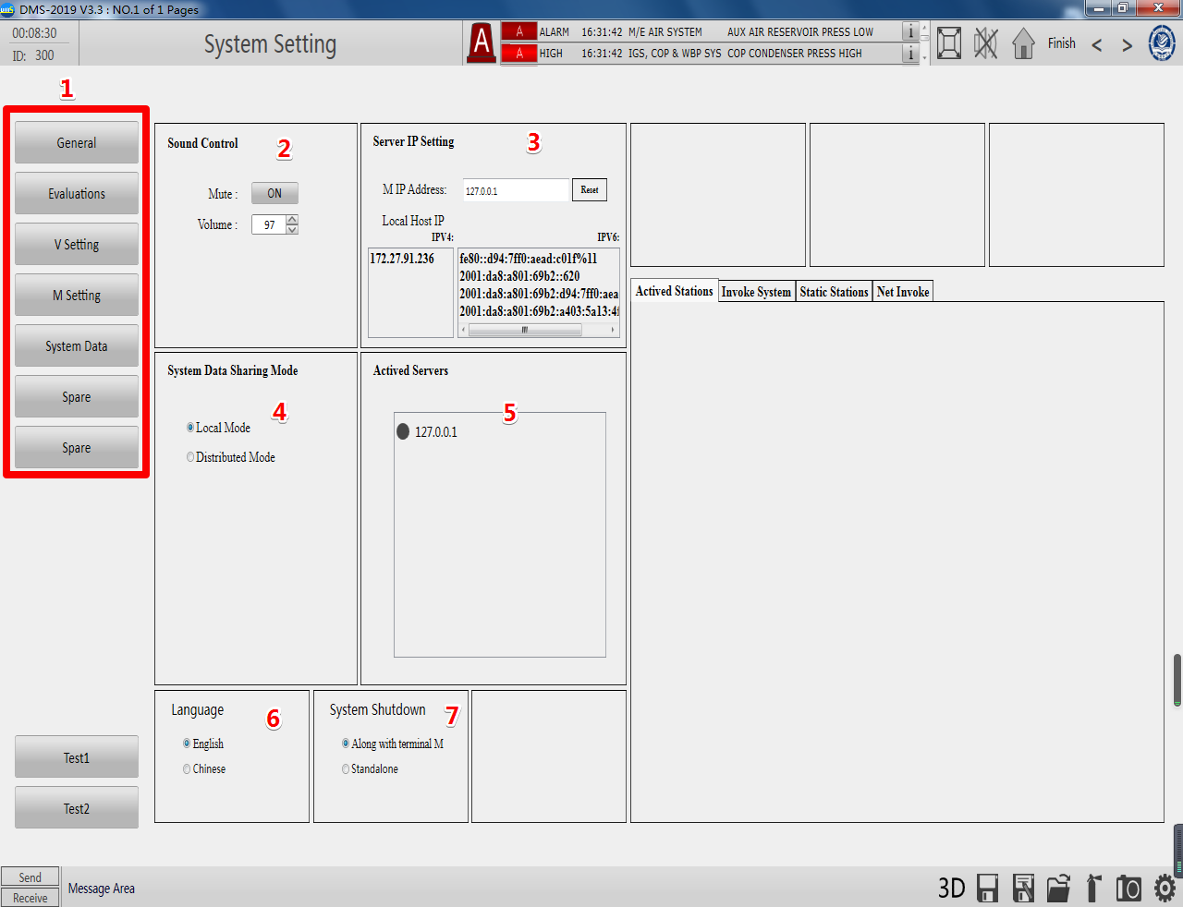

**Figure 2 Overall Page**

1. Network service display: display the IP address of the connected computer.
2. Languages: Operators can choose the familiar language according to their needs. This reference simulator has two languages, English and Chinese.
3. System Shutdown, you can choose to associate with M-terminal, or you can choose to be independent. When correlated, the 2D end is closed, and the M end is also closed.

## 3.4 Evaluation Page

The interface is a system evaluation page. The projects evaluated are shown in the following figure. When it is necessary to carry out a test and assessment for the operator, the corresponding assessment items can be selected for assessment. Assessment projects include the main operations of ships, such as Power Plant Manu Syn. Para. And Discon. Operation, SW System Preparation and Temp. Regulation and ME Standy etc.

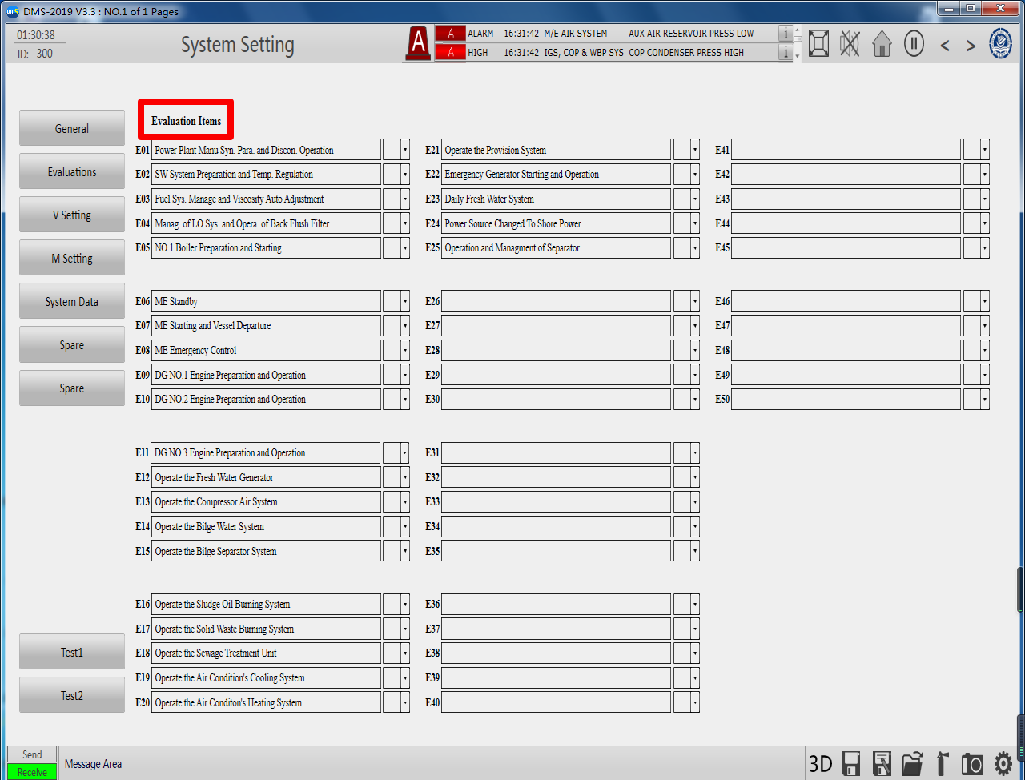

**Figure 3 Assessment Interface**

At the end of the test, the system will give the score of this test. Operators can judge their own deficiencies according to their scores and learn to make up for them in time. The score given by the system is obtained by comparing the set parameters with the actual data of the operator.



**Figure 4 Evaluation Score Page**

## 3.5 V Setting

As shown in the figure below, the interface is a Variable Information & Value Setting. The left side is the group project part, including the Main Engine, Fuel Oil, Lubricate Oil, Water System and so on. All the necessary systems for ships are included. In the middle is the page item, which is the detailed part of the group item. On the right is the right part. E range of values for each variable.

The group items show on this page are water system. The page items (water system) include Sea Water Cooling System, LTFW Cooling System, A/E HTFW Cooling System, M/E HTFW Cooling System, FW Generator, Daily Fresh Water System. On the right is the name of the relevant variables and the range of the variables, as the pressure of the device Main engine fuel mixing barrel, liquid level, light oil daily cabinet pressure, liquid level and so on. The "ID" shown in the figure represents the position of the variable in the simulator; "Value" represents the value displayed by the variable; "0" and "1" represents the two quantities of "on" and "off"; "Description" is the description of the EV ENT variable; "LL" represents the lowest water level; "HL" represents the highest water level.

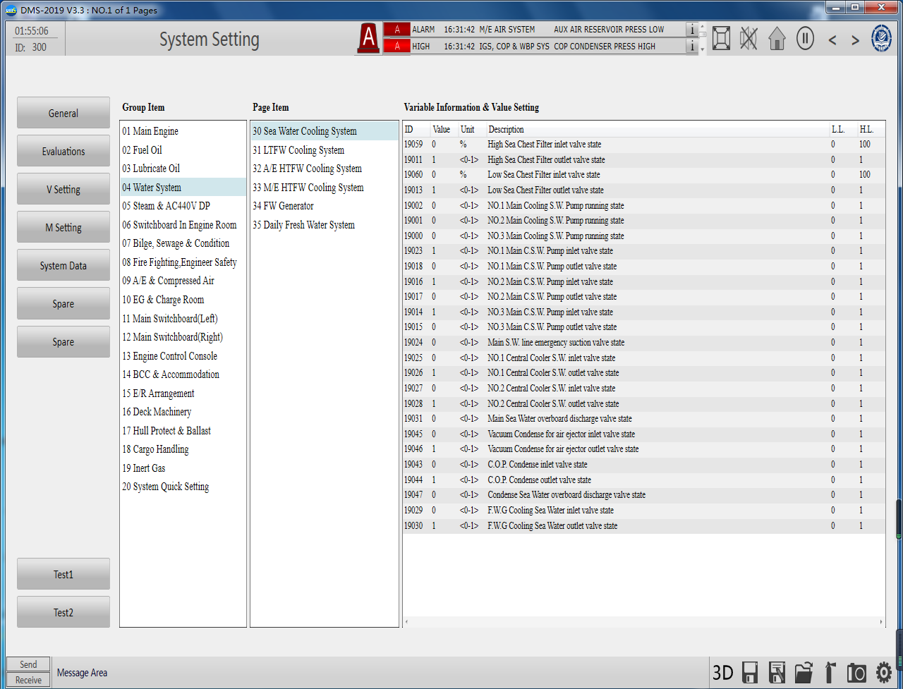

**Figure 5 Variable Settings Page**

## 3.6 M Setting

The interface is Malfunction Information & Value Setting. Its page layout is similar to variable information and value setting pages. The difference is that the part on the right side sets the fault state, which can be changed from "OFF" to "ON" by clicking on the mouse.

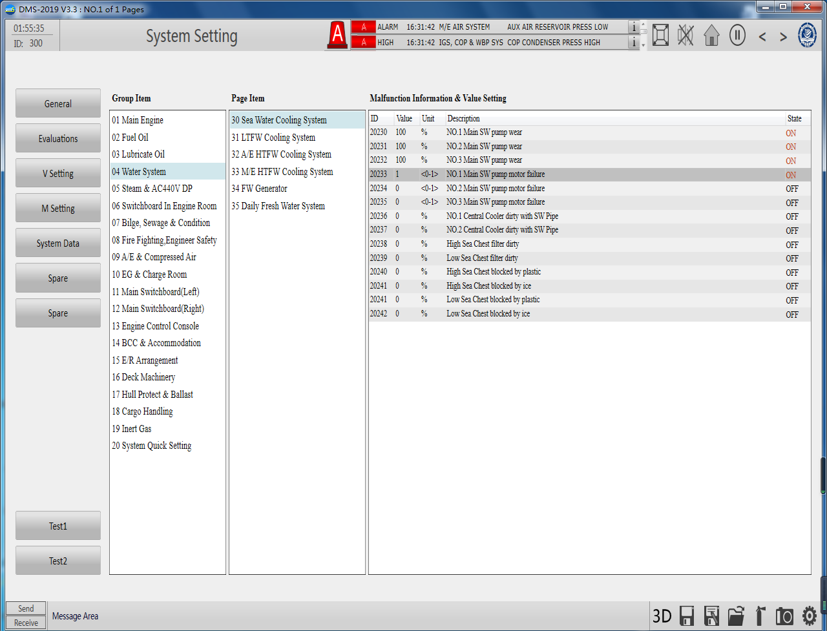

**Figure 6 M Setting Page**

## 3.7 System Date

The interface is the System Data, which mainly shows the name and type of data. "Date Name" is the name of the data and "Type" is the type of the data. It can be seen that the data types are Boolean, Int32, Single and so on. "Value" is the value of the data. Boolean type values are "True" and "False".

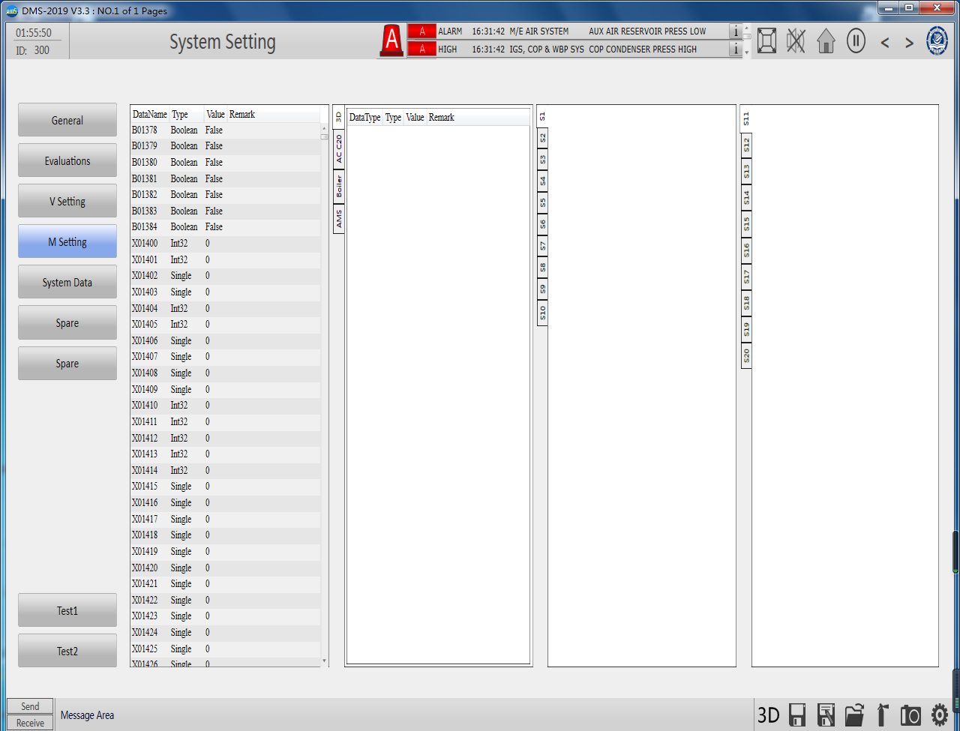

**Figure 7 System Date page**