**Conditionals 0,1,2**

**Υποθετικοί Λόγοι**

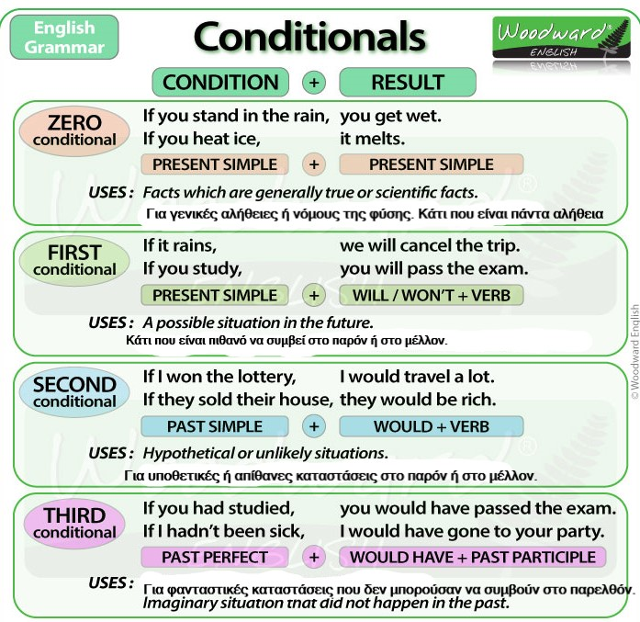

Conditional sentences consist of two parts:  
The **if-clause** (which is a condition) and the **main clause** (which is a result).

Οι υποθετικοί λόγοι αποτελούνται από δυο μέρη: την υπόθεση (if….) και την απόδοση, δηλ. το αποτέλεσμα.   
For example:

* If it rains, we will cancel the trip.

 There are two ways of ordering a conditional sentence.

**Condition, + Result** (with a comma after the condition) …. OR …  
**Result + Condition** (without a comma)

**If it rains**, we will cancel the trip.

**We will cancel the trip** if it rains.

**Complete the sentences with the correct tense.**

1. If I were rich, I ......................................................... ( travel) a lot.
2. If it rains, I ................................................................... ( not go )out.
3. If you ............................................(visit) me, we could play video games.
4. I would be happy, if my friend ........................................(remember) my birthday.
5. If people don’t eat well, they................................ ( get) sick.
6. If Peter .....................................( have) a test, he would study hard.
7. If you are ready, you .................( can) go home.
8. If I .......................................( be invited) to a birthday party, I would buy a present.
9. If my brother participated at the competition, I ........................................... ( not travel).
10. If you .................................(learn) French, you could speak with people when you go there.

**Comment the sentences with 2nd Conditional**

1. Most of my friends can go out at night and travel at weekends, but I can’t because of my bad marks.

...........................................................................................................................................................................

2. You don’t work at an office so you have to go to work on Saturdays.

...........................................................................................................................................................................

3. She is ill but she has an English test.

..........................................................................................................................................................................

4. You are the president of your country.

...........................................................................................................................................................................

5. You want to be an office clerk, but hate paperwork.

...........................................................................................................................................................................

6. Carlos wants to study in England, but he hasn’t got enough money.

...........................................................................................................................................................................

7. I’ m going to visit Paris.

...........................................................................................................................................................................

8. I speak English fluently.

...........................................................................................................................................................................

And never forget……



C.u next time!