Mechanics motion SL 2
1. [1 mark]
A body moves in a straight line. In order for the equations for uniformly accelerated motion to be applied, which condition must be true?
A. A constant net force acts on the body of fixed mass.
B. A constant net force acts on the body.
C. The body falls towards the surface of a planet.
D. The body has an initial velocity of zero.
2. [1 mark]
The graph shows the variation with time of the velocity of a truck of fixed mass.
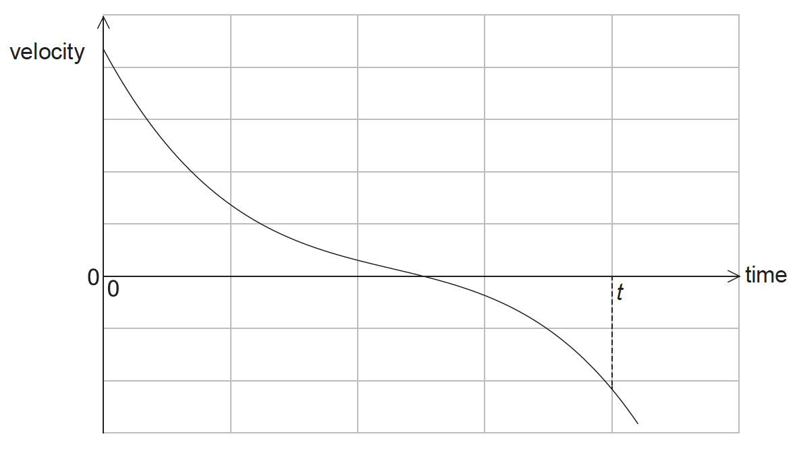
What can be deduced from the graph?
A. The truck is always accelerating.
B. The truck is always moving.
C. The truck is always moving in one direction.
D. The displacement of the truck after time t is zero.
3a. [1 mark]
This question is in two parts. Part 1 is about kinematics and gravitation. Part 2 is about radioactivity.
Part 1 Kinematics and gravitation
A ball is released near the surface of the Moon at time t=0. The point of release is on a straight line between the centre of Earth and the centre of the Moon. The graph below shows the variation with time t of the displacement s of the ball from the point of release.
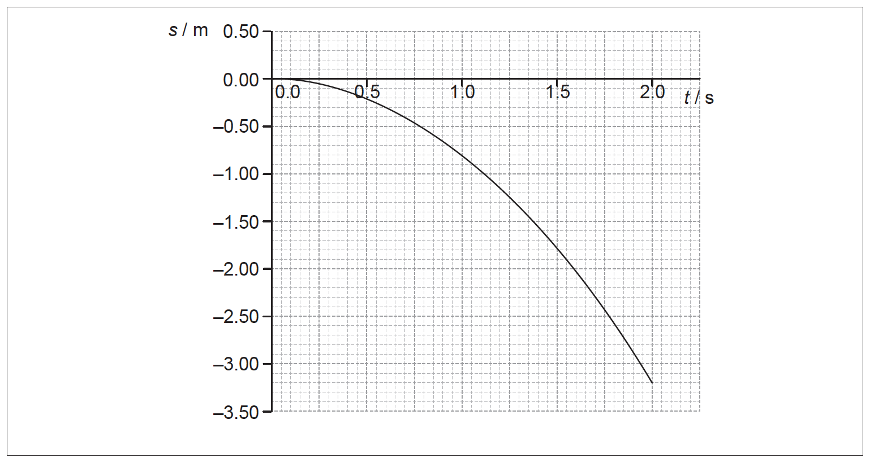
State the significance of the negative values of s.
3b. [6 marks]
Use the graph to
(i) estimate the velocity of the ball at t 0.80 s.
(ii) calculate a value for the acceleration of free fall close to the surface of the Moon.

3c. [4 marks]
The following data are available.
Mass of the ball = 0.20 kg
Mean radius of the Moon = 1.74 10⁶ m
Mean orbital radius of the Moon about the centre of Earth = 3.84 10⁸ m
Mass of Earth = 5.97 10²⁴ kg
Show that Earth has no significant effect on the acceleration of the ball.

3d. [1 mark]
Calculate the speed of an identical ball when it falls 3.0 m from rest close to the surface of Earth. Ignore air resistance.
3e. [3 marks]
Sketch, on the graph, the variation with time t of the displacement s from the point of release of the ball when the ball is dropped close to the surface of Earth. (For this sketch take the direction towards the Earth as being negative.)
3f. [3 marks]
Part 2 Radioactivity
Two isotopes of calcium are calcium-40 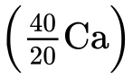 and calcium-47 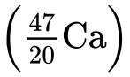. Calcium-40 is stable and calcium-47 is radioactive with a half-life of 4.5 days.
Calculate the percentage of a sample of calcium-47 that decays in 27 days.
3g. [4 marks]
The nuclear equation for the decay of calcium-47 into scandium-47 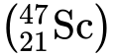 is given by
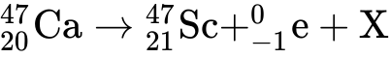
(i) Identify X.
(ii) The following data are available.
Mass of calcium-47 nucleus = 46.95455 u
Mass of scandium-47 nucleus = 46.95241 u
Using the data, determine the maximum kinetic energy, in MeV, of the products in the decay of calcium-47.
(iii) State why the kinetic energy will be less than your value in (h)(ii).
4. [1 mark]
An object is dropped from rest above the Earth’s surface. Air resistance acts on the object. What is the variation of acceleration a with time t for the object?
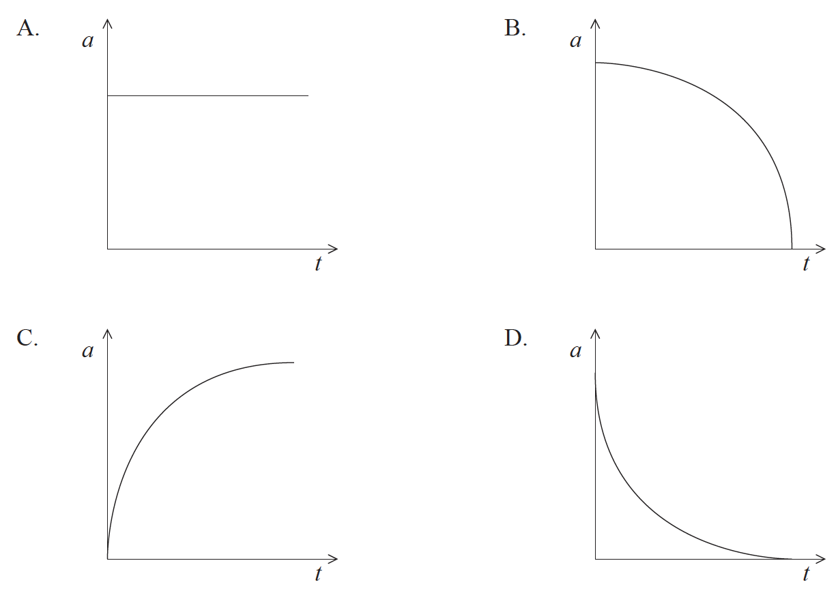
5a. [2 marks]
This question is in two parts. Part 1 is about the motion of a ship. Part 2 is about melting ice.
Part 1 Motion of a ship
Outline the meaning of work.
5b. [2 marks]
Some cargo ships use kites working together with the ship’s engines to move the vessel.
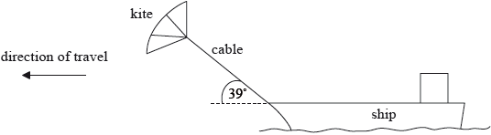
The tension in the cable that connects the kite to the ship is 250 kN. The kite is pulling the ship at an angle of 39° to the horizontal. The ship travels at a steady speed of 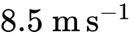 when the ship’s engines operate with a power output of 2.7 MW.
Calculate the work done on the ship by the kite when the ship travels a distance of 1.0 km.
5c. [4 marks]
Show that, when the ship is travelling at a speed of , the kite provides about 40% of the total power required by the ship.
5d. [3 marks]
The kite is taken down and no longer produces a force on the ship. The resistive force that opposes the motion of the ship is related to the speed of the ship by
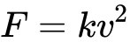
where is a constant.
Show that, if the power output of the engines remains at 2.7 MW, the speed of the ship will decrease to about 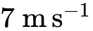. Assume that is independent of whether the kite is in use or not.
5e. [2 marks]
The ship’s engines are switched off and the ship comes to rest from a speed of in a time of 650 s.
Estimate the distance that the ship takes to stop. Assume that the acceleration is uniform.
5f. [2 marks]
It is unlikely that the acceleration of the ship will be uniform given that the resistive force acting on the ship depends on the speed of the ship. Using the axes, sketch a graph to show how the speed varies with time after the ship’s engines are switched off.
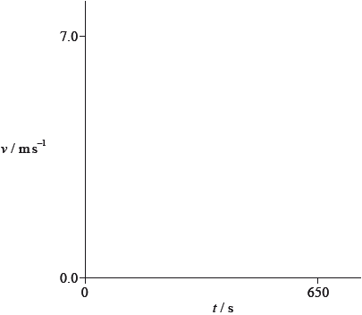
5g. [2 marks]
Part 2 Melting ice
Describe, with reference to molecular behaviour, the process of melting ice.
5h. [2 marks]
A container of negligible mass, isolated from its surroundings, contains 0.150 kg of ice at a temperature of –18.7 °C. An electric heater supplies energy at a rate of 125 W.
After a time interval of 45.0 s all of the ice has reached a temperature of 0 °C without any melting. Calculate the specific heat capacity of ice.
5i. [3 marks]
The following data are available.
Specific heat capacity of water 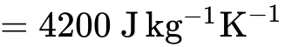
Specific latent heat of fusion of ice 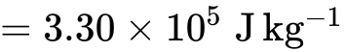
Determine the final temperature of the water when the heater supplies energy for a further 600 s.
5j. [3 marks]
The whole of the experiment in (f)(i) and (f)(ii) is repeated with a container of negligible mass that is not isolated from the surroundings. The temperature of the surroundings is 18 °C. Comment on the final temperature of the water in (f)(ii).
6. [1 mark]
A body moves on a straight line. The graphs show the variation of displacement with time. Which graph shows motion with negative acceleration?
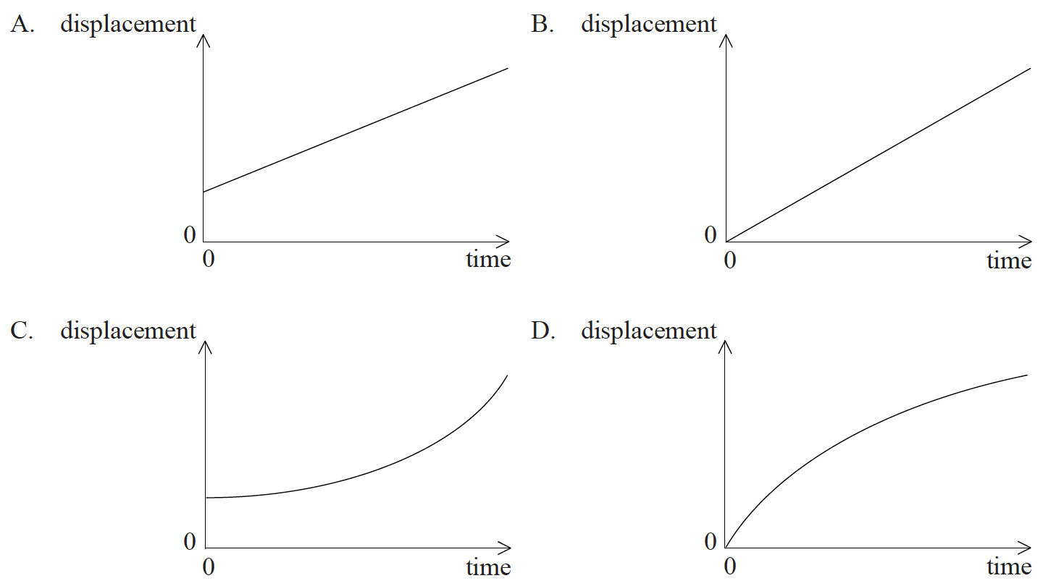
7. [1 mark]
Each side of a metal cube is measured to be 2.0 cm ± 0.20 cm. What is the absolute uncertainty in the calculated volume of the cube?
A. ± 0.08 cm³
B. ± 0.60 cm³
C. ± 0.80 cm³
D. ± 2.4 cm³
8. [1 mark]
A particle accelerates from rest. The graph shows how the acceleration a of the particle varies with time t.
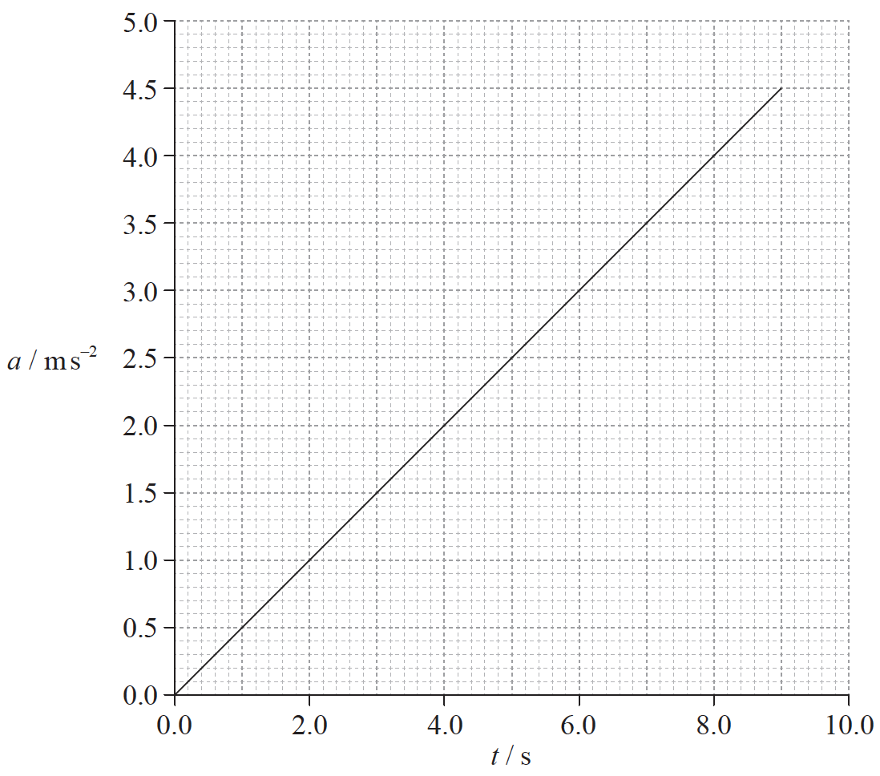
What is the speed of the particle at t=6.0s?
A. 0.5 ms^{–1}
B. 2.0 ms^{–1}
C. 9.0 ms^{–1}
D. 18 ms^{–1}
9a. [2 marks]
This question is in two parts. Part 1 is about two children on a merry-go-round. Part 2 is about electric circuits.
Part 1 Two children on a merry-go-round
Aibhe and Euan are sitting on opposite sides of a merry-go-round, which is rotating at constant speed around a fixed centre. The diagram below shows the view from above.
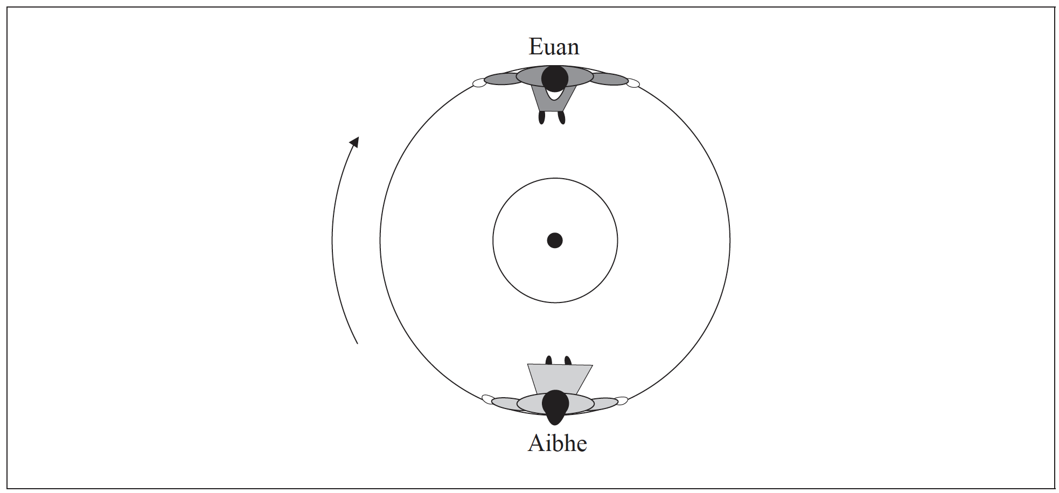
Aibhe is moving at speed 1.0ms^{–1} relative to the ground.
Determine the magnitude of the velocity of Aibhe relative to
(i) Euan.
(ii) the centre of the merry-go-round.
9b. [6 marks]
(i) Outline why Aibhe is accelerating even though she is moving at constant speed.
(ii) Draw an arrow on the diagram on page 22 to show the direction in which Aibhe is accelerating.
(iii) Identify the force that is causing Aibhe to move in a circle.
(iv) The diagram below shows a side view of Aibhe and Euan on the merry-go-round.
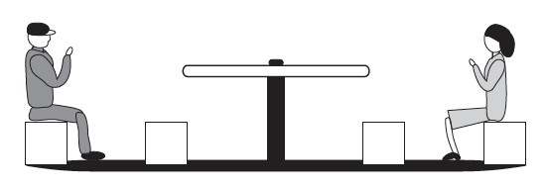
Explain why Aibhe feels as if her upper body is being “thrown outwards”, away from the centre of the merry-go-round.
9c. [2 marks]
Euan is rotating on a merry-go-round and drags his foot along the ground to act as a brake. The merry-go-round comes to a stop after 4.0 rotations. The radius of the merry-go-round is 1.5 m. The average frictional force between his foot and the ground is 45 N. Calculate the work done.
9d. [5 marks]
Aibhe moves so that she is sitting at a distance of 0.75 m from the centre of the merry-go-round, as shown below.
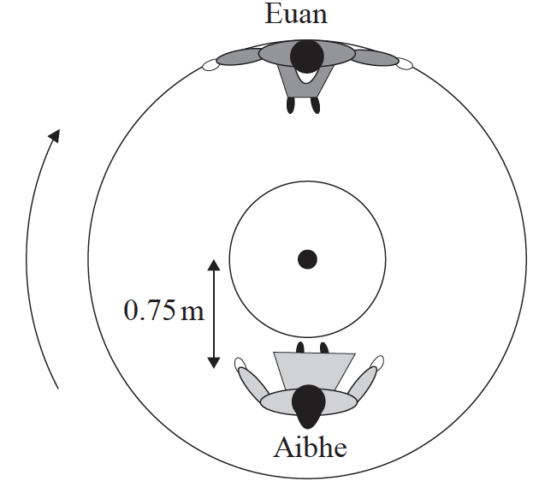
Euan pushes the merry-go-round so that he is again moving at 1.0 ms^{–1} relative to the ground.
(i) Determine Aibhe’s speed relative to the ground.
(ii) Calculate the magnitude of Aibhe’s acceleration.
10. [1 mark]
A tennis ball is dropped from the top of a high building. Air resistance cannot be neglected. Which graph represents the variation with time t of the magnitude of the acceleration a of the ball before it hits the ground?
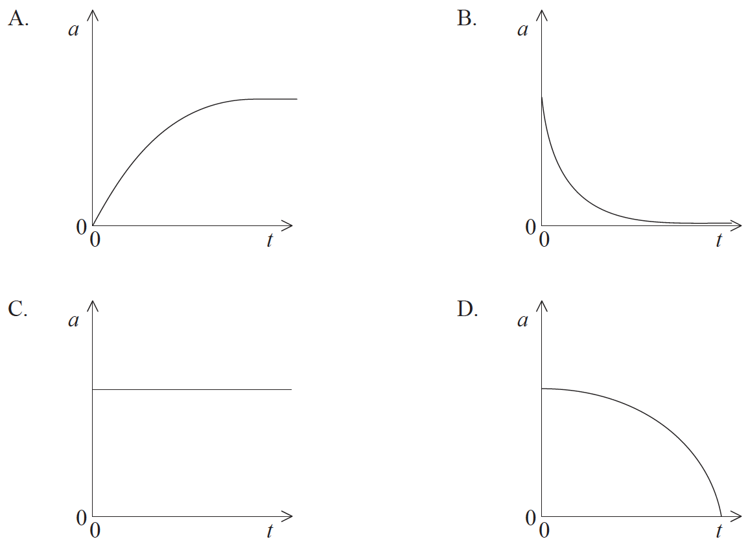
11a. [1 mark]
This question is in two parts. Part 1 is about Newton’s laws and momentum. Part 2 is about the greenhouse effect.
Part 1 Newton’s laws and momentum
State the condition for the momentum of a system to be conserved.
11b. [5 marks]
A person standing on a frozen pond throws a ball. Air resistance and friction can be considered to be negligible.
(i) Outline how Newton’s third law and the conservation of momentum apply as the ball is thrown.
(ii) Explain, with reference to Newton’s second law, why the horizontal momentum of the ball remains constant whilst the ball is in flight.
11c. [2 marks]
The maximum useful power output of a locomotive engine is 0.75 M W. The maximum speed of the locomotive as it travels along a straight horizontal track is 44 m s^{–1}. Calculate the frictional force acting on the locomotive at this speed.
11d. [4 marks]
The locomotive engine in (c) gives a truck X a sharp push such that X moves along a horizontal track and collides with a stationary truck Y. As a result of the collision the two trucks stick together and move off with speed v. The following data are available.
Mass of truck X=3.7×10³ kg
Mass of truck Y=6.3×10³ kg
Speed of X just before collision=4.0 m s^{–1}
(i) Calculate v.
(ii) Determine the kinetic energy lost as a result of the collision.
11e. [3 marks]
The trucks X and Y come to rest after travelling a distance of 40 m along the horizontal track. Determine the average frictional force acting on X and Y.
11f. [5 marks]
Part 2 The greenhouse effect
Nuclear fuels, unlike fossil fuels, produce no greenhouse gases.
(i) Identify two greenhouse gases.
(ii) Discuss, with reference to the mechanism of infrared absorption, why the temperature of the Earth’s surface would be lower if there were no greenhouse gases present in the atmosphere.
12. [1 mark]
The graph below shows how velocity v varies with time t for a ball thrown vertically upwards from the Earth’s surface.
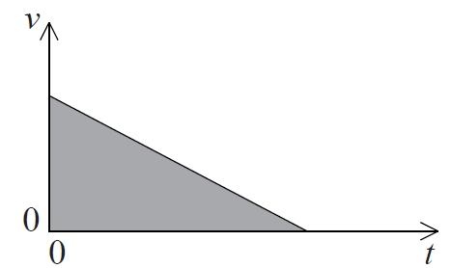

The shaded area is equal to the
A. displacement.
B. final velocity.
C. change in velocity.
D. acceleration
13. [1 mark]
Two identical balls are dropped from a tall building, one a few seconds after the other. Air resistance is not negligible. As the balls fall, the distance between the balls will
A. decrease.
B. increase.
C. increase then remain constant.
D. remain constant.
14. [1 mark]
Which of the following is always true for an object moving in a straight line at constant speed?
A. No forces act on the object.
B. No resultant force acts on the object.
C. The momentum of the object is zero.
D. No work is being done on the object.
15. [1 mark]
An object, initially at rest, travels a distance d in a time t at a constant acceleration. What is the time taken for the object to travel 16d from rest at the same acceleration?
A. 16t
B. 8t
C. 4t
D. 2t
16. [1 mark]
An object is released above the surface of Earth. Which of the following correctly describes the speed and acceleration before it reaches terminal speed?
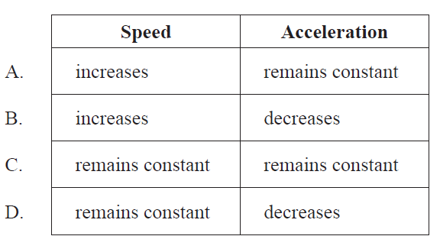
17. [1 mark]
An object of mass m is connected via a frictionless pulley to an object of mass M, where M > m. M rests on a horizontal frictionless surface
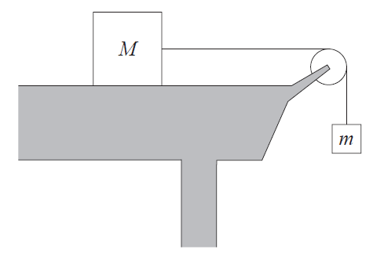
What is the acceleration of the system?
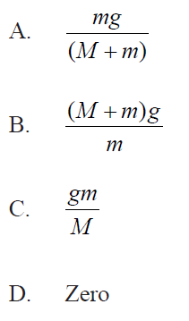
18. [1 mark]
The graph shows the variation with distance x of the magnitude of the net force F acting on a body initially at rest.
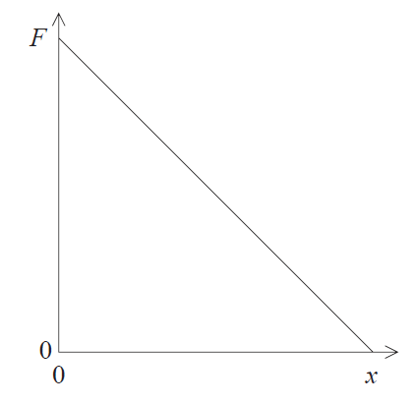
Which of the following describes how the kinetic energy and the acceleration of the body change
with distance?
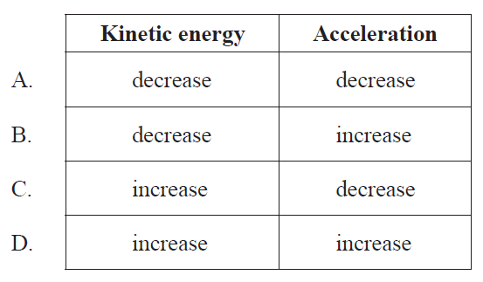

19a. [2 marks]
Define electric field strength.
19b. [5 marks]
The diagram shows a pair of horizontal metal plates. Electrons can be deflected vertically using an electric field between the plates.
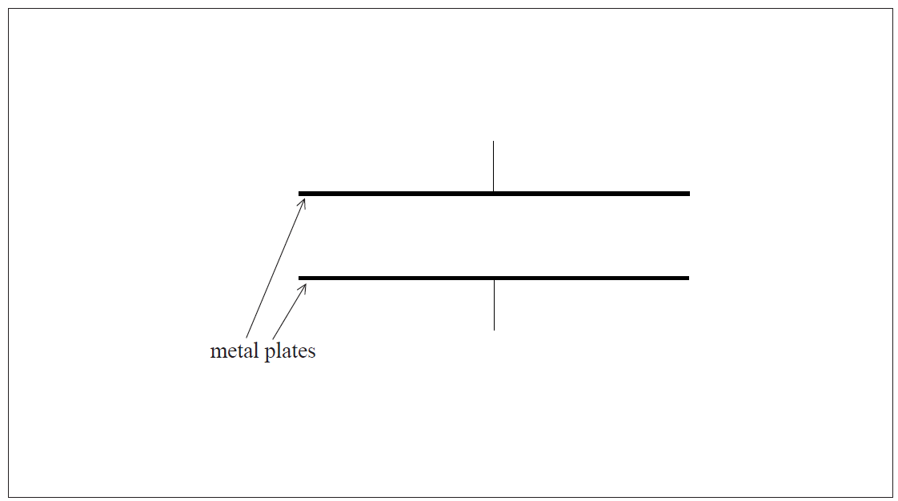
(i) Label, on the diagram, the polarity of the metal plates which would cause an electron
positioned between the plates to accelerate upwards.
(ii) Draw the shape and direction of the electric field between the plates on the diagram.
(iii) Calculate the force on an electron between the plates when the electric field strength has a value of 2.5 × 10³ NC^{–1}.
19c. [8 marks]
The diagram shows two isolated electrons, X and Y, initially at rest in a vacuum. The initial separation of the electrons is 5.0 mm. The electrons subsequently move apart in the directions shown.
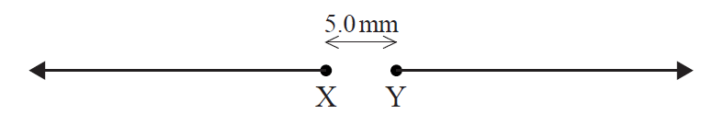

(i) Show that the initial electric force acting on each electron due to the other electron is approximately 9 × 10^{–24}N.
(ii) Calculate the initial acceleration of one electron due to the force in (c)(i).
(iii) Discuss the motion of one electron after it begins to move.
(iv) The diagram shows Y as seen from X, at one instant. Y is moving into the plane of the paper. For this instant, draw on the diagram the shape and direction of the magnetic field produced by Y.

20a. [3 marks]
This question is about kinematics.
Fiona drops a stone from rest vertically down a water well. She hears the splash of the stone striking the water 1.6 s after the stone leaves her hand. Estimate the
(i) distance between Fiona’s hand and the water surface.
(ii) speed with which the stone hits the water.
20b. [3 marks]
After the stone in (a) hits the water surface it rapidly reaches a terminal speed as it falls through the water. The stone leaves Fiona’s hand at time t = 0. It hits the water surface at t₁ and it comes to rest at the bottom of the water at t₂. Using the axes below, sketch a graph to show how the speed v of the stone varies from time t = 0 to just before t = t₂. (There is no need to add any values to the axes.)
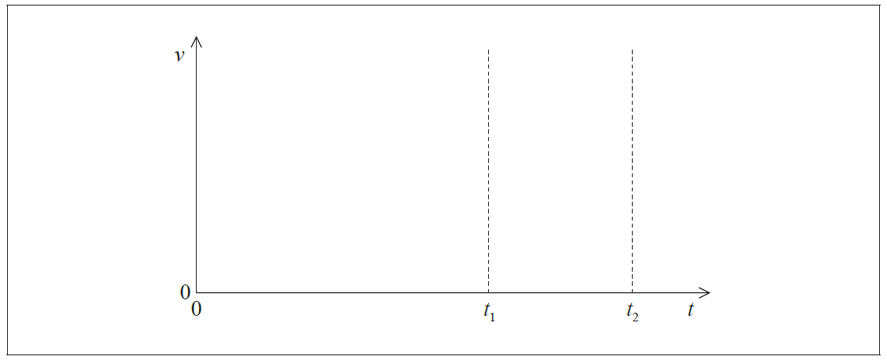
20c. [2 marks]
Draw and label a free-body diagram representing the forces acting on the stone as it falls through the water at its terminal speed.

21. [1 mark]
An object is thrown upwards leaving the thrower’s hand at time t=0. Which graph shows how speed v varies with t as the object rises and falls?
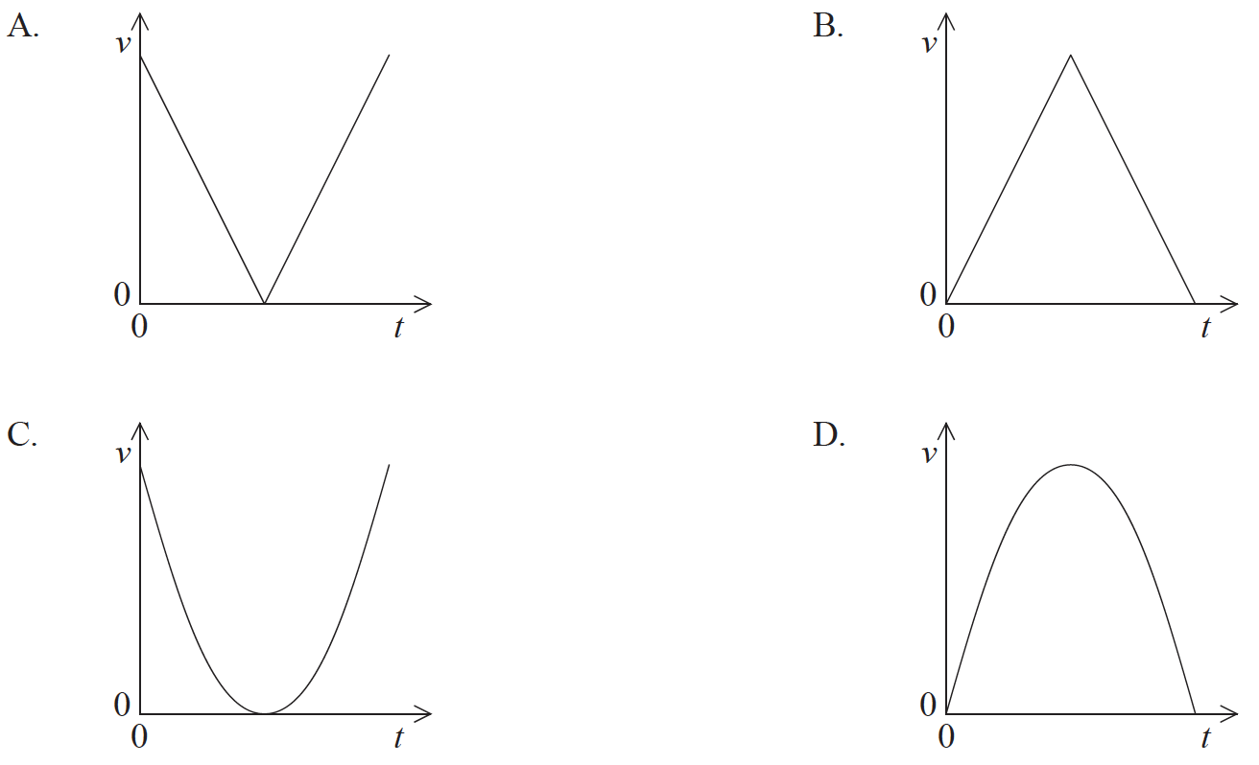
22. [1 mark]
A ball is released at time t=0 above a horizontal surface. The graph shows the variation of velocity v with time. Which of the following shows the highest point of the ball after one bounce?
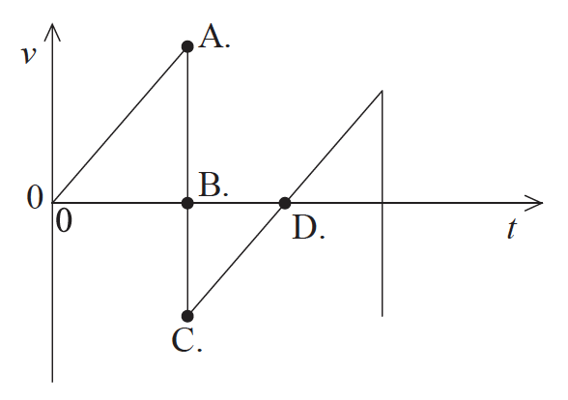
23. [1 mark]
The velocity–time graph for an accelerating object that is traveling in a straight line is shown below.
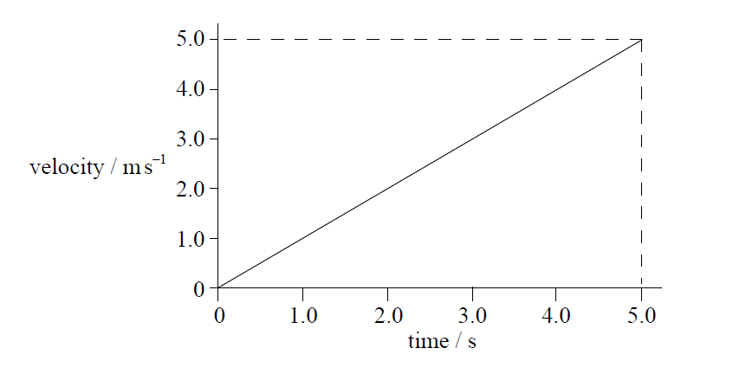

Which of the following is the change in displacement of the object in the first 5.0 seconds?
A. 25.0 m
B. 12.5 m
C. 5.0 m
D. 1.0 m
24. [1 mark]
The graph shows the acceleration a of an object as time t varies.
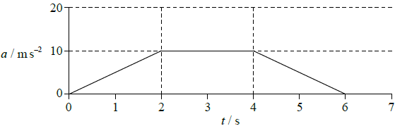
What is the magnitude of the change in the velocity of the object between 0 and 3 seconds?
A. 5 ms^{–1}
B. 10 ms^{–1}
C. 20 ms^{–1}
D. 30 ms^{–1}

25a. [2 marks]
This question is about kinematics.
State the difference between average speed and instantaneous speed.
25b. [3 marks]
The graph shows how the acceleration a of a particle varies with time t.
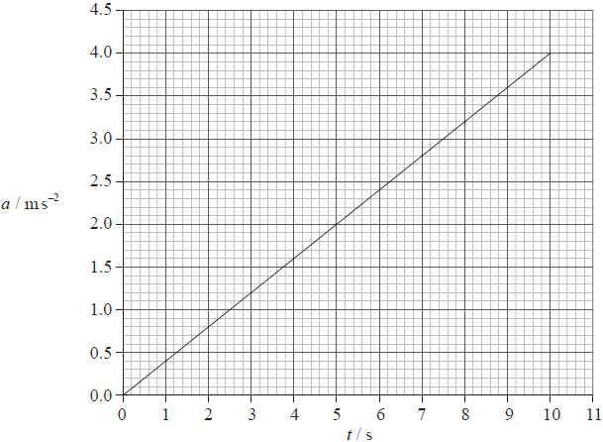
At time t = 0 the instantaneous speed of the particle is zero.
(i) Calculate the instantaneous speed of the particle at t = 7.5 s.
(ii) Using the axes below, sketch a graph to show how the instantaneous speed v of the particle varies with t.
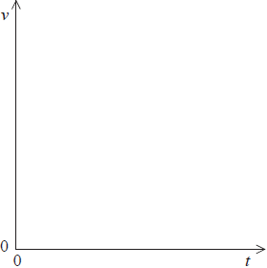
26. [1 mark]
A stone is thrown vertically upwards from the surface of Earth. Which of the following quantities will not become zero while the stone is in the air?
A. Speed
B. Velocity
C. Momentum
D. Acceleration
27. [1 mark]
An ice-hockey puck is slid along ice in a straight line. The puck travels at a steady speed of 20 ms^{–1} and experiences no frictional force. How far does the puck travel in 2.5 s?
A. 5 m
B. 8 m
C. 25 m
D. 50 m
28a. [3 marks]
This question is in two parts. Part 1 is about forces. Part 2 is about internal energy.
Part 1 Forces
A railway engine is travelling along a horizontal track at a constant velocity.
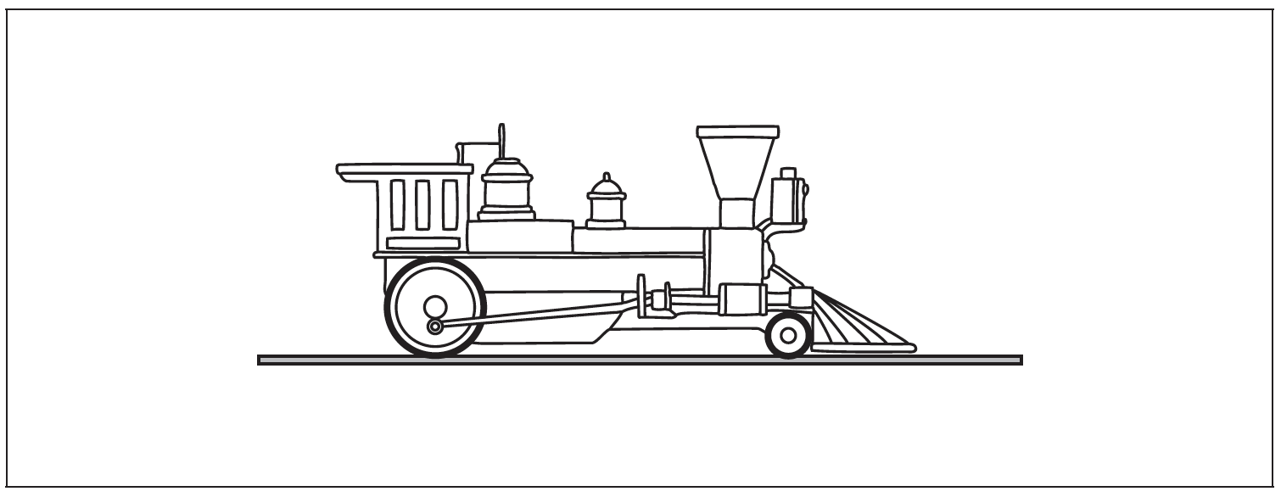
On the diagram above, draw labelled arrows to represent the vertical forces that act on the railway engine.
28b. [2 marks]
Explain, with reference to Newton’s laws of motion, why the velocity of the railway engine is constant.
28c. [2 marks]
The constant horizontal velocity of the railway engine is 16 ms^{–1}. A total horizontal resistive force of 76 kN acts on the railway engine.
Calculate the useful power output of the railway engine.
28d. [2 marks]
The power driving the railway engine is switched off. The railway engine stops, from its speed of 16 ms^{–1}, without braking in a distance of 1.1 km. A student hypothesizes that the horizontal resistive force is constant.
Based on this hypothesis, calculate the mass of the railway engine.
28e. [5 marks]
Another hypothesis is that the horizontal force in (c) consists of two components. One component is a constant frictional force of 19 kN. The other component is a resistive force F that varies with speed v where F is proportional to v³.
(i) State the value of the magnitude of F when the railway engine is travelling at 16 ms^{–1}.
(ii) Determine the total horizontal resistive force when the railway engine is travelling at 8.0 ms^{–1}.

28f. [3 marks]
On its journey, the railway engine now travels around a curved track at constant speed. Explain whether or not the railway engine is accelerating.
29a. [6 marks]
Part 2 Electric motor
An electric motor is used to raise a load.
Whilst being raised, the load accelerates uniformly upwards. The weight of the cable is negligible compared to the weight of the load.
(i) Draw a labelled free-body force diagram of the forces acting on the accelerating load. The dot below represents the load.

(ii) The load has a mass of 350 kg and it takes 6.5 s to raise it from rest through a height of 8.0 m.
Determine the tension in the cable as the load is being raised.
29b. [4 marks]
The electric motor can be adjusted such that, after an initial acceleration, the load moves at constant speed. The motor is connected to a 450 V supply and with the load moving at constant speed, it takes the motor 15 s to raise the load through 7.0 m.
(i) Calculate the power delivered to the load by the motor.
(ii) The current in the motor is 30 A. Estimate the efficiency of the motor.
30. [1 mark]
Joseph runs along a long straight track. The variation of his speed v with time t is shown below.
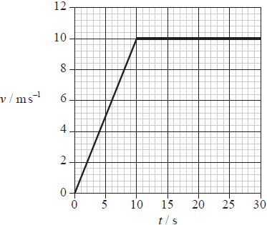
After 25 seconds Joseph has run 200 m. Which of the following is correct at 25 seconds?
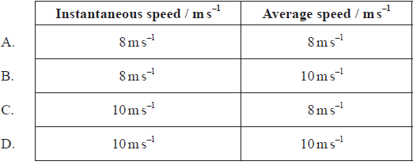

31. [1 mark]
A car of mass 1000 kg accelerates on a straight, flat, horizontal road with an acceleration a = 0.3 m s⁻². The driving force F on the car is opposed by a resistive force of 500 N.
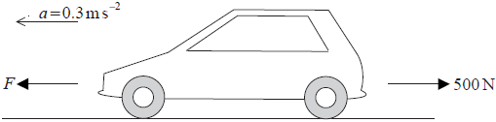
The net (resultant) force on the car is
A. 200 N.
B. 300 N.
C. 500 N.
D. 800 N.

32. [1 mark]

The graph shows the variation with time t of the acceleration a of an object.
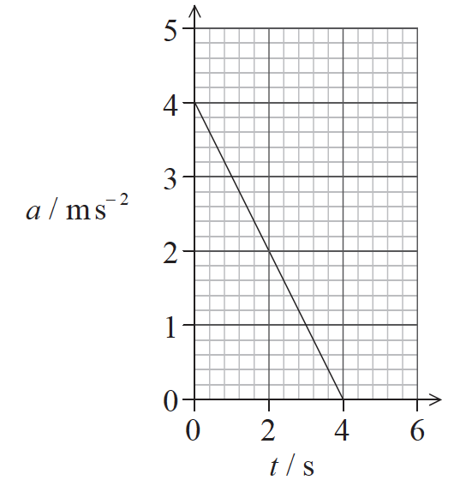
Which of the following is the change in velocity of the object in the time interval 0 to 4s?
A. -8ms
⁻¹
B. -4ms⁻¹
C. +4ms⁻¹
D. +8ms⁻¹
33. [1 mark]
A car accelerates from rest. The acceleration increases with time. Which graph shows the variation with time t of the speed v of the car?
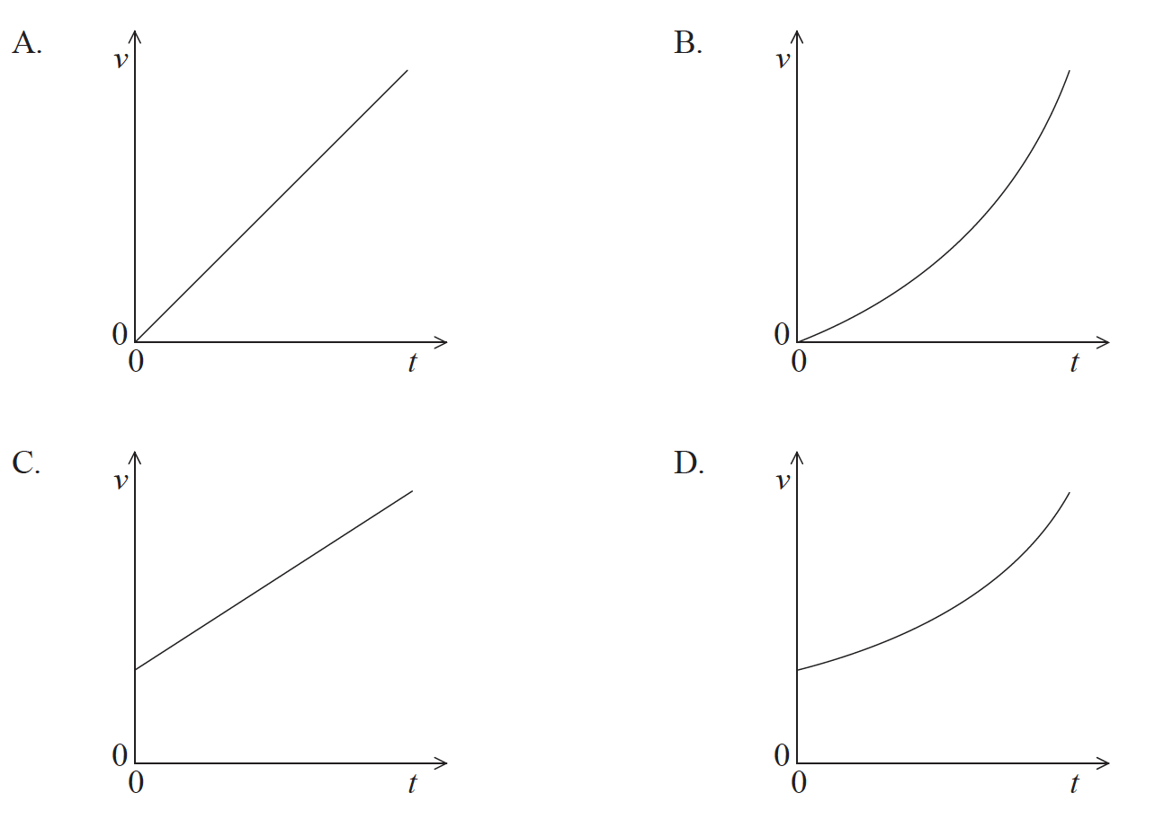
34a. [1 mark]
This question is in two parts. Part 1 is about mechanics and thermal physics. Part 2 is about nuclear physics.
Part 1 Mechanics and thermal physics
The graph shows the variation with time t of the speed v of a ball of mass 0.50 kg, that has been released from rest above the Earth’s surface.
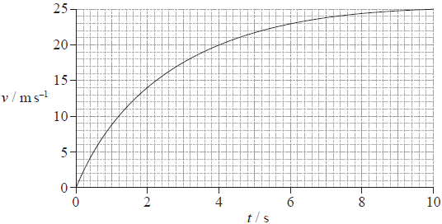
The force of air resistance is not negligible. Assume that the acceleration of free fall is g = 9.81ms⁻².
State, without any calculations, how the graph could be used to determine the distance fallen.

34b. [7 marks]
(i) In the space below, draw and label arrows to represent the forces on the ball at 2.0 s.
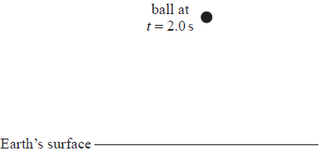
(ii) Use the graph opposite to show that the acceleration of the ball at 2.0 s is approximately 4 ms⁻².
(iii) Calculate the magnitude of the force of air resistance on the ball at 2.0 s.
(iv) State and explain whether the air resistance on the ball at t = 5.0 s is smaller than, equal to or greater than the air resistance at t = 2.0 s.

34c. [6 marks]
After 10 s the ball has fallen 190 m.
(i) Show that the sum of the potential and kinetic energies of the ball has decreased by 780 J.
(ii) The specific heat capacity of the ball is 480 J kg⁻¹ K⁻¹. Estimate the increase in the temperature of the ball.
(iii) State an assumption made in the estimate in (c)(ii).
35a. [2 marks]
This question is about kinematics.
Lucy stands on the edge of a vertical cliff and throws a stone vertically upwards.
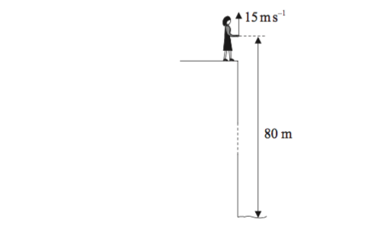
The stone leaves her hand with a speed of 15ms^{–1} at the instant her hand is 80m above the surface of the sea. Air resistance is negligible and the acceleration of free fall is 10ms^{–2}.
Calculate the maximum height reached by the stone as measured from the point where it is thrown.
35b. [3 marks]
Determine the time for the stone to reach the surface of the sea after leaving Lucy’s hand.
36. [1 mark]
A raindrop falling from rest at time 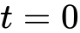 reaches terminal velocity. Which graph best represents how the speed varies with time ?
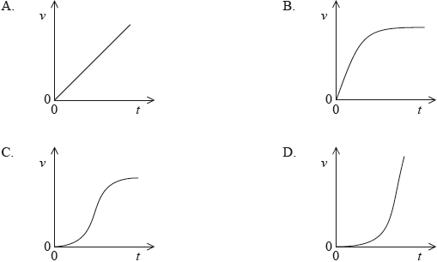
37. [1 mark]
The graph shows how the displacement of an object varies with time . The tangent to the curve at time 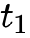 is also shown.
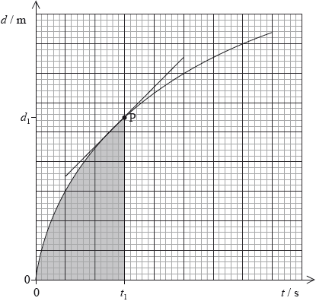
Which of the following gives the speed of the object at point P?
A. the gradient at P
B. the shaded area
C. 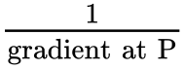
D. 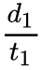
38a. [1 mark]
In 1997 a high-speed car of mass 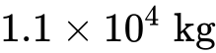 achieved the world land speed record. The car accelerated uniformly in two stages as shown in the table. The car started from rest.
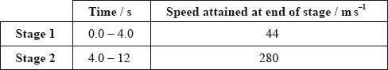
Use the data to calculate the
average acceleration of the car in stage 1.
38b. [3 marks]
average net force required to accelerate the car in stage 2.
38c. [2 marks]
total distance travelled by the car in 12 s.
39a. [6 marks]
This question is in two parts. Part 1 is about the production of energy in nuclear fission. Part 2 is about collisions.
Part 1 Production of energy in nuclear fission
A possible fission reaction is
(i) State the value of .
(ii) Show that the energy released when one uranium nucleus undergoes fission in the reaction in (a) is about 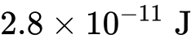.
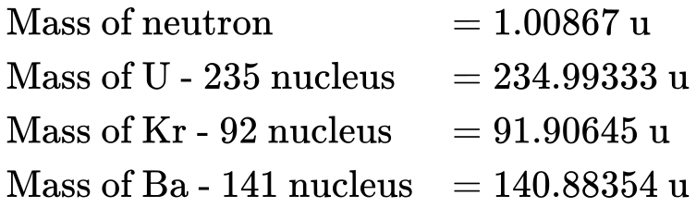
(iii) State how the energy of the neutrons produced in the reaction in (a) is likely to compare with the energy of the neutron that initiated the reaction.
39b. [2 marks]
Outline the role of the moderator.
39c. [4 marks]
A nuclear power plant that uses U-235 as fuel has a useful power output of 16 MW and an efficiency of 40%. Assuming that each fission of U-235 gives rise to of energy, determine the mass of U-235 fuel used per day.
39d. [2 marks]
Part 2 Collisions
State the principle of conservation of momentum.
39e. [6 marks]
In an experiment, an air-rifle pellet is fired into a block of modelling clay that rests on a table.
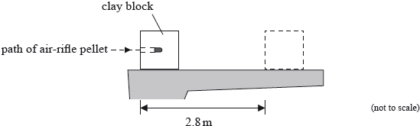
The air-rifle pellet remains inside the clay block after the impact.
As a result of the collision, the clay block slides along the table in a straight line and comes to rest. Further data relating to the experiment are given below.
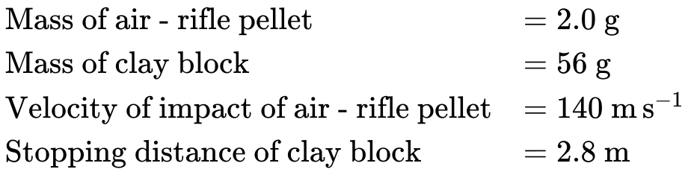
(i) Show that the initial speed of the clay block after the air-rifle pellet strikes it is 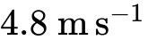.
(ii) Calculate the average frictional force that the surface of the table exerts on the clay block whilst the clay block is moving.
39f. [3 marks]
Discuss the energy transformations that occur in the clay block and the air-rifle pellet from the moment the air-rifle pellet strikes the block until the clay block comes to rest.
39g. [2 marks]
The clay block is dropped from rest from the edge of the table and falls vertically to the ground. The table is 0.85 m above the ground. Calculate the speed with which the clay block strikes the ground.
40. [1 mark]
The time taken for a stone dropped from rest to fall vertically through 16 m is 2.0 s. Based on these measurements, what is the best estimate for the acceleration of free fall?
A. 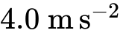
B. 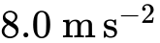
C. 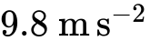
D. 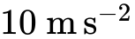
41. [1 mark]
Two balls of different mass are dropped from the top of a tall building one after the other. The distance between the balls
A. increases with time.
B. depends on the initial velocity only.
C. remains constant.
D. depends on the mass of the balls.
42. [1 mark]
The graph shows how the velocity of a particle varies with time.
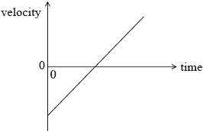
Which of the following graphs correctly shows how the acceleration of the particle varies with time?
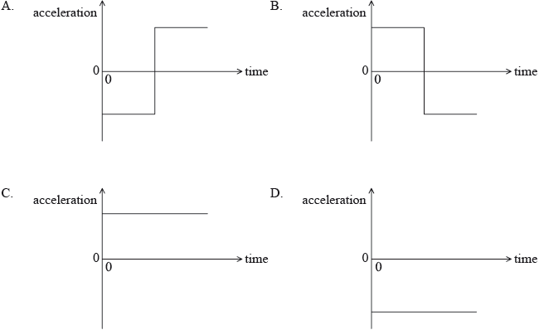
43. [1 mark]
A skydiver jumped out of an airplane. On reaching a terminal speed of 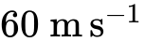, she opened her parachute. Which of the following describes her motion after opening her parachute?
A. She went upwards for a short time, before falling to Earth at a speed of .
B. She continued downwards at , but hit the ground with less force.
C. She continued to fall but reached a new terminal speed of less than .
D. She went upwards for a short time, before falling to Earth at a speed of less than .
44. [1 mark]
The graph is a speed versus time graph for an object that is moving in a straight line.
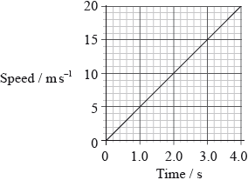
The distance travelled by the object during the first 4.0 seconds is
A. 80 m.
B. 40 m.
C. 20 m.
D. 5 m.

Printed for ACS Athens
© International Baccalaureate Organization 2019
International Baccalaureate® - Baccalauréat International® - Bachillerato Internacional®

