**Animal Rights**

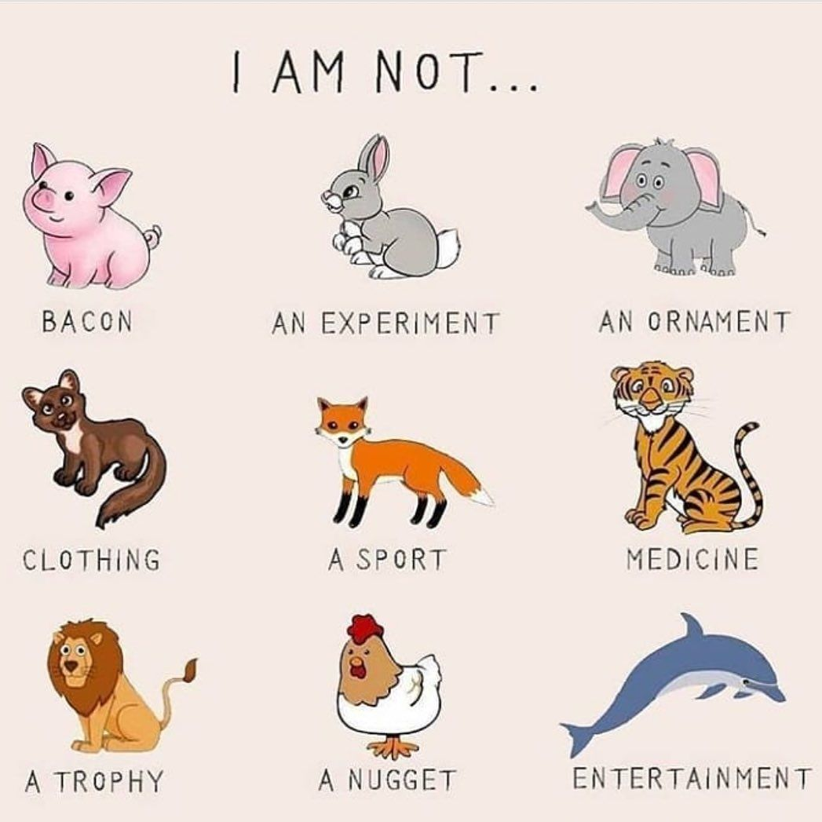

* No experiments on **animals**.
* No breeding and killing **animals** for food or clothes or medicine.
* No use of **animals** for hard labour.
* No selective breeding for any reason other than the benefit of the **animal**.
* No hunting.
* No zoos or use of **animals** in entertainment.