**FAIR TRADE**

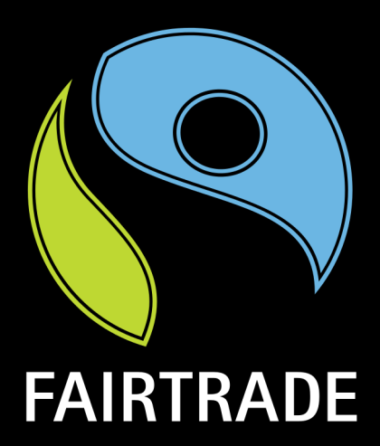Fair trade is an arrangement designed to help producers in growing countries achieve sustainable and equitable trade relationships. Members of the fair trade movement add the payment of higher prices to exporters, as well as improved social and environmental standards. The movement focuses in particular on commodities, or products that are typically exported from developing countries to developed countries, but is also used in domestic markets, most notably for handicrafts, coffee, wine, sugar, fruit, flowers, and gold. The movement seeks to promote greater equity in international trading partnerships through dialogue, transparency, and respect. It promotes sustainable development by offering better trading conditions to, and securing the rights of, marginalized producers and workers in developing countries. Fair trade is grounded in three core beliefs; first, producers have the power to express unity with consumers. Secondly, the world trade practices that currently exist promote the unequal distribution of wealth between nations. Lastly, buying products from producers in developing countries at a fair price is a more efficient way of promoting sustainable development than traditional charity and aid.

**ORGANIC COTTON**

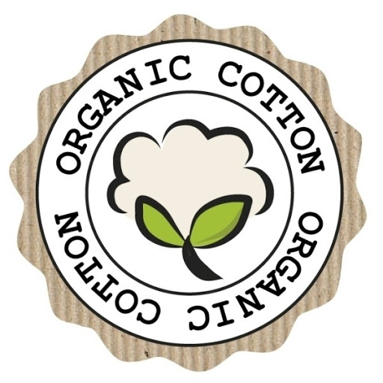Organic cotton is cotton that is produced and certified to organic agricultural standards. Its production sustains the health of soils, ecosystems and people by using natural processes rather than artificial inputs. Importantly organic cotton farming does not allow the use of toxic chemicals or GMOs (genetically modified organisms). Instead, it combines tradition, innovation and science to benefit the shared environment and promote a good quality of life for all involved. According to a report by Textile Exchange 2010 Global Market Report on Sustainable Textiles, global sales of organic cotton apparel and home textile products reached an estimated $5.16 billion in 2010. This reflects a 20 percent increase from the 2009 market. Companies reported significant growth in their organic cotton programs, and increased adoption of standards. Approximately 219,000 farmers grew the fiber.

**SUSTAINABILITY**

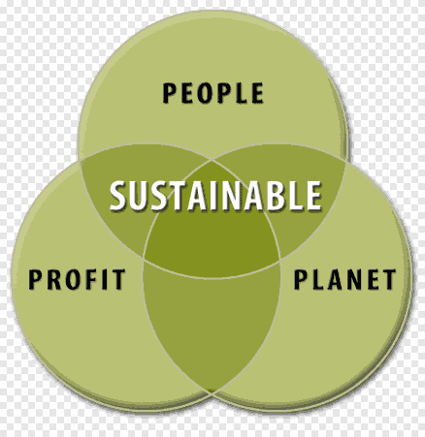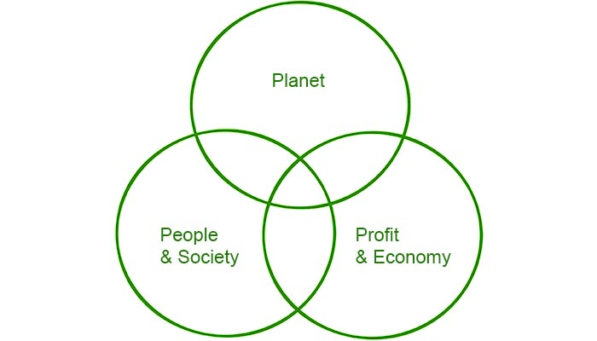The definition of “sustainability” is the study of how natural systems function, remain diverse and produce everything it needs for the ecology to remain in balance. It also acknowledges that human civilisation takes resources to sustain our modern way of life. There are countless examples throughout human history where a civilisation has damaged its own environment and seriously affected its own survival chances. We now live in a modern, consumerist and largely urban existence throughout the developed world and we consume a lot of natural resources every day. In our urban centres, we consume more power than those who live in rural settingsand urban centres use a lot more power than average, keeping our streets and civic buildings lit, to power our appliances, our heating. Sustainability and sustainable development focuses on balancing that fine line between competing needs our need to move forward technologically and economically, and the needs to protect the environments in which we and others live. Sustainability is not just about the environment , it's also about our health as a society in ensuring that no people or areas of life suffer as a result of environmental legislation, and it's also about examining the longer term effects of the actions humanity takes and asking questions about how it may be improved.