VINCENT VAN GOGH (UNIT 4)

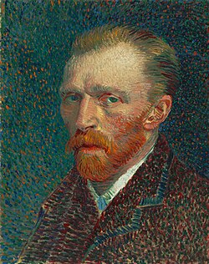

STUDENTS’ PRESENTATIONS, POEMS AND PAINTINGS (OPTIONAL)

