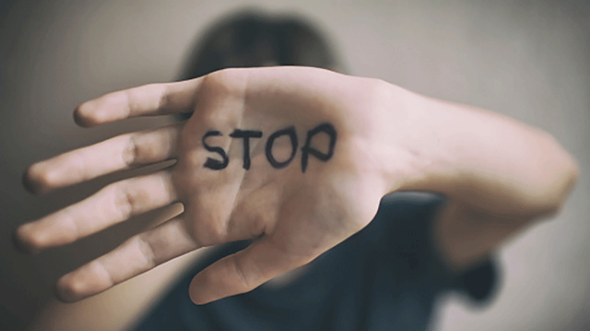
Chapter 13.3 Understanding Violence:
This Photo by Unknown Author is licensed under CC BY-SA

Causes, Effects, and Prevention

Worksheet

Case Studies & Discussion

Case 1: School Violence – “The Silent Hallway: Maya’s Story”
Maya, 15, has been receiving anonymous threatening messages on social media for three months. The messages mock her appearance and call her “worthless.” Classmates share screenshots in group chats. Her grades have dropped; she eats alone and has started missing school. When a teacher notices, Maya insists everything is fine. Amir, a classmate, has seen the bullying but stays silent because the aggressors are his friends.

Case 2: Domestic Violence – “Behind Closed Doors: The Reyes Family”
Carlos, 16, often comes to school exhausted. He confides that his father frequently yells at his mother, throws objects, and blocks the door so she cannot leave. His younger sister has nightmares. Recently, his father lost his job and the situation has worsened. Carlos feels torn and scared. His mother tells him: “Every family has problems. This is private.”

Case 3: Sports Violence – “Win at All Costs: The Eagles Football Team”
The Eagles are a competitive school team. Coach Davis insults players during practice. Senior players force new members into extreme training rituals. During a match, a player intentionally injures an opponent. Fans vandalise the winning team’s bus, and a parent threatens a referee.

Activity 1: Cause → Effect → Solution Map
Write the number of the case your group has been assigned in the first row. Discuss with the members of your group and add at least 2–3 examples per column to complete the table that follows.
Case ________
Root Causes | Effects on Victims | Effects on Community | Solutions
e.g. Peer pressure, lack of empathy | e.g. Anxiety, isolation | e.g. Fear, distrust | e.g. Counselling, policies

Activity 2: Role-Play – Rewrite the Ending
Within your group, create a 2-minute role-play showing how their case could end differently if someone intervened. Prepare to act it out. Consider:
- Characters & Roles: Who is involved?
- Key Moment of Intervention: What does someone say/do?
- New Outcome: How does the story change?
- Message: What should the audience learn?


Activity 3: Quiz / Knowledge Check. Tick the correct answer.

1. Which is an example of school violence?
  - A parent yelling at a referee
  - A student spreading rumours online about a classmate
  - A coach forcing extra drills
  - A fan throwing objects
2. Common root cause of all types of violence:
  - Bad weather
  - Power imbalances and lack of empathy
  - Too many rules
  - Playing sports
3. A bystander who speaks up is called:
  - Instigator
  - Victim
  - Upstander
  - Authority figure
4. Which statement about domestic violence is TRUE?
  - It only involves physical harm
  - It only happens in poor families
  - Victims often feel ashamed and stay silent
  - Children are not affected
5. Most effective prevention strategy:
  - Ignoring the problem
  - Punishing with more violence
  - Education, awareness, and community support
  - Banning all sports
Activity 4: Exit Question.
What is one thing you can do to help prevent violence in your environment?
_______________________________________________________________________________________
_______________________________________________________________________________________

