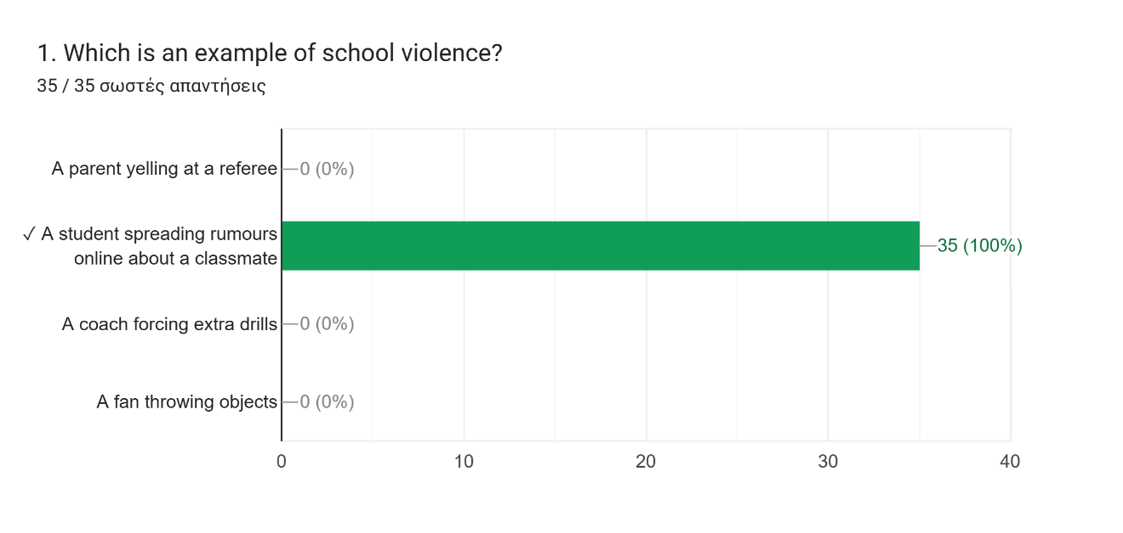
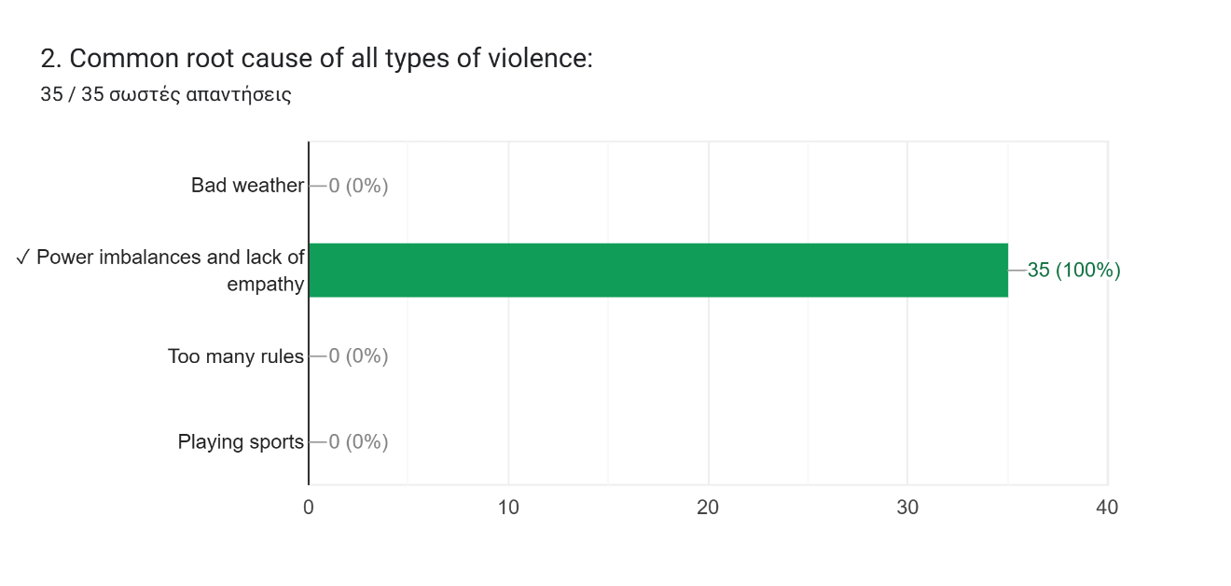
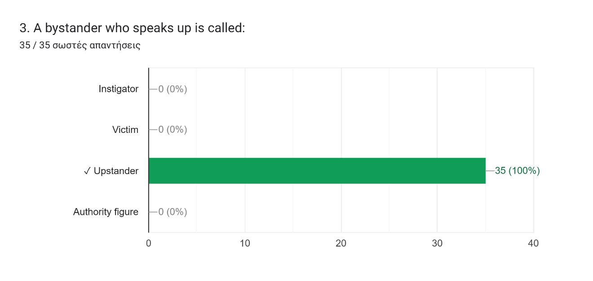
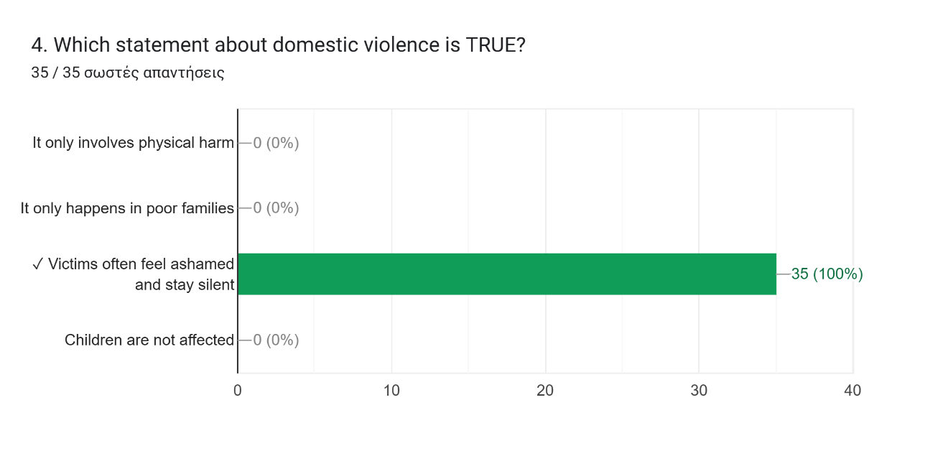
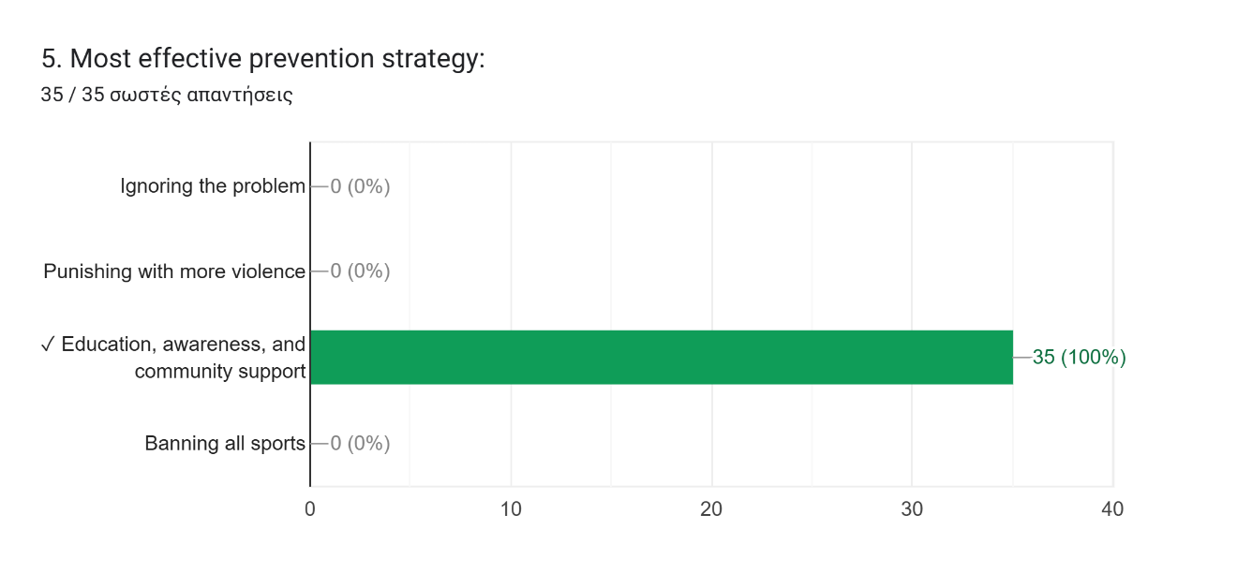

6. What is one thing you can do to help prevent violence in your environment?
Speak up
Raise awareness
Take action
Report it!
We can speak up about several incidents in order to prevent victims
Report
The information is the most appropriate measure
Speak up as a bystander, don't ignore violence , support victims
I can educate my classmates not to use violence or any form of discrimination
Speak and don't ignore the problem
Be more aware
Maintain an environment with little to no tension between classmates and stand up if something happens.
Enforce strict rules that expel students if an act of violence is detected
We should react and not ignore the problem. If necessary we should punish the instigator and everyone who causes violence.
Take action as soon as possible
Telling a teacher or principal
Speak up to protect a victim
Speak up when you spot an act of violence
Make the students aqare of what bullying is.
Speak up - take action
Set strick rules with heavy punishments
Speak to people that can help you
Make sure that children understand that they can speak up anything that worries them any time, by making presentations increasing awareness about this specific problem.
Speak up against bullying and treat others with respect.
Education through school
We can have conversations in school and talk about the affects of violence.
Prevent any action of violence by informing someone with authority
Speak and not being afraid
Lead a less violent lifestyle,spread awareness
Raise awareness, snot stay silent and always help the victims
Call support lines
Personally, I think we should teach the students young how to communicate and not using violence when they don't get what they want

