7.1 The CIVIC role – The free, responsible and active citizen

Task A
Think about the initial questions and fill in Column 1 & 2 of the table.

Define the notion of “a citizen” . What public office does a citizen hold?
Define the concept of “citizenship education”. What does it incorporate?
Who is capable of participating in public affairs and exercising civic and political agency?
Define the role of “active citizen” and “democratic society”

Task B
Conceptualising by naming: Match the definitions to the terms/phrases below. Prepare to explain them.
the ability both to exercise authority and to accept it, a principle that safeguards democracy by preventing a government abuse its powers concentration of power

a person who holds both the right and the responsibility to participate in public life

where an individual is fully recognized by a state as being a member of that state

rights and freedoms which protect an individual citizen from the state

the recognition of an individual’s roles, rights, and responsibilities as a member of a global community

feeling indifferent to political or community activities and refraining from voting

a citizen citizenship global civic consciousness the highest civic competence Civil Liberties civic apathy/ abstention

Task C
In your group, study the question you are assigned, complete the answer and present it in class.
- What does a citizen’s role involve?
civic agency public life
A citizen is a person who holds both the right and the responsibility to participate in ……………………………………—someone who takes part in decision-making and in the administration of justice. A citizen is one who votes and may be elected, one who is capable of governing and of being governed. Every citizen who participates meaningfully in public discourse and collective decision-making demonstrates …………………………………… and contributes to shaping political and social outcomes.

- What is the significance of Citizenship education?
civic participation civic competence
The citizen belongs both to themselves and to the state community. Their identity and agency are inseparable from it. The highest …………………………………… is the ability both to exercise authority and to accept it, a principle that safeguards democracy by preventing the concentration of power. For this reason, civic and political education has always been crucial, aiming at the development of free, responsible, and active citizens. The citizen is concerned not only with the “I” but also with the “We”. They limit self-interest in favor of collective well-being and place the public interest above private gain. …………………………………… is therefore understood not as a means of personal benefit, but as a contribution to the social and democratic fabric of the community.

- Who is capable of participating in public affairs and exercising civic and political agency?
deliberation right and a duty
All citizens are capable of and responsible for participation. Democratic participation does not require expert knowledge; rather, it is grounded in collective ……………………………………. The many, acting together, are stronger and more effective than the few. Citizenship thus represents both a ……………………………………, a democratic privilege and a civic obligation.

- Who is an active citizen?
co-responsible agent social cohesion
In contemporary societies marked by political disengagement and declining participation, the key objective is to shape active citizens. According to OECD and Council of Europe principles, an active citizen is not merely informed, but engaged in social and political processes at local, national, European, and global levels. Participation aims at improving democratic life and ……………………………………, guided by shared values such as human rights, justice, solidarity, and respect for diversity. The active citizen does not simply take part in civic life but thinks and acts as a …………………………………… for the collective, as if entrusted with governance itself.

- What is the role of the democratic society?
a global civic consciousness a “global village”
A democratic society teaches us that autonomy implies self-regulation and that freedom entails responsibility. Some core democratic and social values are integrity, accountability, cooperation, respect for others, and commitment to the rule of law.
The ultimate goal is to strike a dynamic balance between personal autonomy and social responsibility, between individual rights and collective duties, and between participation and accountability. In a globalized world—often described as ……………………………………the promotion of shared, universal democratic values becomes increasingly important. This reality calls for citizens with …………………………………… . At the same time, global citizenship does not replace local, national, or European identities. Rather, it builds upon them and enables individuals to exercise agency and responsibility within their local communities, their nation-states, Europe, and the wider world.

Task D
Fill in the table with relevant lexis from the word cloud.
COMPETENCES for DEMOCRATIC CULTURE
An ideal CDC aligned Citizen
has values | demonstrates attitudes | applies skills | possesses knowledge | exercises agency across
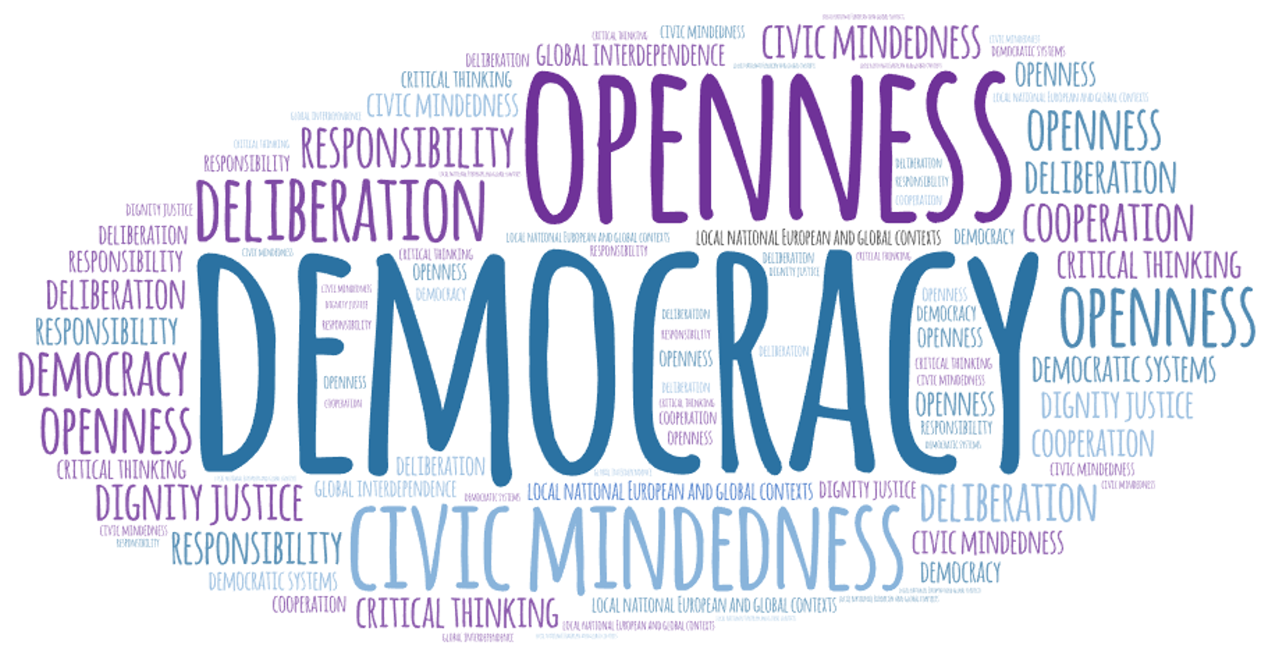

“How is it possible to achieve greater citizen participation if citizens know that, whether they engage or not, nothing will change? Citizens begin to participate when they understand that their presence or absence from collective decision-making can make a difference.
(Cornelius Castoriadis)
“The ancient Greek model is neither collectivist nor individualist. The citizen stands in opposition both to the passive subject and to the disengaged private individual.”(Christos Yannaras)

