9.2. Contemporary Development Models
Task A
Think about warfare & conflict. Which are its triggers and environmental impacts in terms of the Greenhouse Effect, loss of biodiversity and the exploitation of natural resources.
- 1991 Gulf War
- 2003 Iraq War
- 2026 Iran War
Task B
Watch the presentation video “Global Rules – Shared Future” and decide whether the statements below are TRUE (T) or FALSE (F).
 | T | F
- The original "operating system" after the Industrial Revolution viewed a country's wealth as being directly tied to how fast it could extract resources like land and minerals.

- The old growth-focused model saw the world as a complex living system that humans are a part of.

- The 1973 oil crisis served as a "wake-up call" that demonstrated the fragility of the traditional growth-at-any-cost model.

- The Kyoto Protocol was a flexible, bottom-up plan that allowed every country to set its own individual targets.
- The 2030 Agenda is described as "integrated" because it addresses environment, poverty, energy, and inequality as interconnected issues.
- SDG-13 (Climate Action) is designed to stand on its own, separate from other agreements like the Sendai Framework.

- Real lasting change must start with individual choices, even though pushing leaders is also critical.

Task C
Review the presentation, check your answers in Task B. Then, answer the questions below.
The Kyoto Protocol introduced legally binding emission reduction targets mainly for developed countries. The Paris Agreement expanded participation by allowing all countries to submit Nationally Determined Contributions. The Sustainable Development Goals go beyond climate change and aim to achieve a balance between environmental protection, economic growth, and social inclusion.
Answer the questions:
- What is the main difference in participation between Kyoto and Paris?
- What are NDCs and why are they important?
- How do the SDGs differ from the Kyoto Protocol?
- Which agreement is more flexible? Explain why.
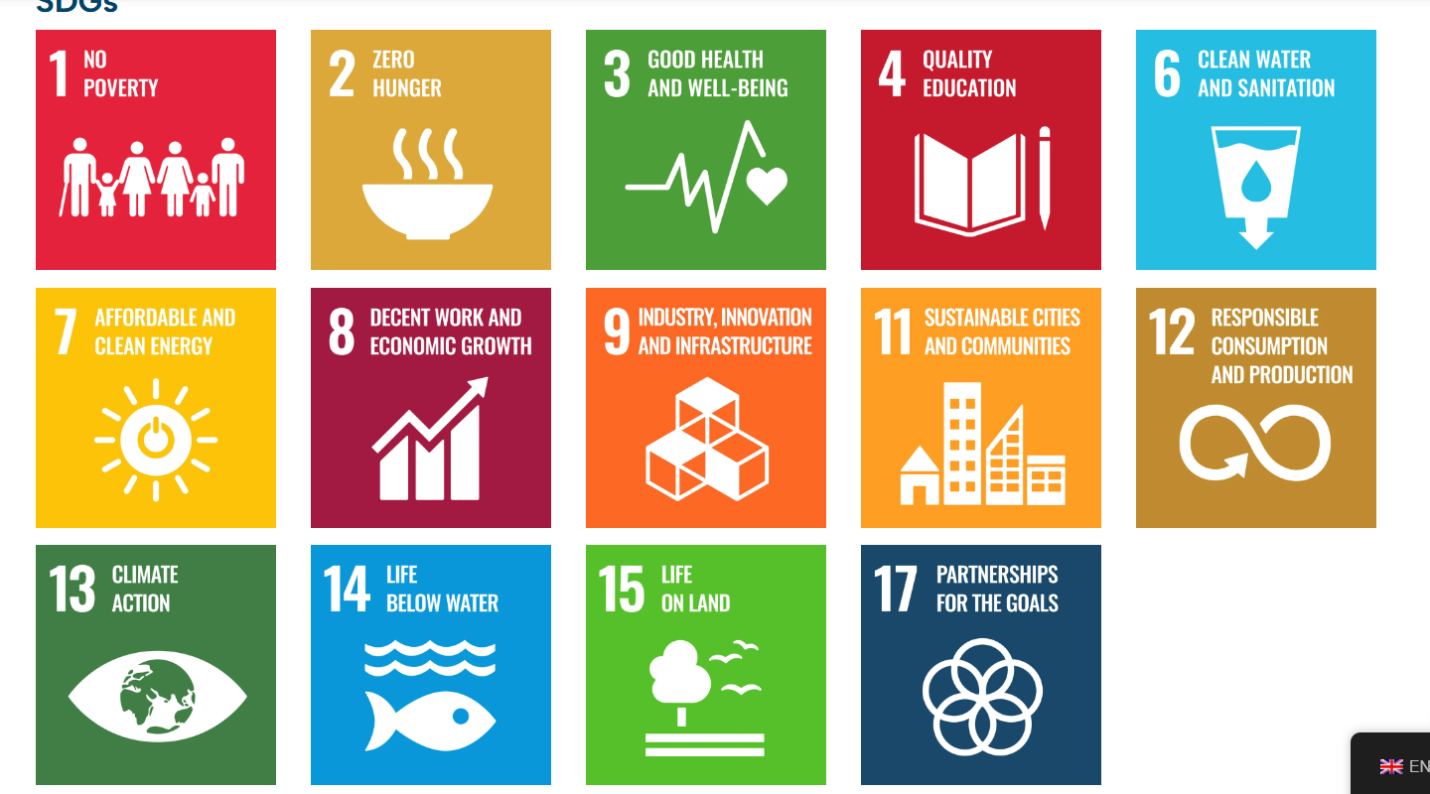
Study the SDG goals and note which goals are compromised because of war conflicts?
Task D
In your group, study The JRC Green Competences Table 11, 12, 13 and the profiles of Nikos and Eleni. Rate them and justify your evaluation.

👤 Profile 1:
Name: Nikos
Age: 17
Profile type:
🧠 Knowledge
- Has basic awareness that environmental issues exist (e.g. pollution, climate change).
- Understands that individual actions matter, but only in a general sense.
- Recognises that sustainability is “important,” without deep understanding of systems or long-term impact.
🛠️ Skills
- Can follow simple sustainable behaviours (e.g. recycling if instructed).
- Needs guidance to take action; rarely initiates change independently.
- Struggles to connect issues (e.g. consumption ↔ environment ↔ society).
- Does not yet mobilise others or plan actions.
💭 Attitudes
- Shows occasional concern for the environment.
- Is willing but inconsistent in sustainable behaviour.
- Tends to prioritise convenience over sustainability.
- Sees sustainability as something others (government, adults) should mainly handle.
🔎 Typical behaviour
- Recycles at school but not always at home
- Knows fast fashion is “bad,” but still buys it
- Talks about climate change but doesn’t act consistently

👤 Profile 2:
Name: Eleni
Age: 25
Profile type: ……………………………………………………….
🧠 Knowledge
- Understands that every action has systemic impact and that inaction is also a choice
- Knows principles like precaution, collective responsibility, and long-term impact
- Sees sustainability as interconnected (environmental, social, economic)
🛠️ Skills
- Takes initiative and persists even in uncertain situations
- Can mobilise others and build networks for change
- Applies principles like:
  - reducing resource use
  - reusing materials
  - improving efficiency
- Overcomes resistance to change and adapts behaviour
- Engages in collective and community-based action
💭 Attitudes
- Strong personal responsibility toward society and the planet
- Proactively cares and acts consistently
- Believes everyday actions matter and influence change
- Motivated to challenge the status quo and improve systems
🔎 Typical behaviour
- Organises local sustainability initiatives
- Influences peers (e.g. promotes sustainable consumption)
- Participates in community or political action
- Makes deliberate lifestyle choices (transport, food, consumption)

