After having thoroughly carried out the BBC interactive application activity
“Syrian Journey: Choose your own escape route” (school textbook: Task B, page 21), describe in about 150 words your and your family’s fleeing attempt from Syria to Europe. You are more than welcome to enrich your description with a drawing or poem of yours inspired by the topic and/or one or more relevant pictures from reliable online sources.
(http://www.bbc.com/news/world-middle-east-32057601)
They call me Ayman. I am among the nine million Syrians who were displaced because of the war. Before fleeing my hometown, Qoraybi, which was destroyed in the battle against ISIS, killing my two brothers, I had done everything in my power to repel the rebellion. Yet, it couldn’t be helped. I was the only survivor in my family. So as to escape arrest and torture, I had to reach the Syrian–Lebanese border near Al-Qusayr. Guided by a man who knew the area well, I with the rest of my group of asylum seekers left the village at dawn in a van and passed several checkpoints in the mountains. Sometimes we heard bomb explosions in the distance but we were determined to carry on. Fearful and hungered, we made it to the riverbed and stepped in Lebanon, near Hermel. Some members of my group cried softly, half from exhaustion, half from relief — we had left Syria behind, but our long journey to safety had only just begun. We stayed for a few days in a crowded camp near Tripoli. The conditions were hard, but at least we were safe from the bombs. From there, we traveled secretly by bus through the mountains to southern Turkey. We reached Izmir, where we met other families trying to cross the sea. One dark night, we got on a small rubber boat with thirty people on board. The waves were high, and everyone was praying. After many terrifying hours, we finally reached the island of Lesvos, Greece. We were exhausted but full of hope. Later, volunteers helped us take a ferry to Piraeus, near Athens. When we saw the Greek coast, we cried with relief — we had survived, and our dream of freedom was finally real.
In the next few months we were to be taken to Eleonas Refugee Camp in the suburbs of Athens. We were placed under the auspices of a Danish volunteer organization that made sure we were protected, properly fed and given the means to prepare our setting up home either in Germany or Sweden where friends or family members of ours had already settled. To this end, we were offered English language lessons at the University of Athens (see pictures 2,3).
This is my life journey as an asylum seeker! Never has a day gone by without wishing for my return in Qoraybi.

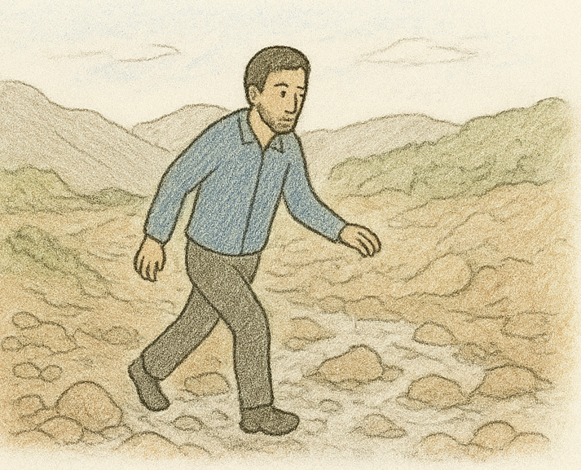
Picture 1 AI Chatgpt engineered photo with prompting from Aysan’s story.

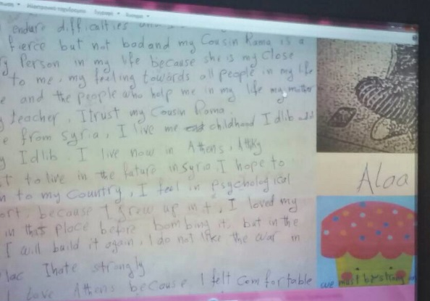
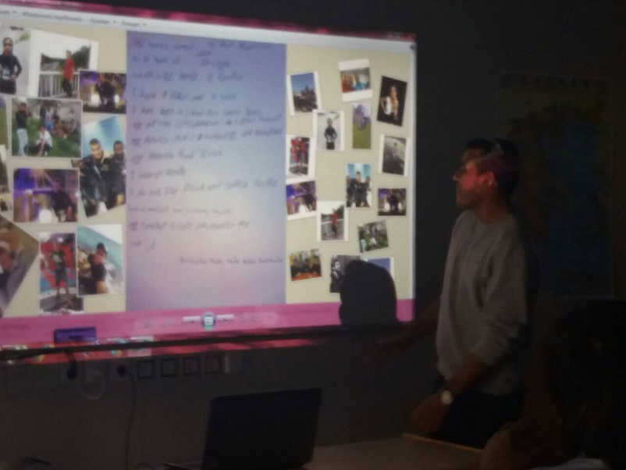
Picture 2 “Aysan, my story presented”

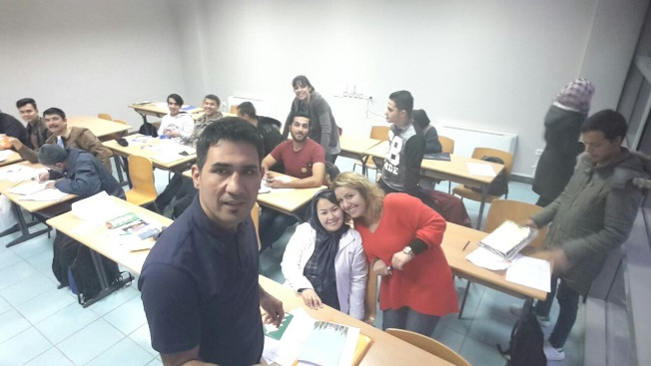

Picture 3 “Aysan, my story presented”
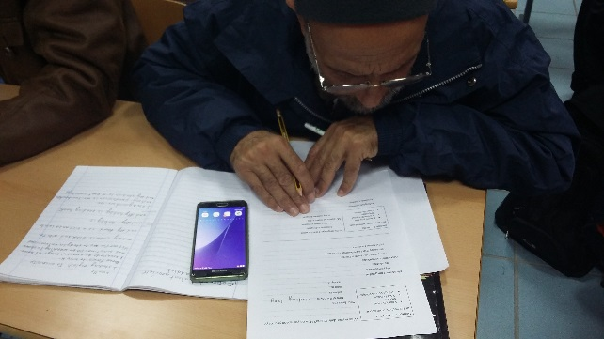

Picture 3 Aysan in class

