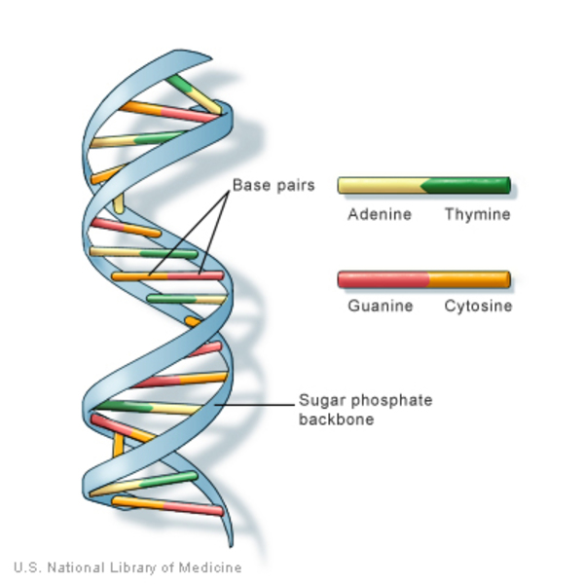

**Fig.1**

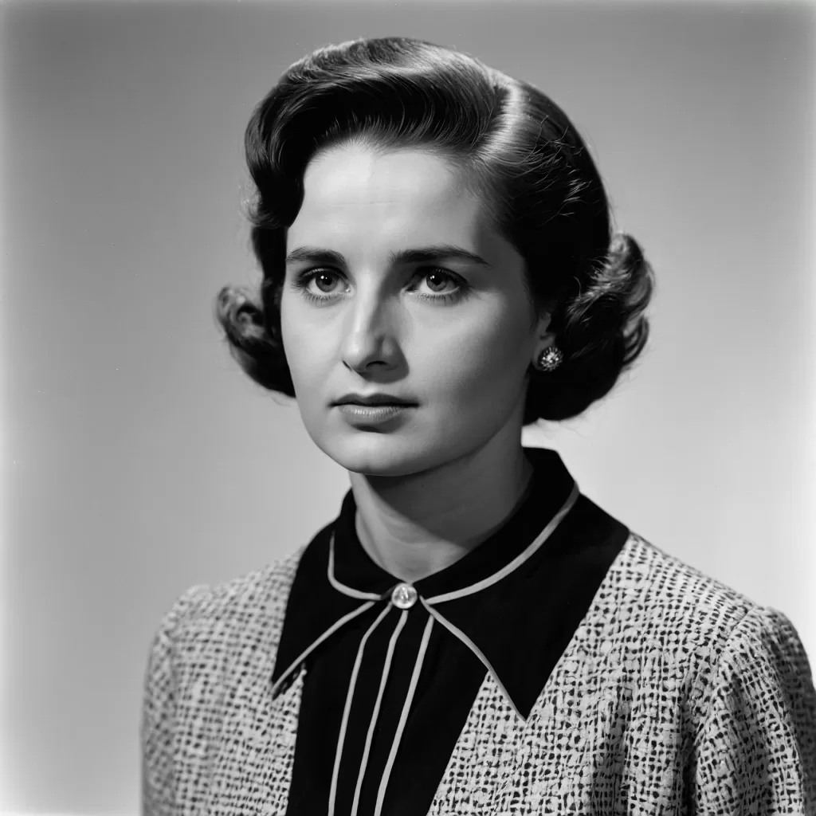

**Fig. 2**

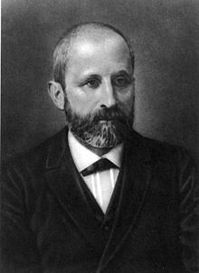

**Fig. 3**

Captions in English and Greek

**Fig.1**

1. DNA double helix.

2. Η διπλή έλικα του DNA.

**Fig.2**

1. Rosalind Franklin 1920-1958.

2. Rosalind Franklin 1920-1958.

**Fig.3**

1. Friedrich Miescher 1844-1895

2. Friedrich Miescher 1844-1895

Links for the images.

**Fig.1**

[*https://www.fialkatr.com/a-pioneer-of-science-the-extraordinary-life-of-rosalind-franklin/*](https://www.fialkatr.com/a-pioneer-of-science-the-extraordinary-life-of-rosalind-franklin/)

**Fig.2**

[*https://www.chemguide.co.uk/organicprops/aminoacids/dna1.html*](https://www.chemguide.co.uk/organicprops/aminoacids/dna1.html)

**Fig.3**

[*https://en.wikipedia.org/wiki/Friedrich_Miescher*](https://en.wikipedia.org/wiki/Friedrich_Miescher)