Permission

Can, could, may, might
The most common modal verbs to talk about permission are can, could, may and might.
- ASKING FOR PERMISSION (INFORMAL): Can I sit here?
- ASKING FOR PERMISSION (FORMAL): Could I use this chair? Might/May I use this chair?
- GIVING PERMISSION (INFORMAL): You can sit here.
- GIVING PERMISSION (FORMAL): You may use this chair.
- REFUSING PERMISSION (INFORMAL): Sorry, you can’t use this chair.
- REFUSING PERMISSION (FORMAL): Sorry, you may not use this chair.

Was/were allowed to, couldn’t
To talk about permission in the past, we can use the forms was/were allowed to or the negative form couldn’t. We don’t use the affirmative form could to talk about permission in the past.
- He wasn’t allowed to sit down during the lesson.
- He couldn’t sit down during the lesson.
- He could receive visits.
- He was allowed to receive visits.

Obligation
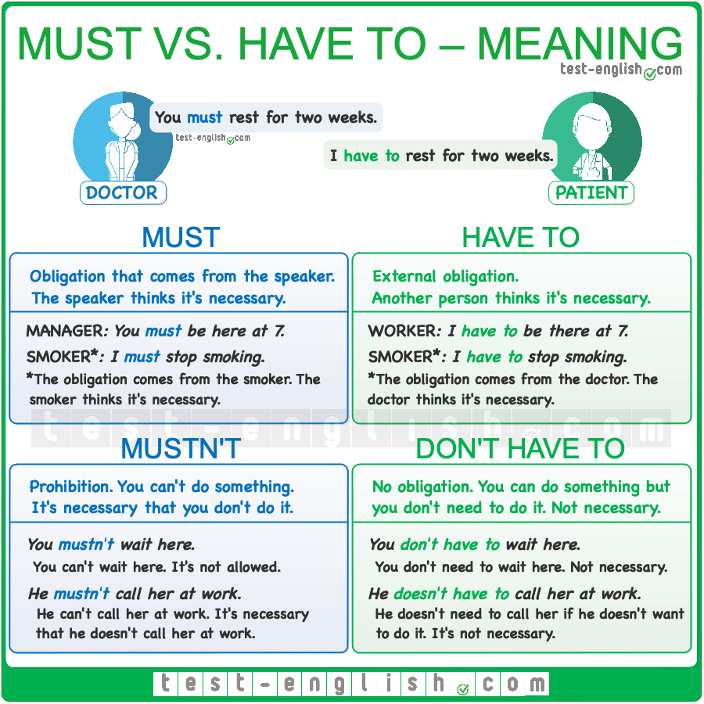

Must / have to
Must and have to are used to express obligation. When we use must this usually means that the obligation comes from the speaker, it’s like a personal obligation, whereas have to normally means that the obligation is external.
- I must give up smoking. (I need to, I say so)
- I have to give up smoking. (I’m obliged. My doctor says so)
In informal English can also use ‘ve got to to express obligation (⇒ See Have – auxiliary or main verb).
- I’ve got to be there before ten.
In the past, we use had to in every instance.
- I had to give up smoking. (because I needed to, or because my doctor forced me to).

Mustn’t / don’t have to
The negative forms mustn’t and don’t have to are completely different. Mustn’t is used to express prohibition (an obligation not to do something), whereas don’t have to is used to express an absence of obligation. (⇒ See Have to, must, should – obligation, prohibition, necessity, advice)
- You mustn’t reveal where you get the information. (=you have the obligation not to do it)
- You don’t have to arrive before 7. (=you can do it, but it’s not necessary, there’s no obligation)

Necessity
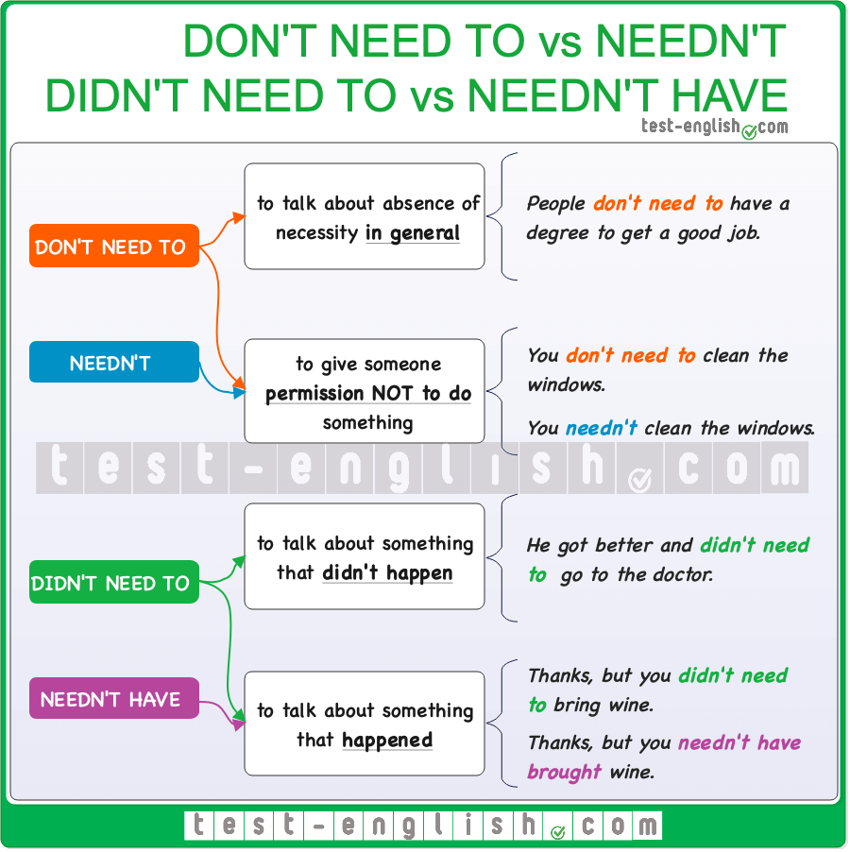

Need to, have to, don’t need to, don’t have to
We use need to/have to or don’t need to/don’t have to + infinitive to say that something is or is not necessary.
- We need to/have to confirm our reservations before Friday.
- You don’t need to/don’t have to believe in God to be a good person.

Don’t need to / needn’t
We can use both don’t need to or needn’t + infinitive to say that it is unnecessary to do something. However, when we are talking about a general necessity (in general, not on one specific occasion), we normally use don’t need to, and we can use both don’t need to or needn’t + infinitive when we are talking about a specific necessity (on one specific occasion).
- The doctor said I don’t need to wear glasses. (In general, all the time)
- Tell him he doesn’t need to/needn’t wash the dishes. I’ll do it later. (On one specific occasion)

Didn’t need to / needn’t have
When something was not necessary but we did it, we can use both didn’t need to + infinitive and needn’t have + past participle.
- Thanks, it’s very beautiful, but you didn’t need to buy/needn’t have bought anything. (=you did it)
However, when something was not necessary and we did not do it, we can only use didn’t need to.
- I didn’t buy any groceries because Sarah told me I needn’t have bought anything.
- I didn’t buy any groceries because Sarah told me I didn’t need to buy anything.

Be able to, be allowed to, be permitted to, be supposed / meant to, had better
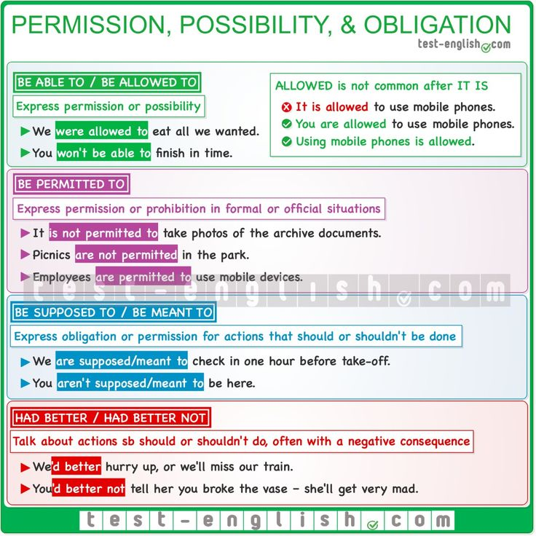

Be able to / be allowed to
We can use subject + be able to / be allowed to instead of can to express permission or possibility. (⇒ See Can, could, be able to – ability and possibility)
- We were allowed to eat all that we wanted.
- You won’t be able to finish before the deadline.
We do NOT normally use it + be able to/be allowed to + infinitive.
- It is allowed to use mobile phones.
- You are allowed to use mobile phones.
- Using mobile phones is allowed.

Be (not) permitted to
We can use be (not) permitted to +infinitive to express permission or prohibition in formal or official situations, to say what the rules or laws are. The form it + be (not) permitted to +infinitive can be used.
- It is not permitted to take photos of the archive documents.
- Picnics are not permitted in the park.
- Employees are permitted to use mobile devices.

Be supposed to / be meant to
We can also use be supposed/meant to + infinitive to express obligation or permission, to say what we should or shouldn’t do.
- We are supposed/meant to check in one hour before take-off.
- What are you doing? You aren’t supposed/meant to be here.

Had better, had better not
We use had better + infinitive (without to) to talk about actions we think someone should or shouldn’t do. There is often a negative result if the action is carried out. We normally use the shortened form ‘d better, and the negative form is ‘d better not (hadn’t is NOT used).
- We’d better hurry up or we’ll miss our train.
- You’d better not tell her you broke the vase –she’ll get very mad.
- You hadn’t better tell her you broke the vase.

Modal verbs of deduction – Grammar chart
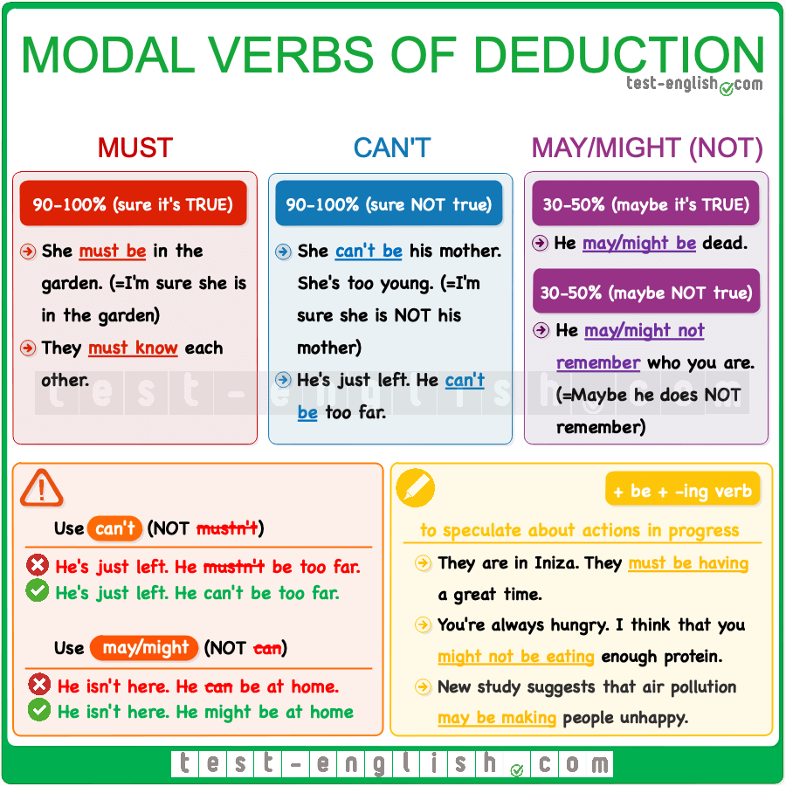

May, might
We use may and might to talk about things that are possibly true, but we don’t know for sure.
- He’s more than 2 meters tall. He might be a basketball player. (=perhaps he is)
- He says Betty is his friend, but I think she may be his girlfriend.
We use may not or might not to talk about things that are possibly not true, but we don’t know for sure.
- You should call her. She might not know where you are. (=perhaps she doesn’t know)

Don’t use can for deduction
We don’t use can as a modal of deduction.
- He can be at home now.
- He might/may be at home now.

Must, can’t
We use must when we are sure, or quite sure, that something is true.
- You must be tired after the long journey. (=I’m sure you are tired)
- I’m sure I had the keys when I left. They must be in the car.
But we use can’t (NOT mustn’t) when we are sure, or quite sure, that something is not true.
- We’ve been walking for hours. It mustn’t be far from here.
- We’ve been walking for hours. It can’t be far from here.
- They’ve lived here only for a couple of months. They can’t know many people.

+ be + -ing
After may, might, must or can’t, we can use be + -ing, when we are talking about actions in progress.
- They’ve gone to Ibiza, and right now, they must be having a great time.
- Call him. He might be waiting for us.

Past modal verbs of deduction – Grammar chart
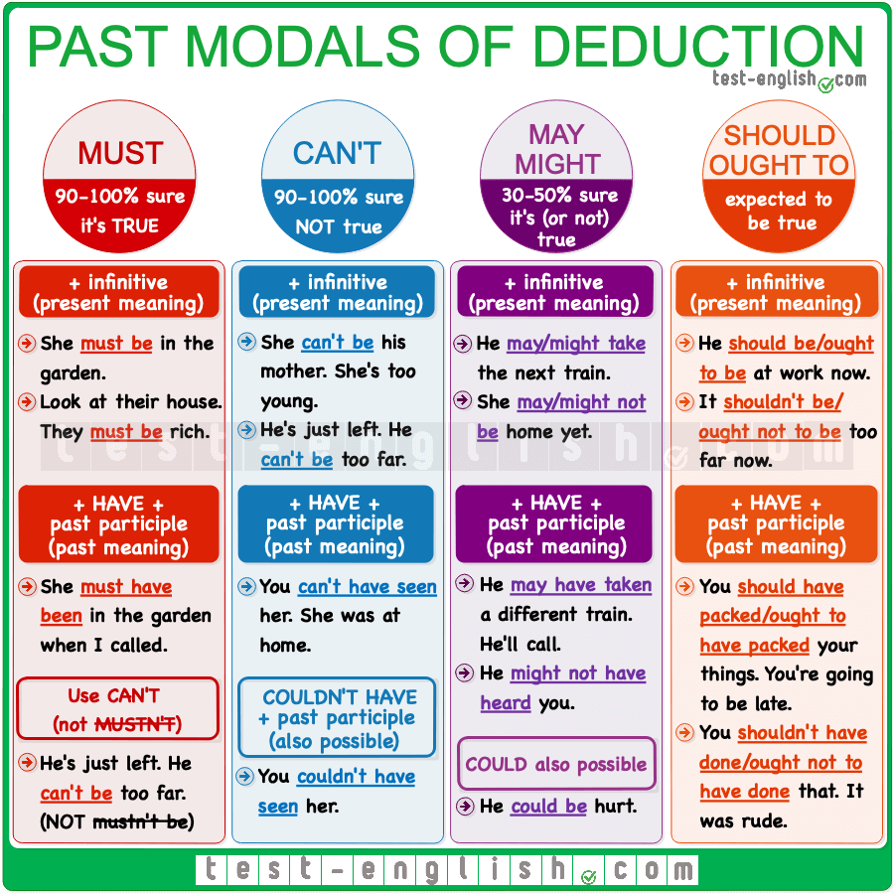

Modal verbs of deduction and speculation
We can use some modal verbs + an infinitive to talk about how certain we are that something is or is not true. We can also use some modal verbs + have + past participle to talk about how certain we are that something was or was not true in the past.

Must have done
We use must have + past participle to say that we are quite sure that something was true or happened in the past.
- I can’t find my wallet! I must have dropped it in the taxi.
- You must have had a real scare when you saw the crocodile.

Can’t have done
We use can’t/couldn’t have + past participle to say that we are quite sure that something did NOT happen or was NOT true in the past.
- You can’t/couldn’t have seen John last night. He was in hospital.
- She can’t/couldn’t have passed the test. She didn’t even open the books.
Note that for negative deduction, we use can’t (NOT mustn’t)
- He mustn’t be that famous.
- He can’t be that famous.

Could/might/may have done
We can use could have + past participle to say that something was possible in the past or someone had the possibility to do something but didn’t do it.
- You could have called me to say you weren’t coming. I waited for hours.
We can also use could/might/may have + past participle to say that it’s possible that something was true or happened in the past.
- It’s been three days. They might/may have finished painting the house by now.
- If they left at 9, they might/may have already arrived.
Note that we use might not or may not (NOT could not) to talk about a negative possibility.
- She might/may not have heard us. Knock again.

Should/ought to have done
We use should have/ought to have + past participle to talk about a situation expected to happen in the past. This form is normally used for criticism.
- You should/ought to have already packed your things. We’re going to be late.
- He should/ought to have studied more. Nobody fails if they study.

