

**ΝΕΑ** ΤΡΑΠΕΖΑ ΘΕΜΑΤΩΝ ΔΙΑΒΑΘΜΙΣΜΕΝΗΣ ΔΥΣΚΟΛΙΑΣ



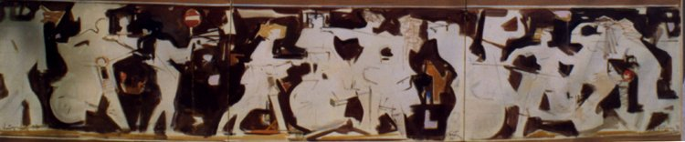

***Κώστας Κοντογιάννης****: “Σύνθεση με νέους και μηχανάκια”*

*ακρυλικά σε ύφασμα 70x300cm - έτος 2000*

**➤ 7973 / B2** [****](https://drive.google.com/file/d/1kYmumnHOkb-ftB4gRp5XjSC7SqyEhrab/view?usp=sharing)

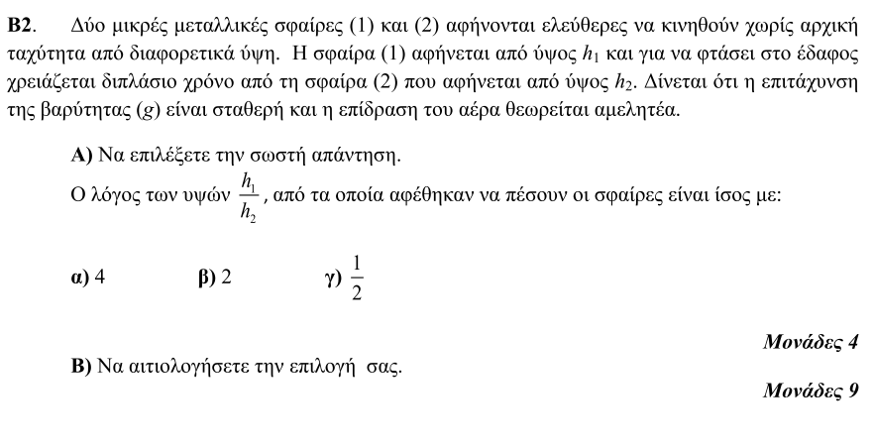

**➤ 7974 / B2** [****](https://drive.google.com/file/d/1DPSmqjPKHK-lNpemHhEbYYQDuSjLkwWz/view?usp=sharing)

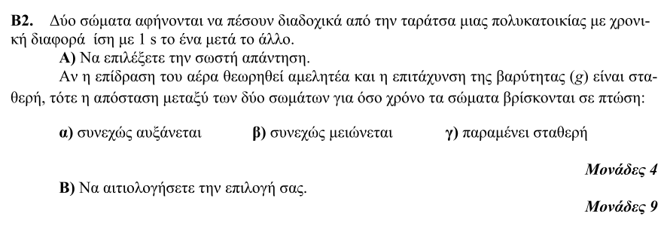

**➤ 7976 / B1** [****](https://drive.google.com/file/d/1Z_j0xIQkwslU-Oh0rhpg6uAfEQb6EjmT/view?usp=sharing)

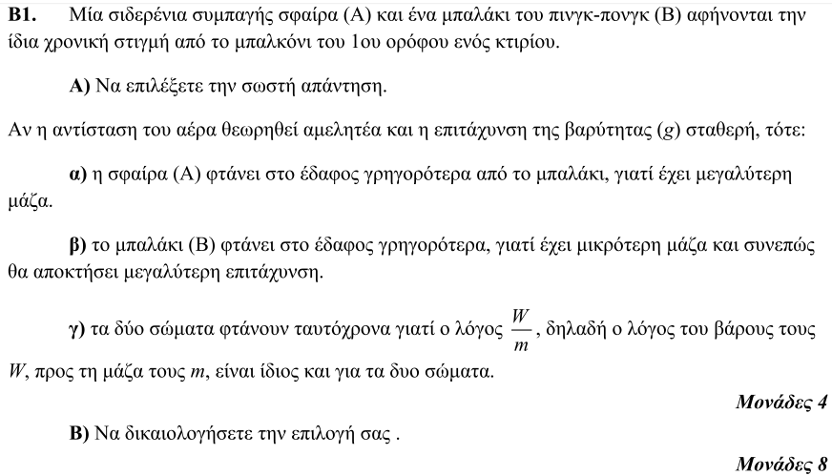

**➤ 7977 / B1** [****](https://drive.google.com/file/d/1Jyt9zwh16tezPx10pYOF2XKdKPmOFSEb/view?usp=sharing)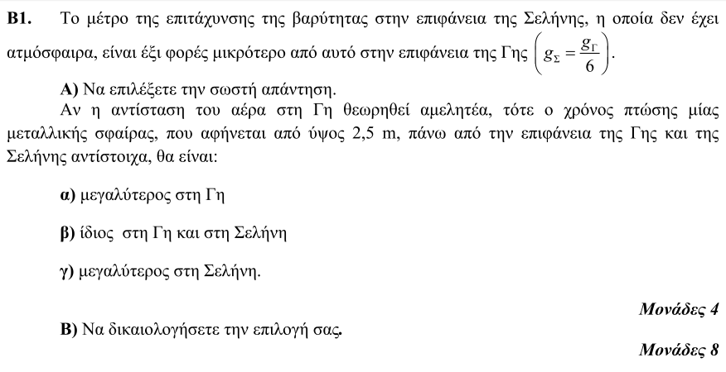

**➤ 7986 / B1** [****](https://drive.google.com/file/d/1lPAHjberIHU-cpZGWn2BQe5TZ0bIHLY6/view?usp=sharing)

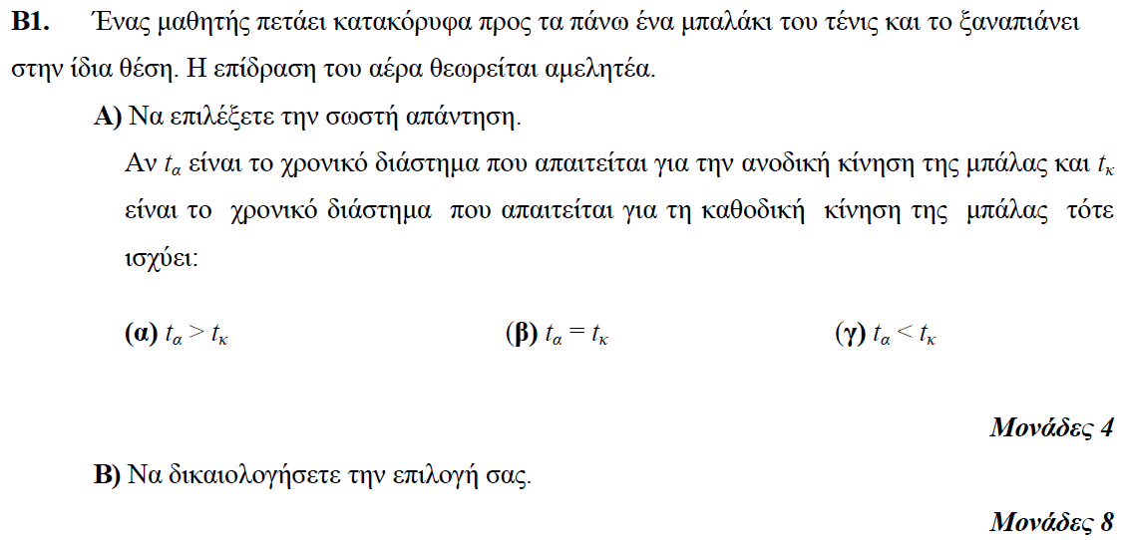

**➤ 7993 / B1** [****](https://drive.google.com/file/d/1YE_7THhvQUf85Lq26FJF4NGocPWeuT5n/view?usp=sharing)

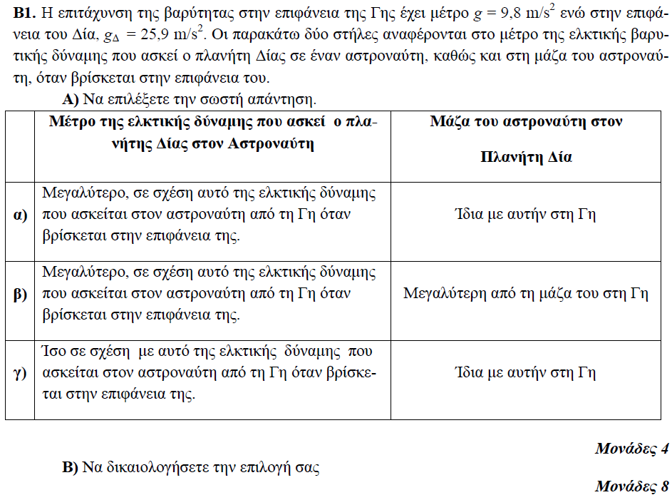

**➤ 7998 / B1** [****](https://drive.google.com/file/d/1kpyNCTKb0PFGkPeLeXkbtD6Mv3S891x0/view?usp=sharing)

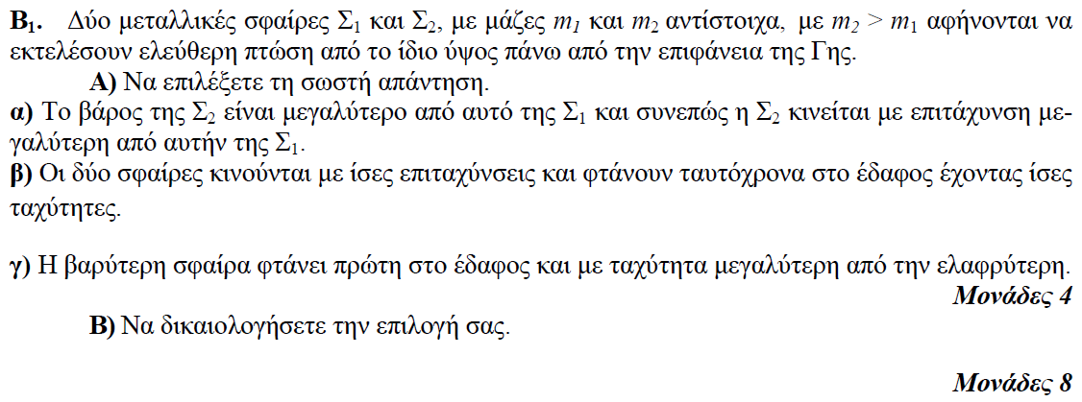

**➤ 8004 / B1** [****](https://drive.google.com/file/d/105Z1XzARMl9kOW49fESQkCjnyjMAIhgY/view?usp=sharing)

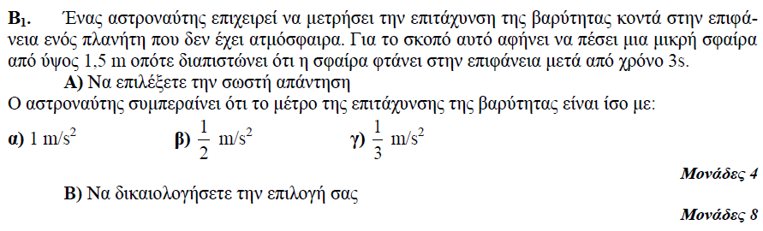

**➤ 8012 / B2** [****](https://drive.google.com/file/d/1ZgyjMKwl3-zQvSRPgfw70bUSxfghLHPW/view?usp=sharing)

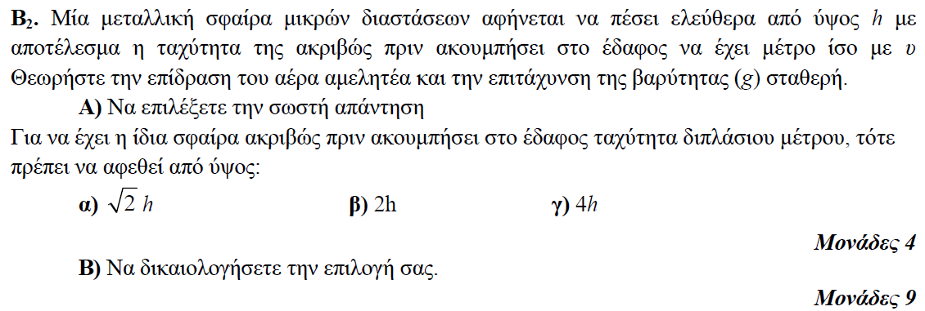

**➤ 8014 / B2** [****](https://drive.google.com/file/d/17iyLHFR8eEdI0obktiVgcrDWFIIcyf8G/view?usp=sharing)

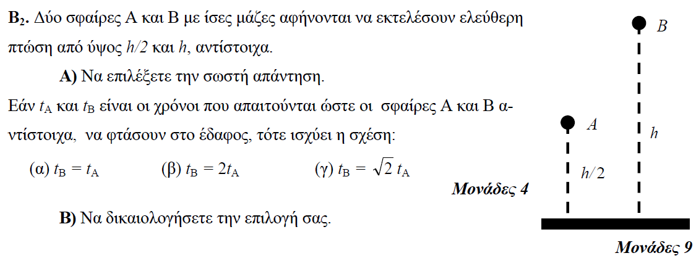

**➤ 8016 / B1** [****](https://drive.google.com/file/d/1w5ze5kTAR8QULcIVORKtdgQ8DRdi9FrY/view?usp=sharing)

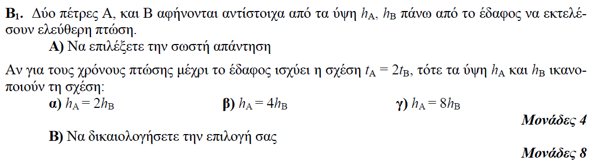

**➤ 8023 / B1** [****](https://drive.google.com/file/d/1GWvyYDyxXJu77I9R6Y2ign8hqy9MaaWF/view?usp=sharing)

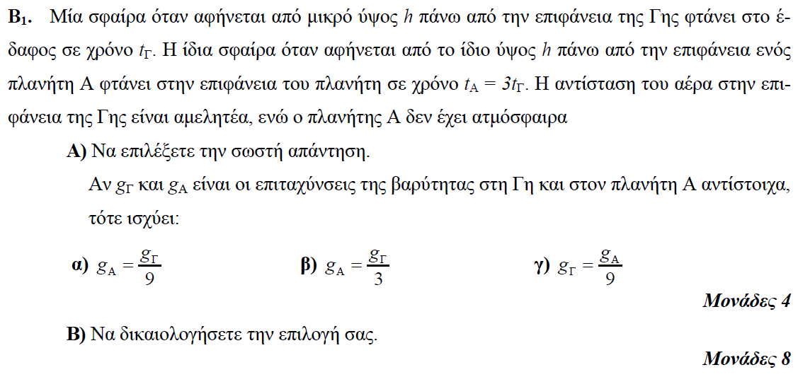

**➤ 8029 / B2** [****](https://drive.google.com/file/d/1J1ufJwv2ufLnrhYqX_3aBsj9WKHA47zo/view?usp=sharing)

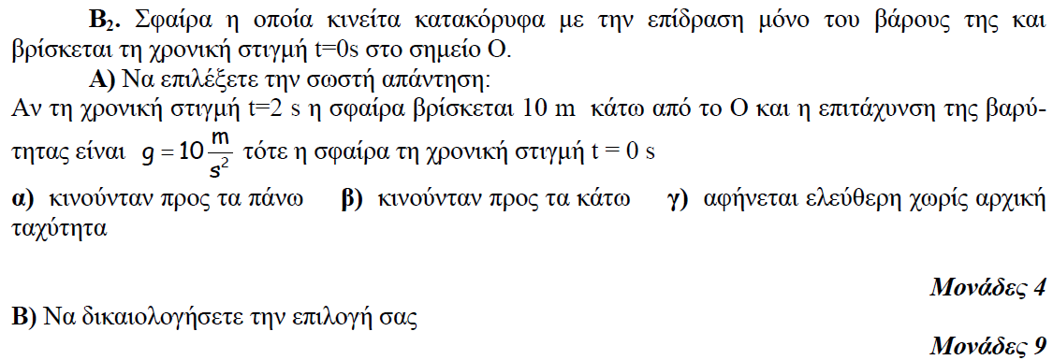

**➤ 8036 / B1** [****](https://drive.google.com/file/d/1GeV8ikiC7VWeRI_hwakITMTxVFqyjnG5/view?usp=sharing)

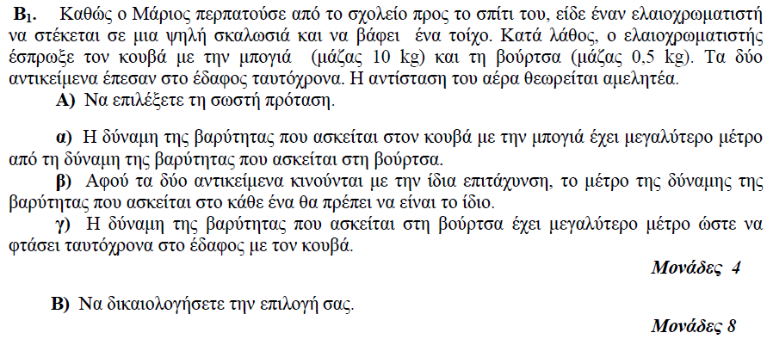

**➤ 8050 / B2** [****](https://drive.google.com/file/d/17BEtEaf2Pqjl_-dYRKBx8WtSxpT6DdIG/view?usp=sharing)

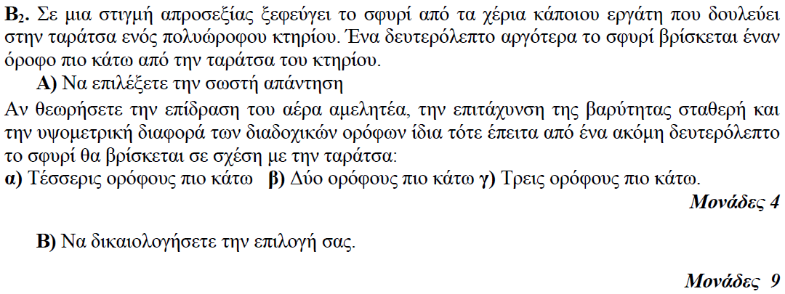

**➤ 12005 / B2** [****](https://drive.google.com/file/d/1Vqp8OtcWlbwMHx3GyhNH0lM4PZB-Oyra/view?usp=sharing)

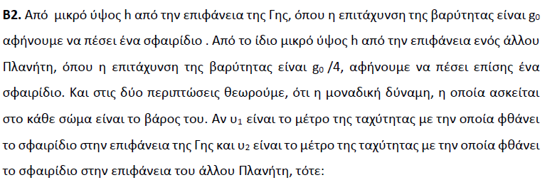

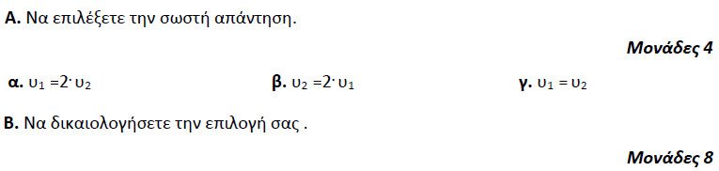

**➤ 12016 / B1** [****](https://drive.google.com/file/d/1LUm7DTmXh0DyfqXtDSHX7ylW7cTaDjC0/view?usp=sharing)

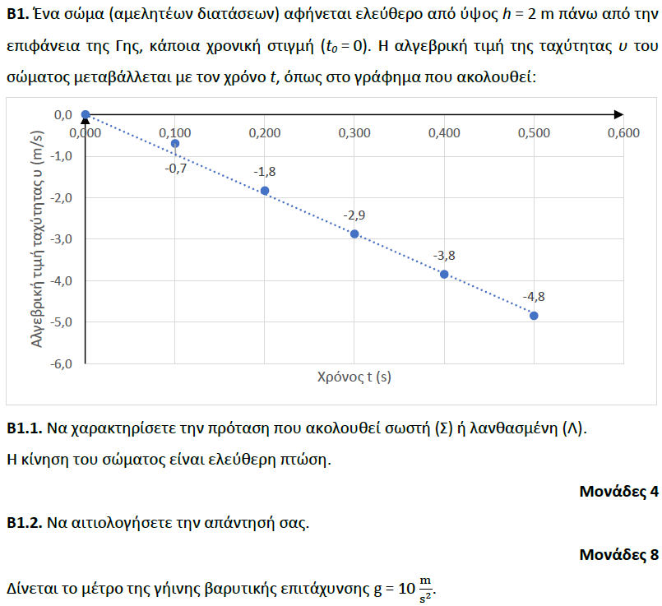

**➤ 12317 / B1** [****](https://drive.google.com/file/d/1oM9oRIO98lCFYU2dYROlaIw_2TrcVb1g/view?usp=sharing)

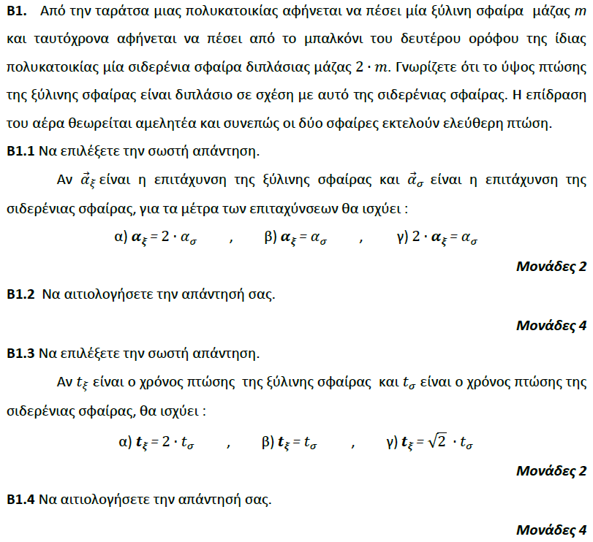

**➤ 13097 / B1** [****](https://drive.google.com/file/d/1tGTPdMZ-wpXGpdDJD50iEU2D1PGSqsT-/view?usp=sharing)

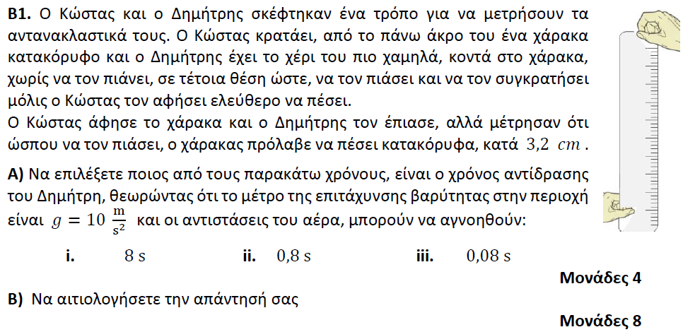

**➤ 13470 / B1** [****](https://drive.google.com/file/d/1Cv18VxCpq3ZaGy3qWMa7p5y3Ed2OE0FN/view?usp=sharing)

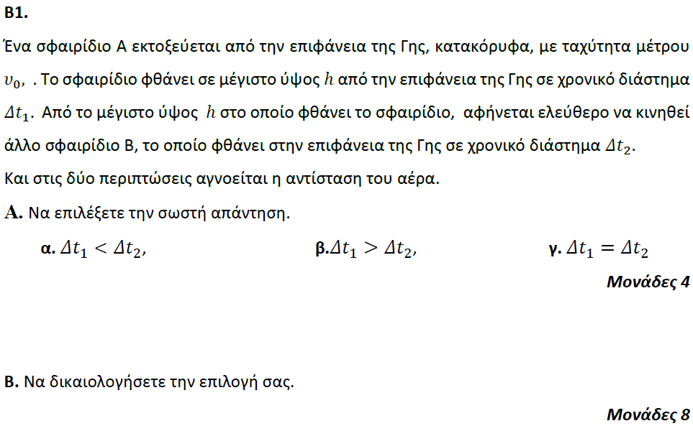

**➤ 13547 / B2** [****](https://drive.google.com/file/d/1BqN9EgtDxXpls-pdaWt-cHZFDcnzjxgq/view?usp=sharing)

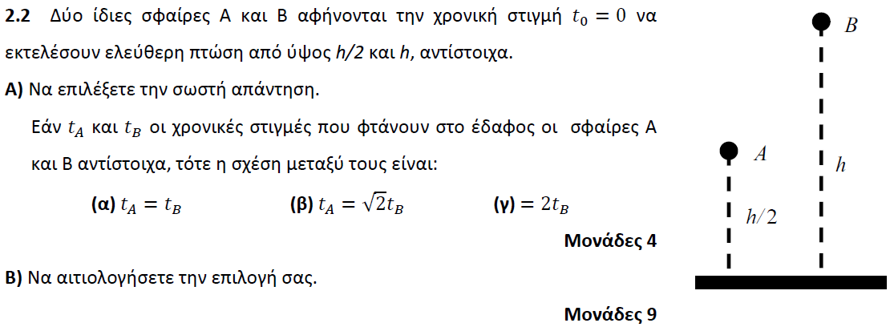

**➤ 13769 / B1** [****](https://drive.google.com/file/d/1AIc6cXJ3UwjoQGCrXMJB8OPIePcj1IT_/view?usp=sharing)

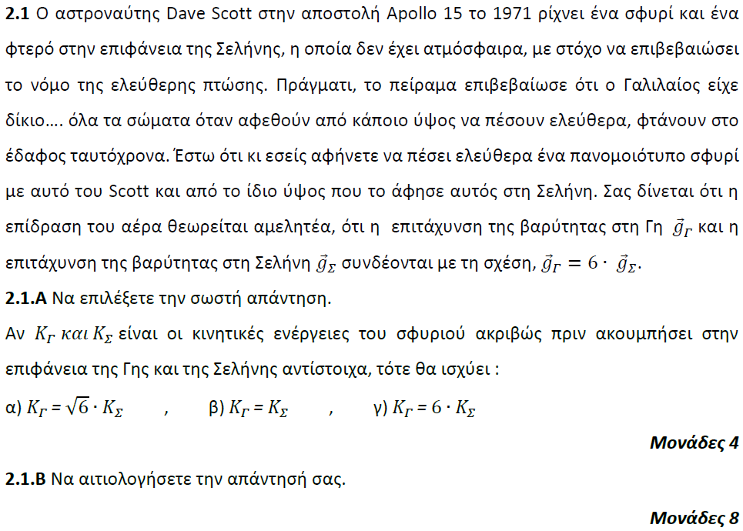

**➤ 13770 / B1** [****](https://drive.google.com/file/d/1Af15rlqsyLvakPsNFVMIy3OQ5oWgfzJ_/view?usp=sharing)

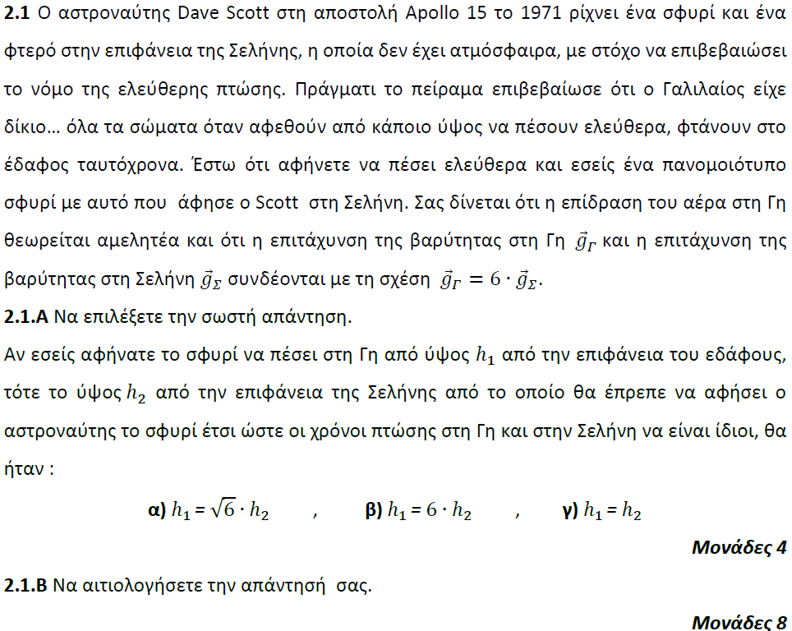

**➤ 13772 / B2** [****](https://drive.google.com/file/d/1igGIeE1P4pm8srJZCyCwWM34b4SwBAjh/view?usp=sharing)

